ELECTRONIC, ELECTRICAL AND COMPUTER ENGINEERING





04 16066/EE4E 206/2007

Object Oriented Programming Using C++

Assessed Programming Assignment

Swarm Intelligence

Dr M. Spann

- Aims and Objectives

This programming exercise is concerned with an investigation into and applications of swarm intelligence or Ant algorithms. Swarm intelligence is a term describing the collective behaviour that emerges from groups of social insects such as ants. There has been a lot of research recently into the application of Ant algorithms to the solution of discrete optimization problems. It has been long recognised in the natural world how swarms of ants are able to find the shortest path between the nest and a food source by communicating via pheromone, a chemical substance that attracts other ants. The key point about this is that there is no direct communication from ant to ant, something that would be extremely inefficient given the large numbers of insects in a swarm. Instead, communication is indirect and efficient in the sense that ants passing over a region pick-up the local pheromone density which is proportional to the number of ants that have previously passed over the same region.

The aim of this programming exercise is to write a program to illustrate how a basic swarm intelligence algorithm, specifically one based on the ant colony optimization algorithm (ACO), can be used to solve a challenging discrete optimisation problem. Objectives will be to develop C++ classes to implement the ACO algorithm with application to the famous Travelling Salesman Problem (TSP), a classic and much studied discrete optimisation problem. Obviously additional classes in the application domain will be required. You will be provided with general descriptions of both the ACO algorithm and the TSP problem. It is up to you to fit them together and provide an implementation of the ACO, which is applicable to the TSP. This is a sizeable document with lots of detail about ant-based algorithms and the TSP. You will need to read it carefully and understand the principles before setting out on an implementation.

- Background

  - The ACO algorithm

Ant-based optimisation algorithms use features exhibited by real swarms of ants in their hunt for food, to solve discrete optimisation problems such as the travelling salesman problem. Similarities include the following. Ants make probabilistic decisions based on local information (in the case of real ants, the amount of locally deposited pheromone) to move through adjacent states. Real ants also use a priori information to control their decision-making policy, for example the nature of the local terrain (hilly, flat, wet etc).

However, there are differences between real and artificial ants. Artificial ants are solving discrete optimisation problems. They move between discrete adjacent states. Artificial ants have an internal memory. They can remember their past states (in other words, where they have been!). Artificial ants, deposit an amount of pheromone that is a proportional to the quality of the solution found. In other words, its not until the solution is found that the pheromone is deposited. Real ants deposit pheromone as they go along. Artificial ants can exhibit other, more advanced features such as local optimisation, backtracking, look ahead etc. However, we will only consider the basic ACO algorithm.

Each ant, acting concurrently and independently from the other ants in the swarm, builds its own solution to the problem. The algorithm executes $t_{\text{max}}$ iterations (thus each iteration is indexed by$t≤t_{\text{max}}$). During each iteration, some number m ants are created and they build solutions to the problem after which all m ants die, the iteration count $t$ is incremented and a new set of ants are created.

A key feature of the algorithm is that individual ants do not exchange information. Each ant is able to find its own solution, which is probably sub-optimal. High quality solutions emerge as more and more ants add to the local pheromone deposits, which control the solutions found by later ants. The key issue in designing ant based optimisation algorithms is to strike a balance between the exploration of new and potentially interesting regions of the solution space so that all possible solutions are explored and the exploitation of accumulated knowledge through the pheromone deposits. Once an ant has completed its task in building a solution and adding to the pheromone deposits, it dies and is deleted from the system.

Besides the locally acting ants, the system can also incorporate a global daemon process, which can observe all of the ants’ behaviours to, for example, deposit additional pheromone to bias the ants’ search. The daemon process has a lifetime equal to the lifetime of the swarm and runs until an optimum solution is found.

A final feature of ant-based optimisation problems is pheromone evaporation. This is a real analogy with real ants in that the pheromone deposit evaporates over a time period less than the time taken for the swarm to find the shortest path so that it must be taken into account of. The purpose of pheromone evaporation is for the swarm to eventually forget past behaviour so that new solution regions can be explored.

In order to describe in detail how the ACO algorithm is applied to the TSP, we will first introduce the TSP, as the notation we will use will be specifically related to the TSP. Note that the TSP was chosen as a vehicle to demonstrate ant-based optimisation algorithms as it is simple to understand and can be solved without the use of daemons. Also, there is lots of test data including optimum solutions, on the internet making algorithm evaluation easier.

2.2 The Travelling Salesman Problem

The travelling salesman problem can be cast as a shortest path problem within a graph $G(N,E)$comprising nodes and arcs connecting those graph nodes. The definition of the TSP is as follows. Given a set of N of nodes which represent cities and a set E of arcs which fully connect all of the nodes N. Define $d_{\text{ij}}$as the length of the arc $(i,j)∈E$ which represents the distance between the cities i and j with $i,j∈N$. The TSP is the problem of finding a minimal length closed tour of the graph, which visits every city once and only once. We will assume that the distances are symmetric (although it is possible to consider an asymmetric TSP) whereby $d_{\text{ij}}=d_{\text{ji}}$.

It is easy to see that for the symmetric case, there are $\left(\left|N\right|−1\right)\text{!/}2$possible closed tours where $\left|N\right|$ is the number of cities. This gets extremely large extremely quickly as the number of cities increases and so an exhaustive search becomes impossible. By way of example, the following image (figure 1) shows a small scale TSP problem (29 cities in Western Sahara), and its optimum tour. The cost of travel between two cities is simply the Euclidean distance between the two points rounded to the nearest integer. Currently problems involving tens of thousands of cities are being studied. Other test data for the TSP can be found at http://www.tsp.gatech.edu/data/index.html. The data is given in the form of a set of $(x,y)$ co-ordinates of each city.

2.2.2 Application of the ACO algorithm to the TSP

To describe the ACO algorithm, a number of definitions are required. An arc in the graph $(i,j)$connects cities i and j. We define $τ_{\text{ij}}(t)$as the amount of pheromone currently (in other words at time t) deposited on arc $(i,j)$. This quantity is updated by all of the ants once they have completed their tour. The amount deposited by an individual ant is added to $τ_{\text{ij}}(t)$ and is proportional to the quality of solution generated. In the case of the TSP, this is simply the inversely proportional to the length of the tour spanning all $\left|N\right|$ cities. Thus the shorter the tour, the greater the amount of pheromone deposited on the arcs, which are members of the tour. As described previously, pheromone evaporation also determines $τ_{\text{ij}}(t)$ and is used to prevent all ants ending up with the same tour (called stagnation). Also, as described previously, each ant has an internal memory and for the case of the TSP, the memory is obviously a list of cities already visited. This allows an ant to determine which cities still remain to be visited as well as enabling it to deposit delayed pheromone on already visited cities.
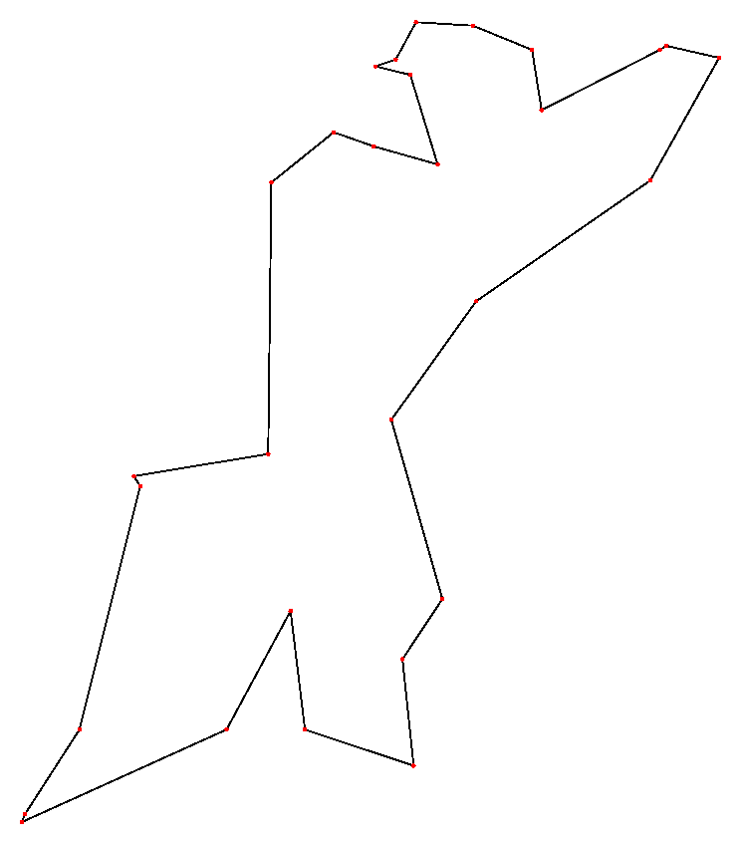

TSP pointset for Western Sahara
TSP optimum tour
Figure 1

2.2.2 Application of the ACO algorithm to the TSP

To describe the ACO algorithm, a number of definitions are required. An arc in the graph $(i,j)$connects cities i and j. We define $τ_{\text{ij}}(t)$as the amount of pheromone currently (in other words at time t) deposited on arc $(i,j)$. This quantity is updated by all of the ants once they have completed their tour. The amount deposited by an individual ant is added to $τ_{\text{ij}}(t)$ and is proportional to the quality of solution generated. In the case of the TSP, this is simply the inversely proportional to the length of the tour spanning all $\left|N\right|$ cities. Thus the shorter the tour, the greater the amount of pheromone deposited on the arcs which are members of the tour. As described previously, pheromone evaporation also determines $τ_{\text{ij}}(t)$ and is used to prevent all ants ending up with the same tour (called stagnation). Also, as described previously, each ant has an internal memory and for the case of the TSP, the memory is obviously a list of cities already visited. This allows an ant to determine which cities still remain to be visited as well as enabling it to deposit delayed pheromone on already visited cities.

Suppose an ant is currently at some city i. Each city has a neighbourhood of cities $N_{i}$that it can move to. Thus we can define a local decision matrix $A_{i}=\left[a_{\text{ij}}(t)\right]j∈N_{i}$, which is used in the final probabilistic determination of the next move:

$a_{\text{ij}}=\frac{\left[τ_{\text{ij}}(t)\right]{\left[η_{\text{ij}}\right]}^{β}}{\sum_{l∈N_{i}}{\left[τ_{\text{il}}(t)\right]{\left[η_{\text{il}}\right]}^{β}}} j∈N_{i}$ (1)
where $η_{\text{ij}}=1/{d_{\text{ij}}}$ and $d_{\text{ij}}$is the length of arc $(i,j)$. $β$is a parameter which control the relative influence of the arc length over the previously accumulated pheromone deposits. Thus if $β=0$the algorithm leads to rapid stagnation whereby an existing route is selected and amplified and all ants follow the same route. In general some value of $β>0$ will optimally combine current information in the form of arc lengths and existing pheromone deposits. The decision matrix is then used to determine the probability $p_{\text{ij}}^{k}(t)$with which an ant k chooses to go from city i to city $j∈N_{i}^{k}$while building its tour:
$p_{\text{ij}}^{k}(t)=\frac{a_{\text{ij}}(t)}{\sum_{l∈N_{i}^{k}}{a_{\text{il}(t)}(t)}} j∈N_{i}^{k}$ (2)

where $N_{i}^{k}⊆N_{i}$is the set of nodes in the neighbourhood of node i that ant k has yet to visit. In this case, ant k can use its internal memory to determine $N_{i}^{k}$. Note that the choice of the neighbourhood $N_{i}$ is optimally $N−i$, in other words all of the cities except i. For increased computational performance $N_{i}$ can be restricted to some subset of $N−i$, for example, the nearest p cities where p then determines the neighbourhood size. Obviously if $p=1$, the algorithm is then the deterministic (and extremely sub-optimal!) nearest neighbour heuristic which simply selects the nearest city as the next one to visit until all cities have been visited.

After all the ants in the current iteration have completed their tour and arrived at a solution, pheromone evaporation is triggered. Also each ant k deposits a quantity of pheromone ${Δτ}_{\text{ij}}(t)$on each arc that comprises its tour where:

${Δτ}_{{}_{\text{iijj}}}^{k}(t)=\left\{\begin{matrix}1/{L^{k}}(t)\text{ if }(i,j)∈T^{k}(t) \\ 0\text{ if }(i,j)∈∉T^{k}(t)\end{matrix}\right.$ (3)

where $T^{k}(t)$is the tour (list of cities visited in sequence) by ant k at iteration t and $L^{k}(t)$is its length. Thus, from equation 3, the shorter the tour the more pheromone is deposited. The pheromone deposit and evaporation can be combined into a single update equation:

$τ_{\text{ij}}(t)←(1−ρ)τ_{\text{ij}}(t)+{Δτ}_{\text{ij}}(t)$ (4)

where $τ_{\text{ij}}(t)=\sum_{k=1}^{m}{τ_{\text{ij}}^{k}(t)}$, m is the number of ants at each iteration (assumed constant) and $ρ∈(0,1]$ is the pheromone evaporation constant. Typically$τ_{\text{ij}}(0)$set to some small positive constant, $m=\left|N\right|$, $t_{\text{max}}=\text{3000}$,$β≈5$and $ρ≈0\text{.}5$are reported to give good results.

The above algorithm is a basic version of the ACO. Various improvements are possible to enable it to tackle larger ($\left|N\right|>\text{100}$) TSP’s. The first improvement is through the use of a daemon process, which further updates the pheromone deposit of the shortest tour for the current iteration according to:

$τ_{\text{ij}}(t)←(1−ρ)τ_{\text{ij}}(t)+{ρΔτ}_{\text{ij}}(t)$ (5)

where in this case, ${Δτ}_{\text{ij}}(t)=1/{L^{+}}$ and $L^{+}$ is the length of the shortest tour $T^{+}$. This update rule is only applied to arcs that are members of the shortest tour. Note that the daemon has to use some optimised search procedure and indexing to find the shortest tour efficiently so that the performance of the algorithm is maintained.

A second improvement involves the probabilistic decision rule determining the next city in the neighbourhood to move to. We define $A_{i}=\left[a_{\text{ij}}(t)\right]j∈N_{i}$ as the ant decision table as before. Let q be a uniformly distributed random variable and $q_{0}∈[0,1]$ be some parameter. A pseudo-random-proportional rule used by ant k currently at city i to choose the next city $j∈N_{i}^{k}$is as follows:

If $q≤q_{0}$then :
$p_{{}_{\text{ij}}}^{k}(t)=\left\{\begin{matrix}1\text{ if }j=\text{argmax}a_{\text{ij}} \\ \text{0 otherwise}\end{matrix}\right.$ (6)

Alternatively, if $q>q_{0}$
$p_{\text{ij}}^{k}(t)=\frac{a_{\text{ij}}(t)}{\sum_{l∈N_{i}^{k}}{a_{\text{il}(t)}(t)}} j∈N_{i}^{k}$ (7)
Thus if $q≤q_{0}$, the decision rule becomes purely deterministic whereas if $q>q_{0}$ the usual probabilistic decision is made. Tuning $q_{0}$allows us to modulate the degree of solution space exploration. Indeed, it is conceivable to make $q_{0}$a function of the iteration number t such that for small t, $q_{0}$ is small and slowly increases, reinforcing existing solutions as t increases.

The third improvement involves the way the pheromone deposits are updated. In contrast to the ’offline’ update performed by the daemon (equation (5)), ants themselves perform online pheromone updates. These updates are intended to allow individual ants to explore new routes and not simply follow, ‘lemming-like’, previous ants. The online update rule is:

$τ_{\text{ij}}(t)←(1−ϕ)τ_{\text{ij}}(t)+{\text{ϕτ}}_{0}$ (8)

where $0<ϕ≤1$is a constant. The value $τ_{0}$is the initial pheromone deposit on each arc and it has been found experimentally that setting $τ_{0}={\left|N\right|}/{L_{\text{nn}}}$ gives good results where $L_{\text{nn}}$is the tour length using the nearest neighbour heuristic.

It has been verified experimentally that by incorporating all of the 4 improvements over the basic ACO, both better (close to optimal) and faster solutions are obtained for larger TSP problems.

3. Practical work

The programming assignment is divided up into 2 parts. The first is to develop C++ classes representing a swarm of ants. The second part is to use your classes in order to solve the Travelling Salesman Problem (TSP). Obviously you will need to set up the data structure representing the city layout for the TSP and this should be independent of the optimization algorithm used to solve the problem. The number of cities in the grid defines TSP’s and you should demonstrate your algorithm on a range of TSP’s of different sizes. You can clearly set up your own datasets or use those at http://www.tsp.gatech.edu/data/index.html (where the ‘optimal’ solution is also given).

You are free to use any combination of the algorithm features described in section 2. You may even want to set up a GUI enabling the user to select different combinations of algorithm features. Obviously the GUI could also display the output route graphically or textually plus the route length.

An important feature of the project will be evaluation of the algorithm, both in terms of the computational performance and the accuracy of the final solution (there is no claim that the ACO produces ‘the’ optimal solution).

Finally you are free to use any programming platform but Visual C++ .NET is the preferred platform.

4. Assessment

The assessment will be on the basis of a report containing descriptions of the design and implementation of your program.

You are not expected to include formal design descriptions (for example UML) but can if you want to. This is mainly an exercise in C++ programming rather than a full-blown exercise in Object Oriented Design. However, I will be looking for flexibility and re-useability in your class design such that it can be used to solve different discrete optimization problems. I will also require you to present your code on a cd accompanying your report. You must include all files necessary to allow me to run your program so that I can assess the functionality. Assuming you are using Visual C++ .NET, this will include all the files in the project directory.

Appendix I gives the assessment pro-forma I will be using so obviously paying full attention to the criteria illustrated here will be of benefit to you.

The deadline for submission is Monday 15th January at 12-00pm for M.Sc Students and Monday 29th January at 12-00pm for M.Eng students. Please hand your report and accompanying cd into the reception. Note that there is a late submission penalty of 5% per day late.

APPENDIX I

04 16066/EE4E
Object-Oriented Programming and Design
C++ Programming Assignment 2005
Dr M Spann

Student's Name: …………………….…..
Grade (%): ……………………………
Assessor: ………………………………..
Date: ………………………………….…..
Moderated by: …………………………..

Date Marked: ……………...……………
Key to Grades %
Outstanding > 80
Very good 70-79
Good 60-69
Pass 50-59
Fail < 50
Serious fail 30-40
No serious attempt < 30

Any evidence of plagiarism Yes No
Report
Structure, style and clarity
Design
Class, object diagrams
Data structures
Discussion of design issues inc. object oriented design and extendibility
Coding and implementation
File organisation
Coding (module length, exception handling, code layout/readability, user interface and comments)
Correct operation (specification fulfilled, extended features)
Testing/Evalution
Discussion and appropriateness of testing procedure. Evaluation procedure applied to the application
Conclusion
Success/failure of assignment. Suggestions about possible bugs, improvements/extensions to the application.
Total |  | 0.0 /100

