



Object Oriented Programming Using C#

Assignment 2008

Dr M. Spann

- Aims and Objectives

The aim of this assignment is to produce an ImageToy game. This is an electronic version of an old children’s game which re-creates a jumbled up picture by moving one piece at a time. Figure 1 shows an original image and it’s jumbled up version with one piece of the original image missing thus creating a gap in which to shuffle individual pieces. By convention the piece at the bottom right of the original image has been removed and then the image shuffled. The image can be re-constructed by moving the mouse pointer into a piece of the shuffled image adjacent to the gap and then clicking the mouse button. This then swaps the image piece and the gap.

- Preparatory Work

Thus assignment will make use of many of the programming techniques we discussed in the lectures such as the use of the OpenFileDialog box to read in an image and display it in a simple form, the use of the Image class to handle images and the use of event handlers to handle mouse button presses. You should read through your lecture notes once again to make sure you understand the material. Also I would suggest you make extensive use of visual programming to design your user interface.

- Lab Work

Your program should ask the user for the number of pieces in which to shuffle the image. It should then randomly shuffle all of the pieces of the image. The number of pieces in the shuffled image, and hence the difficulty of reconstructing the image, should be left as a user choice. (Think carefully about how to shuffle the image. Your program must be able to ‘un-shuffle’ the shuffled image back to its original form by moving image blocks into the adjacent gap. Just randomly moving image blocks around won’t necessarily give you this!)

Finally it should then allow the user to play the game by clicking on pieces to move them. Clearly, only if the user clicks on a piece adjacent to the gap should the piece be moved.

Think carefully how you want to represent the shuffled image. You should certainly avoid having to store the original image and its shuffled version as separate images as this is very inefficient! To shuffle an image, you could use a Bitmap class and access individual image pixels. However, this would be extremely inefficient. Try and think of a better way of doing it.

4. Extension lab work

Keep a track on the movement of image sub-blocks (for example by using a Stack container) so that the user has the option to ‘unshuffle’ the image at any point.

5. Assessment

This coursework represents all of the assessment for this module. The assessment will be based on a submitted formal report as well as my assessment of your program’s functionality. Please submit your program written under Visual Studio 2005 on cd to accompany your report. Please include all of the solution files under a single solution directory Make sure your cd has your name/ID on it in case it gets separated from your report. If I am unable to either compile or run your program you will get zero marks for this component of the marking scheme (Coding and implementation -> Correct Operation).

The deadline for submission of your report is Monday 3rd November at 10am. Please hand your report into the postgraduate office.

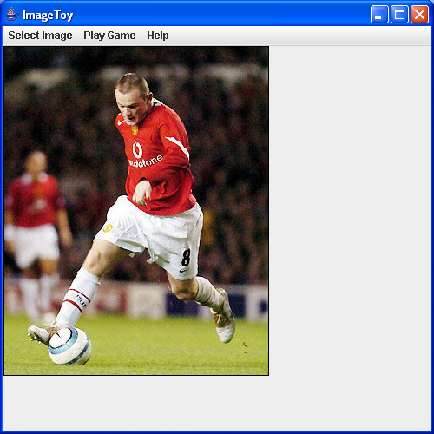
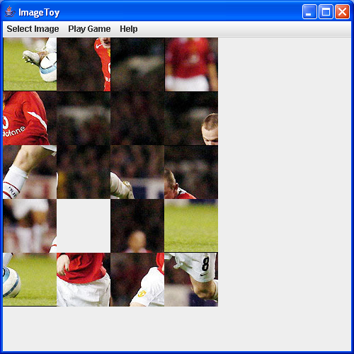

Figure 1

Object-Oriented Programming and Design
Programming Assessment
Dr M Spann

Student's Name: …………………….…..
Grade (%): ……………………………
Assessor: ………………………………..
Date: ………………………………….…..

Key to Grades %
Report
Structure, style and clarity
Design
Class, object diagrams
Data structures
Discussion of design issues inc. object oriented design and extendibility
Coding and implementation
File organisation
Coding (module length, exception handling, code layout/readability, user interface and comments)
Correct operation (specification fulfilled, extended features)
Testing
Discussion and appropriateness of testing procedure
Total |  | /100
Outstanding > 80
Very good 70-79
Good 60-69
Pass 50-59
Fail < 50
Serious fail 30-40
No serious attempt < 30

Any evidence of plagiarism Yes No

