ELECTRONIC, ELECTRICAL AND COMPUTER ENGINEERING





Object Oriented Programming Using C#

Assignment 2011

Swarm Intelligence

Dr M. Spann

- Aims and Objectives

This programming exercise is concerned with an investigation into and applications of swarm intelligence or Ant algorithms. Swarm intelligence is a term describing the collective behaviour that emerges from groups of social insects such as ants. There has been a lot of research over the past 10 years or so into the application of Ant algorithms to the solution of discrete optimization problems. It has been long recognised in the natural world how swarms of ants are able to find the shortest path between the nest and a food source by communicating via pheromone, a chemical substance that attracts other ants. The key point about this is that there is no direct communication from ant to ant, something that would be extremely inefficient given the large numbers of insects in a swarm. Instead, communication is indirect and efficient in the sense that ants passing over a region pick-up the local pheromone density which is proportional to the number of ants that have previously passed over the same region.

The aim of this programming exercise is to write a program to illustrate how a basic swarm intelligence algorithm, specifically one based on the ant colony optimization (ACO) algorithm, can be used to solve a challenging discrete optimisation problem. Objectives will be to develop C# classes to implement the ACO algorithm with application to the famous Travelling Salesman Problem (TSP), a classic and much studied discrete optimisation problem. Obviously additional classes in the application domain will be required. You will be provided with general descriptions of both the ACO algorithm, including extensions to improve performance and the TSP. It is up to you to fit them together and provide an implementation of the ACO, which is applicable to the TSP. This is a sizeable document with lots of detail about ant-based algorithms and the TSP. You will need to read it carefully and understand the principles before setting out on an implementation.

- Background

  - The ACO algorithm

Ant-based optimisation algorithms use features exhibited by real swarms of ants in their hunt for food, to solve discrete optimisation problems such as the travelling salesman problem. Similarities include the following. Ants make probabilistic decisions based on local information (in the case of real ants, the amount of locally deposited pheromone) to move through adjacent states. Real ants also use a priori information to control their decision-making policy, for example the nature of the local terrain (hilly, flat, wet etc).

However, there are differences between real and artificial ants. Artificial ants are solving discrete optimisation problems. They move between discrete adjacent states. Artificial ants have an internal memory. They can remember their past states (in other words, where they have been!). Artificial ants, deposit an amount of pheromone that is a proportional to the quality of the solution found. In other words, it’s not until the solution is found that the pheromone is deposited. Real ants deposit pheromone as they go along. Artificial ants can exhibit other, more advanced features such as local optimisation, backtracking, look-ahead etc. However, we will only consider the basic ACO algorithm.

Each ant, acting concurrently and independently from the other ants in the swarm, builds its own solution to the problem. The algorithm executes $t_{\text{max}}$ iterations (thus each iteration is indexed by$t≤t_{\text{max}}$). During each iteration, some number m ants are created and they build solutions to the problem after which all m ants die, the iteration count $t$ is incremented and a new set of ants are created.

A key feature of the algorithm is that individual ants do not exchange information. Each ant is able to find its own solution, which is probably sub-optimal. High quality solutions emerge as more and more ants add to the local pheromone deposits, which control the solutions found by later ants. The key issue in designing ant based optimisation algorithms is to strike a balance between the exploration of new and potentially interesting regions of the solution space so that all possible solutions are explored and the exploitation of accumulated knowledge through the pheromone deposits. Once an ant has completed its task in building a solution and adding to the pheromone deposits, it dies and is deleted from the system.

Besides the locally acting ants, the system can also incorporate a global daemon process, which can observe all of the ants’ behaviours to, for example, deposit additional pheromone to bias the ants’ search. The daemon process has a lifetime equal to the lifetime of the swarm and runs until an optimum solution is found.

A final feature of ant-based optimisation problems is pheromone evaporation. This is a real analogy with real ants in that the pheromone deposit evaporates over a time period less than the time taken for the swarm to find the shortest path so that it must be taken into account. The purpose of pheromone evaporation is for the swarm to eventually forget past behaviour so that new solution regions can be explored.

In order to describe in detail how the ACO algorithm is applied to the TSP, we will first introduce the TSP, as the notation we will use will be specifically related to the TSP. Note that the TSP was chosen as a vehicle to demonstrate ant-based optimisation algorithms as it is simple to understand there is lots of test data including optimum solutions making algorithm evaluation easier.

2.2 The Travelling Salesman Problem

2.2.1 Introduction

The travelling salesman problem can be cast as a shortest path problem within a graph $G(N,E)$comprising nodes and arcs connecting those graph nodes. The definition of the TSP is as follows. Given a set of N of nodes which represent cities and a set E of arcs which fully connect all of the nodes N, define $d_{\text{ij}}$as the length of the arc $(i,j)∈E$ which represents the distance between the cities i and j with $i,j∈N$. The TSP is the problem of finding a minimal length closed tour of the graph, which visits every city once and only once. We will assume that the distances are symmetric (although it is possible to consider an asymmetric TSP) whereby $d_{\text{ij}}=d_{\text{ji}}$.

It is easy to see that for the symmetric case, there are $\left(\left|N\right|−1\right)\text{!/}2$possible closed tours where $\left|N\right|$ is the number of cities. This gets extremely large extremely quickly as the number of cities increases and so an exhaustive search becomes impossible. In fact, the TSP belongs to a class of computational problems that are termed NP-hard. This means that there is no polynomial time solution (in other words a solution that has O(N^{k}) complexity for some constant k). Figure 1 shows a small scale TSP problem (29 cities in Western Sahara), and its optimum tour. Even for this small problem there are more than 3x10²⁸ possible tours! Currently problems involving tens of thousands of cities are being studied. Other test data for the TSP can be found at http://www.tsp.gatech.edu/data/index.html. The data, which is stored in a simple text file, is given in the form of a set of $(x,y)$ co-ordinates of each city. Also included in the file is the number of cities and the optimum tour length.

2.2.2 Application of the ACO algorithm to the TSP

To describe the ACO algorithm, a number of definitions are required. An arc in the graph $(i,j)$connects cities i and j. We define $τ_{\text{ij}}(t)$as the amount of pheromone currently (in other words at time t) deposited on arc $(i,j)$. This quantity is updated by all of the ants once they have completed their tour. The amount deposited by an individual ant is added to $τ_{\text{ij}}(t)$ and is proportional to the quality of solution generated. In the case of the TSP, this is simply inversely proportional to the length of the tour spanning all $\left|N\right|$ cities. Thus the shorter the tour, the greater the amount of pheromone deposited on the arcs, which are members of the tour. As described previously, pheromone evaporation also determines $τ_{\text{ij}}(t)$ and is used to prevent all ants ending up with the same tour (called stagnation). Also, as described previously, each ant has an internal memory and for the case of the TSP, the memory is obviously a list of cities already visited. This allows an ant to determine which cities still remain to be visited as well as enabling it to deposit delayed pheromone on already visited arcs.
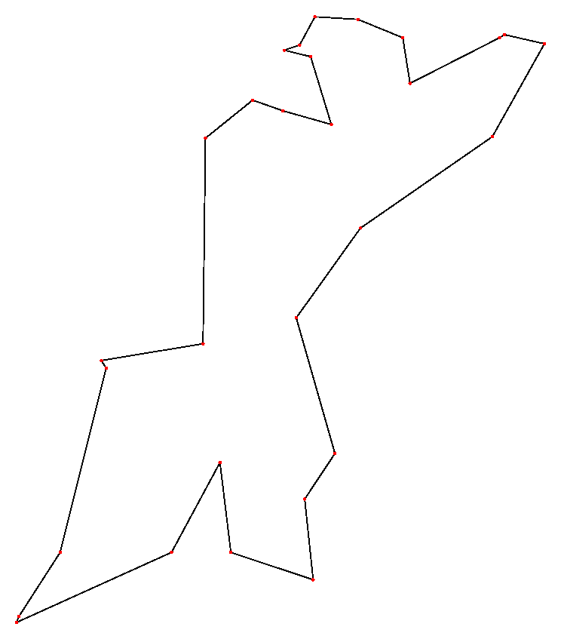

TSP pointset for Western Sahara
TSP optimum tour
Figure 1

Suppose an ant k is at some city i. We can define a local probability $p_{\text{ij}}^{k}$ with which ant k chooses to go from city i to city $j∈N_{i}^{k}$ while building its tour:

$p_{\text{ij}}^{k}=\frac{\left[τ_{\text{ij}}(t)\right]{\left[η_{\text{ij}}\right]}^{β}}{\sum_{l∈N_{i}}{\left[τ_{\text{il}}(t)\right]{\left[η_{\text{il}}\right]}^{β}}} j∈N_{i}^{k}$ (1)
where $η_{\text{ij}}=1/{d_{\text{ij}}}$ and $d_{\text{ij}}$is the length of arc $(i,j)$. $β$ is a parameter which control the relative influence of the arc length over the previously accumulated pheromone deposits. Thus if $β=0$the algorithm leads to rapid stagnation whereby an existing route is selected and amplified and all ants follow the same route. In general some value of $β>0$ will optimally combine current information in the form of arc lengths and existing pheromone deposits. $N_{i}^{k}⊆N_{i}$ is the set of nodes in the neighbourhood of node i that ant k has yet to visit. In this case, ant k can use its internal memory to determine $N_{i}^{k}$. Note that the choice of the neighbourhood $N_{i}^{k}$ is optimally all of the cities except i and those already visited. For increased computational performance $N_{i}^{k}$ can be restricted to some subset of this, for example, $N_{i}^{k}$ could be the nearest p cities currently unvisited where small p decreases the computation time. Obviously if $p=1$, the algorithm is then the deterministic (and extremely sub-optimal!) nearest neighbour heuristic (the ‘Greedy’ algorithm) which simply selects the nearest unvisited city as the next one to visit until all cities have been visited.

After all the ants in the current iteration t have completed their tour and arrived at a solution, pheromone evaporation is triggered. Also each ant k deposits a quantity of pheromone ${Δτ}_{\text{ij}}(t)$on each arc that comprises its tour where:

${Δτ}_{\text{ij}}^{k}(t)=\left\{\begin{matrix}Q/{L^{k}}(t)\text{ if }(i,j)∈T^{k}(t) \\ 0\text{ if }(i,j)∈∉T^{k}(t)\end{matrix}\right. k=1\text{.}\text{.}m$ (2)

where Q is a constant, $T^{k}(t)$is the tour (list of cities visited in sequence) by ant k at iteration t and $L^{k}(t)$is its length. Thus, from equation 2, the shorter the tour the more pheromone is deposited. The pheromone deposit and evaporation processes can be expressed by the following equation:

$τ_{\text{ij}}(t)←(1−ρ)τ_{\text{ij}}(t)+\sum_{k=1}^{m}{{Δτ}_{\text{ij}}^{k}(t)}$ (3)

where m is the number of ants at each iteration (assumed constant) and $ρ∈(0,1]$ is the pheromone evaporation constant. Typically$τ_{\text{ij}}(0)$ is set to some small positive constant, $m=\left|N\right|$, $t_{\text{max}}=\text{3000}$,$β≈7$and $ρ≈0\text{.}5$are reported to give good results. Note that the pheromone updates expressed by equation (3) are carried out after all m ants have completed their tours.

The above algorithm is a basic version of the ACO. Various improvements are possible to enable it to tackle larger ($\left|N\right|>\text{100}$) TSP’s. The first improvement is through the use of a daemon process, which further updates the pheromone deposit of the shortest tour for the current iteration according to:

$τ_{\text{ij}}(t)←τ_{\text{ij}}(t)+K{Δτ}_{\text{ij}}(t) (i,j)∈T^{+}$ (4)

where in this case, ${Δτ}_{\text{ij}}(t)=1/{L^{+}}$, $L^{+}$ is the length of the shortest tour $T^{+}$ (across all m ants) and K is a constant.

A second improvement involves the probabilistic decision rule determining the next city in the neighbourhood to move to. We define $p_{\text{ij}}^{k}$ as the local transition probability for ant k as before. Let q be a uniformly distributed random variable and $q_{0}∈[0,1]$ be some parameter. A pseudo-random-proportional rule used by ant k currently at city i to choose the next city $j∈N_{i}^{k}$ is as follows:

If $q≤q_{0}$then city j is visited where $j=\text{argmax}p_{\text{ij}}^{k}$. Alternatively, if $q>q_{0}$, city j is visited with probability $p_{\text{ij}}^{k}$as before. Thus if $q≤q_{0}$, the decision rule becomes purely deterministic whereas if $q>q_{0}$ the usual probabilistic decision is made. Tuning $q_{0}$ allows us to modulate the degree of solution space exploration. Indeed, it is conceivable to make $q_{0}$ a function of the iteration number t such that for small t, $q_{0}$ is small and slowly increases, reinforcing existing solutions as t increases.

Other improvements include local search heuristics where the ordering of cities in a route are locally shuffled (for example the order of 2 cities can simply be swapped) in order to reduce the route length. These heuristics go under the generic name of k-opt searches where k is a small integer. (For large k the computational effort would be enormous). So for example a 2-opt search where 2 cities are reversed involves removing two edges in the route and replacing them with 2 new edges if the route length is reduced. 3-opt searches are also commonly implemented with a few computational ‘tricks’ to speed up the search.

Incorporating some or all of these improvements over the basic ACO, better (close to optimal) and faster solutions are obtained for larger TSP problems.

3. Practical work

The programming assignment is divided up into 3 distinct projects. The first is to develop C# classes to represent the TSP grid which incorporates information about the inter city distances. Obviously you will need to set up the data structure representing the city layout for the TSP and this should aimed at maximizing the efficiency of the TSP solvers implemented. The second project contains classes which incorporate solvers for the TSP such as the simple Greedy (nearest neighbour) solver and the different versions of the ACO. You should implement some or all of the improvements to the basic ACO algorithm and possibly do an online search for other methods such as simple local search heuristics. The third project is to develop a GUI from which different TSP’s can be loaded from file, the city configuration displayed graphically and from which the solvers can be launched. The GUI should display relevant information about the data and the solution as the algorithm progresses (such as the optimum tour length and the tour length found by the solver for a particular set of input parameters). A screenshot of the GUI that I developed (obviously you don’t have to copy this layout!) is shown in Appendix I where I have included some example runs across a range of problem sizes.

The number of cities in the grid defines different degrees of difficulty of the TSP’s and you should demonstrate your algorithm on a range of grid sizes although for experimentation and ‘tuning’ of your algorithms stick to small scale problems with less than 200 cities. You can clearly set up your own datasets or use those at http://www.tsp.gatech.edu/data/index.html (where the ‘optimal’ solution is also given).

4. Assessment

This coursework represents all of the assessment for this component which makes up 70% of the assessment for the Introductory Module. The assessment will be based on a submitted formal report as well as my assessment of your program’s functionality. Please submit your program written using Visual Studio 2010 on CD to accompany your report. (Visual Studio Express is NOT acceptable but you can write it under VS2008 if you wish). Please include all of the solution files under a single solution directory. Make sure your CD has your name/ID on it in case it gets separated from your report. I randomly check submitted code using anti-plagiarism software (see below). Your program must run on the School’s networked VS2010 so that I am able to verify its reported functionality.

The assessment form that I use is in appendix II so this should give you an idea of the criteria I will use in marking your report. You should be aiming for a report length of around 15 to 20 pages excluding appendices. I am happy for you to include your code listing in an appendix but it is not obligatory. I expect you to use UML to express your formal design but only a minimal level of UML such as class/object diagrams is required. You can include more if your wish. Use pseudo-code to explain algorithm implementation (and not flow charts!) and do not include explicit code snippets in your main report.

Finally, I am sure you are aware there is a lot of published code on the internet for just about every application imaginable. If you are going to use downloaded code for any part of this exercise, make sure you attribute it in your report (referencing the URL is sufficient). Obviously your mark will reflect the amount of original code in your program but you will not be penalized for using small amounts of attributed downloaded code. If you use code from the internet (or code from a colleague) without an adequate reference in the source text, this will count as plagiarism. Any significant plagiarism will result in a zero mark for the exercise. Also, if you submit the same or similar code to a colleague, you will both receive a zero mark irrespective of who copied from whom.

Key dates
Report deadline: Monday 28th November. Please hand in to the General Office by 12 noon. Please be aware that late submission penalties are severe : 5% per day late.
Appendix I

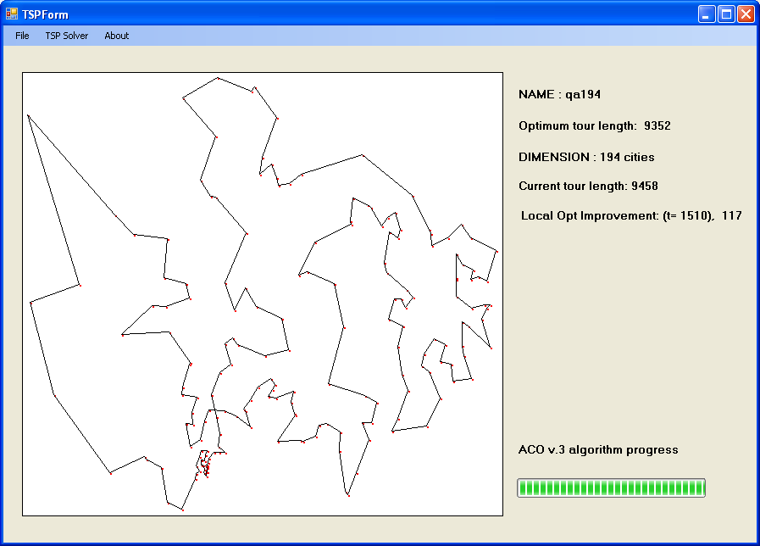

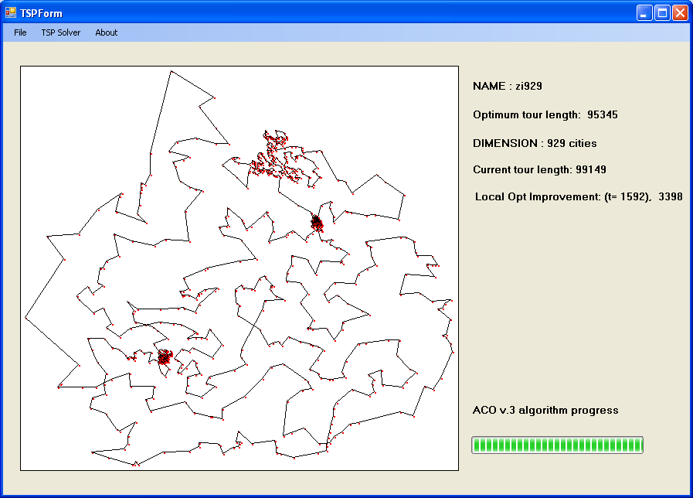

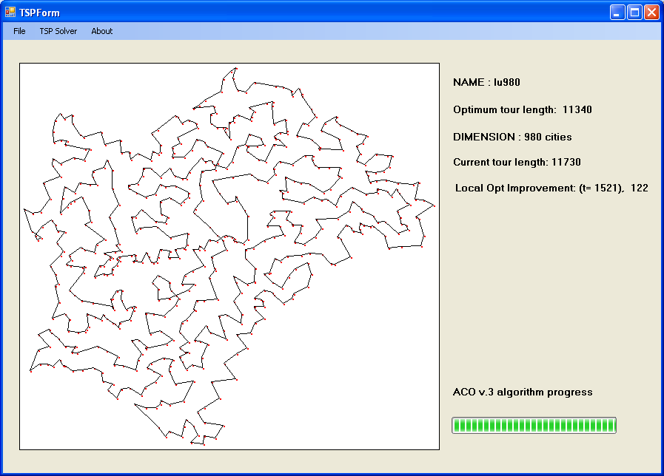

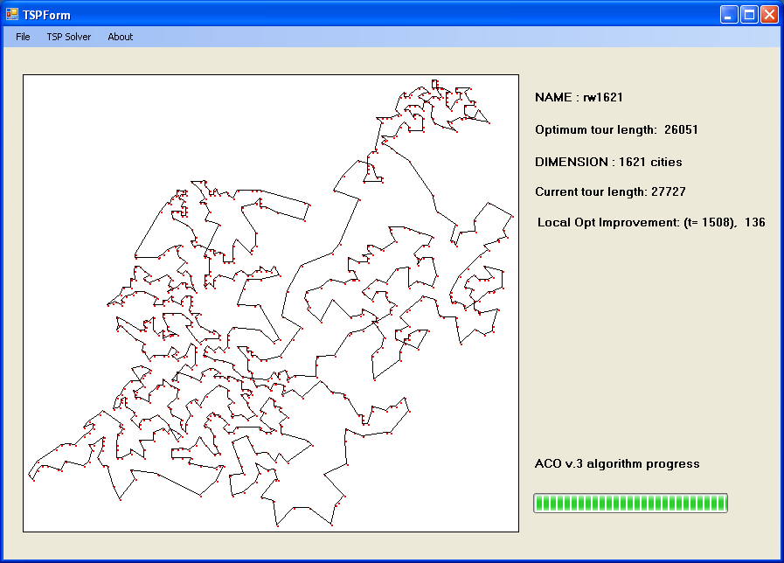

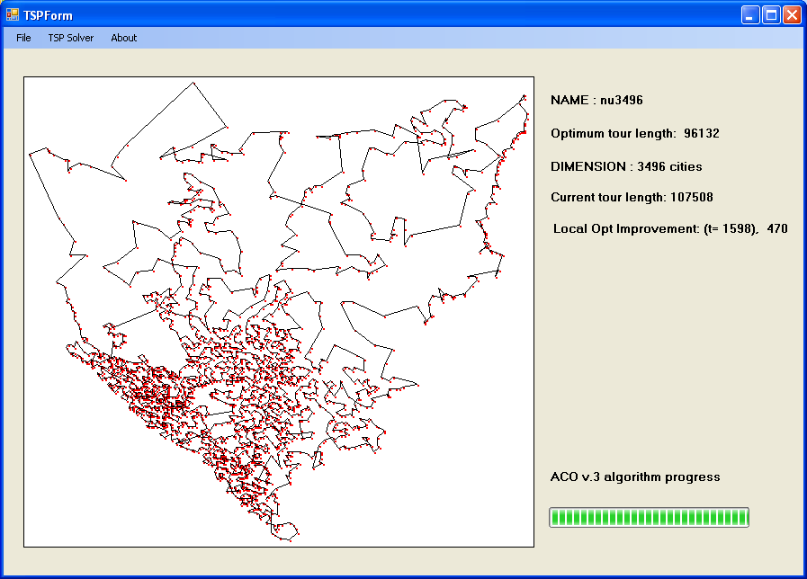

Appendix II

Report Presentation  Cover page  Page numbering  Grammar and spelling  Section layout  Figure labelling and clarity  Correct use of references |  | /10
Program Design  Effective use of classes and object interactions  Discussion of object oriented issues related to design  Effective use of clear formal or semi formal design diagrams |  | /20
Program Implementation  Code layout including use of comments  Effective use of dll’s  Algorithm efficiency and correctness |  | /20
Program Functionality  No, limited, full or extended functionality  Clarity and usability of the graphical user interface |  | /30
Testing  Use of systematic approach to sub system and full system testing  Use of suitable output to verify test results such as screen shots |  | /10
Conclusions  Discussion of possible design and implementation improvements and extensions  Discussion of how well the program meets the specification and, if not, why not  Overall summing up of what has been achieved and what has been learnt |  | /10
Total Mark |  | /100

