ELECTRONIC, ELECTRICAL AND COMPUTER ENGINEERING





Object Oriented Programming Using C#

Assignment 2015

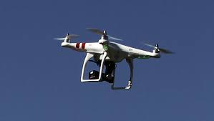

Drone Navigation Using a Particle Filter

Dr M. Spann

- Aims and Objectives

This C# programming assignment will involve the design, implementation and testing/evaluation of an application demonstrating localization of a drone using a particle filtering technique and is an exercise in real-time programming.

A remotely piloted vehicle (drone) is a pilotless aircraft which is controlled either remotely or autonomously. Normally a drone would find its location relative to an internally stored map using gps signals. However, let’s assume that our drone is flying over the surface of Mars where gps would not be available. In this case we are going to assume that the drone can determine its altitude relative to the Martian surface with some degree of accuracy and it is going to use this altitude data to determine its location again using an internally stored altitude map. To do this we propose to use a fairly recent technique known as particle filter. The particle filter is able to estimate the state of something (in our case the drone’s location) based on a model of how that something changes over time and a model of how an observation (in our case the drone’s altitude) varies with the state. Given strong constraints on the probability distribution function (pdf) of the state vector, this could classically be done with a Kalman filter but the neat thing about particle filters is that they work when the pdf is complex and in particular multi-modal.

- Background

  - Particle Filter

A particle filter is the generic algorithm for a function optimization where the solution search space is searched using particles. Each particle comprises its estimate of the state (in our case the drone’s location and velocity) and the weight which is how confident the estimate is based on the observation and the set of particle states populate the solution space of the problem. After each iteration, the good particles (the most confident ones) are multiplied and the bad particles are removed through a re-sampling process. The next particle generation then predicts the next state based on a simple motion model then this generation of particles is evaluated, and the cycle repeats.

The particle filter is fairly easy to understand, but the performance of the filter depends on the particles number where the higher number of particles will lead to a better estimate, but it is more costly. Determining an optimum number of particles for the problem in hand is largely a matter of trial and error trading off accuracy for computational efficiency.

    - Resampling

Resampling is a kind of ‘survival of the fittest’ according to the particle weights. If there are M particles, then after resampling there will still be M particles. However, particles with small weights will be eliminated and particles with large weights will be duplicated perhaps several times. Following resampling, the weights of all of the new set of particles are reset to 1/M. Figure 1a is a diagram of the stochastic universal sampling method which has a computational complexity proportional to the number of particles, unlike other methods which have a higher complexity. The partition size is proportional to the particle weights. As can be seen, a small partition can be skipped completely whereas a large partition can be selected several times. The pseudo-code is shown in figure 1b.

w₂
w₃
w₁
w_{n}
W_{n-1}

Figure 1a. Stochastic Universal Sampling

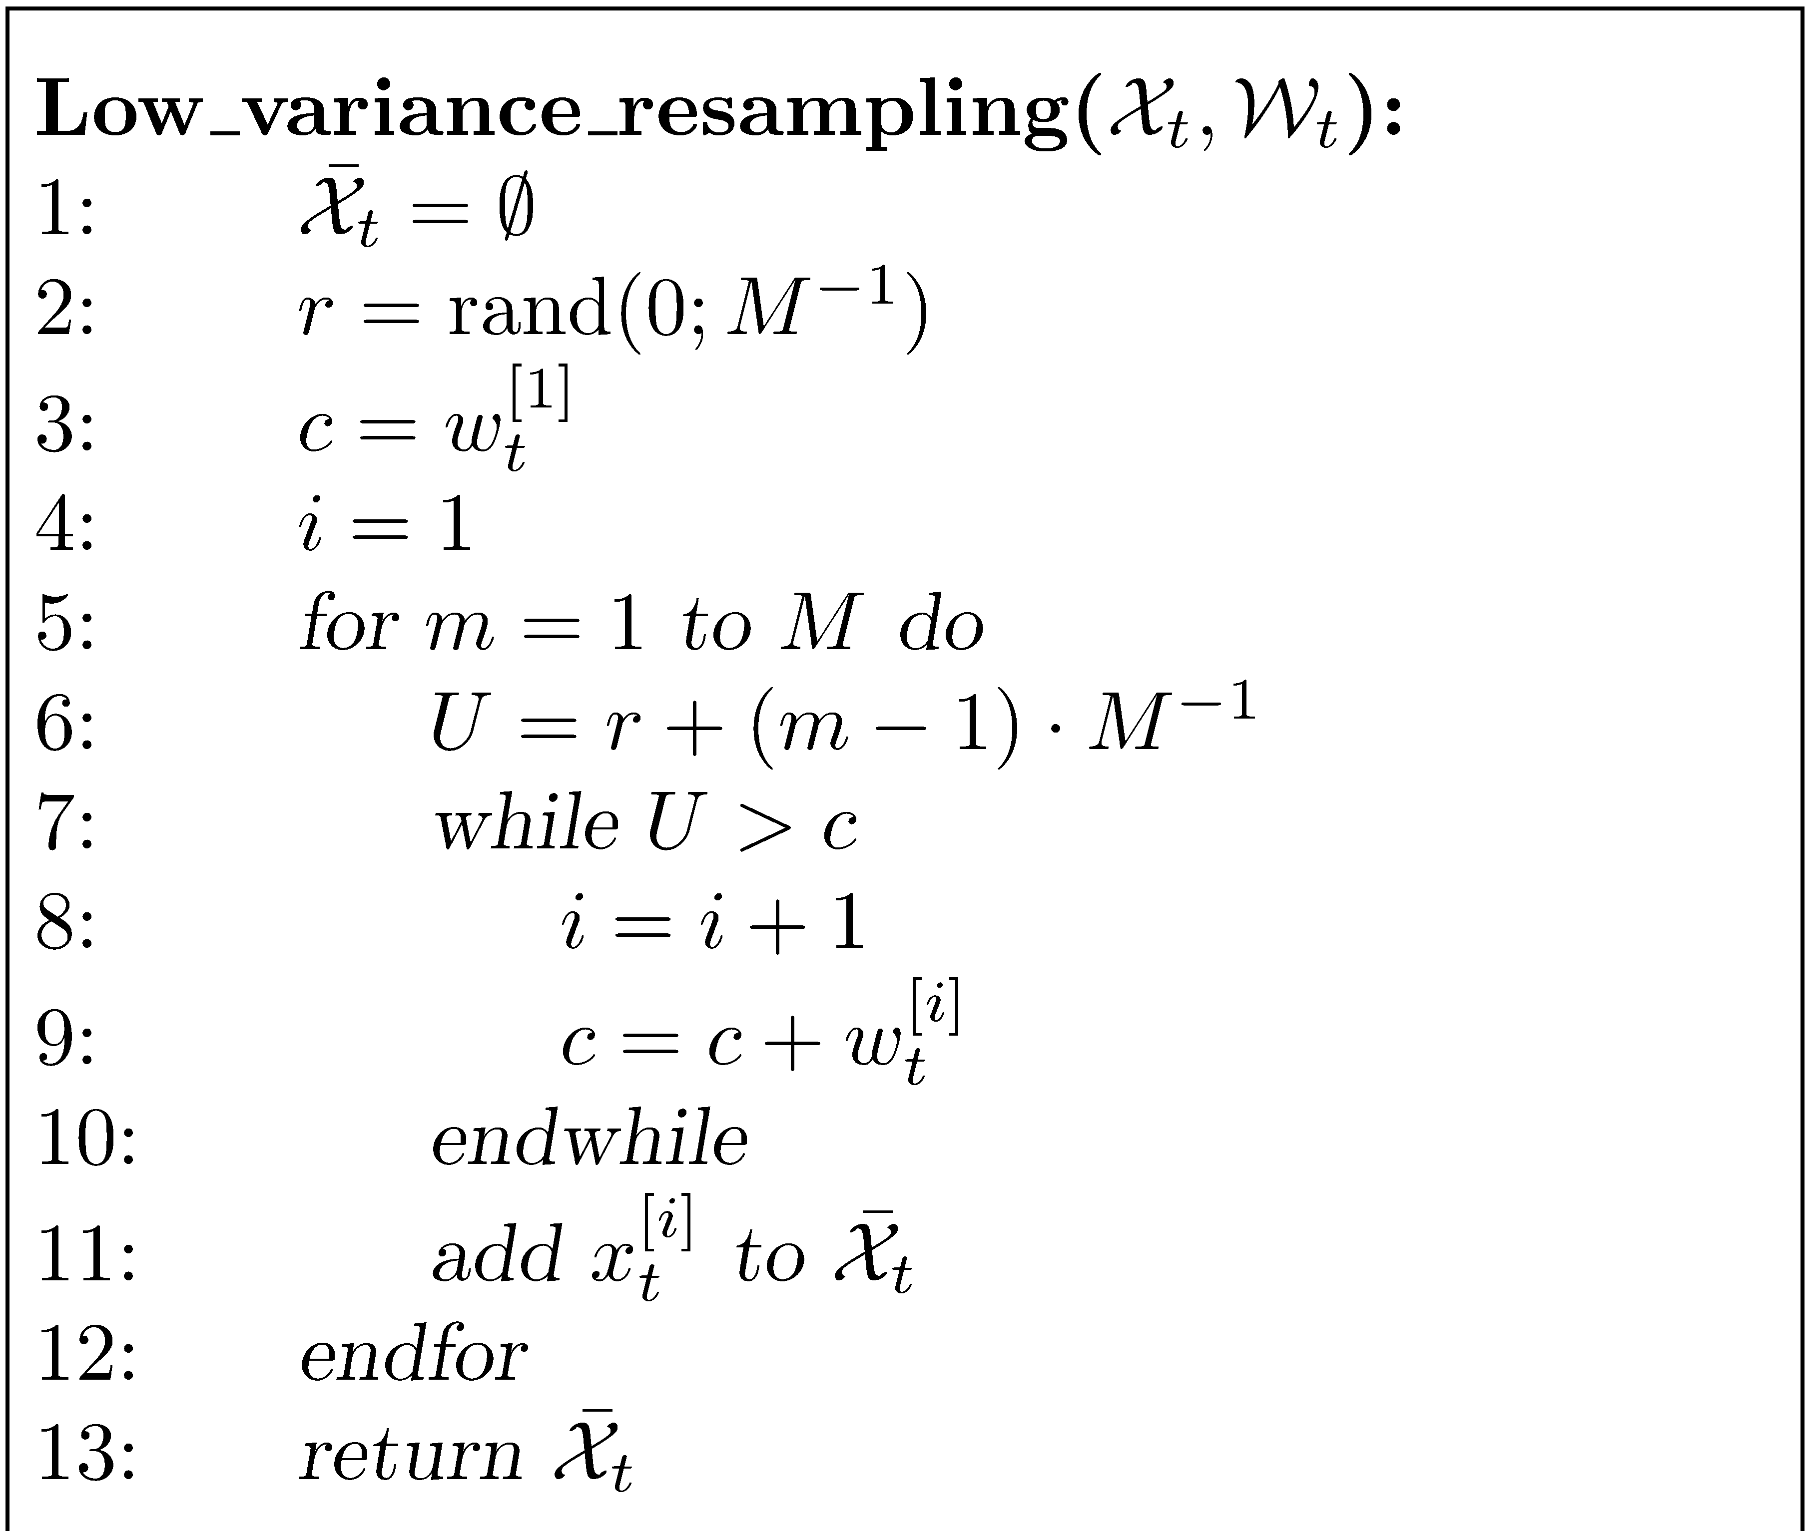

Figure 1b. Pseudo-code

Figure 1b. Pseudo-code

3. Practical work

You will need to develop 3 separate classes at least. A class to display the graphical simulation, a class to represent the drone and a class which represents the particle filter. For the graphics, I have used Windows Presentation Foundation (WPF) which enables high quality vector graphics to be created and updated in real time. This is ideal for quickly moving the graphical rendering of the drone around the screen as an overlay to the altitude image. Normal rasterized (non-vector) graphics based on the WinForm class would be too slow for real time simulation. Creating a GUI using WPF is straightforward using visual designer with similar looking functionality to WinForm based GUI’s. There is a lot of tutorial material online about WPF but you only need a small amount of knowledge to create your application.

Your GUI will allow one of a selection of altitude images (provided) of the Martian surface to be loaded from file and displayed on a canvas. The real position of the drone will be the position of the mouse cursor as it is moved by the user. In my program, the particle filter is run every 0.5 seconds. This can be achieved using a DispatcherTimer object whose Interval property can be set so that an event handler is called after this corresponding interval in time has elapsed. The time interval is chosen so that the filter is able to run to completion within this time. An asynchronous approach could be adopted using events where the filter is called each time it completes its processing on the current state. This is obviously more complex.

4. Assessment

This coursework represents all of the assessment for this component which makes up 70% of the assessment for the Introductory Module. The assessment will be based on a submitted formal report as well as my assessment of your program’s functionality. Please submit your program written using Visual Studio 2010 on CD to accompany your report. (Visual Studio Express is NOT acceptable but you can write it under VS2008 if you wish). Please include all of the solution files under a single solution directory. Make sure your CD has your name/ID on it in case it gets separated from your report. I randomly check submitted code using anti-plagiarism software (see below). Your program must run on the School’s networked VS2010 so that I am able to verify its reported functionality.

The assessment form that I use is in appendix II so this should give you an idea of the criteria I will use in marking your report. You should be aiming for a report length of around 15 to 20 pages excluding appendices. I am happy for you to include your code listing in an appendix but it is not obligatory. I expect you to use UML to express your formal design but only a minimal level of UML such as class/object diagrams is required. You can include more if your wish. Use pseudo-code to explain algorithm implementation (and not flow charts!) and do not include explicit code snippets in your main report.

Finally, I am sure you are aware there is a lot of published code on the internet for just about every application imaginable. If you are going to use downloaded code for any part of this exercise, make sure you attribute it in your report (referencing the URL is sufficient). Obviously your mark will reflect the amount of original code in your program but you will not be penalized for using small amounts of attributed downloaded code. If you use code from the internet (or code from a colleague) without an adequate reference in the source text, this will count as plagiarism. Any significant plagiarism will result in a zero mark for the exercise. Also, if you submit the same or similar code to a colleague, you will both receive a zero mark irrespective of who copied from whom.

Key dates
Report deadline: Monday 28th November. Please hand in to the General Office by 12 noon. Please be aware that late submission penalties are severe : 5% per day late.
Appendix I

Appendix II

Report Presentation  Cover page  Page numbering  Grammar and spelling  Section layout  Figure labelling and clarity  Correct use of references |  | /10
Program Design  Effective use of classes and object interactions  Discussion of object oriented issues related to design  Effective use of clear formal or semi formal design diagrams |  | /20
Program Implementation  Code layout including use of comments  Effective use of dll’s  Algorithm efficiency and correctness |  | /20
Program Functionality  No, limited, full or extended functionality  Clarity and usability of the graphical user interface |  | /30
Testing  Use of systematic approach to sub system and full system testing  Use of suitable output to verify test results such as screen shots |  | /10
Conclusions  Discussion of possible design and implementation improvements and extensions  Discussion of how well the program meets the specification and, if not, why not  Overall summing up of what has been achieved and what has been learnt |  | /10
Total Mark |  | /100

