

**Object Oriented Programming Using C#**

**Resubmission Exercise 2011**

**Dr M. Spann**

1. **Aims and Objectives**

### This is a resubmission programming exercise is designed to be completed in 5 hours. You can use code that has been provided in the lecture course and which is accessible from <http://www.eee.bham.ac.uk/spannm/Courses/MSc%20OOP.htm>.

The exercise involves loading an image from file and displaying it on a windows form. Once the image is loaded, the user should be able to select two points on the image using mouse clicks. After the second mouse click, a straight line joining the two points is drawn and a plot of the variation of greylevel along the line is displayed in a separate form window. (To compute the greylevel of a colour image, just take the average of the R, G and B components). Figure 1 demonstrates a sample output of the program. (Ignore the labelling of the axes and the additional buttons on the graph).

1. **Programming Hints**

Use code in the *Graphics and Multimedia* lecture which demonstrates how to process images, including how to access the R, G and B values of pixels in an image. It also shows how to plot lines on an image as well as implementing an event handler to listen for and process mouse button events. You will need to think about how to access all of the image points along a line which need not necessarily be horizontal or vertical.

**3. Assessment**

You will be required to demonstrate your program at the end of the examination. This will provide 50% of the final mark. Also you will be required to submit your code and an assessment on a labelled cd and this will provide the other 50% of the final mark.

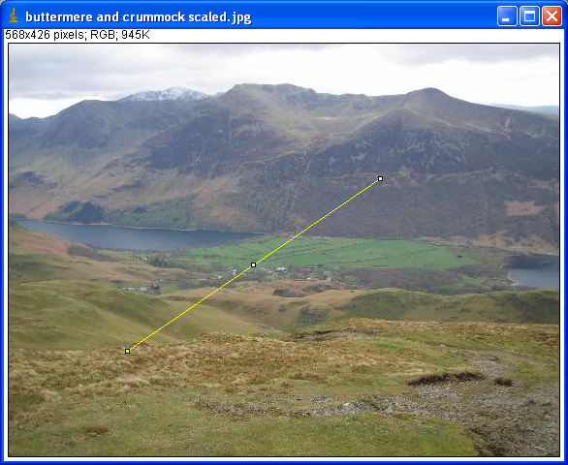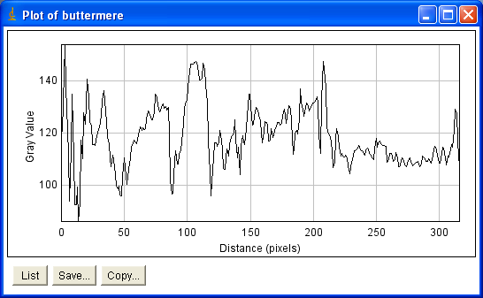

Figure 1

# Assessment Form

**Name : ID:**

## Compilation Check

PROGRAM COMPILED PROGRAM DIDN’T COMPILE

## Program Functionality

NONE SOME FULL EXTENDED

## ***Mark Scheme***

**Name: ID:**

|  |  |  |
| --- | --- | --- |
|  | Mark (/10) | Comments |
| Code – layout, use of comments, efficiency |  |  |
| Design – use of classes, class relationships |  |  |
| GUI – functionality, effectiveness, ease of use |  |  |