



Object Oriented Programming Using C#

Visual Programming Exercise

Dr M. Spann

- Aims and Objectives

This programming exercise is intended to give you experience of developing a relatively complex graphical application using visual programming. Recall that visual programming techniques reduce the amount of code that an application programmer has to write by partially developing the application in Visual Studio’s design view. Required GUI components can simply be dragged from VS’s toolbox and dropped into the outer Form. We have seen how we can develop a simple image viewer using visual programming which involved writing a minimum amount of code. Essentially the only code required is the event handler code for components making up the GUI.

- Preparatory Work

This programming exercise will extend our Image Viewer application we discussed in lectures to being able to display multiple images simultaneously and to be able to carry out simple editing on the images under mouse control. Figure 1 is a suggested layout of the tool which is currently displaying 2 images. Text representing the image content is displayed in a list inside the main GUI and, as previously, each image is displayed in its own independent window. The “active” image is the image to which processing selected from the tool’s menubar applies to. The active image is either selected from the list and highlighted or the image frame currently in focus. This a normal feature of image processing tools such as ImageJ which are able to handle multiple images.

- Lab Work

Implement the image viewer to enable multiple images to be handled and processed. Add a simple editing facility to your tool which will allow a region of interest to be selected on the currently active image and that region copied across to another image currently loaded (figure 2). Decide on the most efficient way of doing this from a user perspective for example under menu, mouse or keyboard control. You will have to use Bitmap objects to do this. Also, it should be possible to save the newly updated image to file using a SaveFileDialog control.

4. Assessment

You will be assessed on the basis of a formal programming report and a demonstration of your program. The approximation sub-division of marks will be 70% for the report and 30% for the demonstration. Please include a listing of your code in an appendix to your report.
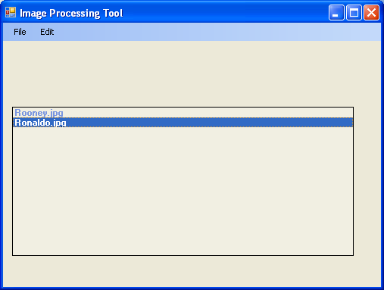

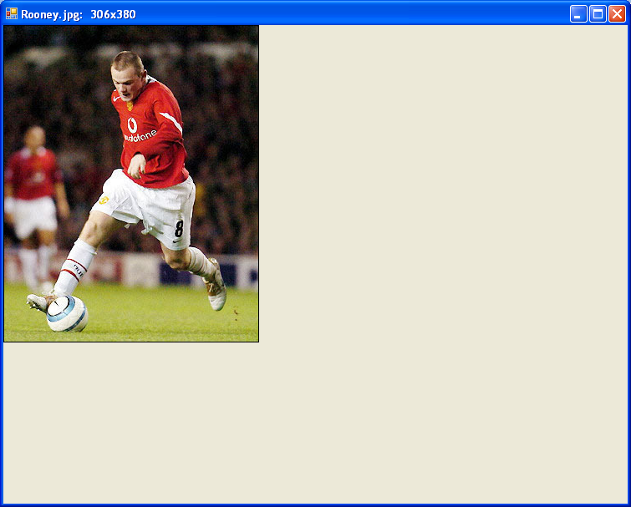
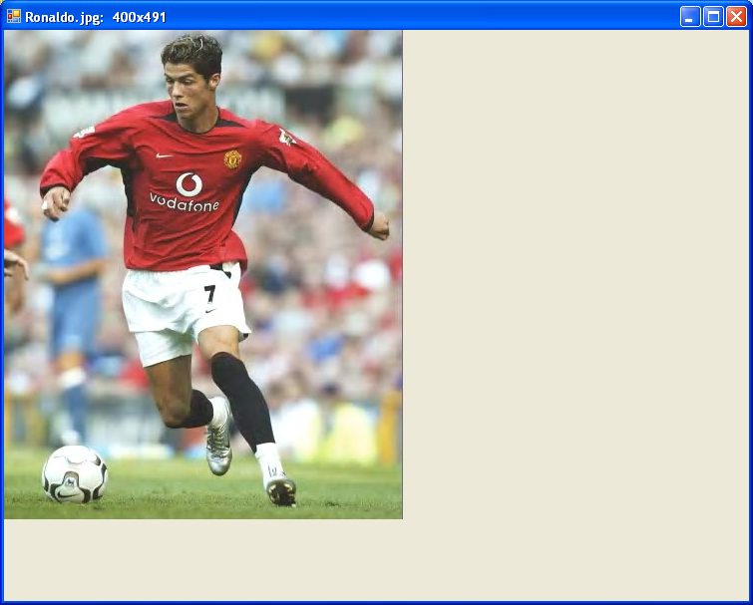

Figure 1

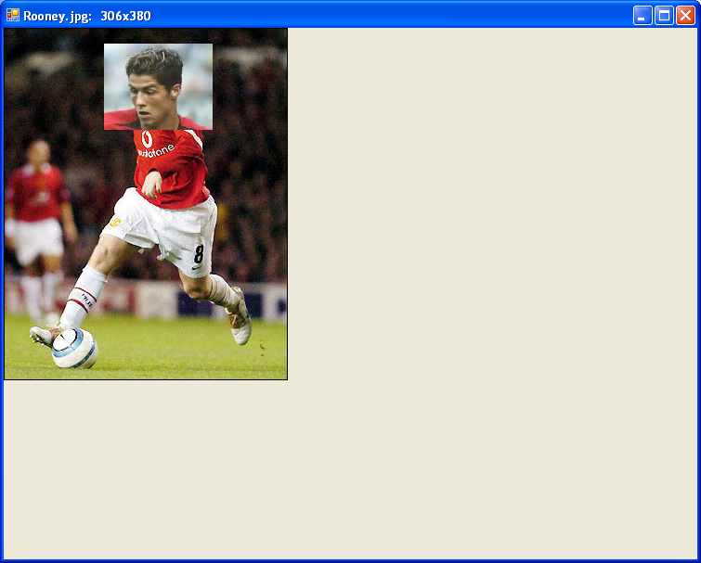
Figure 2

