ELECTRONIC, ELECTRICAL AND COMPUTER ENGINEERING





Object Oriented Programming Using C#

Assignment 2013

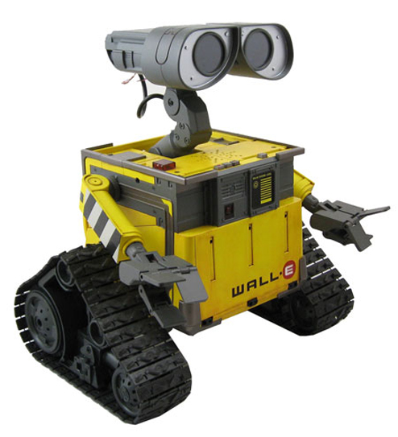

Mobile Robot Simulator

Dr M. Spann

- Aims and Objectives

A mobile robot is a complex real-time system involving a number of components working asynchronously. The system components include the control unit for the robot platform motors, onboard sensors such as laser range-finders and an intelligent processing unit which may or may not be onboard. The latter component would perform tasks such as obstacle detection and mapping along with path planning and navigation. The robot will also need to support asynchronous communications between the system components.

This C# programming assignment will involve the design, implementation and testing/evaluation of an autonomous mobile robot simulator.

- Background

  - Mobile Robot model

The robot sits on a four-wheeled rectangular base as shown in figure 1. It is rear wheel driven with differential motors controlling the rear wheels. This enables the platform to turn about an axis mid-way between a line connecting the 2 rear wheels. The simulation assumes the robot moves in a two dimensional area defined by the global system X-Y as shown in figure 1. Also there is a local coordinate system x-y which defines positions on the robot base. The origin of this coordinate system is at the centre of rotation mid-way between the rear wheels as shown in figure 1. This coordinate system is in general rotated with respect to the global coordinate system. The robot can only move forward along its local x-axis so, in order to move to some location, it much first rotate to the required heading and then proceed forward. The simulator must assume realistic dynamics for the robot, specifically a finite acceleration/deceleration and finite maximum speed.

Mounted on the base will be sensors as well as an on-board processor. In general an autonomously navigated vehicle would use different types of sensors. A laser range finder would give accurate range sensing as it has a narrow beam and hence has high spatial resolution but has limited range and they are not able to detect opaque objects. A sonar range finder has a broader beam and hence a lower resolution but they have the advantage of being able to detect opaque objects as they rely on acoustic signals.

X

y
x
y
θ

Y

Figure 1. Robot platform coordinate system

  - Environment model

The environment model comprises a list of obstacles which are assumed to be simple polygons. These obstacles are therefore represented by their vertex coordinates with respect to the global coordinate system in which the robot moves. For the purposes of the simulator we can assume that all obstacles have non-opaque surfaces so would be visible to a laser range finder. Obviously we could generalize the properties of the obstacles to include opaque or other types of surface that would only be visible to certain types of sensor.

The environment description can be specified in a text file using XML syntax. Figure 2 shows an environment comprising 3 obstacles and the associated XML file.

<MAP>
<OBSTACLE NAME="Wall-A" OPAQUE="false">
<POINT X="60" Y="60"/>
<POINT X="100" Y="60"/>
<POINT X="100" Y="140"/>
<POINT X="60" Y="140"/>
</OBSTACLE>

<OBSTACLE NAME="Wall-B" OPAQUE="false">
<POINT X="60" Y="240"/>
<POINT X="100" Y="240"/>
<POINT X="100" Y="320"/>
<POINT X="60" Y="320"/>
</OBSTACLE>

<OBSTACLE NAME="Door" OPAQUE="false">
<POINT X="65" Y="140"/>
<POINT X="95" Y="140"/>
<POINT X="95" Y="240"/>
<POINT X="65" Y="240"/>
</OBSTACLE>

<OBSTACLE NAME="Wall-C" OPAQUE="false">
<POINT X="320" Y="80"/>
<POINT X="450" Y="80"/>
<POINT X="450" Y="300"/>
<POINT X="410" Y="300"/>
<POINT X="410" Y="120"/>
<POINT X="320" Y="120"/>
</OBSTACLE>

<OBSTACLE NAME="Table" OPAQUE="false">
<POINT X="180" Y="140"/>
<POINT X="200" Y="110"/>
<POINT X="240" Y="110"/>
<POINT X="260" Y="140"/>
<POINT X="260" Y="220"/>
<POINT X="220" Y="180"/>
<POINT X="180" Y="220"/>
</OBSTACLE>
</MAP>

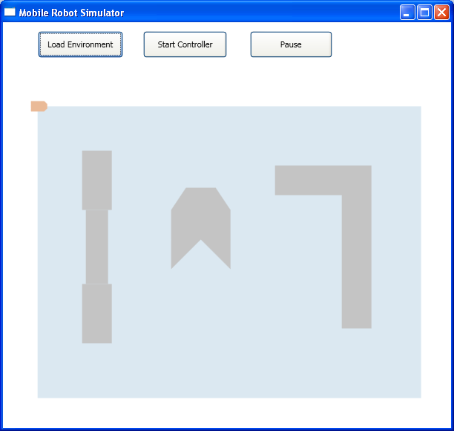

Figure 2. XML environment description

2.3 Sensors

It is possible to mount various kinds of sensor on the robot platform and combine the measurements made by each for navigation and mapping. For this exercise we will assume that the robot has a single
laser range finder mounted on a tower towards the front of the robot platform that rotates the laser beam around a vertical axis. The laser range finder has high precision and the rotary tower has high angular resolution (+=1 degree). By combining the orientation of the tower and the range, the Cartesian coordinates of any intersection point on the boundary of an obstacle can be determined as shown in figure 3.

Figure 3. Laser range finding

2.4 Controller

The Controller is a remote workstation that coordinates and plans the robots activities. Specifically it builds a representation of the explored environment and communicates commands to the robot and onboard sensors in order to achieve this. Initially the environment is completely unknown to the Controller. The robot is able to move in its environment whilst avoiding obstacles and as it does this, it transmits range measurements, obtained from the onboard laser range finder, back to the Controller. From these measurements, the Controller is able to builds its representation of the environment and plan further exploratory movement.

The controller maintains an internal representation of the environment in the form of a spatial lattice known as an occupancy map. This is a matrix of cells where each cells stores the state of the corresponding rectangular area of the environment. A cell can be classed as ‘occupied by an obstacle’ or ‘unoccupied’ or ‘unexplored’. The latter classification enables the controller to plan the route of the robot to visit unexplored areas. The cell size is a trade-off between precision and computational complexity as the controller needs to update the cell state in real time in response to sensor measurements. Figure 4 shows a screen shot of the simulator user interface with the environment on the left and the current occupancy map on the right.

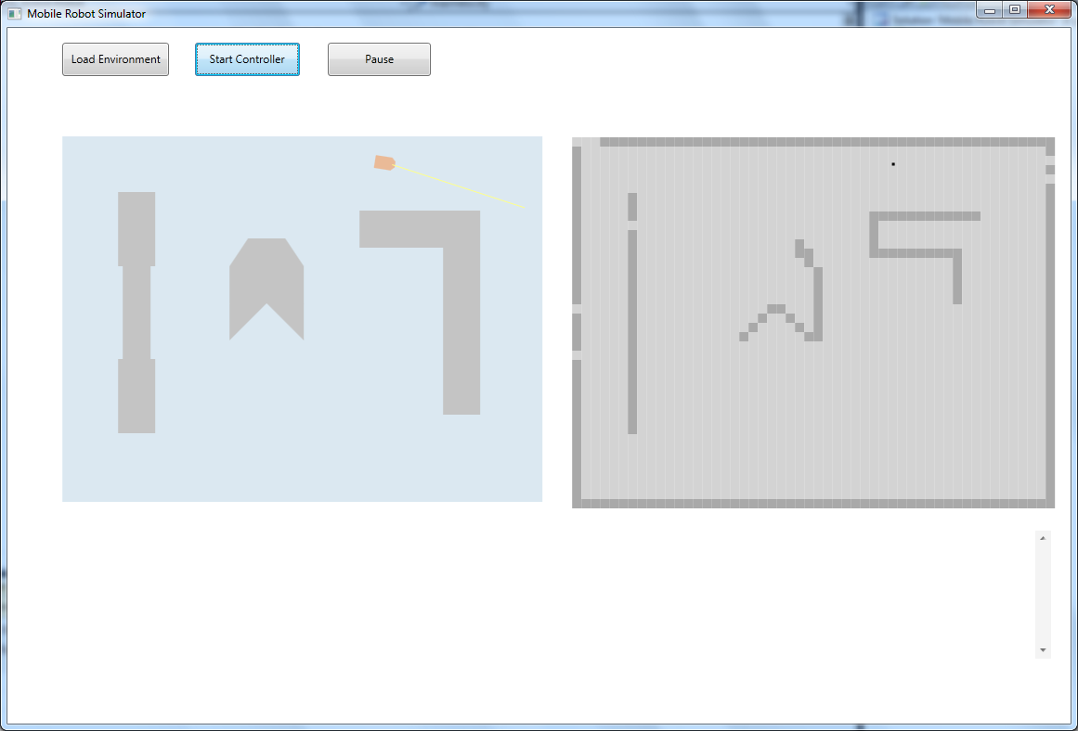

Figure 4. Graphical user interface

The controller communicates wirelessly and asynchronously with the robot and on-board sensors. The robot would issue commands to the robot and laser such as to move forward or start scanning. Robot position data or obstacle range information would be transmitted in the reverse direction in order for the controller to build its map.

3. Practical work

In this section some programming hints will be provided as to how to implement each part of the system. These are of course only suggestions which you can choose to ignore.

- The graphical user interface should be implemented using Windows Presentation Foundation (WPF) and not standard windows forms. WPF is based on scalar vector graphics (SVG) rather than bitmaps and hence doesn’t suffer from pixelization and rasterization effects. Simple geometric transformations (translation and rotation) can be applied to polygons to move them smoothly on the canvas. Visual programming techniques can still be used to design the GUI with WPF. It is also possible to implement the GUI using the XAML (similar to XML) scripting language.

- The best way to simulate asynchronous communication between the controller and the robot are with named pipes. The classes NamedPipeClientStream and NamedPipeServerStream allow simple communication the using ReadLine() and WriteLine() methods of the StreamReader and StreamWriter classes respectively. All that you need to do is to establish an infinitely looping reader thread in the robot and controller objects. When there is no data to read from the pipe, the thread blocks thus enabling asynchronous communication.

4. Assessment

This coursework represents all of the assessment for this component which makes up 70% of the assessment for the Introductory Module. The assessment will be based on a submitted formal report as well as my assessment of your program’s functionality. Please submit your program written using Visual Studio 2010 on CD to accompany your report. (Visual Studio Express is NOT acceptable but you can write it under VS2008 if you wish). Please include all of the solution files under a single solution directory. Make sure your CD has your name/ID on it in case it gets separated from your report. I randomly check submitted code using anti-plagiarism software (see below). Your program must run on the School’s networked VS2010 so that I am able to verify its reported functionality.

The assessment form that I use is in appendix II so this should give you an idea of the criteria I will use in marking your report. You should be aiming for a report length of around 15 to 20 pages excluding appendices. I am happy for you to include your code listing in an appendix but it is not obligatory. I expect you to use UML to express your formal design but only a minimal level of UML such as class/object diagrams is required. You can include more if your wish. Use pseudo-code to explain algorithm implementation (and not flow charts!) and do not include explicit code snippets in your main report.

Finally, I am sure you are aware there is a lot of published code on the internet for just about every application imaginable. If you are going to use downloaded code for any part of this exercise, make sure you attribute it in your report (referencing the URL is sufficient). Obviously your mark will reflect the amount of original code in your program but you will not be penalized for using small amounts of attributed downloaded code. If you use code from the internet (or code from a colleague) without an adequate reference in the source text, this will count as plagiarism. Any significant plagiarism will result in a zero mark for the exercise. Also, if you submit the same or similar code to a colleague, you will both receive a zero mark irrespective of who copied from whom.

Key dates
Report deadline: Monday 28th November. Please hand in to the General Office by 12 noon. Please be aware that late submission penalties are severe : 5% per day late.
Appendix I

Appendix II

Report Presentation  Cover page  Page numbering  Grammar and spelling  Section layout  Figure labelling and clarity  Correct use of references |  | /10
Program Design  Effective use of classes and object interactions  Discussion of object oriented issues related to design  Effective use of clear formal or semi formal design diagrams |  | /20
Program Implementation  Code layout including use of comments  Effective use of dll’s  Algorithm efficiency and correctness |  | /20
Program Functionality  No, limited, full or extended functionality  Clarity and usability of the graphical user interface |  | /30
Testing  Use of systematic approach to sub system and full system testing  Use of suitable output to verify test results such as screen shots |  | /10
Conclusions  Discussion of possible design and implementation improvements and extensions  Discussion of how well the program meets the specification and, if not, why not  Overall summing up of what has been achieved and what has been learnt |  | /10
Total Mark |  | /100

