[](http://www.bham.ac.uk/default.asp)



University-of-Birmingham-logo

**Object Oriented Programming Using C#**

**Resit Assignment 2013**

**Dr M. Spann**

**1. Aims and Objectives**

### This is a resit assignment for the object oriented programming module and will be to design and implement an image viewer application for multiple images as well as incorporating a simple editing facility. You should make full use of visual programming techniques which will significantly reduce the amount of code you will have to write by partially developing the application in Visual Studio’s design view.

**2. Preparatory Work**

This programming exercise will extend our *Image Viewer* application we discussed in lectures to being able to display multiple images simultaneously and to be able to carry out simple editing on the images under mouse control. Figure 1 is a suggested layout of the tool which is currently displaying 2 images. Text representing the image content is displayed in a list inside the main GUI and each image is displayed in its own independent window. The “active” image is the image to which processing selected from the tool’s menubar applies to. The active image is either selected from the list and highlighted or the image frame currently in focus. This a normal feature of many image processing development platforms such as *ImageJ*.

**3. Lab Work**

Implement the image viewer to enable multiple images to be handled and processed. Add a simple editing facility to your tool which will allow a region of interest to be selected on the currently active image and that region copied across to another image currently loaded (figure 2). Decide on the most efficient way of doing this from a user perspective for example under menu, mouse or keyboard control. You will have to use *Bitmap* objects to do this. Also, it should be possible to save the newly updated image to file using a *SaveFileDialog* control.

**4. Assessment**

The assessment will be based on a submitted report (**maximum length 10 pages**) as well as my assessment of your program’s functionality through a demonstration. These will be in proportion report 70%, program functionality 30%. Include in your report a detailed UML design description, program implementation and testing. The pro-forma for the assessment is shown in appendix I at the end of this document which gives you an idea of the criteria of assessment. Also include a cd containing your source code along with your report.

Please submit your program **written under Visual Studio 2010** on cd and include in your report. Please include all of the solution files under a single solution directory. Make sure your cd has your name/ID on it in case it gets separated from your report.

The deadline for submission of your report and code will be **15th July.**

Please submit the report and the cd to the postgraduate office.

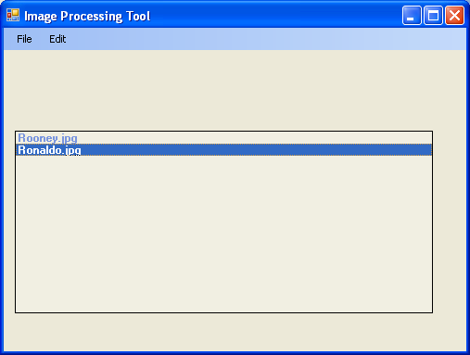

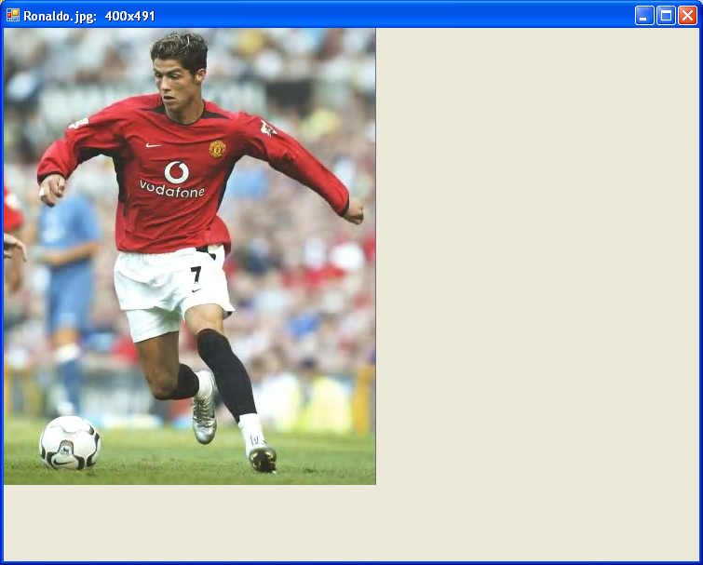

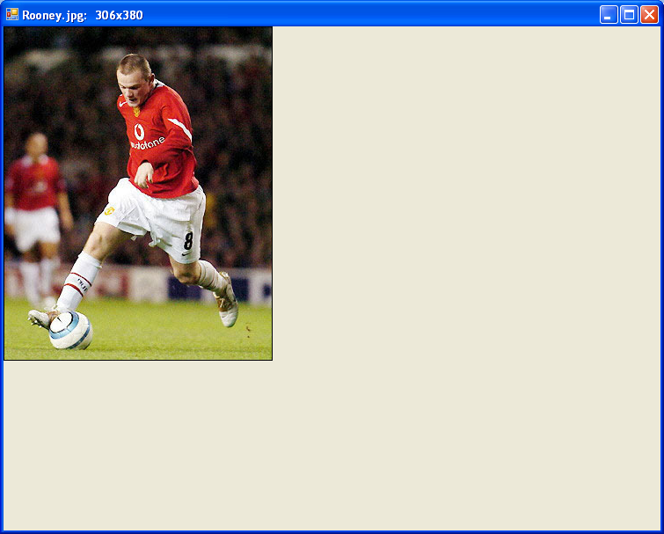

Figure 1

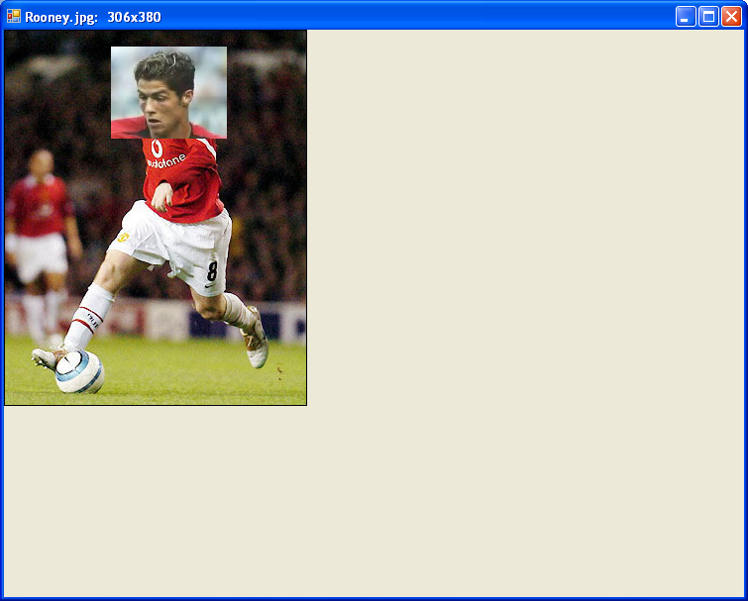

Figure 2

**Appendix I**

Object-Oriented Programming and Design

Programming Assessment

Dr M Spann

|  |  |  |
| --- | --- | --- |
| **Report Presentation**  Cover page  Page numbering  Grammar and spelling  Section layout  Figure labelling and clarity  Correct use of references |  | **/5** |
| **Program Design**  Effective use of classes and object interactions  Discussion of object oriented issues related to design  Use Case Model and Design Model, State Charts, interaction diagrams and class diagrams |  | **/30** |
| **Program Implementation**  Code layout including use of comments  Effective use of dll’s  Algorithm efficiency and correctness  Effective use of multithreading and event handling |  | **/20** |
| **Program Functionality**  No, limited, full or extended functionality  Clarity and usability of the graphical animation |  | **/30** |
| **Testing**  Use of systematic approach to sub system and full system testing  Use of suitable output to verify test results such as screen shots |  | **/10** |
| **Conclusions**  Discussion of possible design and implementation improvements and extensions  Discussion of how well the program meets the specification and, if not, why not  Overall summing up of what has been achieved and what has been learnt |  | **/5** |
| **Total Mark** |  | **/100** |