EE1F2 Multimedia Data
Laboratory Exercise 2: Image Compression Exercise
By Luis Hernandez and Dr. Sandra I. Woolley
- Using the compression Programs
  - Creating the folder
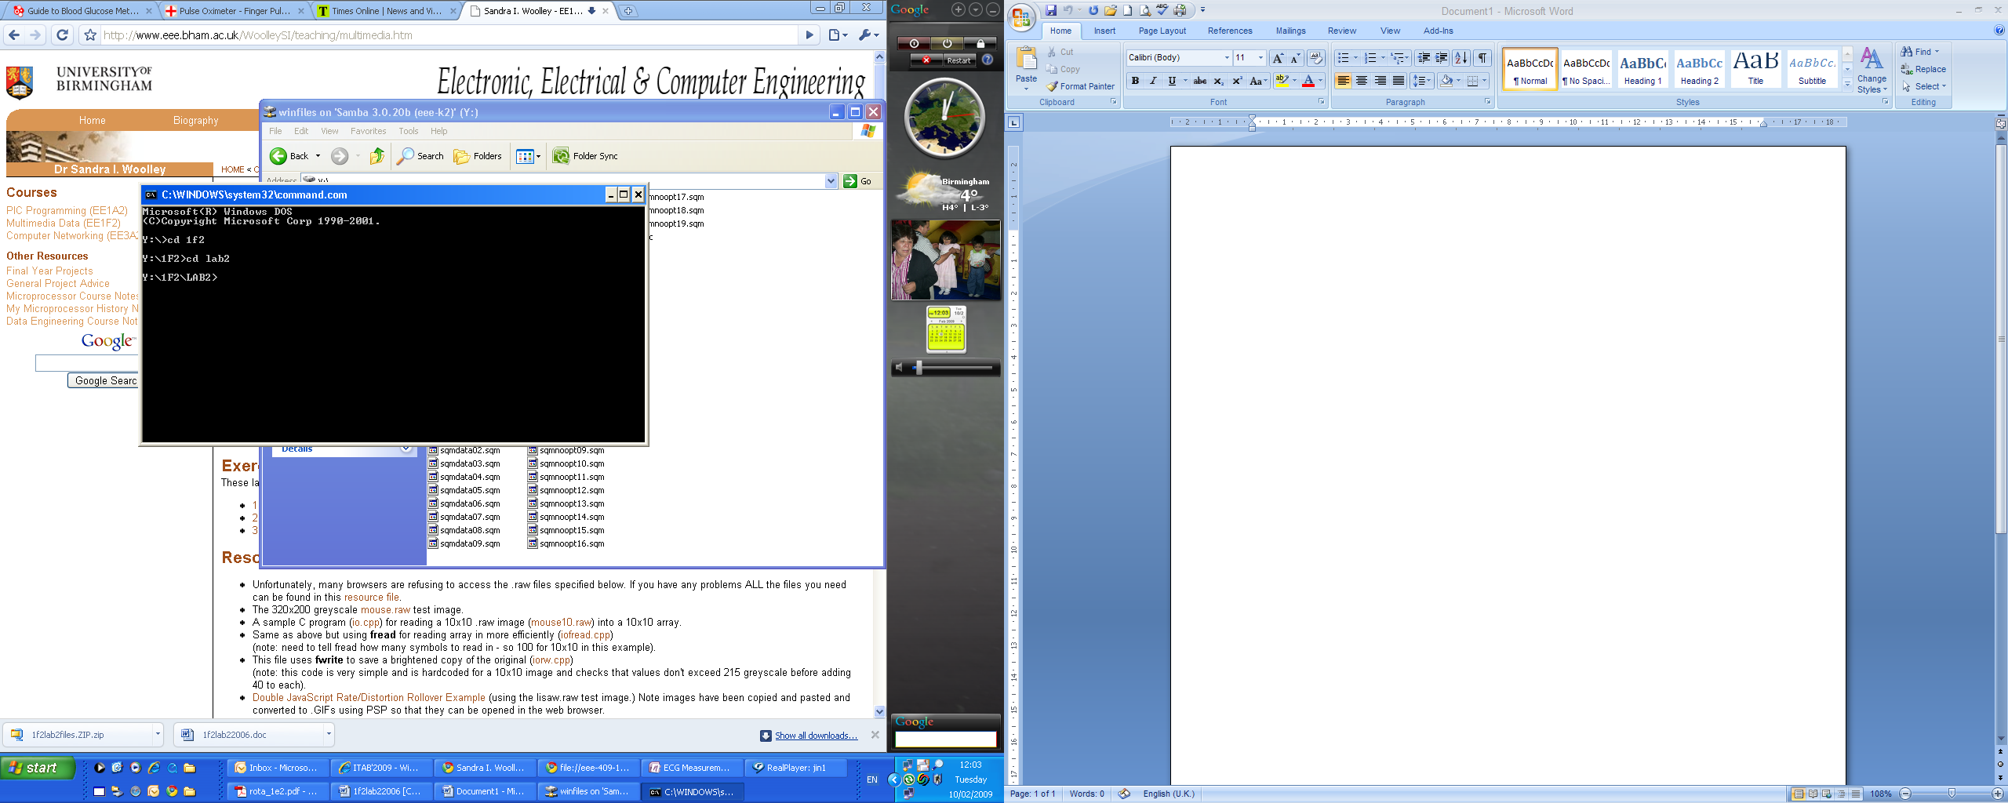

1.2 Testing the commands
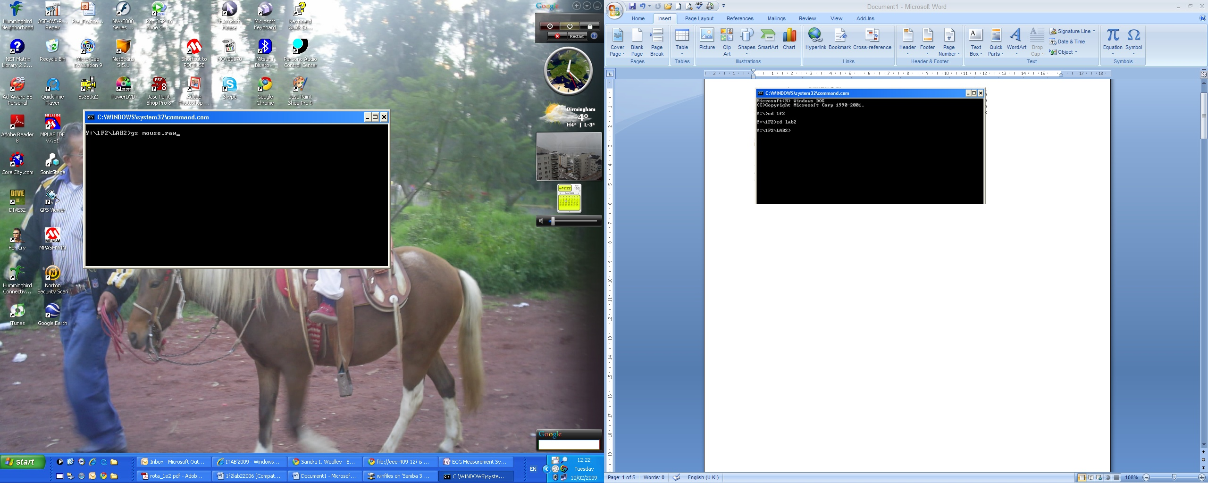
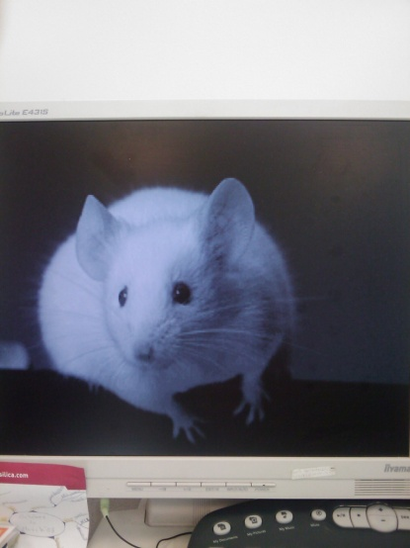

  - Viewing multiple images
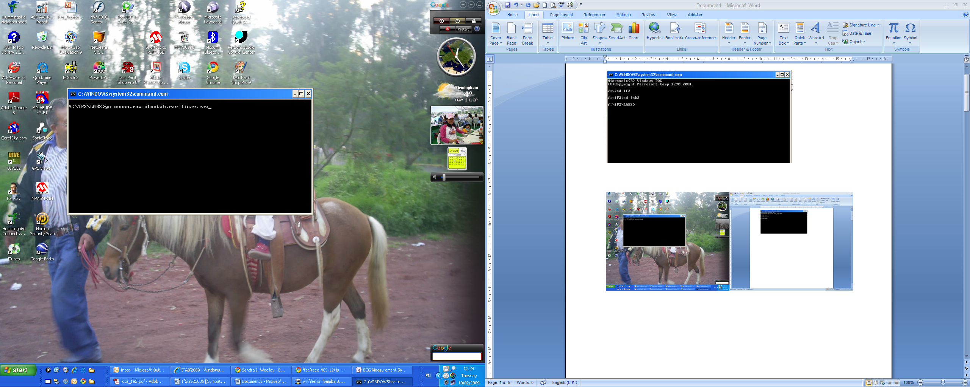
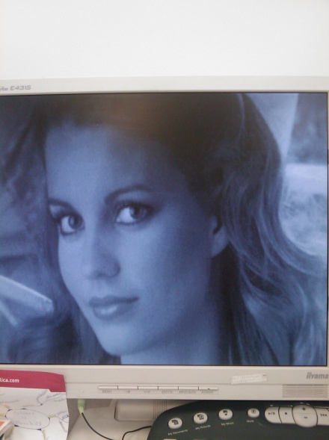
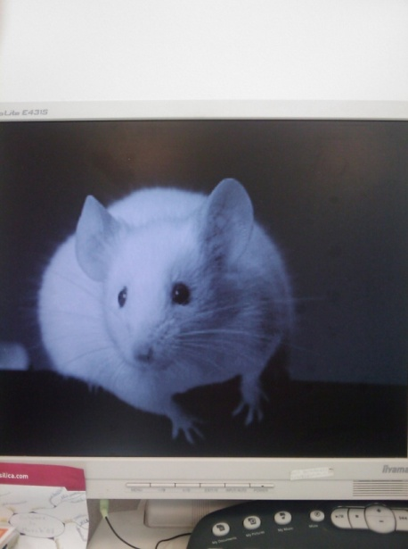
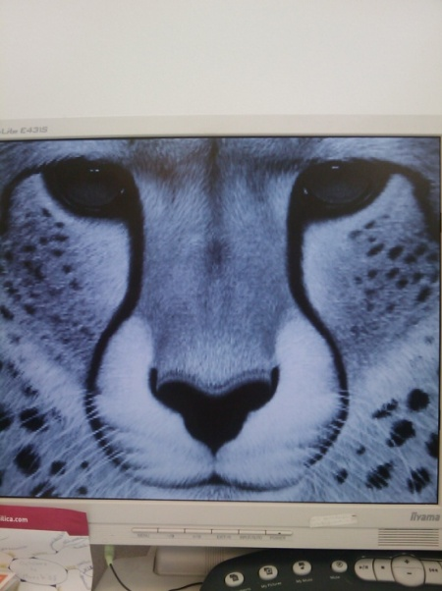
1.4 Comparing two images with gsdiff and getting the RMS error
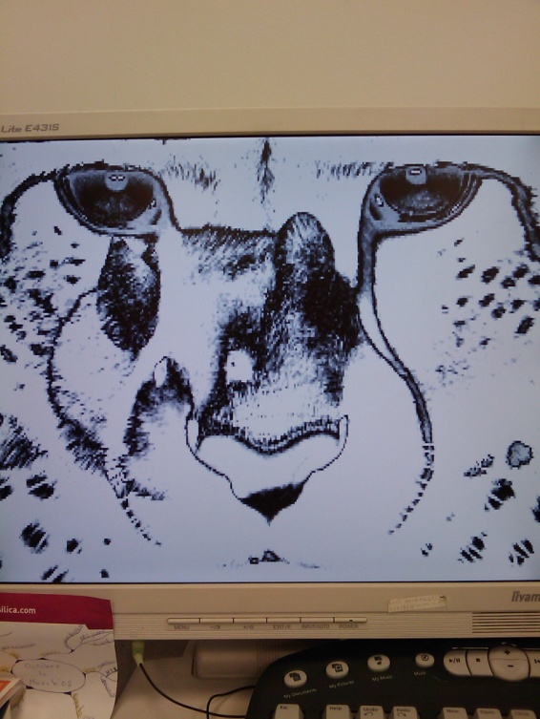
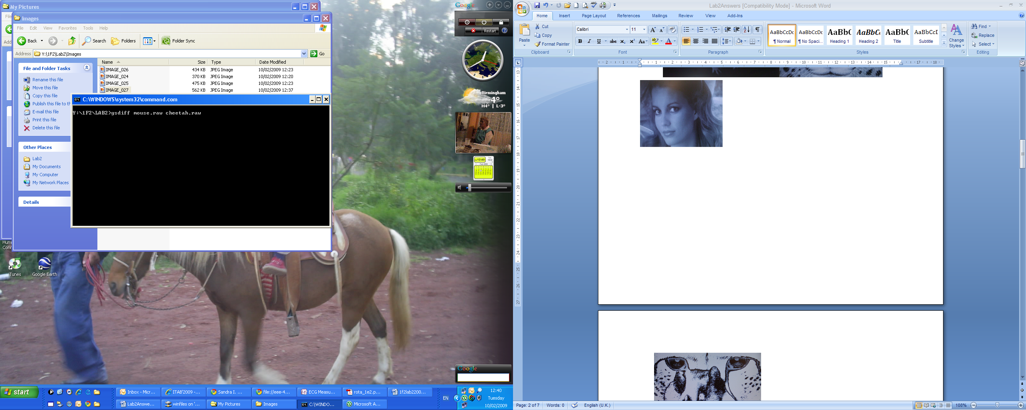

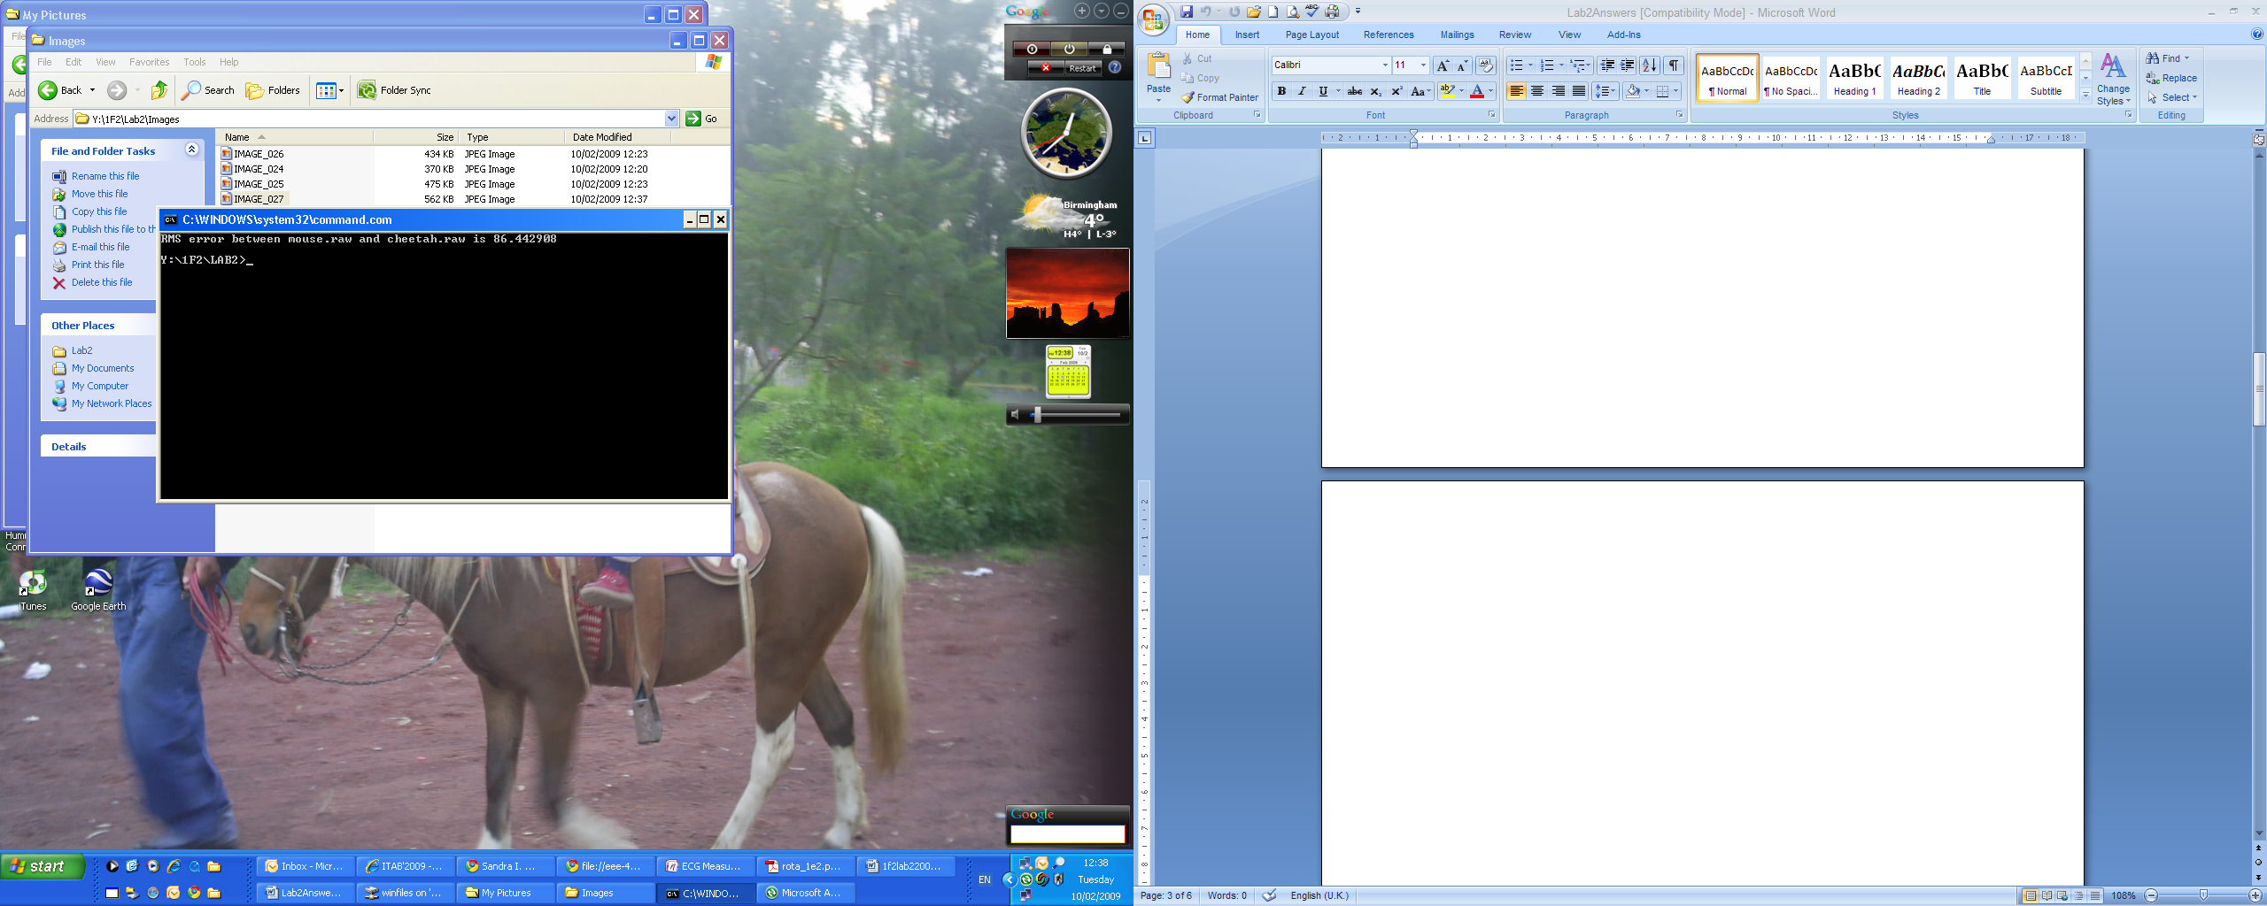

2. Lossless Compression
2.1 Compressing images using the Lossless-Huffman method
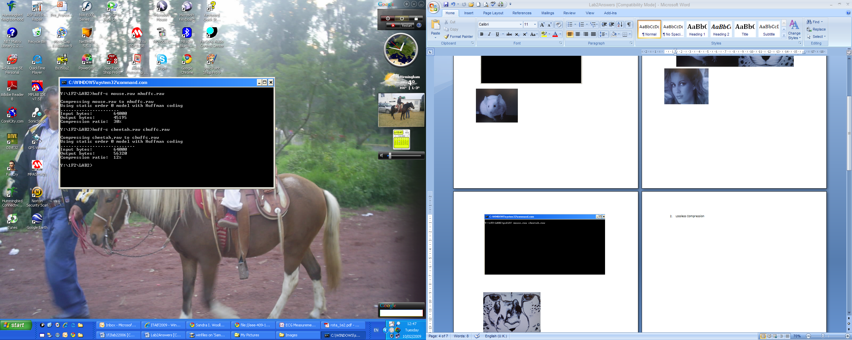

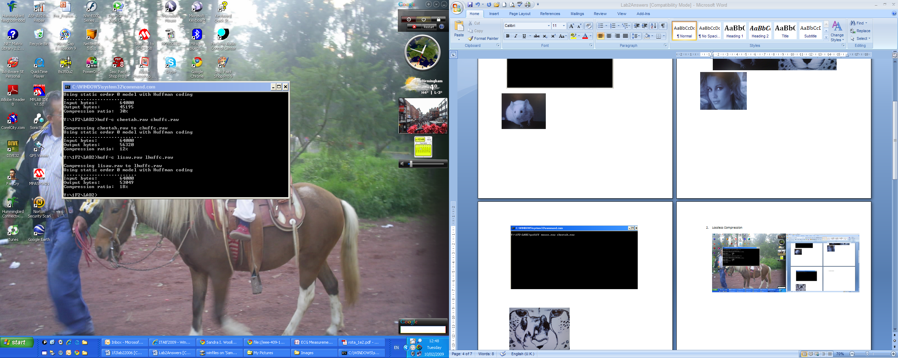

2.2 Compressing images using the Lossless-LempelZiv’77 method
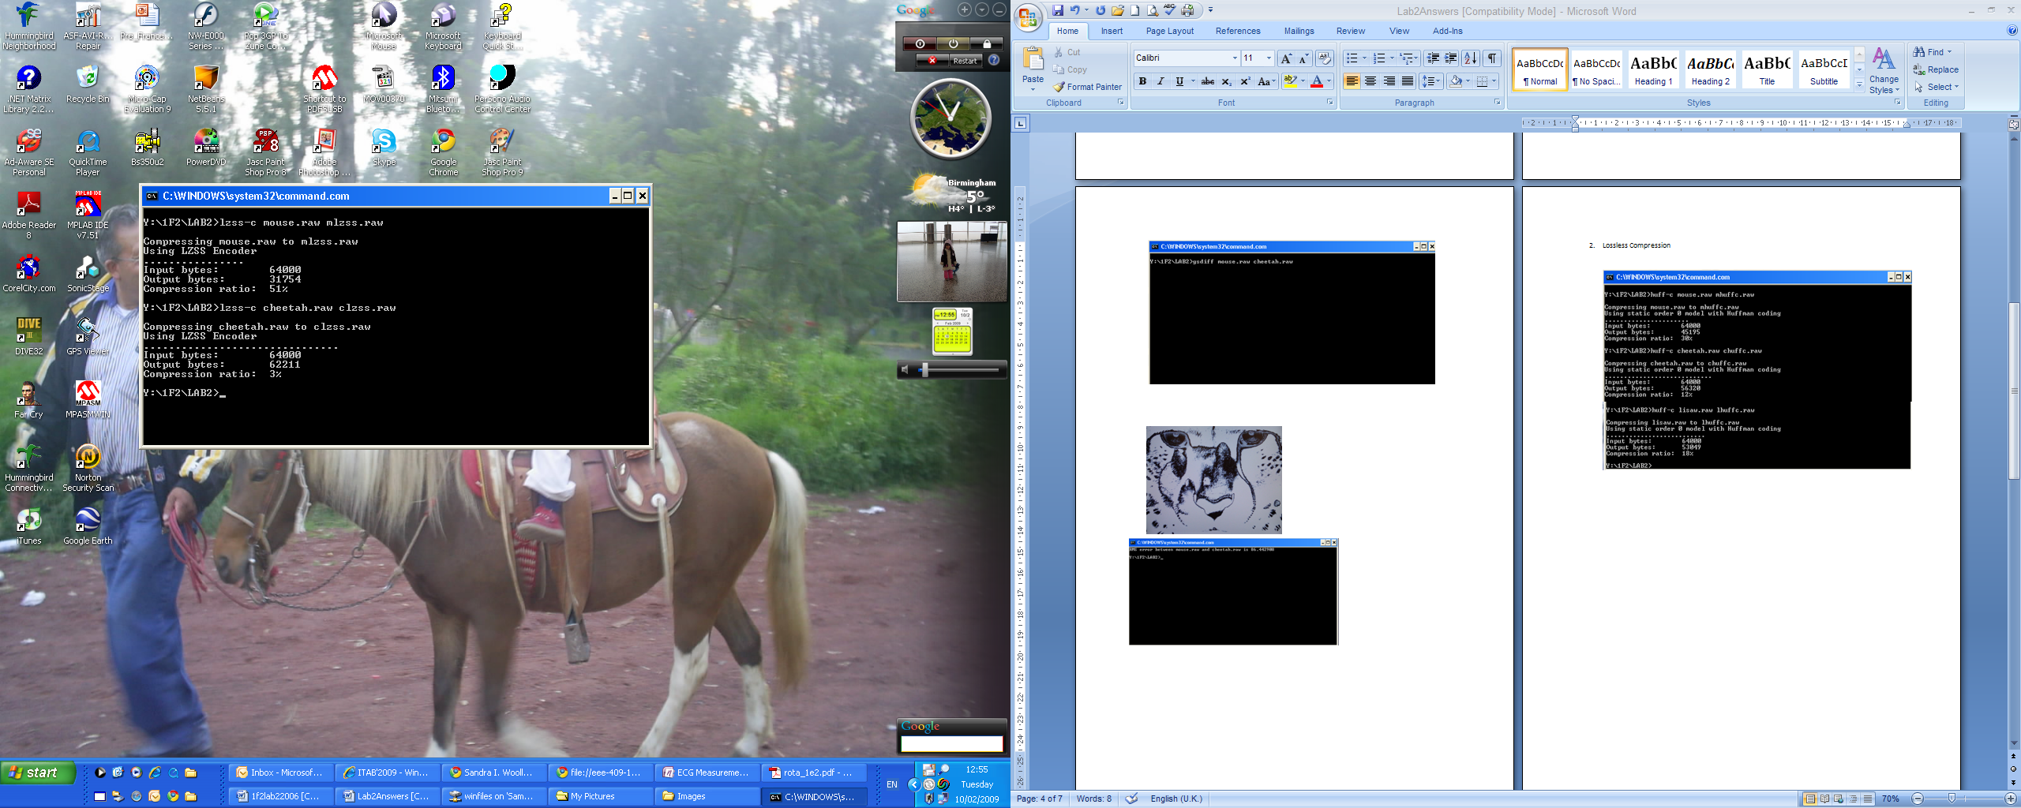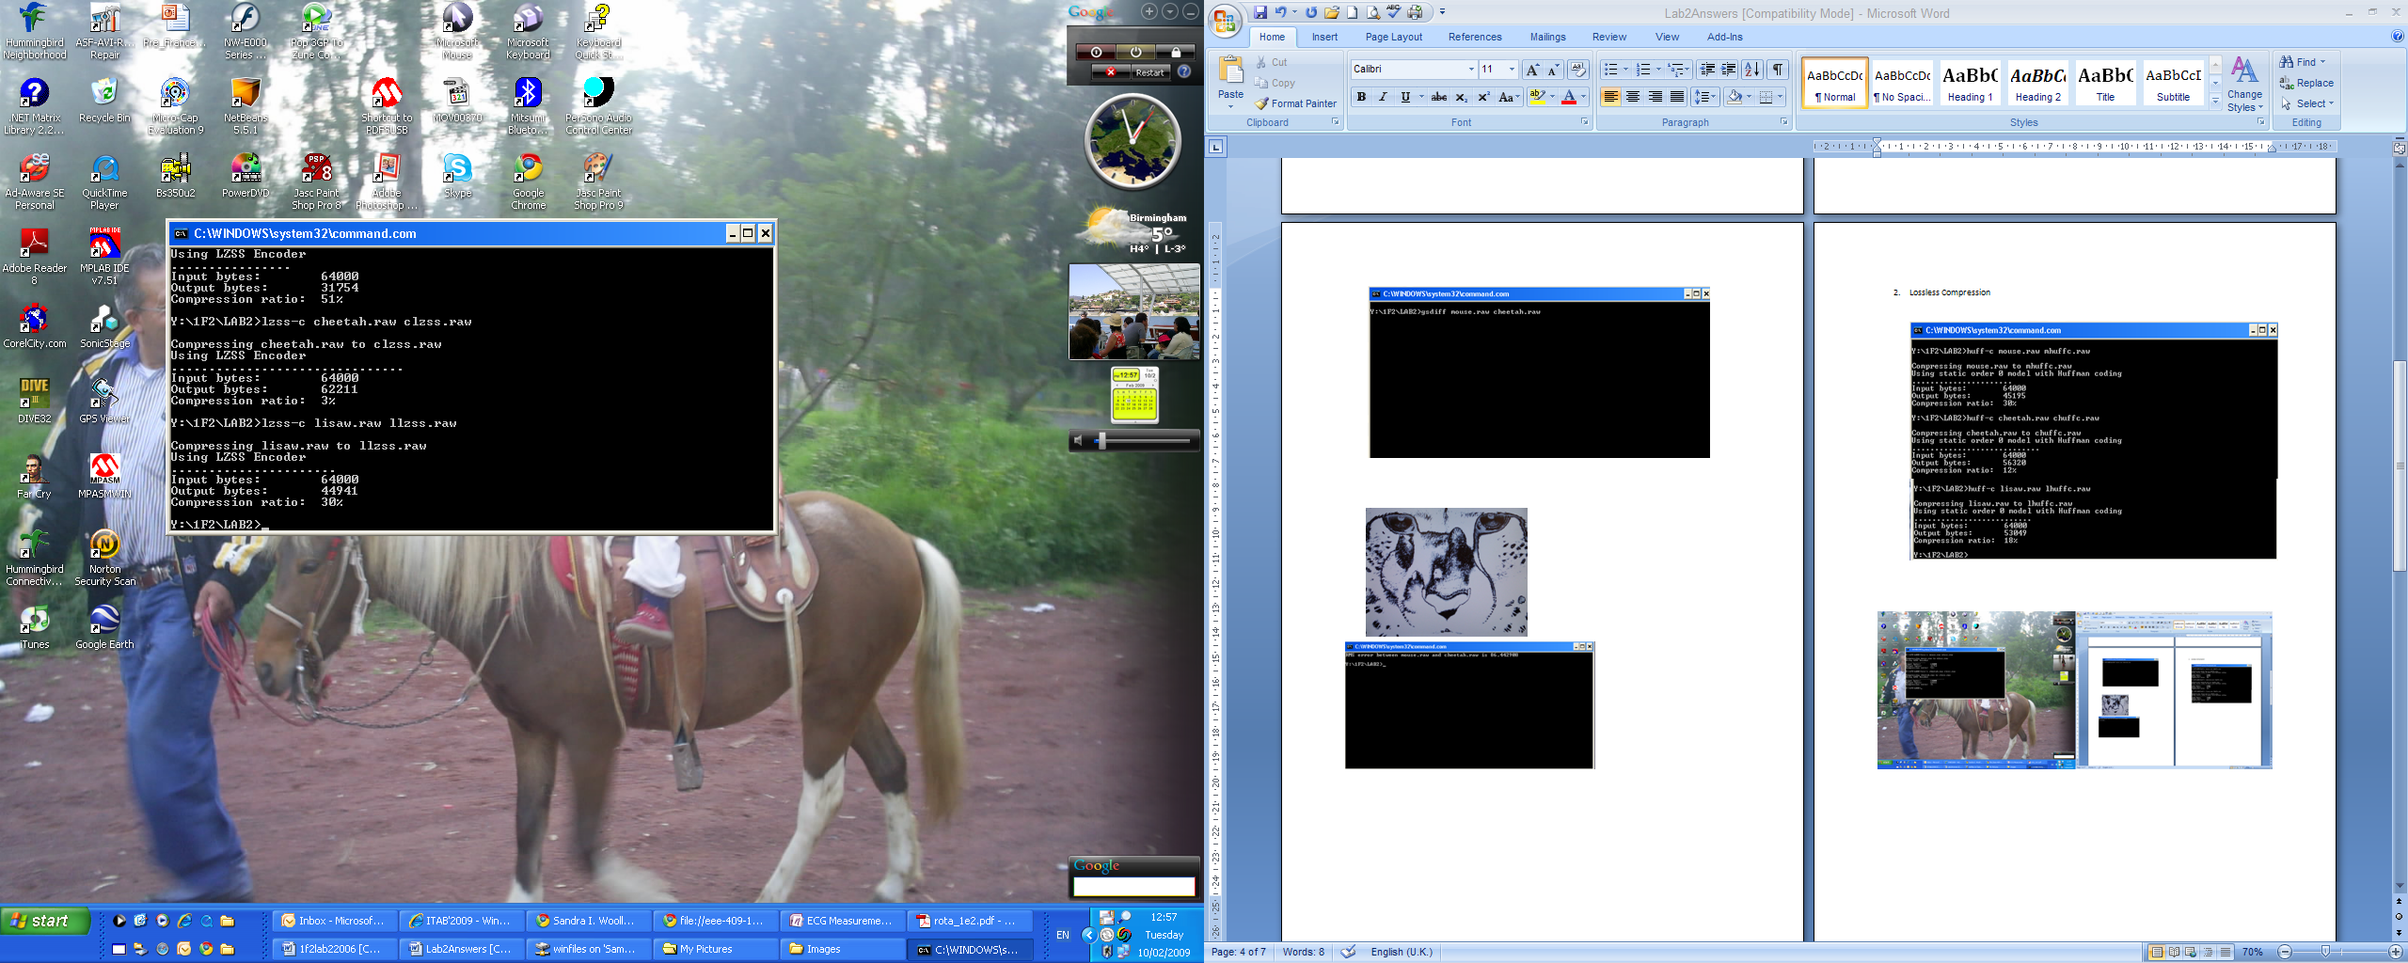

2.3 Calculating the Compression ratio and the bits per pixel.
$$Compression Ratio=\frac{old file size}{new file size}$$
$$Bits per pixel \left(bpp\right)=\left(\frac{new file size}{old file size}\right)*old bpp$$

Test Image | Method | Input bytes | Output bytes | Compression Ratio | Bits per pixel(bpp)
Mouse | Huff | 64000 | 45195 | 1.416 | 5.649
 | lz | 64000 | 31754 | 2.015 | 3.969
Cheetah | Huff | 64000 | 56320 | 1.136 | 7.040
 | lz | 64000 | 62211 | 1.029 | 7.776
Lisaw | Huff | 64000 | 53049 | 1.206 | 6.631
 | lz | 64000 | 44941 | 1.424 | 5.618

- Lossy (DCT) Compression
2.1 Compressing mouse.raw image with different Q values
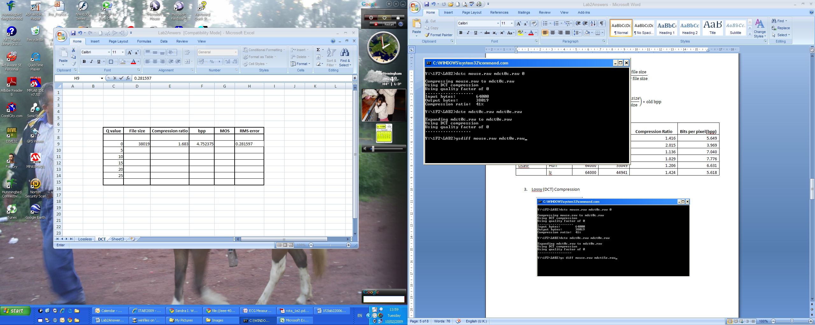

2.2 Images examples after compressing and decompressing with different Q values
Q=0
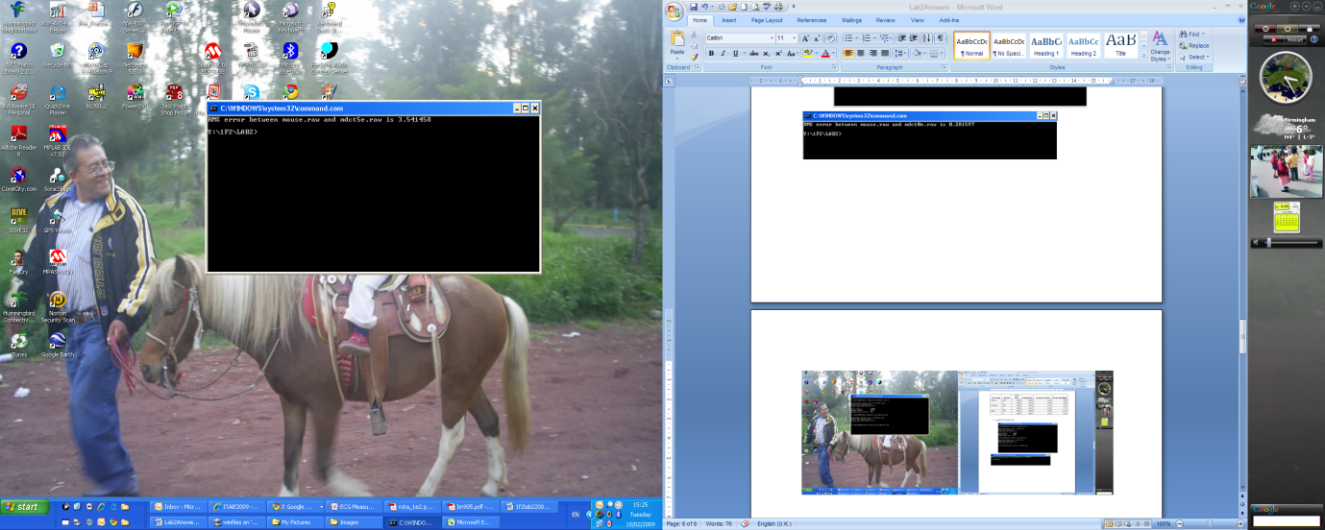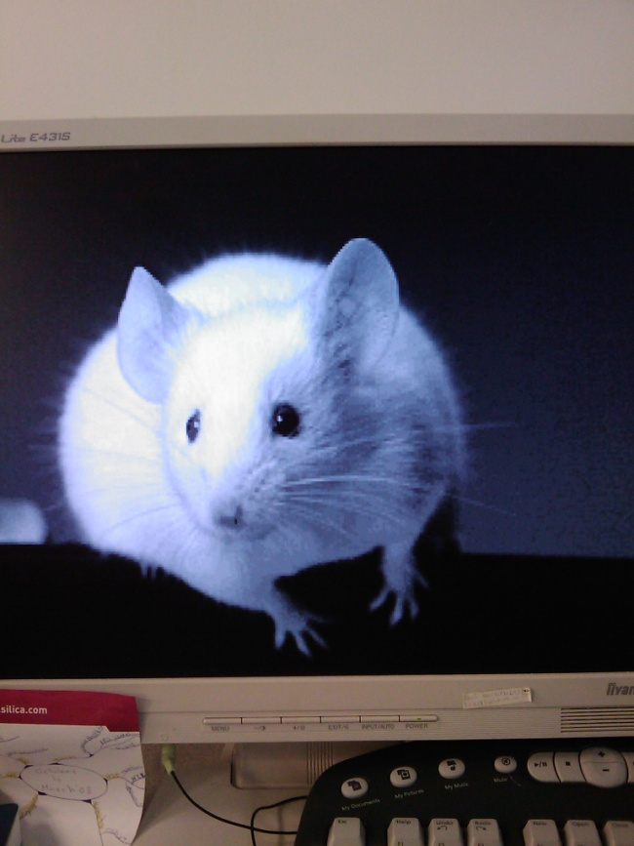
- gsdiff mouse.raw mdct0e (no difference at all) b) mdct0e.raw

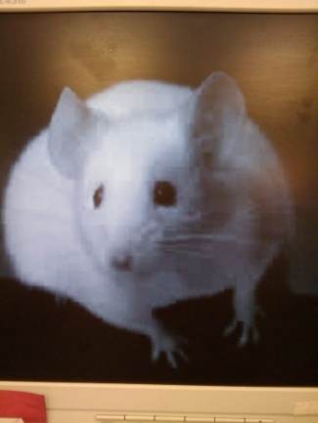
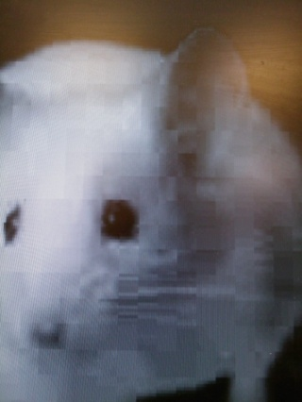
Q=5
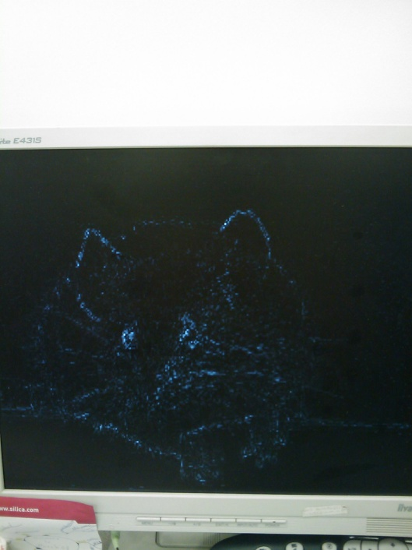
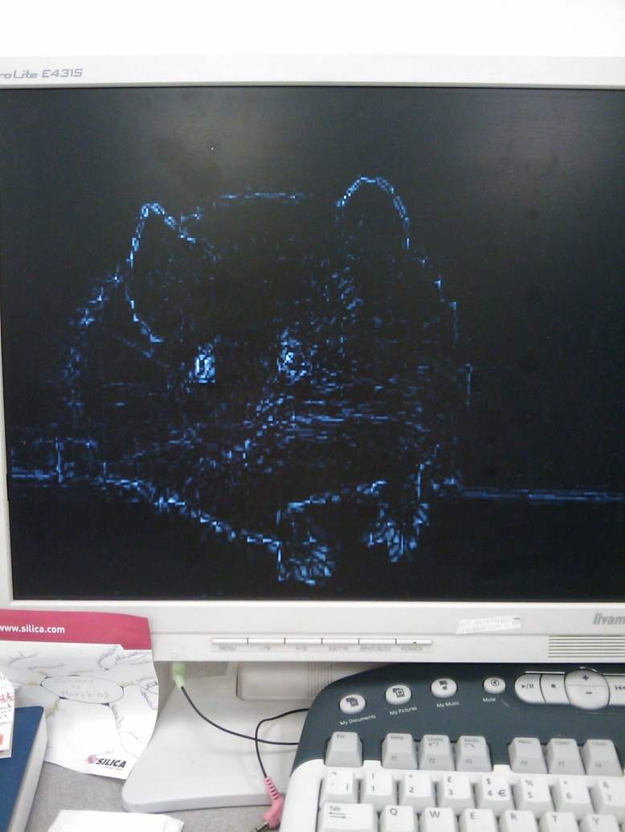
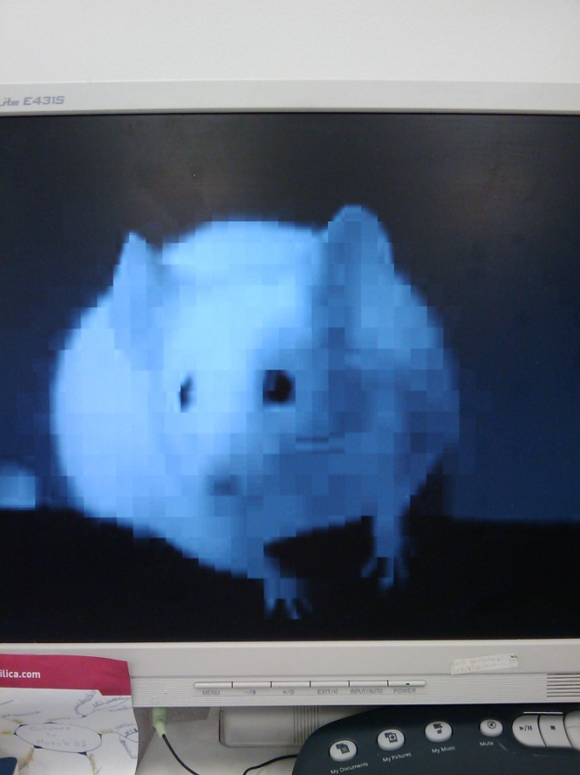
Q=15

- Using gsdiff b) Image after decompressing (mdct15e.raw)
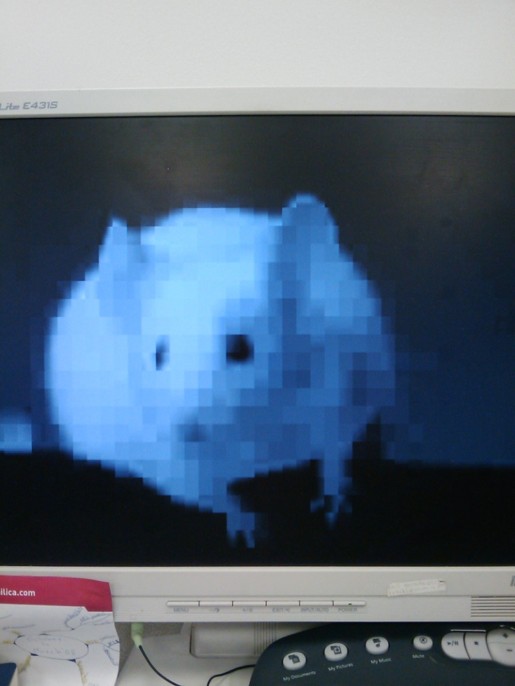
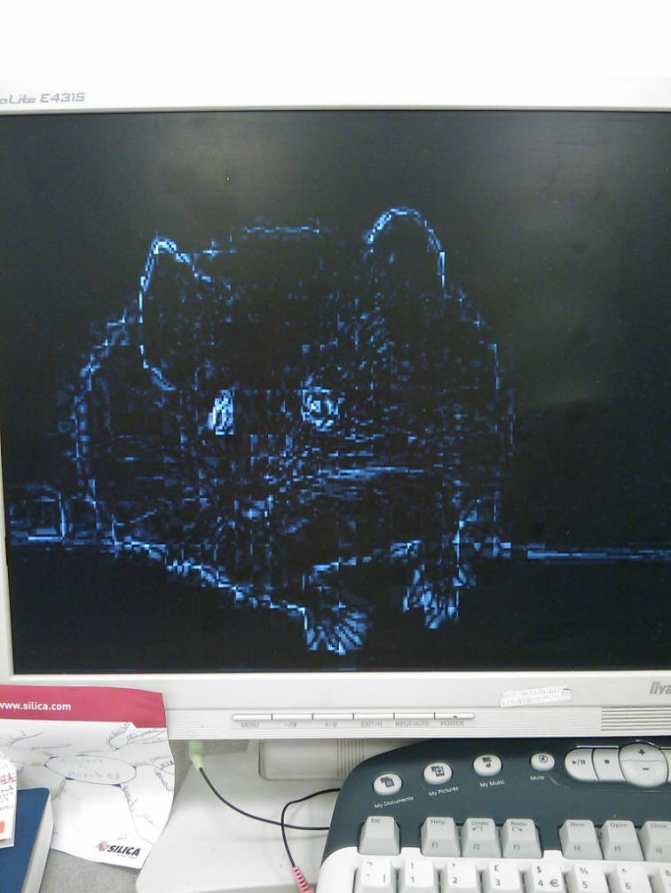
Q=25
2.3 Results

Q value | File size | Compression ratio | bpp | MOS | RMS error
0 | 38019 | 1.683 | 4.752 | 5 | 0.281597
5 | 5651 | 11.325 | 0.706 | 4 | 3.541458
10 | 4917 | 13.016 | 0.615 | 3 | 4.489757
15 | 4640 | 13.793 | 0.580 | 3 | 5.199216
20 | 4442 | 14.408 | 0.555 | 2 | 5.790469
25 | 4337 | 14.757 | 0.542 | 1 | 6.293969

- Investigating the Effects of Errors on Compressed Data
3.1 Making a compressed image copy
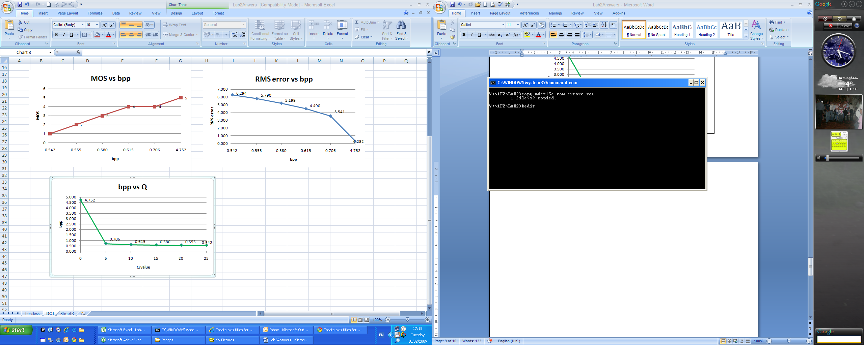

3.2 Editing the compressed image file (errorc.raw)
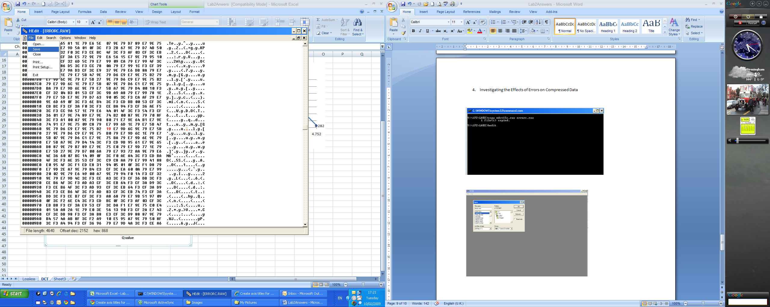
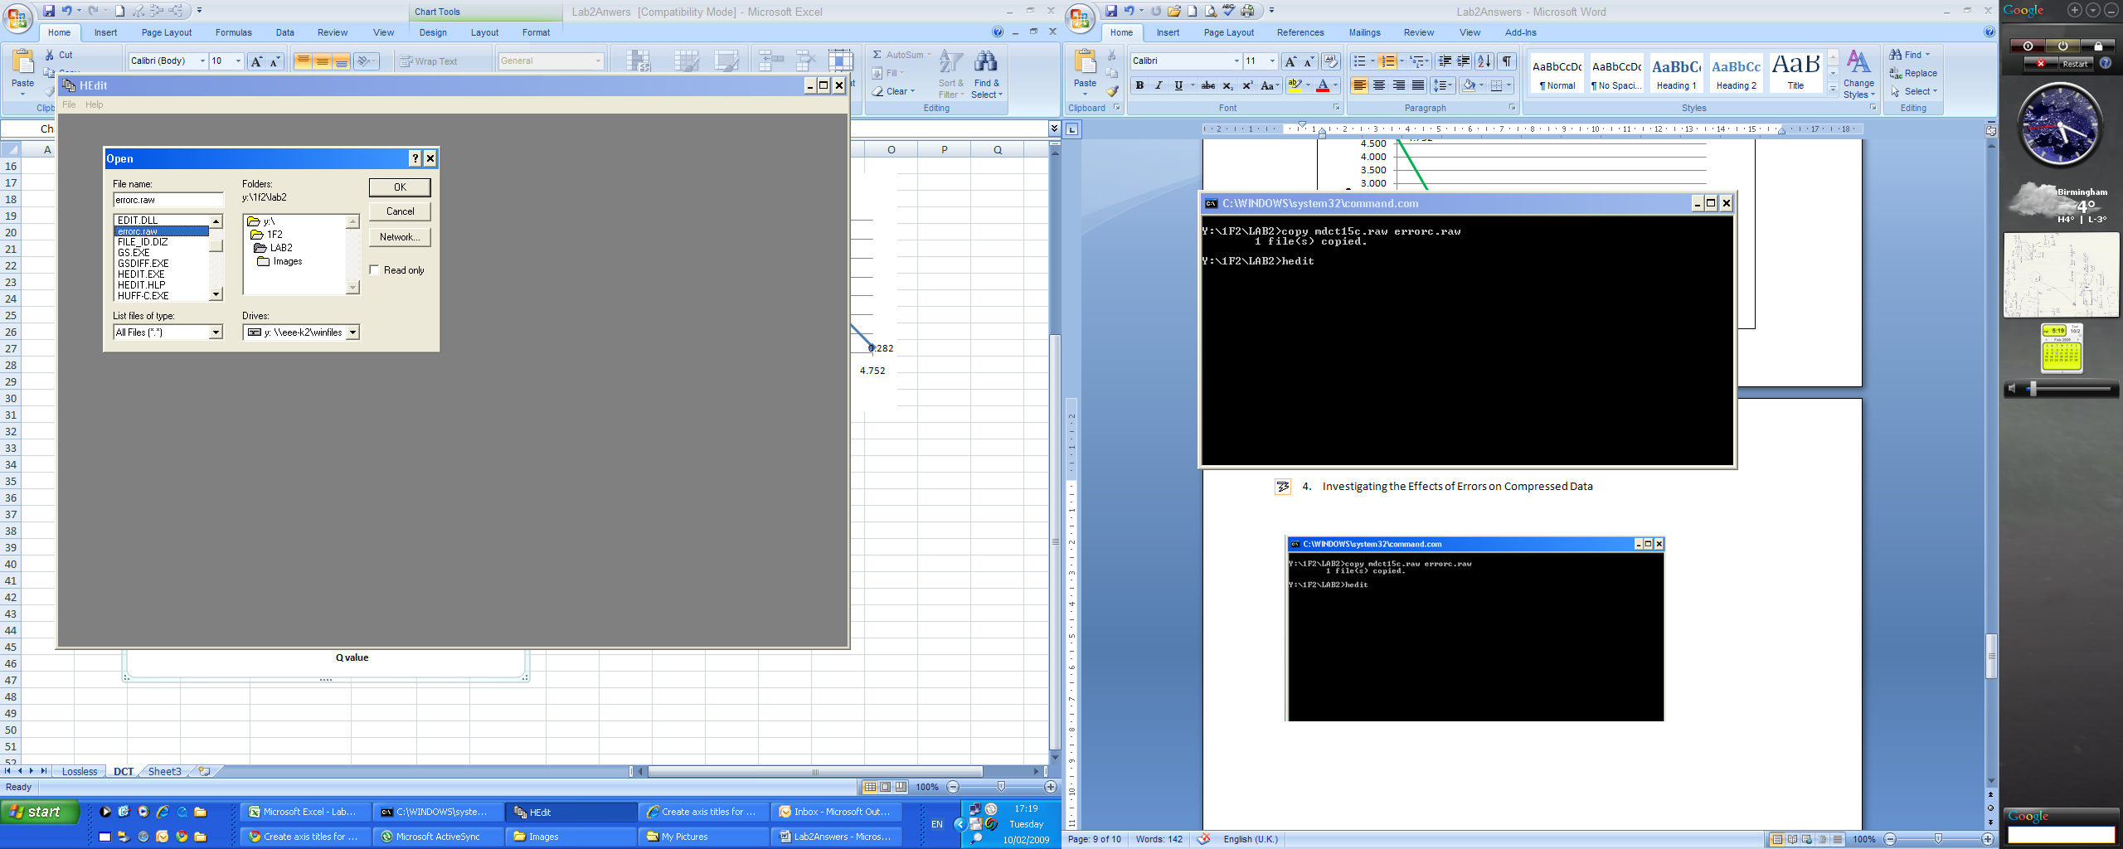
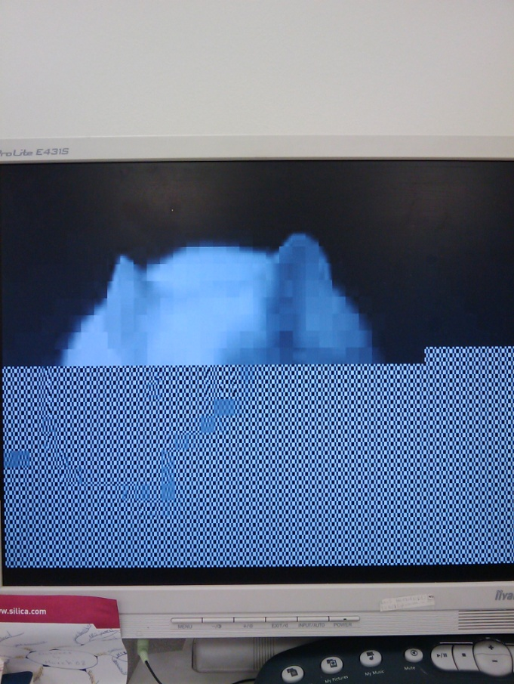
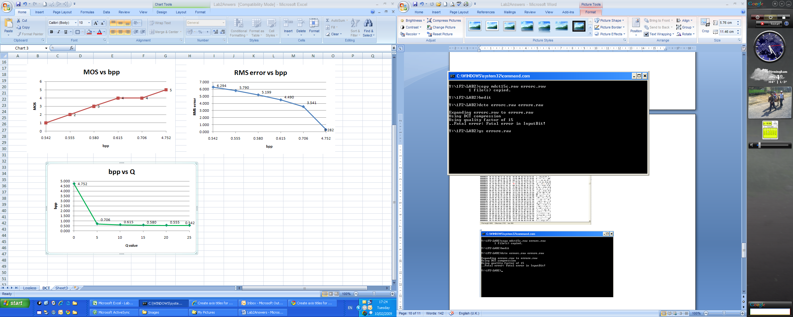
3.3 Decompressing the errorc.raw image and viewing the result (errore.raw)

