Supervisor: Mr Book



IEE- Final report

ECOCAMP SOLUTION

Group 5

Group Members: Eleanor Peel, Charuka Pathirennehelage,

Paul Paine, Adam Rachidy and Ori Rubin

**Table of Contents**

1 Introduction 3

1.1 Aim 3

1.2 Recommendations 3

1.3 Assumptions 3

2 Method 4

2.1 Technical Feasibility 4

2.1.1 Land 4

2.1.2 Energy and Power Requirements 4

2.1.3 Energy Generation 4

2.1.4 Energy Storage 5

2.2 Financial Feasibility 5

3 Results 5

3.1 Technical Feasibility 5

3.1.1 Land 5

3.1.2 Energy and Power Requirements 5

3.1.3 Energy Generation 6

3.1.4 Energy Storage 6

3.2 Financial Feasibility 6

3.2.1 Capital costs 6

3.2.2 Income 7

3.2.3 Payback Time 7

4 Discussion 7

4.1 Technical Feasibility 7

4.1.1 Land 7

4.1.2 Energy Requirements 8

4.1.3 Energy Generation 9

4.1.4 Energy Storage 11

4.2 Financial Feasibility 12

5 Conclusions and Recommendations 13

6 References 14

7 Appendices 16

Table of Figures

Figure 1: Map showing the layout of the campsite 8

Figure 2 Contour map of the campsite 9

Figure 3 Graph showing the outdoor pool energy balance 10

Figure 4 Map showing the average solar intensity in the UK 10

Figure 5 Graph showing the campsite energy use and generation 11

Figure 6 NaS compared to other battery types, such as lead-acid, lithium ion and NiH 12

Figure 7 Top performing sectors 13

# 1 Introduction

## 1.1 Aim

To outline the requirements of the EcoCamp and produce a recommendation for a viable EcoCamp which uses only off-grid energy. A detailed discussion of the technical and financial feasibility of the camp will be outlined in the report, as well as plans of the layout of the camp.

The camp had to fulfil the following requirements:

* Area for 12 caravans and 200 tents
* A facilities block with coin operated hot showers, washer- driers, large freezers and sink with hot water
* A clubhouse with a restaurant, games room and bar
* A private chalet for the proprietors with cooking facilities, lighting and domestic heating
* An outdoor heated children’s swimming pool
* It would be closed from November to February where there would only be the proprietors on site

## 1.2 Recommendations

Before starting to calculate and research anything it is important to decide what recommendations are needed. These were split into two categories; technical and economic feasibilities. To assess whether the campsite is technical feasible it was decided that the power and energy requirements needed to be calculated as well as the energy storage and generation. Once all of these have been calculated it is then important to look at the economic feasibility of the campsite. To do this the initial costs and annual income of the campsite must be found in order to calculate the payback time. This will allow for a thorough assessment of whether the campsite is feasible and thus, whether it is a good recommendation.

## 1.3 Assumptions

Before any of the calculations could be made a list of assumptions that would be followed was created. These assumptions are as follows:

* Our clients are the campsite proprietors and wish to put down the initial capital investment in order to live on and run the campsite collecting the profits after the payback time which means there will be no labour costs
* Visitors
  + 150 tents on the weekend and 50 on weekdays giving ~78.57 tents per day, assuming each tent has on average 2 people giving 157 campers every day
    - Each camper showers once every two days on average giving 78.57 showers a day, and the average shower is 7 minutes long
    - Each tent load of people uses the washer-driers once a week on average so they are used 11.22 times a day
  + 12 Caravans on the weekends and 6 on weekdays giving an average of 7.7 Caravans per day, with an average of 3 people per caravan giving 23 caravaneers

# 2 Method

## 2.1 Technical Feasibility

### 2.1.1 Land

To calculate the cost of the land and the layout of the camp, a suitable plot of land had to be found. Once this was found it was possible to determine the cost of the land and what kind of potential energy resources could be made use of. It also showed the geographical layout of the land and whether the buildings, tents, etc. could be placed.

### 2.1.2 Energy and Power Requirements

Before we could design the energy system we needed to calculate the energy requirements of the campsite. This was done by working out the energy requirements of each individual appliance and adding up the total. The energy requirements of the individual components were found by researching the energy usage of the component per hour and multiplying it by the number of hours it will be in use. Once the energy requirements have been calculated the power requirements can then be found for the individual components and the whole campsite.

### 2.1.3 Energy Generation

#### 2.1.3.1 Waterwheel

The following equations were used to calculate the power generated by the waterwheel.

$$Ep=mgh$$

Where Ep = potential energy, m = mass, g = acceleration due to gravity, h = height

For the waterwheel this equation can be adapted with a constant, C which represents the efficiency of the waterwheel

$$P=CFgh$$

Where P = Power produced by the waterwheel in watts, C = efficiency of the waterwheel, F = flowrate of the river in litres/second, g = acceleration due to gravity, h = head of water

We took the value for the water wheel efficiency, C as 0.6 (British Hydropower Association, n.d.) and the height (diameter) of the water wheel, h as 2.5m

F = density x width x depth x velocity = 1000 kgm3 x 5 m x 0.2 m x 1.7 ms-1 = 1700 Kgs-1

P = 0.6 x 1700 x 9.81 x 2.5 = 25kW

#### 2.1.3.2 Generator

As a backup for the waterwheel in the electrical power system a diesel powered generator with an output which can power the campsite. This will only be used in times of emergency such as times of drought when the river could dry up, or if the waterwheel is not operational due to damage or maintenance (SGS, 2015).

#### 2.1.3.3 Solar Thermal

Research can give values for what percentage of the pools surface area should be covered in solar thermal panels to maintain a temperature of over 25ºC.

#### 2.1.3.4 Log Burning Stove

Research can be done to find a sufficiently powerful log burning stove in order to heat the water as a backup in case the solar thermal isn’t sufficient to keep the swimming pool above 25°C. It must have a suitable efficiency and be able to be fuelled by onsite or local resources such as wood.

### 2.1.4 Energy Storage

After the energy requirements and energy production of the campsite has been finalised, an energy storage system can be designed which can supply power to supplement the power generation during peak times and store excess energy generated during off-peak times. The energy storage system should be able to store enough energy in case the campsite is suddenly without a source of energy generation to allow time for fuel for the backup generator to be acquired, so 2 days of energy storage for the campsite should be sufficient. Also the energy storage type should be the best balance of: high capacity energy storage; high energy density; price per kilowatt hour storage; and long life time.

## 2.2 Financial Feasibility

The financial feasibility of the campsite is derived from payback times. Payback time for the campsite can be calculated from the total cost of the campsite and its annual income. Total costs can be calculated from an itinerary of the building, equipment and land costs. Annual income of the campsite can be calculated by the number of guests multiplied by the income per guest. The payback time for the energy system - after which the energy system has paid for itself, compared to buying power from the grid - can be calculated by dividing the total cost of the energy system divided by the product of the energy produced by the energy system multiplied by the cost per unit energy. The campsite is financially feasible if these payback times are short, a payback time of under 10 years is considered feasible.

# 3 Results

## 3.1 Technical Feasibility

### 3.1.1 Land

The 10.3 acres consists of 1.73 acres of flat land and 8.75 acres of natural woodland meadow ideal for tent pitches. The asking price for the plot of land stands at £55, 000 freehold (Woods 4 Sale, 2015).

### 3.1.2 Energy and Power Requirements

The energy requirements for each component are as follows:

*Caravans*: UK caravan sites offer 10 amp supply at 230 volts so a maximum of 2,300 W per caravan, combined the caravans can draw a maximum of 2.76 kW, with an average power consumption of about 1 kW per caravan using on average **185 kWh per day** (The Camping and Caravanning Club, n.d.).

*Children’s heated swimming pool*: The pool is not to be heated by electricity however the pool pump and filtration system is rated at 0.23 kW, using **2.76 kWh per day** (Ecopump, n.d.).

*Showers*: 10 energy efficient electric showers rated at 7.5 kW, if used on average by each camper once every two days, 78.57 times a day, for 7 minutes using **68.75 kWh per day** (Sust-it, n.d.).

*Washer-driers*: 5 integrated washer-driers drawing up to 11.5 kW, using 4.81 kWh to run each, assuming they are used once a week by each tent, 11.22 times a day, they would use **54 kWh per day** (Bosch, n.d.).

*Fridge*: A++ energy rated, 116 kWh (per year), using **0.32 kWh per day** (Bosch, n.d.).

*Freezer*: 183 kWh (per year), using **0.50 kWh per day** (Bosch, n.d.).

*Lights*: 100, 15W energy saving light bulbs, on for 15 hours a day uses **22.5 kWh per day** (Tesco , n.d.).

*Point-Of-Sales system*: “Shopify” which is based on the use of iPads to save energy instead of energy demanding computer systems. Used during the day and charged up at night, during times with minimum power be used. Battery is 27.62 Wh, charging 5 iPads require **0.14 kWh per day** (Arce, 2014).There is also1 receipt printer drawing an average 24 W for 15 hours uses **0.36 kWh per day** (Star, n.d.).

*Private chalet*: This is for the camp proprietors with domestic heating, lighting and cooking facilities. If it is assumed that the average annual UK household energy consumption is 4,192 kWh, it will require **11.5 kWh per day** (Department of Energy and Climate Change, 2014).

The total average energy demand of the campsite is approximately **345.83 kWh per day**. With a maximum energy demand of 93 kW, and an average power demand of **14.4 kW**.

### 3.1.3 Energy Generation

#### 3.1.3.1 Electrical Energy

A single waterwheel with a 2.5m diameter, overshot design with ~60% efficiency can produce 25 kW of electricity if river flows at 1.7 ms-1 (British Hydropower Association, n.d.). The Back-up generator, a 25.0 kVA Kubota Super Silent Diesel Generator - 1500 RPM, has an output of 20 kW (SGS, 2015).

#### 3.1.3.2 Heat Energy

Covering the roof of the Energy Storage building, with an area of 25x10m (250m2) the same size and dimensions of the children’s swimming pool, with solar thermal panels should maintain the temperature of the pool above 25°C as an area 100% of the pool area is covered. A backup Log burning “Klover Log Boiler 40”, 83% efficient can produce 38.6 kW of heat, in case the solar thermal isn’t sufficient for maintain the temperature of the pool (Stovesonline Ltd., n.d.).

### 3.1.4 Energy Storage

A storage system with 770 kWh of storage should be sufficient as the round trip efficiency of the storage cells is 90%, which should mean a useful energy storage of 693 kWh which exceeds two days of the campsites electrical energy requirements (Energy Storage Association, n.d.). According to (Liu, n.d.) the cost of NaS battery systems is ~ £195/kwh meaning the system should cost about £150,000.

## 3.2 Financial Feasibility

### 3.2.1 Capital costs

To calculate if the campsite is financially feasible first a value for the cost for the campsite needs to be calculated.

The initial capital costs are as follows:

* Land: £55,000 (Woods 4 Sale, 2014)
* Waterwheel: £10,000 (Water Wheel Factory, n.d.)
* Kubota Diesel Generator: £9,238.80 (SGS, 2015)
* Solar Thermal: £20,000 (Jacksons Leisure Supplies, 2014)
* Klover Log Boiler 40: £3,757.16 (Stovesonline Ltd., n.d.)
* NaS Battery System: £150,000 (NGK Insulators, Ltd. , n.d.)
* Buildings: £617,334 (Build It, n.d.)
* Furnishings, equipment, permits and other costs : £21,000

Total costs ≈ £886,329.96

### 3.2.2 Income

The majority of the campsites income comes from the guests hiring pitches so values per pitch are required. (Gateway Holiday Park, 2015) is a comparable Campsite – with a pool, restaurant and laundry room which can be used to estimate the price of pitches after tax.

* Grass Pitch Non Electric ~ £18 per night (approximately 150 tents on the weekends and 50 on weekdays) 8 months a year = **£343,200 per year**
* Hard Standing Electric ~ £22 per night (approximately 12 caravans on the weekends and 6 on weekdays) 8 months a year = **£41,184 per year**

The campsite also produces excess energy which can be sold to local residents or businesses. 254.19 kWh extra is produced each day, ~ 62 MWh total energy generated while open over 6 months, and ~ 71 MWh while closed for 4 months. If sold at £0.1377/kWh = **£18,300 per year** (Gateway Holiday Park, 2015).

Annual income for the income is ≈ **£402,684**

### 3.2.3 Payback Time

The Payback time for the campsite was calculated from the initial costs of the campsite - including land, building, and equipment – divided by the annual income. This gave a payback time of 2.2 years, any income after this time is profit.

$$Campsite Payback time=\frac{Initial costs}{annual income} =\frac{£886,329.96}{£402,684}≈2.2 years$$

The time for the energy system to pay for itself, after which the system is effectively producing free energy as if energy had been bought from the grid it would have cost the same as the energy system, is about 5.6 years. This is calculated from the cost of the energy system divided by the product of the energy produced by the campsite and the cost per unit.

$$Energy system Payback time =\frac{initial cost of energy system}{energy produced per year ×cost of energy}=$$

$$\frac{£169,238.80}{219000 kWh×£0.1377/kWh}≈5.6 years$$

# 4 Discussion

## 4.1 Technical Feasibility

### 4.1.1 Land

The location of an off grid campsite is essential as its geographical location and natural resources are actively incorporated into the running of its facilities. Geographical, a location situated in a region of the UK that hosts high levels of UV radiation, high wind speeds, fast flowing rivers and usable natural resources is ideal for such a project. By taking all these factors into account, a 10.3 acre plot of land (Woods 4 Sale, 2015) situated in south Wales (near Carmarthen) provides the perfect balance with its picturesque woodlands and usable natural resources.

Figure 1: Map showing the layout of the campsite

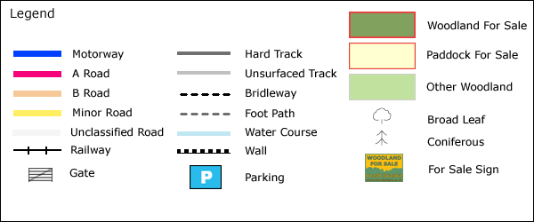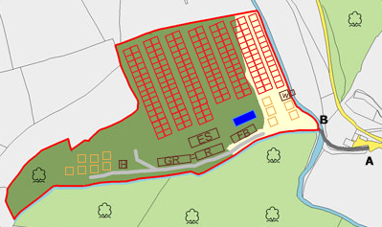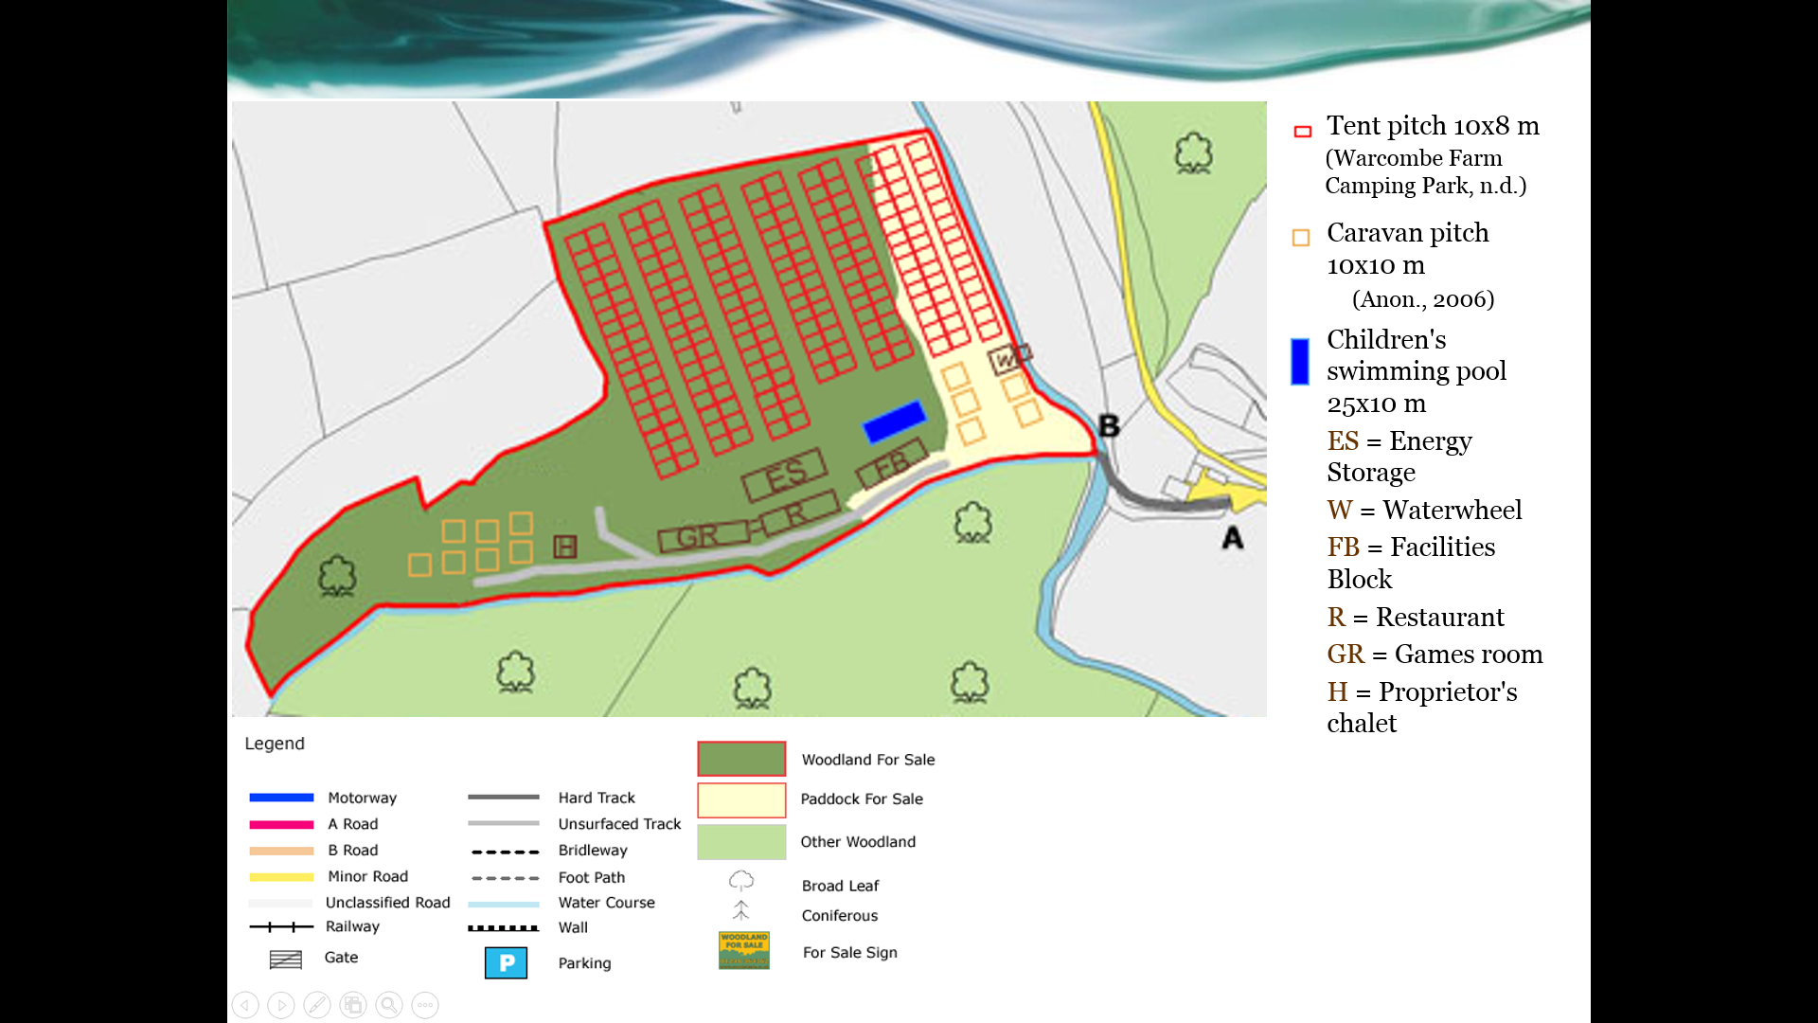

Figure 1 shows the potential layout of the campsite with the facilities and condition stated in the brief above. The northern region of the plot accommodates 200 tent pitches with regulation pitches of 10 by 8 meters. Whereas the left and right hand side shows twelve yellow boxed representing caravan pitches complete with electrical hook ups. By utilising the pre-existing road running the length of the Southside of the plot, placing all the communal facilities allows for better accesses for visitors. However the plots major natural resource is a 170 meter stretch of fast flowing river alongside its eastern border.

### 4.1.2 Energy Requirements

The best way to decrease the price of the energy production and storage is to minimise the energy requirements of the campsite. This is done through the use of less energy hungry, higher efficient equipment such as low energy showers (Sust-it, n.d.) and a POS system which requires iPads instead of conventional computers which require more power. Also the iPad only need to be charged once a day so they can be charged at night at off peak hours reducing the load at peak times. Appliances with A++ energy ratings were selected to minimise their energy usage, and energy saving lightbulbs were used.

### 4.1.3 Energy Generation

#### 4.1.3.1 Electrical Energy

This campsite has a fast flowing river, ‘Bele’, to the eastern border with an incline or drop as shown by the river crossing a contour line within the campsite boundaries on the map in figure 2 (each line represents a height change of 20 metres). This could be utilized by an overshot waterwheel to generate electricity as a 2.5 m drop is feasible. A waterwheel should provide a constant and reliable supply of energy, with a power of 25kW as the power production depends on the flowrate of the river, which shouldn’t fluctuate very much. Also the iconic image of a waterwheel increases the visual appeal and brand image of the campsite.

Figure 2 Contour map of the campsite

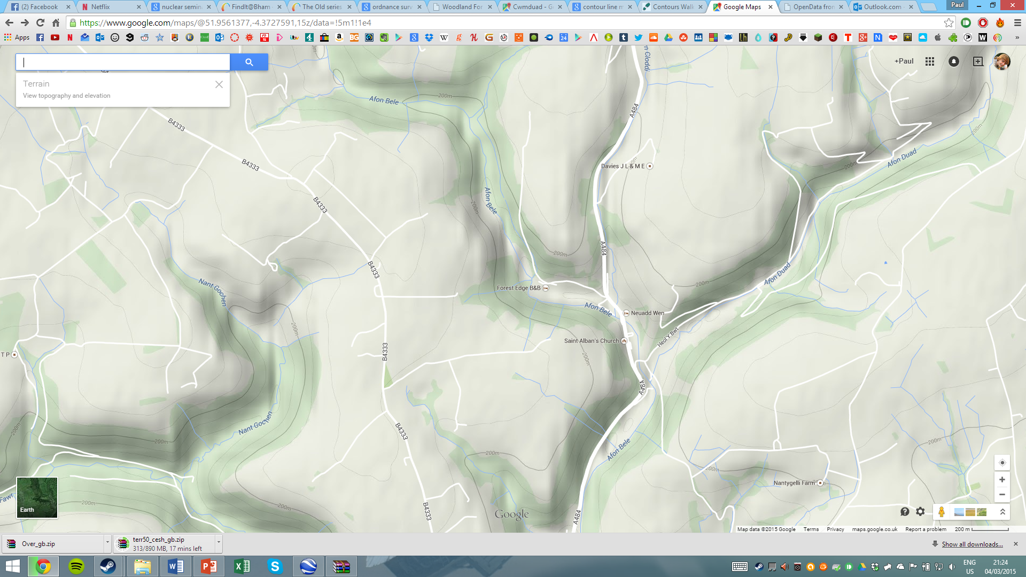

Source Compiled: https://www.google.com/maps/@51.9561377,-4.3727591,15z/data=!5m1!1e4

#### 4.1.3.2 Heat Energy

Despite the campsites location in the UK solar thermal panels can provide a sufficient energy to heat the children’s swimming pool. South wales has a higher solar intensity than much of the UK as shown by figure 3.

The collector’s surface area of the panels in hot countries is usually 50% of the size of the pool itself. In cooler countries there is a need to increase this surface area, usually to 70% of the pools surface, but to ensure the pools temperature can maintained it was decided to go for a surface area as large as the pool itself (250 m2). This should maintain a warm temperature above 25°C from the early spring to the end of autumn (The Solarblogger, 2012)

[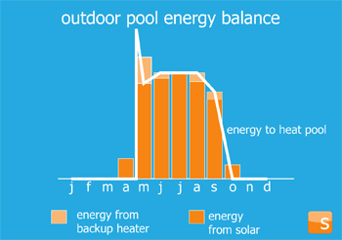](http://3.bp.blogspot.com/-rCMt8Fme_5Y/UA7hl8NbRKI/AAAAAAAAAUA/sKOGmYtiZKI/s1600/Solar_Energy_Outdoor_Pool.jpg)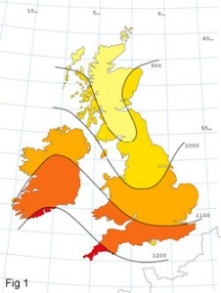According to figure 3, which shows the solar energy addition to an outdoor swimming pool from May to October, an outdoor pool is likely to have use profile that matches the availability of solar energy. A scenario where the ratio between solar and backup system in our location may not match perfectly is taken into account as illustrated in figure 4, so the portion of backup system might increase and the portion of solar might decrease. In situations that it does not match we have a backup system to heat up water. It is called ‘Klover Log Bolier’ and can produce 38.6 Kw by burning local woods.

Figure 3 Map showing the average solar intensity in the UK

Source Compiled: http://3.bp.blogspot.com/-rCMt8Fme_5Y/UA7hl8NbRKI/AAAAAAAAAUA/sKOGmYtiZKI/s1600/Solar_Energy_Outdoor_Pool.jpg accessed on 12th March 2015

Source Compiled: <http://www.uksolarenergy.org.uk/solar-panels-uk.html> accessed on 12th March 2015

Figure 4 Graph showing the outdoor pool energy balance

After the cost of the solar thermal system and installation which will cost approximately £20,000 pounds, the camp proprietors maintaining the system should incur almost zero cost for 10-20 years.

The backup Log burning“, Klover Log Boiler 40”, Can produce 38.6 kW of heat, more than enough to heat the swimming pool (Stovesonline Ltd., n.d.). This should be only used after long periods of very little sunlight when, or to initially get the pool up to temperature at the beginning of the season. It can be fuelled by logs from onsite or locally sourced, meaning it has a reduced carbon footprint.

### 4.1.4 Energy Storage

As seen in the figure 5 the energy usage of the campsite fluctuates throughout the day, with peaks at 8am, 1pm, and 8pm and troughs through the early morning. The waterwheel produces energy at a constant rate as the flowrate of the river doesn’t fluctuate very much through the day. However this means at these peak times the waterwheel does not produce enough power to supply the power requirements of the campsite. An energy storage system which can discharge when the power usage is above the waterwheel power generation, and charge up while the campsite is using less energy than is being generated should mean the energy requirements of the campsite can be met at all times. This should mean the campsite can run continually without running out of energy, even at peak times.

Figure 5 Graph showing the campsite energy use and generation

A Sodium Sulphur (NaS) battery system (NGK Insulators, Ltd. , n.d.) was chosen as NaS batteries have a longer lifetime, higher energy density, are cheaper and have a longer continuous discharge with rated output when compared to the main alternative, lithium ion batteries as shown in figure 6. NaS battery systems are a tried and tested method of large scale energy storage and are used in over 190 sites in Japan, the largest of which has an energy storage capacity of 245 MWh for wind power stabilisation in northern Japan (Energy Storage Association, n.d.).A NaS battery system with a 770 kWh capacity should be suitable for the campsite as at 90% efficient it will be able to provide 693 kWh, which exceeds two days of the campsites required energy (Energy Storage Association, n.d.).

## http://www.renewableenergyworld.com/assets/images/story/2010/11/19/1332-korea-s-posco-develops-nas-battery-for-energy-storage.jpg4.2 Financial Feasibility

Source Compiled: NGK Insulators, Ltd. accessed on the 8th March 2015

Figure 6 NaS compared to other battery types, such as lead-acid, lithium ion and NiH

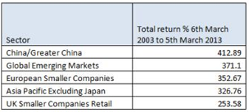The project is viable if the probable revenues cover the total costs of the campsite, as after a time of 2.2 years the campsite has paid for itself, the campsite could be said to be financially feasible as this is quite a short payback time (Investorwords, 2015). Another test of financial feasibility is if the initial investment of £886,329.96 was put in the bank and left for 10 years, with compound interest at the bank of England base rate which is currently 0.5% (Bank of England, 2015), the investment will be worth £931,763.37 (thisismoney, 2015), which is a return of £45,433.41. However after the Campsite pays for itself in 2.2 years, for the next 7.8 years the gross return will be the annual income of £402,684 multiplied by 7.8 years giving, £3,140,935.20 which is much larger than if the money was left in the bank. This is a return over the 10 years of 354%, which is on par with the top performing sectors for return on investment for 10 years, 2003 to 2013, as shown in figure 7 (Thisismoney, 2013).

Figure 7 Top performing sectors

Source Compiled: http://www.thisismoney.co.uk/money/diyinvesting/article-2289151/The-best-investments-past-years.html accessed on 12th March 2015

# 5 Conclusions and Recommendations

From the recommendation of the energy system with the built in redundancies of: the waterwheel producing well over average power requirements; the backup energy systems, of the generator and the log boiler; and the energy storage system which will ensure energy can always be supplied to the campsite, and if both power systems fail the campsite will be supplied with energy for up to 2 days of regular use or much longer with energy rationing. We concluded the campsite it technologically feasible.

The payback times of 2.2 years for the campsite and 5.6 years for the energy system are relatively short. In the introduction it was stated payback times of under 10 years are feasible and as the campsite payback time is well under this and the energy system is under 10 years so the campsite is financially feasible.

# 6 References

Anon., n.d. [Online]   
Available at: http://www.ukcampsite.co.uk/chatter/display_topic_threads.asp?ForumID=4&TopicID=72330  
[Accessed 8 March 2015].

Arce, N., 2014. *iPad Air 2 battery is more powerful than iPad Air battery, iFixit suggests.* [Online]   
Available at: http://www.techtimes.com/articles/18505/20141024/ipad-air-2-battery-is-more-powerful-than-ipad-air-battery-ifixit-suggests.htm  
[Accessed 8 March 2015].

Bank of England, 2015. *Home.* [Online]   
Available at: http://www.bankofengland.co.uk/Pages/home.aspx  
[Accessed 7 March 2015].

Bosch, n.d. *Home Appliances.* [Online]   
Available at: http://www.bosch-home.co.uk/  
[Accessed 8 March 2015].

British Hydropower Association, n.d. *Waterwheels.* [Online]   
Available at: http://www.british-hydro.org/waterwheels.html  
[Accessed 12 March 2015].

Department of Energy and Climate Change, 2014. *Energy Consumption in the UK (2014).* [Online]   
Available at: https://www.gov.uk/government/uploads/system/uploads/attachment_data/file/338662/ecuk_chapter_3_domestic_factsheet.pdf  
[Accessed 8 March 2015].

Ecopump, n.d. *Pool Pump Reviews.* [Online]   
Available at: http://www.ecopoolpumps.com/pool-pump-reviews.html  
[Accessed 8 March 2015].

Energy Storage Association, n.d. *Sodium Sulfur (NaS) Batteries.* [Online]   
Available at: http://energystorage.org/energy-storage/technologies/sodium-sulfur-nas-batteries  
[Accessed 8 March 2015].

Gateway Holiday Park, 2015. *Prices.* [Online]   
Available at: http://www.caravanparkgower.co.uk/booking/prices-tariffs  
[Accessed 12 March 2015].

Investorwords, 2015. *Financial feasibility.* [Online]   
Available at: http://www.investorwords.com/15399/financial_feasibility.html  
[Accessed 7 March 2015].

Liu, G., n.d. *A Storage Revolution.* [Online]   
Available at: http://ei.haas.berkeley.edu/c2m/2013/Slides/Sulfur%20and%20Sodium%20Metal%20Battery.pdf  
[Accessed 8 March 2015].

NGK Insulators, Ltd. , n.d. *NaS Batteries.* [Online]   
Available at: http://www.ngk.co.jp/english/products/power/nas/  
[Accessed 8 March 2015].

SGS, 2015. *25.0 kVA Kubota Super Silent Diesel Generator - 1500 RPM.* [Online]   
Available at: http://www.sgs-engineering.com/generators/diesel/ssdk25m-silent-diesel-generator  
[Accessed 12 March 2015].

Star, n.d. *TSP100.* [Online]   
Available at: http://www.starmicronics.com/printer/thermal_printers/tsp100  
[Accessed 8 March 2015].

Stovesonline Ltd., n.d. *Klover Industrial Log Boilers.* [Online]   
Available at: http://www.stovesonline.co.uk/wood_burning_stoves/Klover-Industrial-Log-Boilers.html  
[Accessed 12 March 2015].

Sust-it, n.d. *Electric Shower Electricity Cost Calculator.* [Online]   
Available at: http://www.sust-it.net/electric-showers.php  
[Accessed 8 March 2015].

Tesco , n.d. *Kosnic 15W B22 Decor Glass Bulb (Set of 5) - 11.* [Online]   
Available at: http://www.tesco.com/direct/kosnic-15w-b22-decor-glass-bulb-set-of-5-11/314-0641.prd?pageLevel=&skuId=314-0641  
[Accessed 8 March 2015].

The Camping and Caravanning Club, n.d. *Electricity for Campers and Caravanners.* [Online]   
Available at: http://www.campingandcaravanningclub.co.uk/helpandadvice/technicalhelp/power/electricity-for-campers-and-caravanners/  
[Accessed 8 March 2015].

The Solarblogger, 2012. *Bathing in Sunshine - Solar Heating for Swimming Pools.* [Online]   
Available at: http://www.solarblogger.net/2012/07/bathing-in-sunshine-solar-heating-for.html  
[Accessed 12 March 2015].

Thisismoney, 2013. *The best investments of the past ten years.* [Online]   
Available at: http://www.thisismoney.co.uk/money/diyinvesting/article-2289151/The-best-investments-past-years.html  
[Accessed 7 March 2015].

thisismoney, 2015. *Savings Calculator.* [Online]   
Available at: http://www.thisismoney.co.uk/money/saving/article-1633419/Monthly-lump-sum-savings-calculator.html  
[Accessed 7 March 2015].

Warcombe Farm Camping Park, 2015. *Pitch Types.* [Online]   
Available at: http://www.warcombefarm.co.uk/pitch-information.html  
[Accessed 8 March 2015].

Woods 4 Sale, 2015. *Woodland For Sale Carmarthenshire.* [Online]   
Available at: http://www.woods4sale.co.uk/woodlands/south-wales/608.htm  
[Accessed 8 March 2015].

# 7 Appendices

A – Table used to generate energy usage graph for the campsite (figure 5)



B – Job roles

|  |  |
| --- | --- |
| Name | Main Responsibilities |
| Charuka Pathirennehelage | * Energy generation * Presentation * Location and land acquisition |
| Paul Paine | * Project manager * Energy storage * Energy requirements * PowerPoint for presentations |
| Eleanor Peel | * Final report * References * Spokesperson |
| Adam Rachidy | * Project progression * Meeting minutes |
| Ori Rubin | * Heat energy generation * Swimming pool * Solar thermal |

C – Meeting Minutes

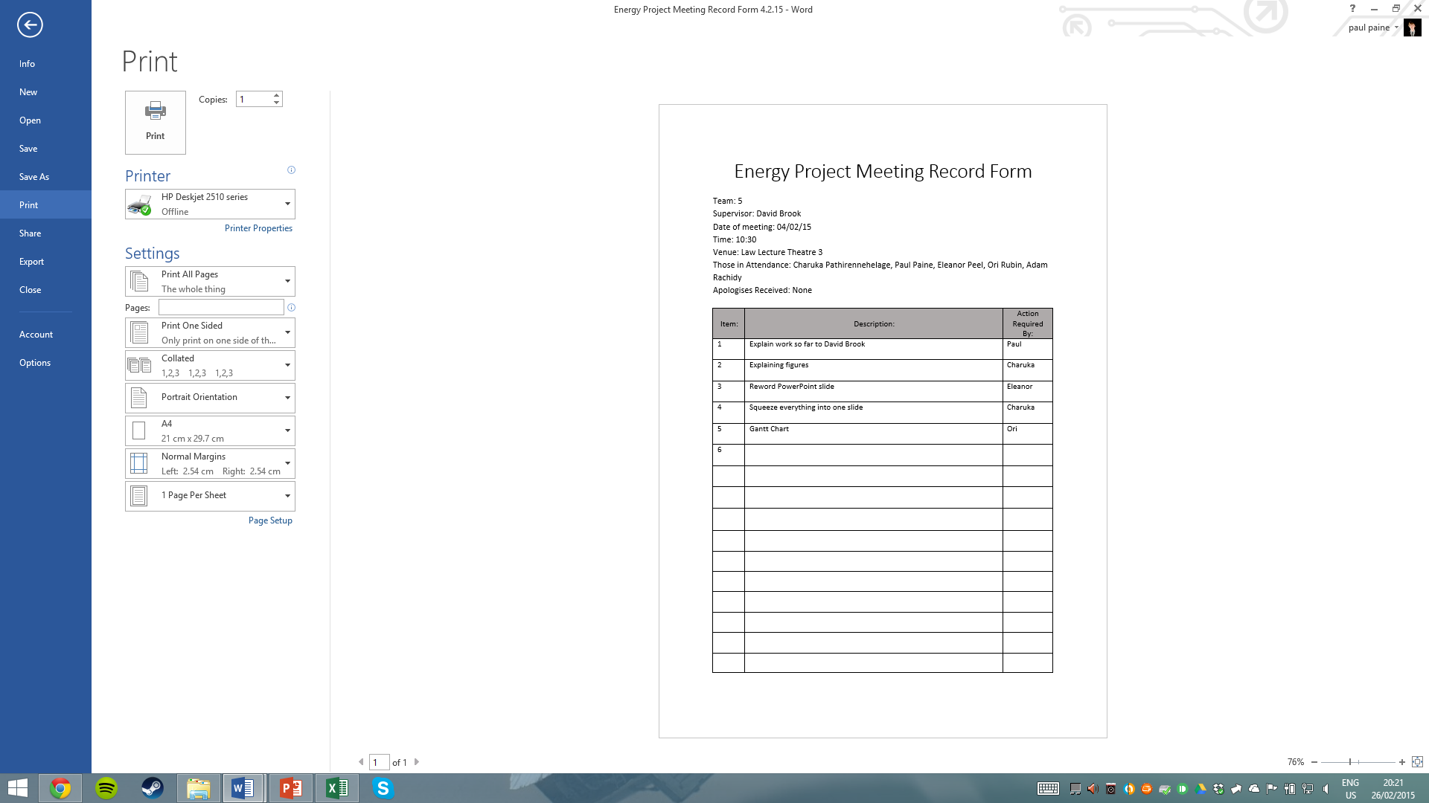 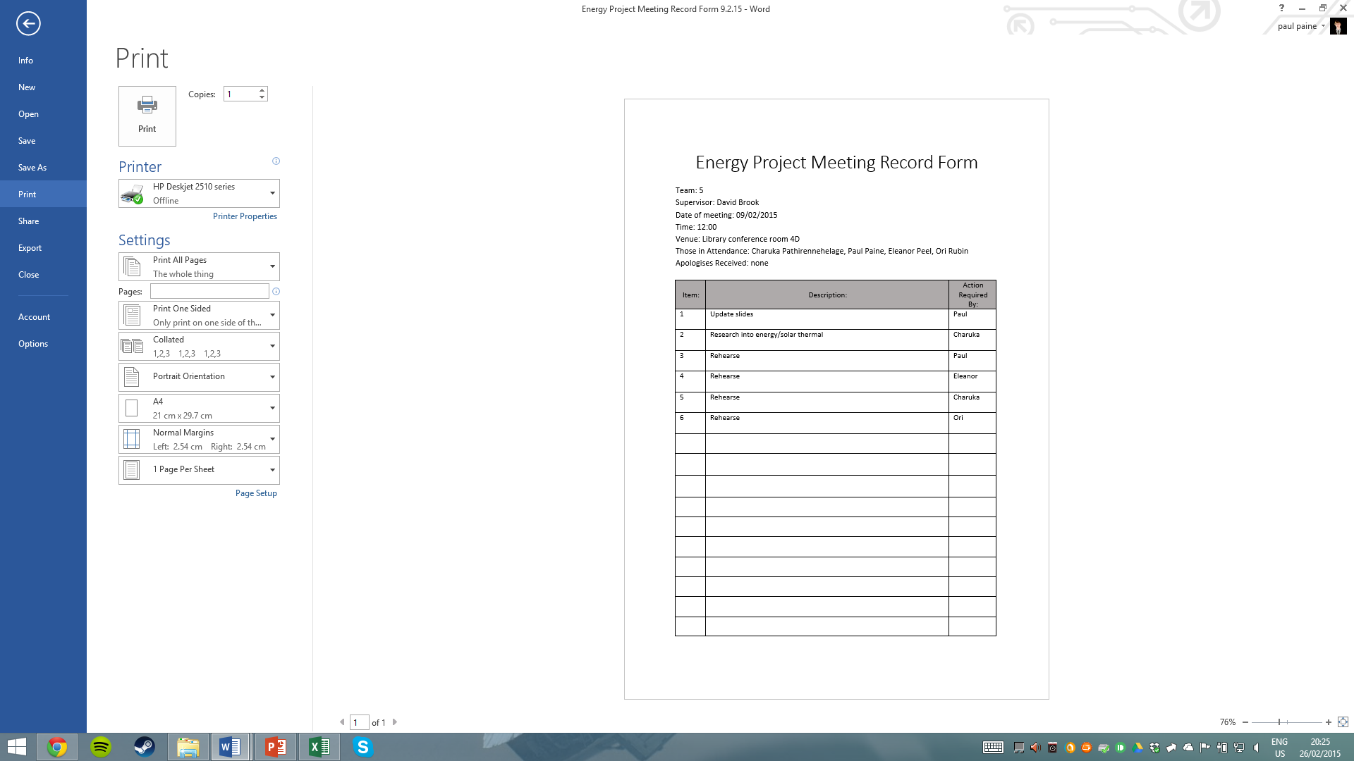

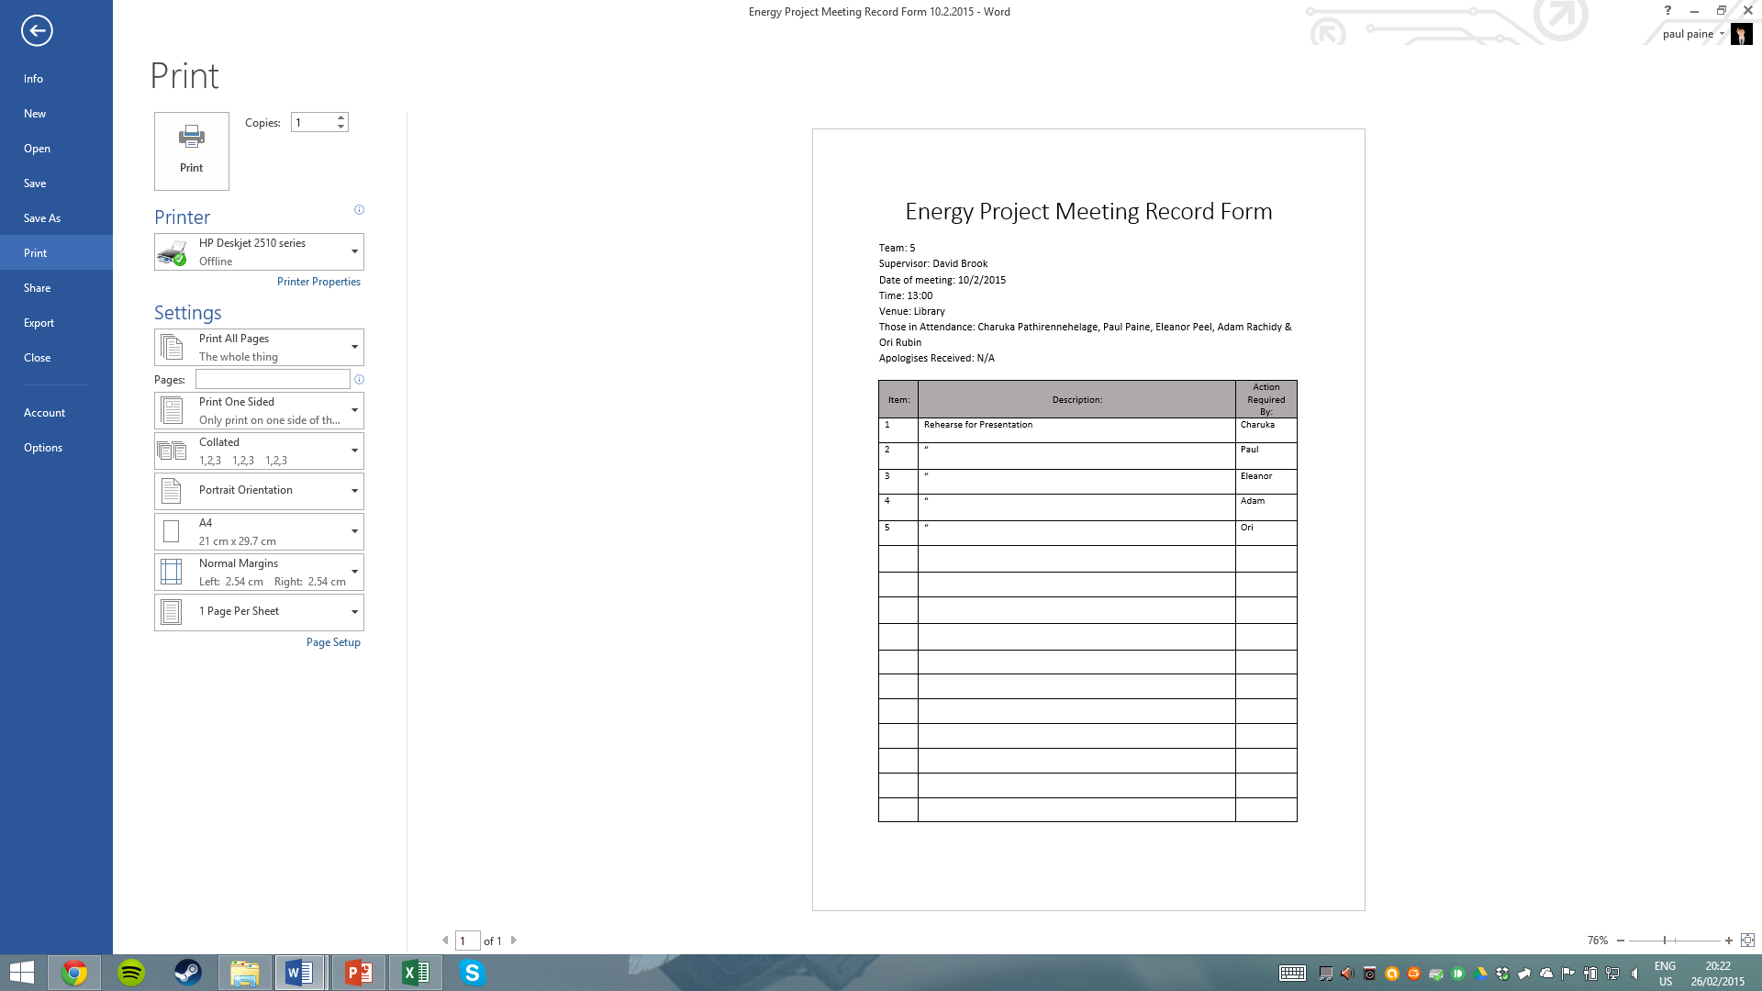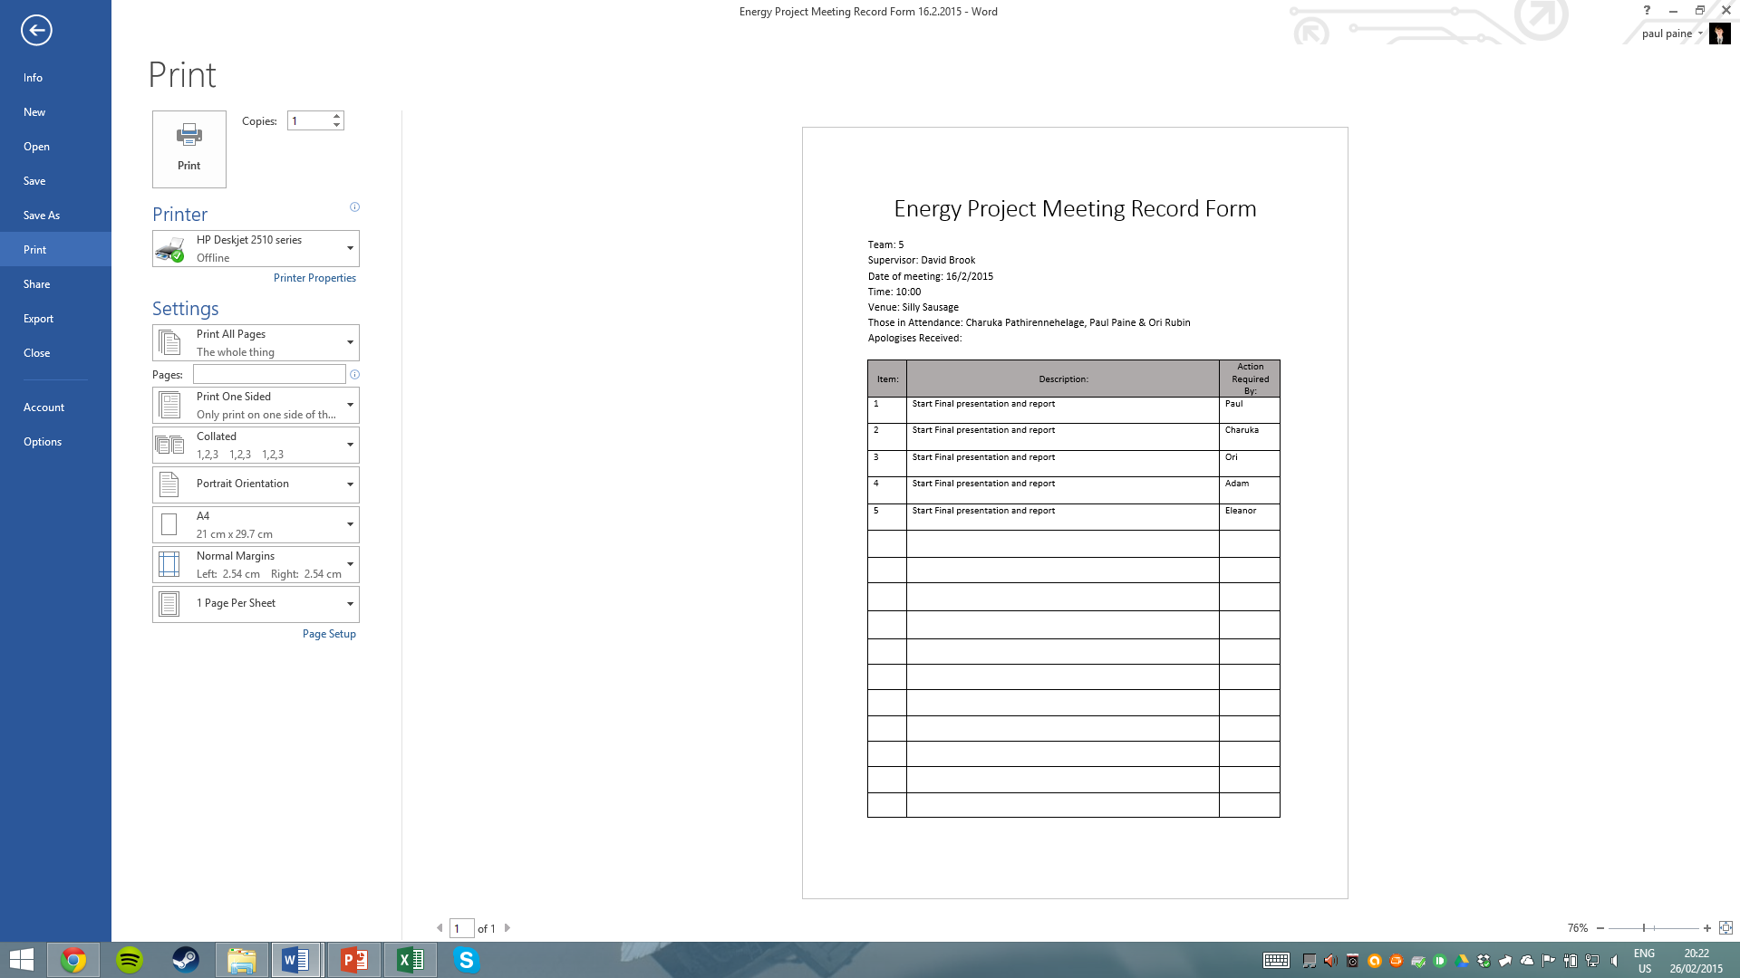

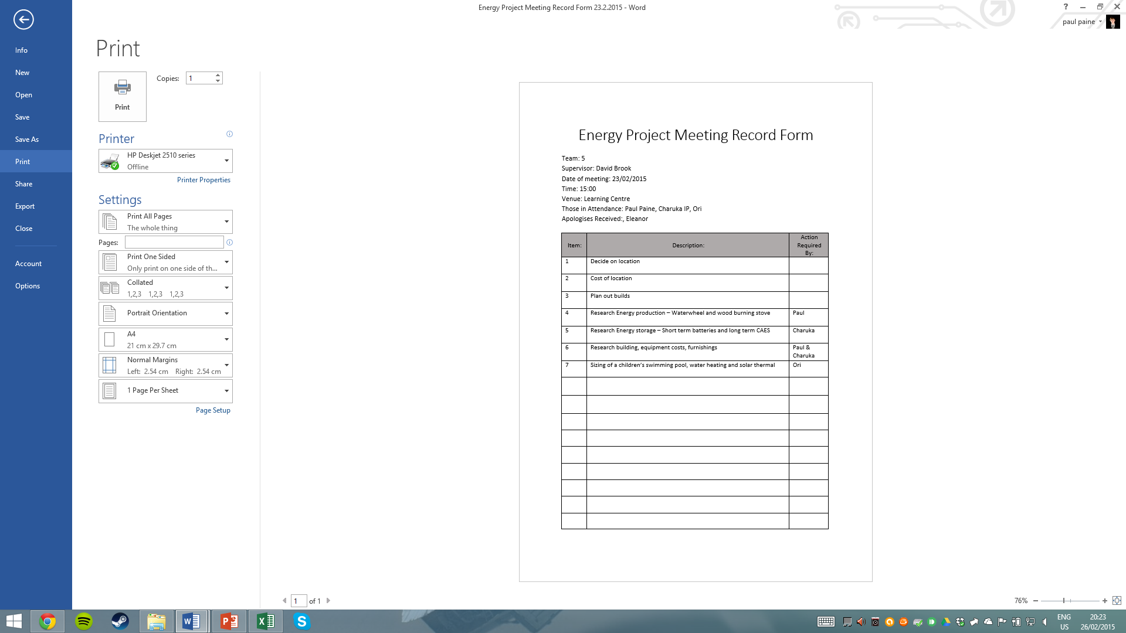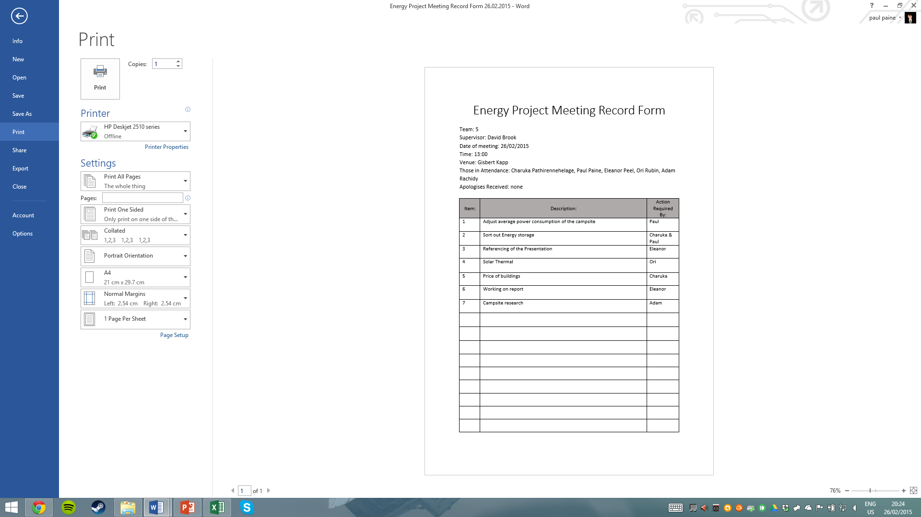

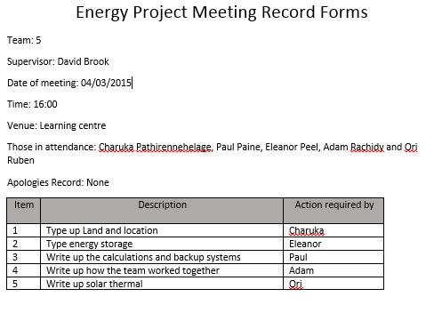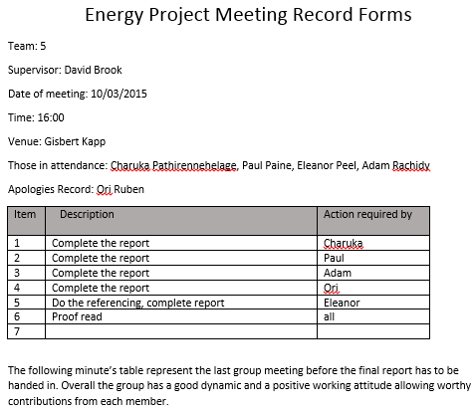

D – Supervised Meeting notes

Power generation:

• Waterwheel

• Burning fast growing trees

• Solar thermal or wood burning to heat outside swimming pool

Power storage:

• To look into: batteries (different types) – heat – what’s most suitable to a campsite eg batteries or combinations – hydrogen as an energy storage

• Look into waste removal – power drain or power source

Project plan

• Gantt chart

Costs

1. Buy land

2. planning permission

3. building costs

4. operating costs

Facilities – power demand