**Introduction to energy engineering**

**Off-grid gym concept » research, results and recommendations**

**Group 7 report**

**March 2015**

**Daniel Webster**

**James Lane**

**Jet Len**

**Josh Stoneham**

**Ben Sharp**

**Phil Wong**

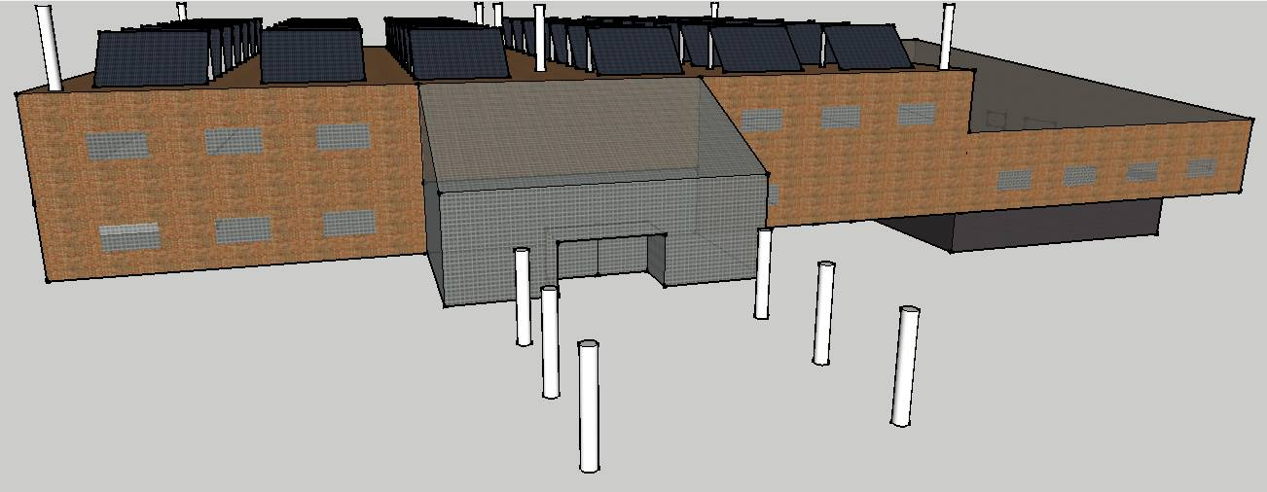

**(Rendered design of gym building for title page)**

**Contents**

1. **Introduction of brief**
2. **Methods**
3. **Results and research**
   1. **Gym equipment and facilities**
   2. **Discussion of facilities**
4. **Energy generation and storage**

**4.1. Wind energy**

**4.2. Solar energy**

**4.3. Inverters**

**4.4 Storage**

**4.5. Charge controller**

**4.6. Discussion of energy generation solutions**

**5. Heating and ventilation  
 5.1. Pool area  
 5.2 Hot water supply for complex  
 5.3. Air conditioning  
 5.4. Insulation  
 5.5. Heating and ventilation discussion**

**6. Feasibility-costing and power  
 6.1. Power consumption calculations and considerations  
 6.2. Total costing  
 6.3. Capital**

**7. Conclusions and recommendations**

**8. References**

**9. Appendix**

1. **Introduction of brief**

The aim of this project is to design and evaluate the economical and technical feasibility of an off-grid gym in a city centre location. As a team of engineers, the object is to provide an energy solution in a presentable business format that is worthy of investment to a client.

The Eco-Gym will consist of a variety of cardio-vascular machines, a heated 25m pool, changing room facilities with hot showers and a cafeteria serving hot drinks and snacks. The gym will be located in the city centre of Plymouth and provides facilities for 1500 members with opening hours of 7:00-21:00. The design of the building is included with specified dimensions to provide a layout of the gym.

Calculations and costing breakdown are carried out to determine the feasibility of the Eco-Gym.

1. **Methods**

The aims of this report are to provide information and conclusions from an engineering and business perspective for:

1. Solutions for energy generation and storage
2. Equipment and facilities of the gym
3. Efficient heating and ventilation of the building
4. Final recommendations to the client

The research and discussion for this report was split between the team members in order to ensure areas of specialist knowledge could be addressed by the relevant members. Critical analysis of the feasibility of each solution was conducted thoroughly to ensure the business model was realistic and possible to carry out upon investment from a client.  
Throughout this project we have made appropriate assumptions that:

* The client already own the building in the city centre of Plymouth
* Water and gas tariffs will be decided upon and managed by the client
* Staff will be employed and managed by the client

**2. Results and research**

**3.1** Gym equipment and facilities

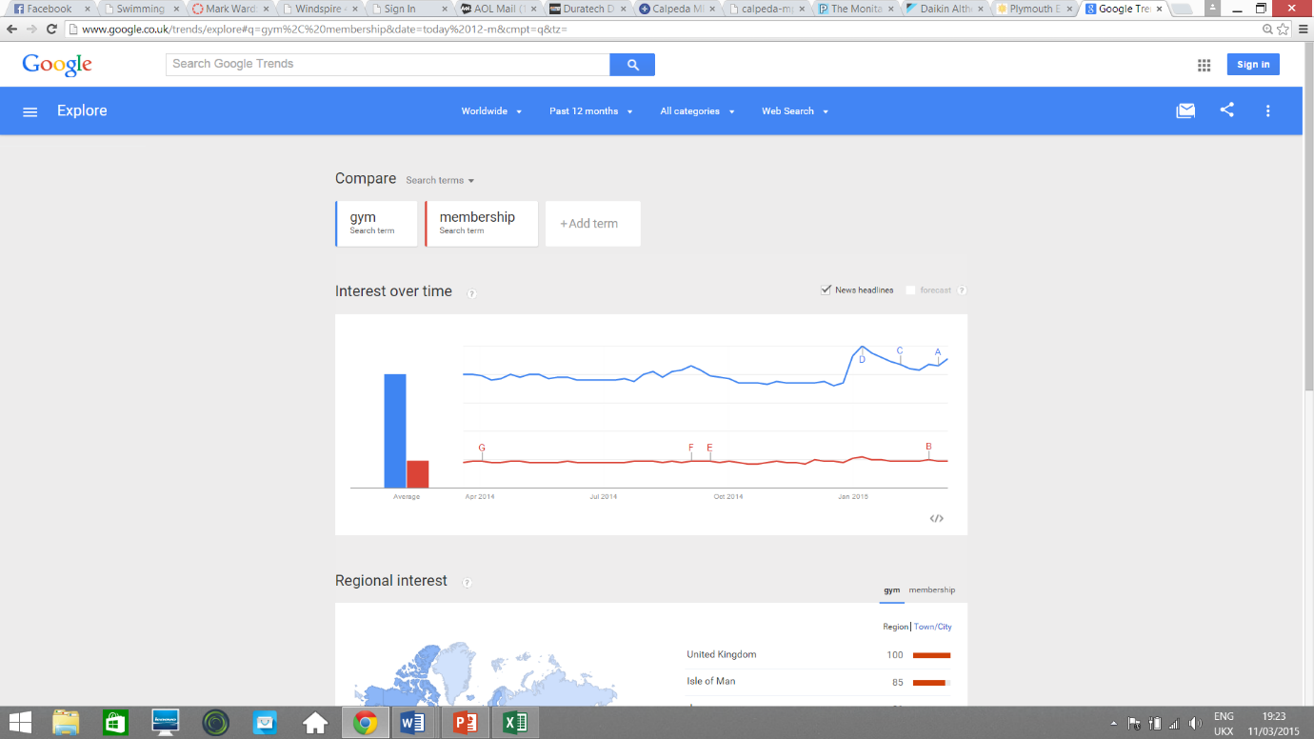All the cardio machines in the gym will be self-powered by the work of the user. These models of equipment are more expensive than regular machines but will save money and energy in the long run . The setup will constitute of 45 cardio machines-make and model shown in brackets: 25 treadmills

**Figure 1-annual trends of interest in gym membership**

(google trends, 2015)

(Woodway Curve), 10 ellipticals (sportsart performance), 17 spin bikes (Kettler golf eco upright bike), 3 rowing machines (Body sculpture rower) and 2 steppers (confidence twist stepper) along with a variety of resistance machines. Research has also been conducted in finding the best value weights, benches, mirrors, water fountains, showers, cubicles etc. The gym also includes appliances such as TV’s, radios hand dryers and lighting. Further information on all equipment and associated references found in spreadsheet in APPENDIX. See section 6 for costings.

The graph above shows the interest in gym memberships throughout the year (2014). Average values show that there is no great difference that would affect the quantity of equipment and so it can be assumed that the gym use will be near enough constant throughout the year.

The café area has been sized appropriately (see APPENDIX) for the membership numbers to include coffee machines, fridge freezers, display cabinets, a Panini press and computers. Costing and referencing of these items can be found in APPENDIX.

**3.2** Discussion of facilities

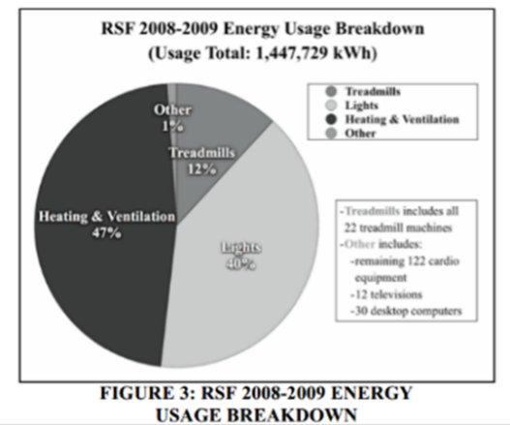The self-powered gym equipment was decided on after available data from a report on the university of California gym showed that cardio machines consume 12% of their total energy usage (Maha and Haji, 2010), this is mainly due to the treadmills. Treadmills are highly energy consuming due to their mechanical design as they are operated by a motor that turns the belt to match the velocity of the runner. They require 1.5-3 horse power so at maximum capacity would require 2.2kW to power, leading to around 170000kWh per year - around one third of our total energy usage (Maha and Haji, 2010). For this reason self-powered machines have been selected considering the initial cost is greater. The benefits of not needing to generate the extra energy was the deciding factor. The concept of generating energy from human power through the machines was  
researched, but the very large equipment cost (£20000) (Maha and Haji, 2010)was not a worthy  
investment when only an insignificant amount of energy could be  
generated.

The café is worth investing in as it will also generate an income for  
the business (quantified in a later section) as it will also be open to  
non-members.   
 **Figure 2- Energy usage breakdown  
 for UoC gym** (Human power generation in fitness  
 facilities, 2010)

**2. Energy generation and storage**

**4.1** Wind energy

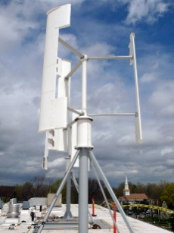Wind spires are vertical wind turbines developed by an energy company named ‘Hyperion’. The unit consists of a turbine, generator and inverter/converter, it can be equipped to generate either single phase or three phase electricity. The wind spires can be installed as a fully integrated system with capability of generating up to 5kW at maximum capacity. Due to the minimisation of moving parts and a highly aerodynamic structure, the unit operates with minimal sound, tests show that the sound of the wind interacting with the building itself will produce a louder noise than the spire. Below are the relevant specifications: **Figure 3- Windspire 4.0kW**

Rated Wind Speed: 12.5m/s (28mph) (windspireenergy.com, 2015)  
Survival Wind Speed: 45m/s (100mph)  
Overall Height: 3.11m (10.2ft)  
Rotor Diameter: 2.75m (9.02ft)  
Nominal Power: 4.0kW  
Peak Power: 5.0kW

(windspireenergy.com, 2015)

The unit can be installed on either the roof or a ground mount, it can be fitted for on-grid connection to enable excess energy to be sold back to the grid. They can operate in turbulent winds and are low maintenance with high generation capabilities.

The wind spire network would be installed to supply 85% of the gyms energy needs, It is assumed that the spires would operate continually at half the rated nominal power of 2kW - as this is what would be produced during the average annual wind speed for Plymouth and that they will be running 24 hours per day with surplus energy generated being stored in a battery network (see section 5) and extra excess being sold back to the grid. In order to meet the demand of 768kWh per day, the formula below us used to calculate the number of units needed: (calculations of energy usage see **6.1)**

**(Number of wind spires)*(Power rating)*(operational hours per day)=(kWh gen. per day)**

**16 Units * 2kW * 24hours = 768kWh per day**

We would need a total of 13 wind spires to meet the specified for wind energy.

**4.2** Solar energy

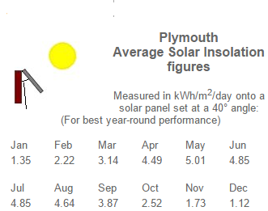For the remaining 100kWh/day required for the electricity needs, 526 panels were decided to be the number needed to provide a slight excess of around 110kWh per day. The excess was deemed necessary to counter possibilities of shade and other inefficiencies that could occur. They would be placed at a 40o angle to the vertical facing south on the flat roof. An angle was decided because at a tilt, the panels are able to capture more sunlight than being horizontal (Boxwell, 2012).

The optimal tilt all-year-round for Plymouth was found from the formula 90o – Latitude (Boxwell, 2012). Plymouth’s latitude is around 50o (Latlong.net, n.d.) thus the tilt stated earlier. The direction of south-facing is the best direction for countries in the Northern Hemisphere (Boxwell, 2012).

**Figure 4- Insolation Figures in Plymouth**(Solar Electricity Handbook, 2015)

From this tilt, direction and the location of Plymouth, the solar insolation values can be obtained, see Figure **XXXXXX** below for the average monthly values. Solar insolation is defined as the rate of solar energy falling on an area over a period of time (3tier.com, n.d.). The units are usually, and in this scenario, kWh/m2.

In order to find out the electricity produced from each solar panel, the formula, adapted from Photovoltaic-software.com (n.d.), is $E=A ×r×I ×C$.

E is electricity produced in kWh, A is the area of the solar panel, r is the ratio of the peak wattage of the solar panel to its area, I is the insolation figure of the month and C is the performance co-efficient. C represents the inefficiencies of power generation and distribution caused by factors such as shading and snow, inverter inefficiencies, temperature and resistance in the DC and AC cables. Here the default coefficient will be used which is 0.75.

Hence in order to calculate the number of solar panels needed, the minimum electricity the solar panels will generate in the year is calculated. This means the worst insolation figure is used for the calculation, which is December. Therefore 1.64m2 (see 1.1.2.) multiplied by 0.152 (peak power of 0.25kW (see…) / area of 1.64m^2) multiplied by 1.12 and by 0.75 gives 0.209kWh.

**1.64*0.152*1.12*0.75 = 0.209kWh**

The excess of 110kWh divided by 0.209kWh gives 526.

**110 / 0.209 = 526 Solar panels required**

Solar Panels Used for the Gym

The solar panels that were chosen for the gym were the ‘ECO FUTURE 250W Mono All Black’ panels (Buypvdirect.co.uk, n.d.). They were of reasonable expense, costing £130 per panel, and were of a standard peak wattage of 250W.

The dimensions of each module were 165cm x 99.2cm x 4cm, the cell efficiency was stated at 17.4% and with a module efficiency of 15.27%.

At 40o, due to trigonometry, the solar panel will be 76cm tall to the vertical and 64cm long to the horizontal. Therefore the area each panel would take up on the roof, excluding spaces in-between the panels, would be 1.65m x 0.64m = 1.05m2.

**4.3** Inverters

The current supplied by the solar panels to the batteries needs to be DC, this means that inverters must be included in the circuitry to convert the DC from the batteries to AC as AC is required to power the equipment in the building. The recommended model to invest in is the OutBack Power GS8048A Inverter. This is a suitable off-grid option for producing the single phase AC electricity required by the gym. This particular model cannot connect straight to the photovoltaic panels, instead drawing power directly from the battery bank. It is designed to work with a 48-volt lead-acid battery bank hence fitting perfectly into the designed energy system (Outback Power Inc, 2014). A rectifier also needs to be connected in the network to convert the AC power from the wind spires to DC in order to be stored in the batteries. The rectifier we recommend is the ‘Casey 480V brake rectifier’ as it fits the required voltage for AC to the DC required by the battery bank. (caseyUSA.com)

**4.4** Storage

The energy storage solution recommended is a bank of rolls batteries (windandsun,2015). A combination of 24 6V 428Ah capacity batteries supply an output voltage of 48V. This output voltage is ideal for use with the inverter to supplement energy requirements while energy generation from solar panels is low. The storage capacity in kWh can be calculated using the principle of P=IV.

428Ah * 24 batteries * 48V (Output) = 493kWh (Energy Storage Capacity)

Given the average consumption per day of the gym as 841.542kWh (see section 6.1) per day, this amount of storage will be enough to supplement a poor day of generation. It will be ensured that the battery bank maintains good health by keeping the batteries fully charged during times of high energy generation from the solar panels. This can be done using the charge control system that will be included in the network (see discussion).

Lead acid batteries have been preferred to Lithium ion batteries in our project to minimise costs whilst maintaining high storage capacity capabilities. The price of this bank is £5500 whereas the cost of similar capacity Lithium ion batteries could expect to incur costs around 100 times greater.

**4.5** Charge controller

The charge controller is a crucial part of the energy system, the recommended Outback Power Flexmax 80 Charge Controller as it has been designed to connect to the chosen inverters (Outback Power Inc, 2014). It uses maximum power point tracking (MPPT), a technique which achieves the maximum power output to the battery bank from the connected photovoltaic modules (Northern Arizona Wind & Sun, 2015), it also prevents damage by undercharging and overcharging of the battery bank. We estimate that 14 of these charge controllers would be required to manage the needs of the energy system, one for each of the large solar arrays.

**4.6** Discussion of energy generation solutions

Wind spires would make a suitable selection for the final energy solution due to their low cost/high power output and ability to generate single phase or three phase electricity depending on the model installed. The Average yearly wind speed for Plymouth (5m/s)(weatherspark.com, 2014) was also a factor contributing to the selection of the wind spires because they would be able to generate 100kwh more than our energy needs on average per year. The spires would be fitted on the flat roof above the gym rooms with separate support stands, the structures would total 3.11m high. 7 of the wind spires will be equipped to generate three phase electricity as this is what is required by the pool heat pump. The remaining 6 spires will be generating single phase to be used by the rest of the equipment.

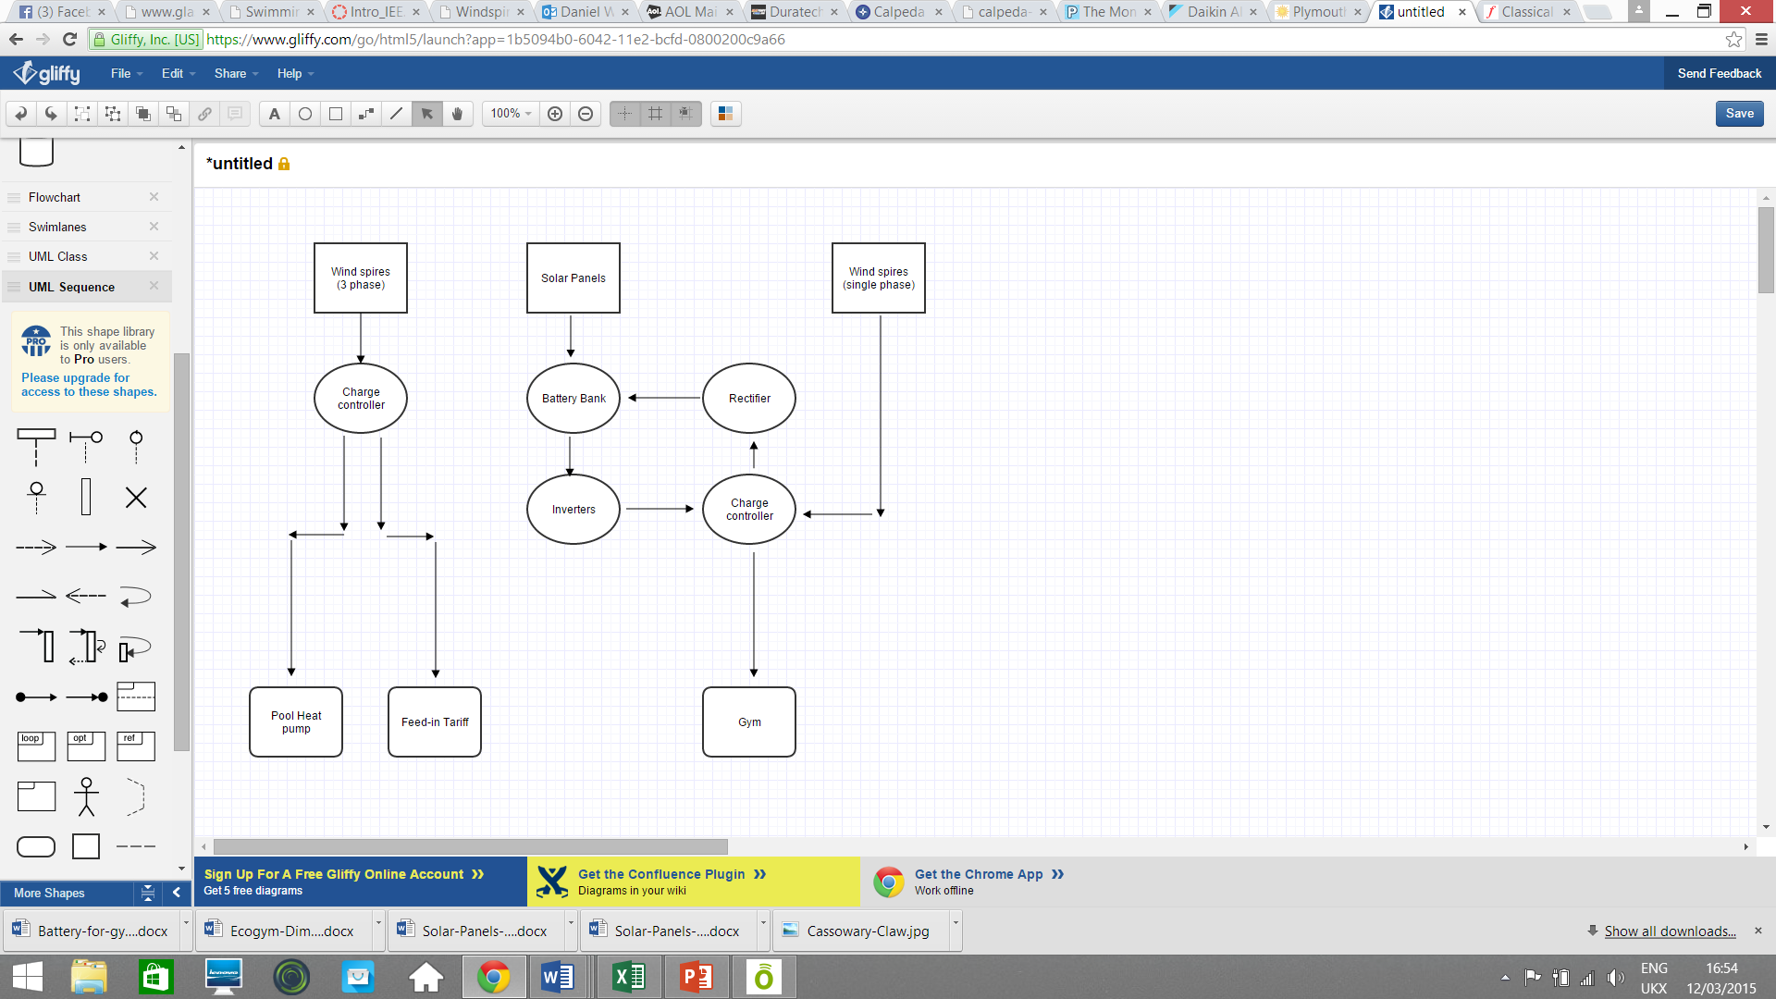The insolation figures for Plymouth are encouraging and affirm that solar power would be the best choice to supply the rest of our energy needs. The solar panel array will be on the roof of the building at the tilt stated previously. The mixture of solar and wind energy is ideal as they can compensate for each other at times when one of the systems is not generating at a high enough capacity. The battery bank also has enough storage to be used as a backup when power generation drops to a low enough level. At time when excess energy is being generated, the electricity produced by the three phase wind spires is of correct standard to be sold back to the national grid. The power network for the gym is shown in the flow chart.

**Figure 5- flow chart showing energy network of gym**(Diagram made using gliffy.com)

It is estimated that we would need up to 7 of the 8kW inverters (see APPENDIX for calculation) synchronised in parallel to fulfil the maximum AC electricity demand of the gym and all the associated appliances (50kW). Whilst it was considered to use fewer higher rated inverters it was decided to use with this model to have more units so that were there a failure of a single inverter we would still be able to convert the DC power coming from the batteries using the remaining ones, independently of the malfunction.   
**Please see final page of APPENDIX for diagram showing layout of solar panels and wind spires.**

1. Heating and ventilation

**5.1** Pool area

Ensuring that the pool will be kept at a safe constant temperature of 28degrees Celsius (stated by hse.gov) will be a powerful air source heat pump, the use of heat from the air will reduce the need for electricity that would otherwise be used for conventional immersion pool heaters. The specific model being considered has been recommended through contact with a professional from ‘heatpumps4pools.com’; the ‘Dura+90T’(heatpumps4pools.com,2015). The features as stated by the manufacturer include:  
-High efficiency coefficient of 6 (Ratio of heating provided to electrical energy consumed)  
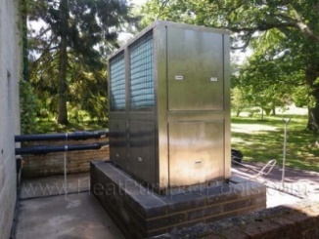-Heat exchanger made of titanium to resist chlorine and salt erosion  
-All seasons’ model, works until -10°C **Figure 6- outdoor unit of**  
-Heating and cooling of the pool water **Dura +90T**  
-Quiet running with low sound scroll compressor, low noise fan  
-Up to four compressors, with cycled defrosting function  
-Stainless steel casing  
(heatpumps4pools, 2015)  
The unit will be installed outside the building and requires power of 15kW. Contact with professional retailer regarding this pump is recorded in APPENDIX. When outside   
temperature drops below freezing for a substantial length of time  
the heat pump will require back up from the boiler via an immersion heater   
implemented in downtime hours.

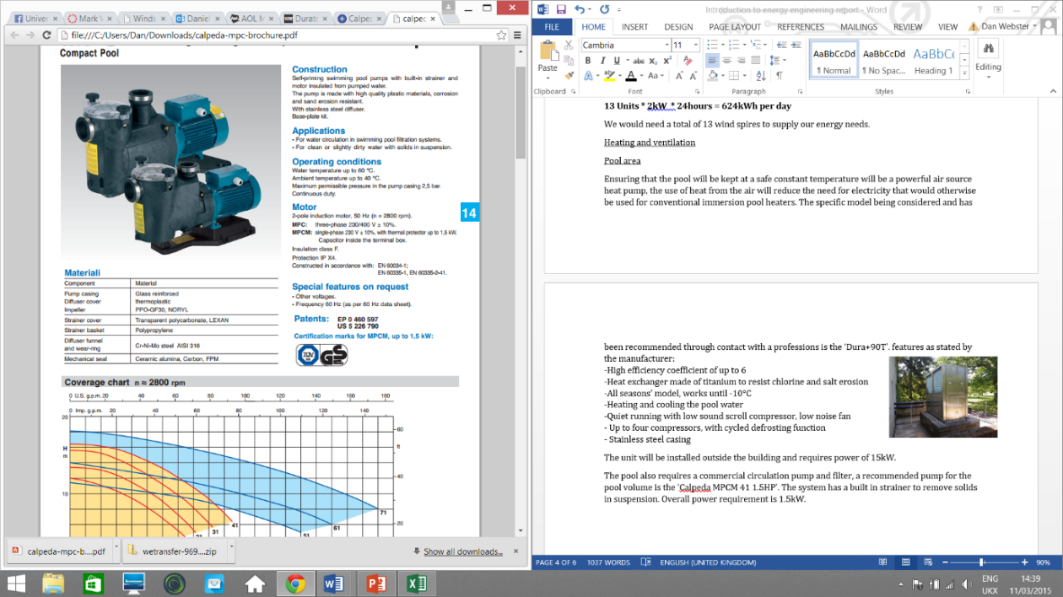The pool also requires a commercial circulation pump and filter, a recommended pump for the pool volume is the ‘Calpeda MPCM 41 1.5HP’ (Anchorpumps,2015). The system has a built in strainer to remove solids in suspension. Overall power requirement for the unit is 1.5kW.

A commercial grade dehumidifier will also be necessary in the area, the  
 ‘monitair 110’ model was selected for this job. Rated at 8.9 kW the unit  
is of the right specification for the gym pool area. Requires no special   
installation, price of £3775 (poolstore.com,2015).

**5.2** Hot water supply for complex **Figure 7- calpeda pump/filter**

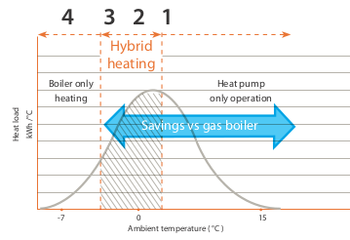A suitable boiler must be chosen to supply the complex with hot water to be used in showers, taps and the café area. The boiler of choice must be sustainably powered in order to maintain the ‘eco-gym’ … whilst delivering a high efficiency and reliability. Research showed that the ‘Daikin Altherma hybrid heat pump’ matched our requirement for hot water needs. The hybrid boiler is named so as it heats the temperate water using a combination of power sources; LPG and an Air source heat pump. The pump automatically selects the most cost effective heating mode at any time of day or night taking into account external temperature, internal heat and hot water demand. The hybrid function transition is shown on the temp/heat load graph below:

The boiler achieves up to 15% greater  
efficiency than standard gas  
condensation boilers. The hybrid  
technology provides certainty of hot  
water of up to 80degrees Celsius (Daikin, 2015).   
The boiler is also eligible for the  
renewable heat incentive   
(discussed in section 6.2).

**Figure 8- Graph to show transition between**

**5.3** Air conditioning **heat pump and LPG**

The air conditioning units to be installed in the gym are the Toshiba KFR-32GW/X1C. Data and specifications from the supplier allow calculation to be conducted to attain the number of integrated units required.  
Technical data:   
Power Rating (Ph-V-Hz) 1, 220-240, 50  
Capacity Max BTU/h of 3.5kW (Cooling) 12000  
Power Input (W) Cooling~Heating) 1000~890  
Current Input (A) Cooling~Heating 4.4~4.0  
(Aircon247.com, 2015) (appendix)

12000 BTU/h can cool up to 500 sq. feet, therefore 3000 sq. feet requires 72000 BTU/h (Energystar.gov, 2015).

Adjustment is made due to the following circumstances:

* + If more than two people occupy the room, add 600 BTUs for each additional person (Energystar.gov, 2015).

72000 + 600*50 = 102000Btu/h

102000/12000:~ 9 Toshiba units needed.

Each unit costs £500.

On average, a 3,000 sq. ft. complete gym can accommodate up to 50 people therefore 9,000 sq.ft. (Approximately 868 sq.m.) is needed to accommodate 150 people, assuming only 10% of the total number of gym members would present in a gym room at the same time (Gymstarters.com, 2014). Hence, 150 people in a large room would require (150/50)*9 = 27 units.

15 units will be installed in the Café and 8 units will be distributed among the reception and other fitness rooms. Approximately 40 units would be installed, therefore the total cost is £500*40 = £20000 including capital and installation costs.

**5.4** Insulation

With energy being generated on site, it is vital that every effort is made to ensure the minimum possible is wasted.

|  |  |  |  |
| --- | --- | --- | --- |
| Type of Insulation | Area (m2) | Price/m2 (£) | Overall Cost (£) |
| Cavity Wall | 1084 | 4.70 | 5095 |
| Roof/Loft | 1283 | 9.00 | 11547 |
| Pool Cover | 350 | 22.80 | 7985 |
| Low-E Glass | 946 | 150 | 141900 |

(Dimensions in table from building plan in APPENDIX)

Cavity wall insulation

Provides further insulation to the walls with a filling of foam. This helps to reduce energy requirements for heating with a low installation cost and typical 5 years payback time for energy savings. (Energysavingtrust.org.uk) **Figure 9- cavity wall illustration**

Loft Insulation (reuk.co.uk, 2015)

Assuming the building acquired has the old standard 120mm of loft wool insulation, a top up to the new standard 270mm would incur significant energy savings and a payback time of 10 years. If the building has no loft insulation, installation of 270mm wool would result in energy savings equivalent to 1.5 years. (Energysavingtrust.org.uk)

Swimming Pool Cover

A cover that can be placed over the surface of the pool whilst not in use can help to reduce evaporation and heat loss, resulting in a less of a need for dehumidification. Covers can be transparent or coloured, transparent would allow for solar penetration, however when weighing the extra cost against heat benefit given the relatively cold location, it is recommended that the cheaper standard blue covers be used. The Thermalux 12mm Heat Retention cover was chosen for its sector leading qualities, with closed cell polyethene foam making it lightweight, resistant to chemicals and bacteria growth and most importantly, highly insulative. The typical payback time for this model is around 1 year. (agbudget.com) (worldofpools.com)

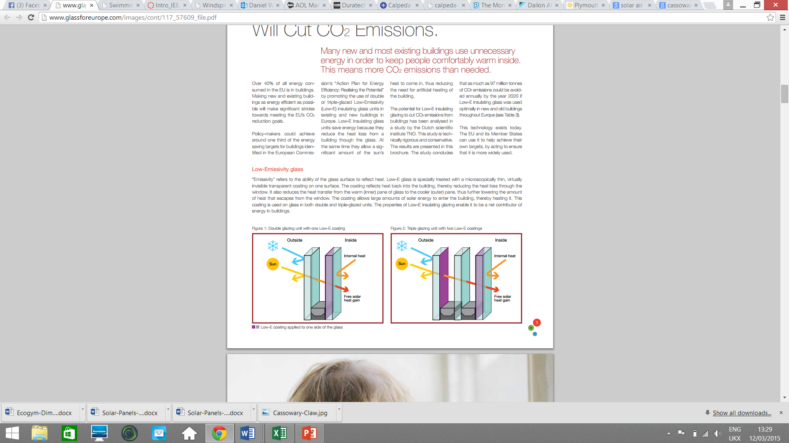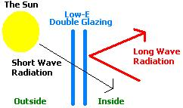Low-Emissivity Double Glazed Windows

Low emissivity glass windows provide heat retaining properties very similar to that of triple glazing. They possess a thin metallic layer on one side, this blocks long wave radiation (Infrared) but allows short wave radiation (UV from the sun) to pass through. In this way low emissivity glass allows rooms to retain their temperature, hence requiring less temperature controlling methods and ultimately requiring less energy. **Figure 10- Low-E glass** (reuk,2015)

Heating and ventilation discussion

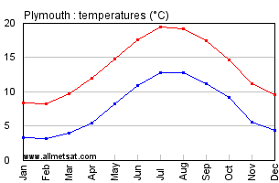The partial reliability on air source heat pumps for the hot water and pool heating is justified for the location as the average temperate in Plymouth is consistent with the operating requirements of the pumps. Figure 11(weatherspark.com, 2015) shows average temperature in **Figure 11- Plymouth**   
Plymouth over a year, this is an indication of how the hybrid ratio   
of the boiler will be set and times when the pool heat pump may need  
backup from the boiler. General heating for the gym building will be   
achieved by underfloor heating with the hot water supplied by the  
hybrid boiler. Under floor heating from the boiler water provides more  
 efficient space heating than radiators as the heating element area is  
 greater than if the heat was supplied through a small area such as a  
 radiator (connectingindustry.com, 2015). Combined with the high grade insulation to be installed in the building, the heating costs will be kept as low as possible whilst the rooms remain at a comfortable temperature for exercise with the integrated air conditioning units.

1. **Feasibility –costing and power**

**6.1** Power consumption calculations and considerations

In order to begin selecting and analysing possible energy solutions for the gym, the total power consumption of the gym building needs to be calculated. This was done by summation of the power consumed per day of all the unit and equipment in the gym, these calculations are presented in the table below:

|  |  |  |  |  |
| --- | --- | --- | --- | --- |
| **Equipment** | **Quantity** | **Total power (kW)** | **Time used per day (hours)** | **Total energy consumed per day (kWh)** |
| **Air conditioning** | 40 | 9.6 | 14 | 134.4 |
| **LED Lamp** | 80 |  | 14 | 44.8 |
| **Vending machine** | 1 | 0.7 | 14 | 9.8 |
| **T.V** | 3 | 0.1 | 14 | 1.4 |
| **Radio** | 1 | 1 | 14 | 14 |
| **Pool heat pump** | 1 | 15 | 20 | 300 |
| **Circulation and filter** | 1 | 1.1 | 20 | 22 |
| **De humidifier** | 1 | 1.75 | 15 | 26.5 |
| **Underfloor heating** | 1 | 7.5 | 14 | 105 |
| **Hand dryer** | 2 | 1.1 | 1.3 | 1.433 |
| **Hybrid heat pump/LPG boiler** | 1 | 8 | 14 | 112 |
| **Shower extractor fan** | 2 | 0.068 | 9 | 0.162 |
| **Coffee machine** | 1 | 2.7 | 1.5 | 4.05 |
| **Panini press** | 1 | 0.2 | 2 | 0.4 |
| **Fridge freezer** | 1 | 0.8 | 24 | 19.2 |
| **Computers** | 2 | 0.8 | 14 | 11.2 |
|  |  | **TOTAL** | **40** | **841.542** |

The total power consumption per day of the gym comes to 841.542kWh. Where possible the equipment was selected on a lower power basis and for this reason calculations for comparison of lifetime power use cost against initial cost of equipment were completed.

**6.2** Total costingsince we are working on the assumption that the client already owns the gym building with pool, the total capital investment of all the equipment needs to be calculated using the final expense list.The costs needed to be invested for the purchase and installation/setup of the gym facilities is shown in the table (breakdown of each section of costs in the table can be found in APPENDIX:

|  |  |
| --- | --- |
| **Equipment** | **Purchase cost (£)** |
| **Solar panels** | 68380 |
| **Inverters** | 48000 |
| **Wind spires** | 78000 |
| **Exercise equipment** | 63400 |
| **Pool running** | 6800 |
| **Heating, ventilation, insulation, lighting and facilities** | 194081 |
| **Furniture** | 7390 |
| **Cafe** | 2890 |
| **TOTAL** | **468941** |

**Figure 13- Table showing costs for gym equipment**

**6.3** Capital

Excess energy we generate can be sold back to the grid at a price of 10p per kWh (fitariffs.co.uk,2015), calculations show (see APPENDIX) we have on average 10950 kWh per year available to sell to the grid.

The government ‘renewable heat incentive’ will provide 7p per kWh (rhincentive.co.uk, 2015) of renewable heat generated, our air source heat pump and hybrid boiler provide on average 129940 kWh of renewable heat per year.

The predicted profit from the café was based on data from existing cafes of similar size and can be estimated to generate generally £10000 per year (smallbuisness.chron, 2014).

The gym membership will be priced at £35 per calendar month and based on the brief the gym will have 1500 members, this will generate income of £630000 per year (£35*12*1500).

This brings the total income each year from the business to be:

**(10950*0.1)+(129940*0.07)+10000+630000 = £650190.80 per year**

**Conclusions and recommendations**

In conclusion, the recommended energy solution for the eco gym consists of wind spires and solar panels supplying the energy for the building at both single and three phase depending on the appliance.

**Figure 14- pie chart to**

**Show energy generation**

**Methods**

Excess energy is stored in a battery bank so that when generation conditions are low the necessary energy can be taken from the storage in order to keep the gym supplied with a constant correct amount of energy. Any surplus energy from this will be sold back to the national grid. The electricity supply is managed automatically by a charge controller to ensure the right amount of power is going to the right place at the correct time. The heating for the building will be supplied by air source heat pumps with an option to switch to LPG fuel when external temperature drops. The high grade insulation and air conditioning systems will ensure a comfortable workout environment at the minimal energy generation expense.

From the previous calculations and figures, it can be concluded that the EcoGym business concept is both technically feasible and profitable for investment from a client.   
Payback time of the gym for the equipment proposed in this report can be calculated:

**Initial investment / profit made in a year = payback time (years)  
468941/ 650190.8 = 0.721 years** This is excluding real estate costs and staff costs.  
If an educated assumption for the real estate and staff costs was £1500000, based on average commercial property price in city centre Plymouth and assumption of 20 staff members on £30000 salary the payback time can be calculated to demonstrate that this investment would be feasible:  
**(302414+1800000) / 650190.8 = 3.49 years** (property price average from rightmove, 2015)Taking into account the reasonable assumptions, this is an appealing and feasible payback time.

Therefore, a summary of the recommendations for a potential client investing in the EcoGym are as follows:

**Self-powered cardio machines;** this will greatly reduce the load on the energy wind and solar generation methods since electrically powered machines would require a large proportion of the energy.

**Wind and solar energy generation;** Calculations have shown this to be a feasible and reliable method for powering the gym with single and three phase electricity, coupled with the charge manager the network will be fully functional and automatic.

**Lead acid battery storage;** this will provide a large amount of storage which can be use as backup when conditions do not favour the methods of energy generation

**Air source heat pumps with hybrid LPG boiler;** with high efficiency coefficient the pool heat pump will generate all the heat required for the large volume of the pool with minimal intake of electricity. The boiler is a reliable option as the work for the heating is shared between the heat pump and LPG fuel, the ration for which will be altered to attain the most economical supply of heat

**High grade insulation and low-E glass;** will ensure that heat warmth is minimalized and thus energy throughout the complex will be consumed as efficiently as possible.

This report has concluded that investment in this gym concept will be ultimately profitable and the energy solutions are proven by calculation and analysis to be feasible to ensure that the gym can function totally independent of grid energy.

**Referances**

Google trends (2015), annual trends in gym membership for 2014, [online] available from: <https://www.google.co.uk/trends/explore#q=gym%20membership> [date accessed: 01/03/2015]

Maha and Haji (2010), Human power generation in fitness facilities, university of California, 4th international conference on energy sustainability

Windspireenergy, windspire 4.0kW specifications, [online] available from: <http://www.windspireenergy.com/> [date accessed: 03/03/2015]

Boxwell, M. (2012). *Solar Electricity Handbook 2012 Edition*. 6th ed. [ebook] Ryton on Dunsmore: Greenstream, pp.42-45. Available at: <https://books.google.co.uk/books?id=C9a1Mse_1-kC&pg=PA41&lpg=PA41&dq=how+much+electricity+can+I+expect+from+irradiance&source=bl&ots=LHravXdkuC&sig=fZNHXpN86QEJJZl8PEWWIrYrohQ&hl=en&sa=X&ei=z7TvVOC_D4GtPeu7gJgL&ved=0CDwQ6AEwBQ#v=onepage&q=how%20much%20electricity%20can%20I%20expect%20from%20irradiance&f=false> [Accessed 11 Mar. 2015].

Latlong.net, (n.d.). *Plymouth, UK Map Lat Long Coordinates*. [online] Available at: <http://www.latlong.net/place/plymouth-uk-828.html> [Accessed 11 Mar. 2015].

3tier.com, (n.d.). *What are the units of irradiance? :: Solar Prospecting Tools FAQ :: Support :: 3TIER*. [online] Available at: <http://www.3tier.com/en/support/solar-prospecting-tools/what-are-units-solar-irradiance/> [Accessed 11 Mar. 2015].

Solar Electricity Handbook, (2015). *Solar Irradiance Calculator*. [online] Available at: <http://solarelectricityhandbook.com/solar-irradiance.html> [Accessed 11 Mar. 2015].

Photovoltaic-software.com, (n.d.). *How to calculate the output energy or power of a solarphotovoltaic system, Excel PV calculator to estimate solar electricity output*. [online] Available at: <http://photovoltaic-software.com/PV-solar-energy-calculation.php> [Accessed 12 Mar. 2015].

Buypvdirect.co.uk, (n.d.). *Eco Future 250w Mono All Black*. [online] Available at: <http://www.buypvdirect.co.uk/PV_Panels/Eco-Future/ECO-250-C60> [Accessed 12 Mar. 2015].

Pavegen Systems Ltd. (n.d.). Projects and Case Studies. Retrieved March 11, 2015, from <http://www.pavegen.com/projects>

Outback Power Inc. (2014). FLEXmax 60/80. Retrieved March 11, 2015, from <http://www.outbackpower.com/outback-products/charge-controllers/item/flexmax-6080?category_id=438>

Northern Arizona Wind & Sun. (2015). What is Maximum Power Point Tracking (MPPT). Retrieved March 11, 2015, from <http://www.solar-electric.com/mppt-solar-charge-controllers.html/>

Outback Power Inc. (2014, February). Radian Series Inverter/Charger Instruction Manual. Retrieved March 11, 2015, from [http://pdf.wholesalesolar.com/inverter pdf folder/GS8048-4084A-install.pdf](http://pdf.wholesalesolar.com/inverter%20pdf%20folder/GS8048-4084A-install.pdf)

Weatherspark (2014), Average weather for plymouth-UK, [online] avaiable from:https://weatherspark.com/averages/28715/Plymouth-England-United-Kingdom [accessed 08/03/2015]

Gliffy.com (2015) Flowchart creator [online] available from: [www.gliffy.com](http://www.gliffy.com) [date accessed 24/02/2015]

Heatpumps4pools (2015), Dura +90T specifications [online] available from:http://www.heatpumps4pools.com/Duratech-Commercial/Duratech-Commercial-Swimming-Pool-Heat-Pump-Heaters [date accessed 01/03/2015]

Anchorpumps.com (2015), calpeda pool pumps, [online] availabe from: <http://www.anchorpumps.com/calpeda-mpcm-41-1-5hp-compact-pool-pump-240v> [date accessed: 04/03/2015]

Poolstore.com (2015), monitair 110, [online] available from:http://poolstore.co.uk/product/dehumidifiers/the-monitair-75-and-110-range [date accessed:05/032015]

Aircon247.com, (2015). *TOSHIBA compressor KFR-32GW/X1c 3.5kw Air Conditioning.* [online] Available at: <http://www.aircon247.com/p/554960/toshiba-compressor-kfr-32gwx1c-35kw-air-conditioning-centre-4m-easy-install-wall-mounted-air-conditioning-system.html> [Accessed 10 Mar. 2015].

Energystar.gov, (2015). *Properly Sized Room AC : ENERGY STAR*. [online] Available at: <http://www.energystar.gov/index.cfm?c=roomac.pr_properly_sized> [Accessed 10 Mar. 2015].

Gymstarters.com, (2014). *3000 Square Foot Room*. [online] Available at: <http://www.gymstarters.com/gym-equipment-packages-based-on-square-footage/3000-square-foot-room/> [Accessed 10 Mar. 2015].

Solar Systems, (2013). *Hybrid Solar Air Conditioner - Solar Systems*. [online] Available at: <http://solar.upstime.com/hybrid-solar-air-conditioner/> [Accessed 10 Mar. 2015].

Energy saving trust (2015), Insulation, [online] avaiable from:http://www.energysavingtrust.org.uk/domestic/content/home-insulation [date accessed: 26/02/2015]

Worlds of pools (2015), Thermalux insulative pool cover, [online] available from:http://www.worldofpools.com/certikin-heat-retention-cover-thermalux-6mm-foam-details.htm [dae accessed: 15/03/2015]

Reuk (2015), Cavity wall insulation and low-E glass, [online] available from:http://www.reuk.co.uk/Cavity-Wall-Insulation.htm [date accessed:17/03/2015] and <http://www.reuk.co.uk/Low-E-Double-Glazing.htm> [date accessed:17/03/2015]

Connectngindustry.com (2015), Energy managemant, [online] available from: <http://www.connectingindustry.com/energymanagement/underfloor-heating-vs-radiators-everything-you-need-to-know.aspx> [date accessed: 18/03/2015]

Smallbuisness.chron (2014), yearly profit of small cafe [online], available from:http://smallbusiness.chron.com/average-profits-small-cafe-30768.html [date accessed: 28/03/2015]

Fitariffs.co.uk (2015), Feed in tariff levels, [online] available from: <http://www.fitariffs.co.uk/eligible/levels/> [date accessed: 02/03/2015]

Rhincentive.co.uk (2015), Renewable heat incentive levels, [online] available from:http://www.rhincentive.co.uk/ [date accessed: 06/03/2015)

Rightmove (2015), commercial property in city centre plymouth, [online] available from:http://www.rightmove.co.uk/commercial-property-for-sale/Plymouth.html [date accessed:06/03/2015]

Windandsun.com (2015), rolls battery bank, [online] available from: <http://www.windandsun.co.uk/products/Batteries/Rolls-Batteries#.VQdj_I7kctc> [date accessed: 25/03/2015]

1. **Appendix**

Table showing inverter data

|  |  |  |  |
| --- | --- | --- | --- |
| **Total Energy Requirement** | 50kW |  |  |
| **Component** | **Component Power** | **No. of Modules** | **System Power** |
| OutBack Power Flexmax 80 Charge Controller | 4kW | 14 | 56kW |
| Rolls Battery Bank S550 (24 Batteries) | 61kW | 2 | 122kW |
| OutBack Power GS8048A Inverter | 8kW | 7 | 56kW |

Emails exchanged with heat pump professional





Eco-Gym Layout and Dimensions

This section describes the layout, with their dimensions, of each part of the building (see the title page for the model as a whole).

**Gym**

Layout of Bottom Floor

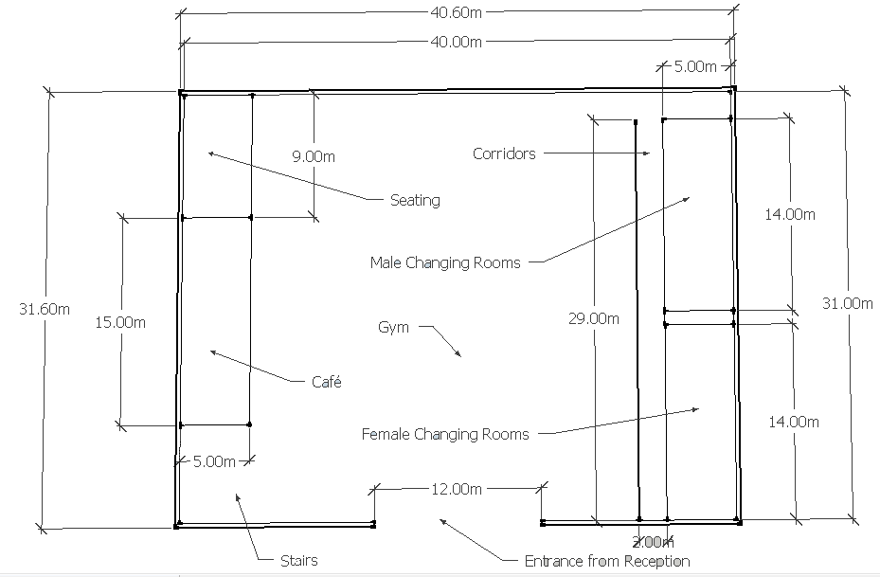

Layout of Top Floor

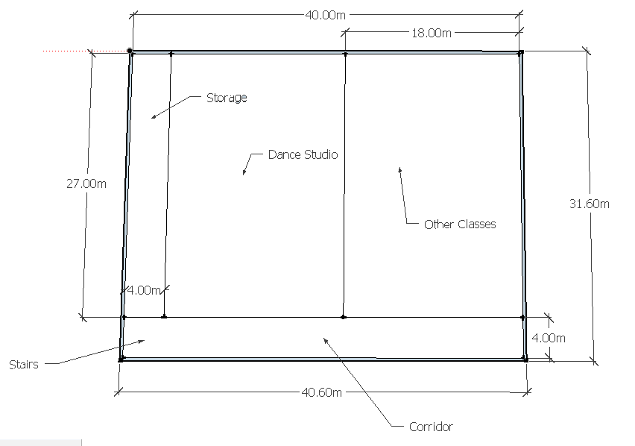

Front View

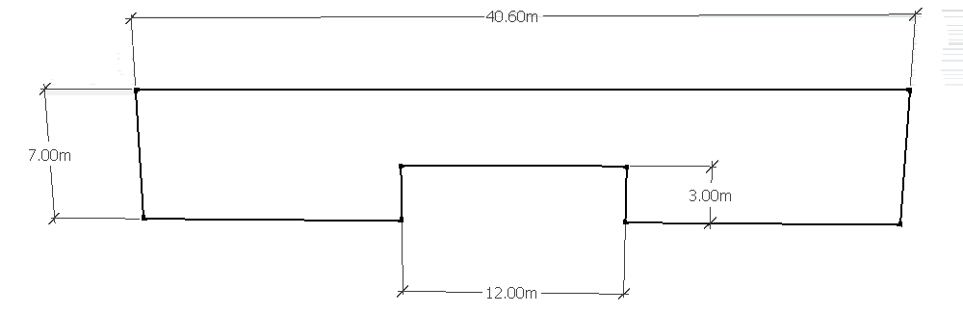

Back View

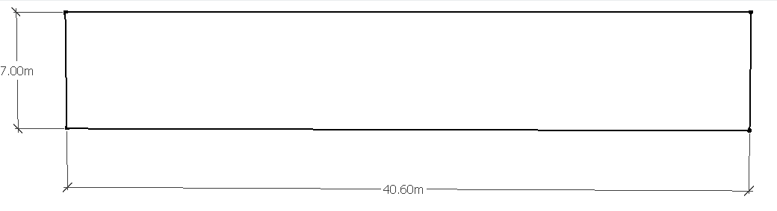Side View

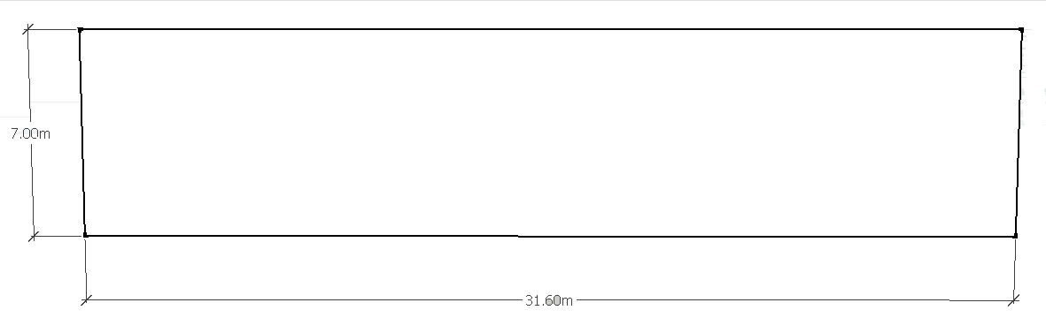

**Reception**

Front View

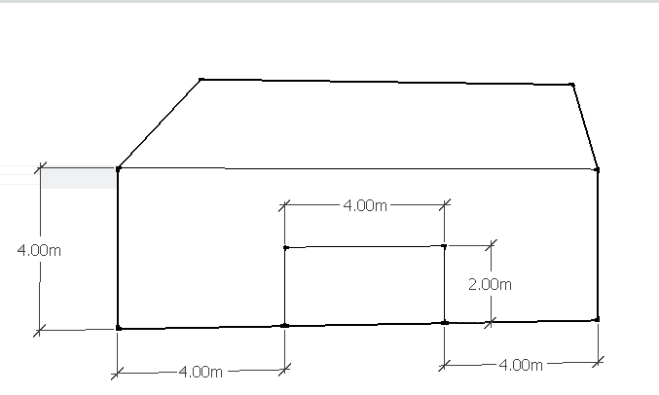

Side View

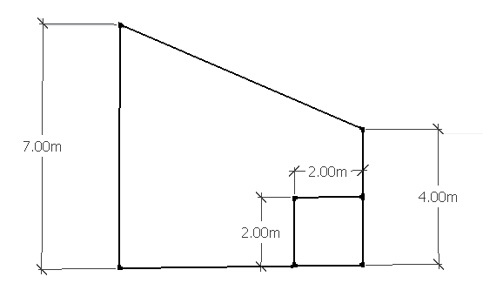

**Swimming Pool Room**

Front View

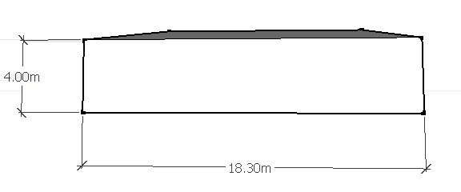

Side View

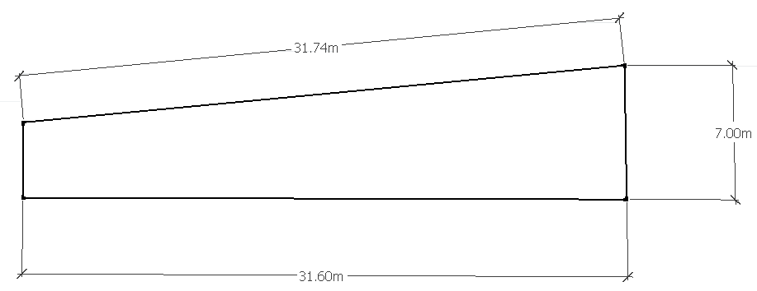Top View

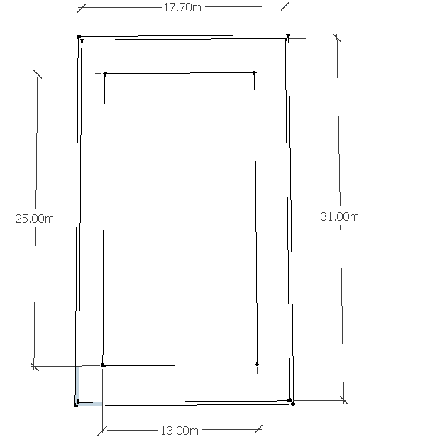

Swimming Pool Side Dimensions

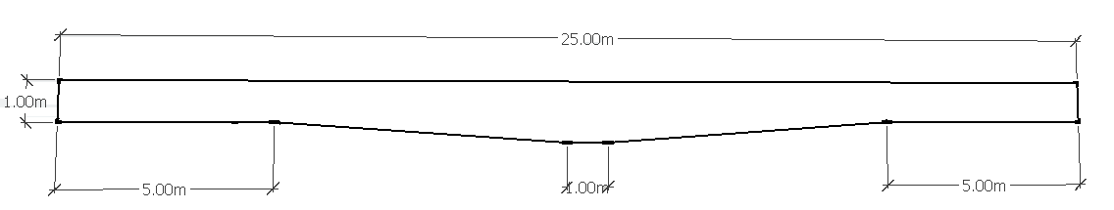

Calculation for excess energy per year

(Energy generated per day-energy used per day)*days in a year

= (871kwh-841kwh)*365=10950

Master spreadsheet for total power generation, use and total cost

Correction-insulation final cost=£166527





Rendered design of gym building



(James Lane University of Birmingham group 7, 2015)