Eco-Campsite
Energy Engineering
Group 1
Lewis Coulter, Liam Hargrave-Gibson, Musa Abbas,
Siti Nur Syahmina Zaini and Abdulla Alajmi
University of Birmingham
Semester 2 2015

Executive Summary.
The aim of this project was to ascertain the feasibility, from a technical and economical perspective, of setting up an off grid energy system for a campsite. In order to do this the energy consumption and power requirement of the campsite was considered, a suitable energy system with storage was selected (whilst considering how the system could be controlled) and then the financial implications of this system were examined. It was concluded that although this system was feasible in the long term, it would take approximately 8 years for the system to pay for itself, past that point the system would be making a profit. So although the off grid energy system is feasible overall, from a purely financial perspective it would be recommended to have the same energy system on the grid, without the electrical storage, and benefit from feed-in tariffs for significantly larger profit.
Table of Contents
1.Introduction 2
2. Method 2
2.1 Finding the Population of the Campsite 2
2.2 Electrical Consumption of the Campsite 3
2.3 Differences Between the Maximum and Average Capacity 3
2.4 Campsite Water Consumption 3
2.5 Energy Needed to Heat the Water 4
2.6 Heating the Water 4
2.7 Electrical Power Requirements 4
2.8 Typical Power Output of Solar Panels 5
2.9 Typical Power Output of Wind Turbine 6
2.10 Heat Storage System 6
2.11 Electrical Storage System 6
3. Results 7
3.1 Summary 7
4. Technical Feasibility 7
4.1 Electrical Energy System: Combined Wind and Solar 7
4.1.1 Two-in-One Charge Controller 8
4.1.2 Monitoring 8
4.2 Thermal Energy System: Biomass Boiler 8
4.2.1 Buffer Tank Sensors 8
4.2.2 Monitoring 9
5. Economic Feasibility 9
5.1 Biomass 9
5.2 Electrical 9
5.3 Storage System 10
5.4 Comparison to Cost of On Grid 10
5.5 Overall Economic Feasibility 10
5.6 ‘Break-even’ 10

6. Conclusion 11
7. Reference List 12
8.Appendices 15
Appendix A. 15
Appendix B 16
Appendix C 16
Appendix D 17
Appendix E 18
Appendix F 18

1. Introduction
Going off the grid would offer energy independence, there would be no grid outages, and it will not be subject to the policies or terms of the local utility company, and the system owners would not worry about rate increases, brownouts, or blackouts, but conserving energy will need to be kept in mind. The task given was to provide a campsite with an off grid energy system, meaning there is no connection to the national grid. The campsite will occupy a 12-acre site and will have a space big enough for 200 tent pitches as well as 12 hard standing areas for caravans with an electrical hook-up. It would also have a facilities block that includes hot showers; washers, dryers, a large freezer, and sinks with hot water. Additionally, it would benefit from a private chalet for the camp proprietors with domestic heating, lighting and cooking facilities. A heated swimming pool for the children that will be available in the summer and a clubhouse facility; including arcade machines, a bar and a small restaurant. Despite all the advantages of having an off grid energy system there are many challenges needed to be overcome, the challenges the group will address are:
- Calculation of energy and power demand
- Selection of suitable renewable energy sources
- Selection of an efficient storage system
- Ensuring there is a suitable control and monitoring system
- Judging whether the chosen system is economically feasible.
The group arrived at a plan for the 12-acre site, which is seen in Figure 1 below. It was decided this campsite would be placed in Cornwall, as for a U.K. location; it has the optimum balance of wind speed and solar radiation.
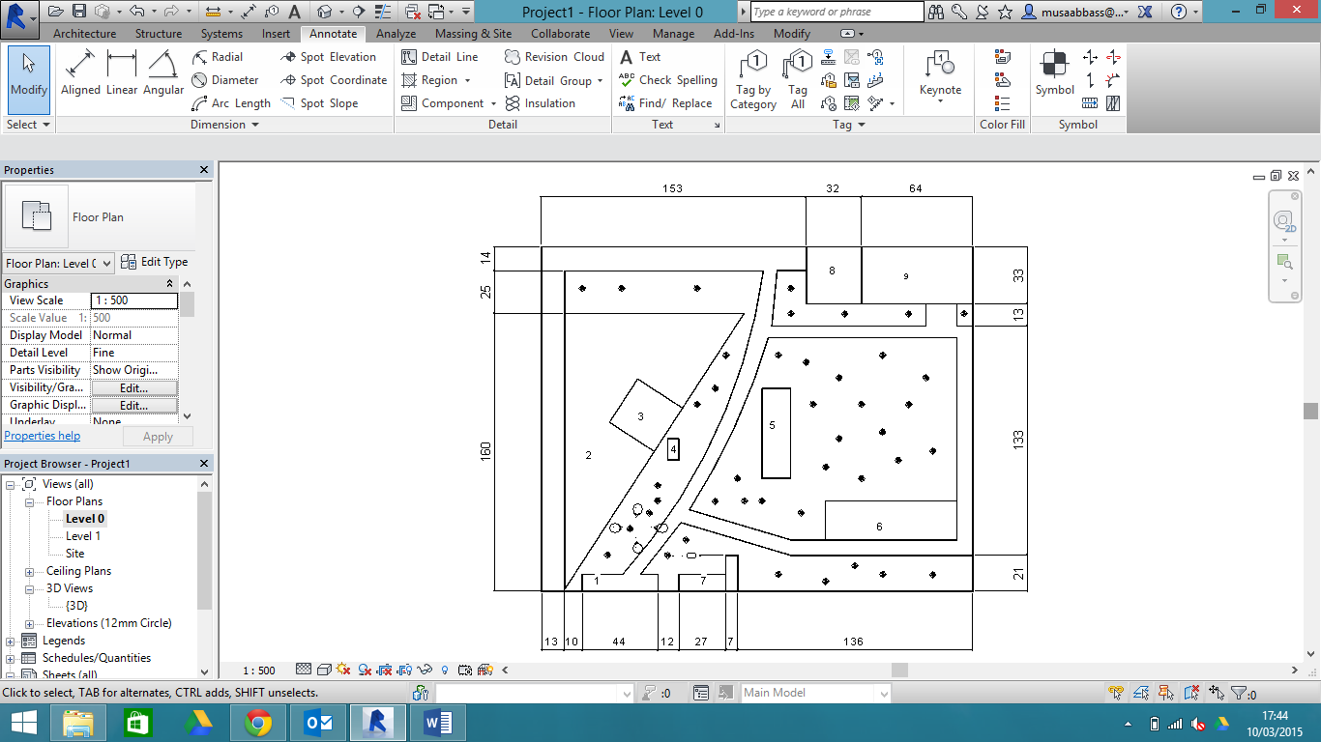
Notes - All dimensions in metres
1: Entrance & road
2: Tents site
3: Games room and bar
4: Children’s swimming pool
5: Facilities block
6: Caravan parking bay
7: Private chalet
8: Wind turbines and solar panels
9: Biomass boiler, energy storage system and central control systems

Figure 1: Camp Layout
2. Method
2.1 Finding the Population of the Campsite
As mentioned before it was known that the campsite had a capacity to hold 12 caravans as well as 200 tents. It was essential that the campsite could provide energy for the most demanding period conceivably possible, where the campsite would be at full capacity. For this it was assumed that there would be 4 people per tent or caravan at maximum capacity. However, it would be unlikely the campsite would ever have a capacity this large and so the average capacity was calculated. It was estimated that it would more likely be 65% of the maximum capacity, 550 people with 3 people per tent/caravan and so 183 groups of guests at the campsite. There will be proportionally less caravans at average capacity ~65% max caravan capacity (8) as opposed to tents ~88% max tent capacity (175).
2.2 Electrical Consumption of the Campsite
The campsite had 6 washing machines, 6 tumble dryers, a large freezer, 5 arcade machines, a 27 m² children’s swimming pool and a private chalet for the camp proprietors, exact figures for each can be found in appendix A. It was assumed that every group of guests used the washing and drying machines once a week, from this it is was possible to calculate the average washing machine or tumble dryer usage per day per machine.
$$kWh per day per machine=\left( \frac{No. of groups}{No. of days staying*No. of machines}\right)*appliance consumption$$
It is important to note the number of uses of machine per day values is rounded (the brackets of the equation above), for maximum capacity this was 5 and for average capacity this was 4 and it was assumed the length of stay was 7 days. The energy consumption per machine per day was finally multiplied by the number of machines we had (6) to give the total energy consumption for the utility per day. It was assumed that the private chalet would have the same energy consumption as the average annual UK household, and so the consumption per day was
$kWh per day=4192/365=11.5$ (Department of Energy & Climate Change, 2014).
For the restaurant the appliance power consumptions were looked up for a large freezer, a fridge, LED lighting, a microwave, a grill and an oven. Assumptions were then made for how long each appliance would be used for per day. The campsite also had a large freezer for the campers, this was assumed to be running for 24 hours a day. Both these figures can be found in appendix A.
The campsite had a games room that would have a selection of arcade machines. The energy consumption per day was found for a quiz machine, an arcade machine and a fruit machine an average for all the machines was made then multiplied by the number of machines at the campsite.
It was assumed that every caravan was fitted with: a domestic kettle, an iron, a microwave, an LCD TV, a refrigerator, a hair dryer, a domestic fan heater and LED lights. For specific values for the caravan see Appendix B.
Overall, it is expected that at average campsite capacity, the electrical energy consumption will be 233 kWh and that at maximum capacity it will be 280 kWh.
2.3 Differences Between the Maximum and Average Capacity
The only difference in the energy consumption between the maximum capacity and the average capacity, is that there would be more uses of the washing machines and tumble dryers at maximum capacity, 5 uses per machine per day as opposed to 4 at average. There would also be 4 more caravans at maximum capacity.
2.4 Campsite Water Consumption
For the water consumption it was realised there would be two main consumers of water: hot showers and full sinks used for washing up. It was assumed on average 2 gallons of hot water are used when washing up and that every group of campers or people caravanning washed up once a day. The campsite will have a token system, whereby every guest will be entitled to a 4 minute shower a day. It was assumed every guest at the campsite had one shower a day and it was also assumed that the water would be heated from room temperature 23°C. It was decided, from online research, that 45°C would be an ideal temperature to heat the water to, as it is hot enough to kill pathogens, but cold enough not to scald the users. (lifehacker, 2013).
2.5 Energy Needed to Heat the Water
Using:
$$m=ρV (1)$$
Where m is the mass of water (kg), ρ is the density of water (1000kg m⁻³) and V is the volume of water (m³). This can be used to work out the mass of water and then used in:
$$q=mc∆T (2)$$
Where q is the heat transferred (Joule), m is the mass of water (kg); c is the specific heat capacity of water (4.181 kJ/(kg °C)) (BBC, 2014) and ΔT is the change in temperature (°C). This is used to work out the amount of energy needed to heat water from 23 °C Celsius to 45 °C.
$$q=19263.9*4.181*\left(45-23\right)=1771.929 MJ (3)$$2.6 $Heating the Water$
It was decided early on in the process that the water was going to be heated by a biomass boiler, but the required size of the boiler was unknown. Using the energy needed to heat the water as seen in equation 3 and converting it into kilowatt-hours, it is possible to work out the size of the boiler needed.
$$Total kWh per day= \frac{kJ}{day (in seconds)}*24 \left(hours\right)=492.2 kWh (4)$$
It was decided that the biomass boiler for 18 hours, from 06:00-00:00, and so the size of the biomass boiler can be calculated by:
$$kW=\frac{kWh}{Number of hours used for}=\frac{492.2}{18}=27.34 kW$$
As 27kW boilers aren’t sold and so that the campsite could cope better with peak demand as well as with populations greater than 550 people it was decided a 30kW Guntamatic Biocom wood pellet boiler would be used.
2.7 Electrical Power Requirement
When the campsite is occupied at average capacity, assuming little electrical energy is used between 23:00 and 6:00, so taking 10 kWh off the 233 kWh needed in the day (to be used on lighting etc.). This 223kWh can then be divided by the 17 hours that is being considered in order to see what the ‘average’ power requirement would be.
$$\frac{223}{17}=13.11 kW$$
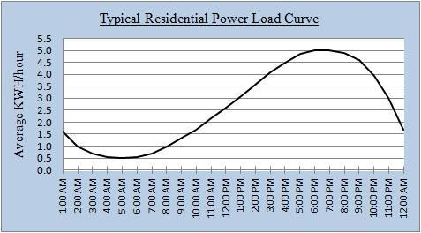
Figure 2: typical residential power load curve
Using this typical residential power load curve (Figure 2). (Miller, J. 2013). It can be seen there is a peak between the hours of 6 and 8 p.m. and it is 2.5 times as great as the average, assuming this holds true for this campsite the peak power requirement will be:
$$2.5\left(32.11\right)=32.78 kW$$
Using the same theory for maximum capacity, average power requirement is:
$$\frac{270}{17}=15.88 kW$$
And peak power demand at maximum capacity is:
$$2.5\left(15.88\right)=39.7 kW$$
It was decided a combination of solar panels and wind turbines would be employed in order to attempt to meet this power demand.
2.8 Typical Power Output of Solar Panels
Results for the expected generation of the solar panels were found using an online solar panel calculator, this works by entering a postcode for where the campsite is expected to be placed, as well as the area of land over which the solar panels will be placed. Then the solar profiles for that particular area are used to calculate how much energy the solar panels will produce over the course of a particular year (Solarguide, [n.d.]). It was decided that a 60 kWp system consisting of 240 Canadian Solar 250W Mono solar panels would be employed. By entering the post code of where the campsite is expected to be based the following graph was obtained (Figure 3), the figure of generation for each month can be divided by the days of that particular month to get an average daily generation value. This was done for the months of June, July and August (when the electrical demand will be greatest) and an average daily value for these three months was found to be 227.35 kWh per day. Should the system be implemented it is essential that the solar panels face south.
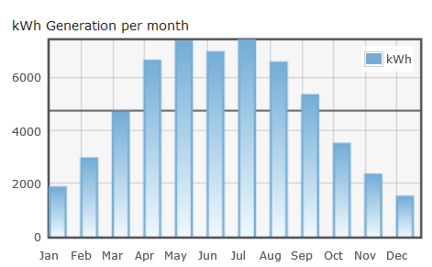
Figure 3: Expected electricity generation of 60-kWp system. (Solarguide, [n.d.])
Taking the 227.35 kWh of electricity being produced and dividing it by the 16 hours of daylight expected on a British summer day, the average power output of the solar panels can be found (Barrow, M. [n.d.]):
$$\frac{227.35}{16}=14.2 kW$$
2.9 Typical Power Output of Wind Turbine
For calculating the electrical energy production of the wind turbines another online calculator was implemented, the postcode for the campsite was inputted and an average wind speed for that particular area is quoted. The average wind speed where the campsite is based is 6 ms⁻¹ (Aeolus Power Wind Energy, [n.d.]). The wind turbine that has been selected is the Westwind 20 kW. From the brochure it can be quoted that at an average wind speed of 6 ms⁻¹ the Westwind 20 kW will produce 43,435 kWh on an annual basis. (VGenergy, [n.d.]). So the average daily production of electricity will be approximately:
$$\frac{43,435}{365}=119 kWh$$
And dividing this by the 24 hours in a day the expected power output is:
$$\frac{119}{24}=5 kW$$
So in conjunction these two systems should be able to meet the ‘average’ power requirement of the campsite. However, at times there will be insufficient energy production to meet the demand. Therefore, there must be a storage system which can adapt to fluctuations in demand.
2.10 The Heat Storage System
For the heat storage system, a buffer tank for the biomass boiler was chosen to store a large volume of hot water in a well-insulated vessel to reduce any heat loss. (Blakemoreandchell.co.uk, 2015). The benefits of having a buffer tank in conjunction with a biomass boiler is that heat is stored so the boiler can be run at a convenient time, and the heating and hot water can be timed independently with a timer/programmer when it is required. This means that the boiler doesn’t need to be fired up for small demand of hot water instead the hot water can be taken directly from the buffer tank.
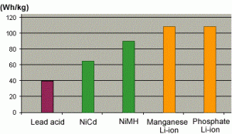
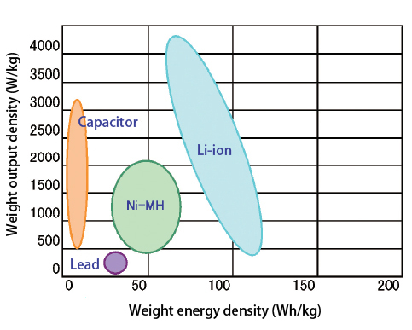
2.11 The Electrical Storage System
Figure 5 (Utility Free Living, 2014)
Figure 4 (E2af.com, 2015)
One of the most convenient ways of storing electrical energy is by using large lithium ion battery packs. This is because the energy density of a lithium-ion battery is normally two times that of the standard nickel-cadmium battery therefore there is potential for higher energy output per kilogram as shown in figure 4. Also the load characteristics are similar to nickel-cadmium in terms of discharge (Batteryuniversity.com, 2015) Lithium ion batteries have a low maintenance and hence have a longer battery life.
Solar hydrogen production and storage was considered. This uses hydrogen in combination with oxygen to produce an electrical current in a hydrogen fuel cell which is useful because most solar power systems cannot produce adequate energy consistently due to intermittency. An intelligent solution to this problem is to use a device that is able to store energy in the form of hydrogen. For this one of the best methods of producing hydrogen is through a photoelectrochemical (PEC) water-splitting process where solar energy is used to split water molecules into hydrogen and oxygen through a process called hydrogen evolution reaction (Theengineer.co.uk, 2014). By considering the advantages and disadvantages it can be shown that this system is just not feasible either technically or economically on such a small scale, as this type of technology is still being developed and is not yet commercially available.
During the evening where the energy production of the solar panels or wind turbine generator is lower, the campsite will need a reliable back-up source which will be able to handle the difference between the maximum demand of the campsite and the minimum output of renewables which is approximately 120 kWh a day. Subsequently, the battery system required must be able to store 120kWh of electrical energy. As figure 5 shows that a lithium ion battery has the highest watt-hours per kilogram of battery making it the most feasible for the electrical storage system. Calculations for the cost of the battery system are found in appendix C.
3. Results
3.1 Summary
Table 1 highlighting the key values that were calculated for the campsite
Energy aspect at average capacity | Key values
Population (average) | 550
Electrical consumption (average) | 233 kWh
Energy needed to heat water | 492.2 kWh
Daily energy generation from solar | 227.35 kWh
Average solar power output | 14.2 kW
Daily energy generation from wind | 119 kWh
Average wind power output | 5kW
Peak power requirement | 32.78 kW
Average power output requirement | 13.11 kW
Battery storage | 120 kWh
4. Technical Feasibility
After deciding on the energy sources, further consideration was taken on the design of a suitable control and monitoring system. This is crucial because unlike using electricity from the grid, extra installations are required. Plus an efficient design leads to efficient performance resulting in reduced power cost. When considering the economics it is assumed any installation costs also include the monitoring system in them. The following will ensure the technical feasibility of the off-grid system whilst delivering a convenient and user-friendly system for the client:

4.1 Electrical Energy System: Combined Wind and Solar
Figure 6, below, shows the main components of the electrical energy system. According to ENERGY.GOV, a typical balance-of-system equipment for off-grid includes batteries, charge controller, power conditioning equipment, safety equipment, meters and instrumentation. (Energy.gov, 2012). More details on the core functions of the components can be found in appendix D. The electrical system will power all electrical appliances in the campsite.

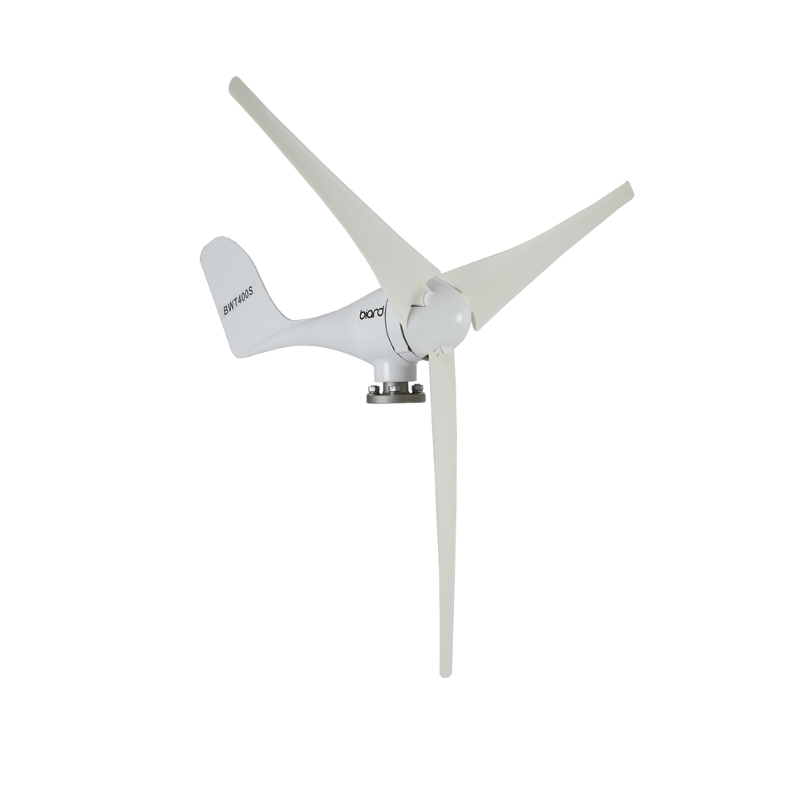
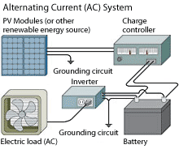

Figure 6(after Energy.gov, 2012)

4.1.1 Two-in-One Charge Controller
One of the drawbacks of having two different electrical energy sources in the campsite is the complication of having a number of different systems. Typically, wind and solar energy sources have two different control systems, displays and set points, which can be a messy, set up. This is why it is more convenient to use Solar Boost 3024iL Duo charge controller, which can control both the solar panels and the wind turbine so the batteries are charged from multiple power sources. It has relatively cheap installation and effective battery charging. More background of this charge controller can be found in appendix E.

4.1.2 Monitoring
Smart Gauge battery monitor is one user-friendly metre, which is simple to install, and has a highly accurate ‘state of charge’ meter. It displays charge status in percentage, has programmable alarm functions and a user friendly interface to the battery banks split charge control system (Smartgauge, 2009).

More conveniently, clients can opt for wired remote or iPad control and monitoring. The main display will show power house loads, battery state of charging/discharging, battery capacity and input power from sources. This helps the client to keep track of all the elements (Energy Solutions, 2012).

4.2 Thermal Energy System: Biomass Boiler
A suitable control system for biomass is important to ensure that heat is moved efficiently to the point of use when required. The main components include a 3 tonne domestic pellet hopper, Guntamatic Biocom 30kW biomass boiler, 1500 litres Cordivari buffer tanks, pumps, loads and Guntamatic Biocom control panel. It will mainly heat up the showers and sinks.
The control of biomass is determined by three factors. Firstly, the buffer tank, either it is charged or discharged; secondly, the thermostat and the associated timer and thirdly the hot water usage. (Renewableenergyhub.co.uk, 2015).

4.2.1 Buffer Tank Sensors
The buffer vessel sensors primarily decide when the biomass boiler is switched on and off after the timer and room thermostat have asked for heating. There can be one of two main setups for this. First option is simply: a ‘top’ (boiler start) sensor and ‘bottom’ (boiler stop) sensor in the buffer vessel. The second option is the progressive control shown in figure 2 in which multiple sensors can monitor the state of the thermal store buffer vessel as it charges and discharges.

The problem with the first option is that at daily start-up, the tank is emptied and the following heat is supplied by the boiler at the time it is heated up. Option 2 was selected, where the system is aware of the state of discharge of the thermal store and will fire the boiler when it knows there is enough time for it to get up to temperature before the buffer vessel fully discharges (Renewableenergyhub.co.uk, 2015).

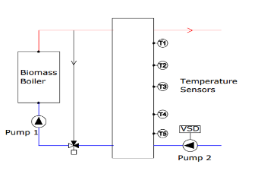
Sinks and showers

Figure 7(after Palmer, 2010)

4.2.2 Monitoring
The Guntamatic Biomass boiler comes with a touch screen control panel that features displays of combustion efficiency, boiler output and temperature. It also assists with fault diagnosis and maintenance. The control panel tells the client when the grate needs cleaning, when the ash bin needs emptying and monitors the temperature in the tank. Optionally, the client may also opt for Treco’s remote monitoring system which is a remote web access to live information from any PCs at any moment, as long as they have internet and password access. Moreover, data is downloadable, which means that the data can be exported and used for analysis of the performance of the biomass boiler. It can also give an indication of the amount of fuel used and generate refuel alert, greenhouse gas savings and an estimation of the RHI income earned. (Treco, 2015).
5. Economic Feasibility
5.1 Biomass
The price of the wood pellet chips needed for the biomass boiler is around 4.5p per kilowatt-hour of thermal energy, however taking into account the inefficiency of the boiler this increases to 5.4p per kilowatt-hour of thermal energy. It was decided that the campsite would be delivered 3 tonnes of wood pellet chips every 3 weeks for £660; this figure takes into account delivery costs (Forrest Fuels, 2013). The biomass boiler is eligible for a non-domestic Renewable Heat Incentive tariff of 6.8p per kilowatt-hour of thermal energy; greater than the corresponding price of the wood pellets (Ofgem, 2015). This means that the Renewable Heat Incentive can pay for the wood pellet fuel and at average capacity the campsite will actually make a profit of £6.89 per day. The boiler will need to be visually inspected each week, as well as a check-up each month however these can be carried out by staff of the campsite. The boiler will need to be externally serviced annually for around £750 (Treco, 2014). The boiler itself costs £17,500 to install and the accompanying 3 tonne wood pellet storage unit costs £1,300 (Treco, 2014; GET-Direct, 2013)
5.2 Electrical
Solar panels:
A typical initial outlay for purchasing and installing a 60 kWp system varies around the value of £70,000 (Solarguide, [n.d.]). The cost of maintenance for the solar panel system is typically quite small, it is assumed a member of staff on the campsite (for example a groundskeeper) would be able to clean the solar panels regularly. So analysing the typical annual costs of solar panel maintenance it is assumed that this particular system would cost roughly £450 annually, despite the size of the system as a third party cleaner would not be necessary so only occasional equipment replacements would be required.
Wind turbine:
One recommended installer values the cost, including installation, of the Westwind 20 kW wind turbine at £60,000 + VAT, taking VAT as 20% this means the initial cost would be £72,000. (bettergeneration, [n.d.]). This particular turbine’s brochure quotes the annual maintenance cost of this turbine as £750. (VGenergy, [n.d.]).
Potential for feed-in tariffs:
Feed-in tariffs are only applicable to ‘on grid’ systems, they are a combination of generation tariffs and export tariffs. Generation tariffs are payments from the energy company for every kWh of electricity generated. This rate fluctuates but a newcomer will receive the tariff for 20 years. A solar system of 60 kWp can expect a generation tariff of 10.71 p/kWh and the selected wind turbine can expect a generation tariff of 17.78 p/kWh. Export tariffs are a bonus payment for every kWh of electricity generated, not used and so exported to the grid. The export tariff is currently 4.77 p/kWh. (Hull, R. 2014).
Were the campsite to take a very similar system to that which has been proposed but work on grid instead there would be no need to rely on battery storage, as any difference between demand and generation would be made up by the grid. Also when the campsite is not open, and so not generating revenue from camping, but still generating electricity, it would be able to generate income from these feed-in tariffs.
5.3 Storage Systems
The cost of a LM 1500L - 2 coils - stainless steel buffer tank including the cost of installation is £1338.00 (Buffer-tank.co.uk, 2015).The overall cost for a lithium ion battery storage system with a capacity of 120kwh is approximately £18,488.00 this is justified in appendix C.
5.3 Comparison to Cost of On Grid Energy
The cost of running of running the campsite on grid for the campsite was calculated by multiplying the equivalent kilowatt-hours by the electricity tariff for the campsite 16.43p/kWh (British Gas, 2015). For the showers the kilowatt-hours is calculated by multiplying the energy consumption per use, 0.5kWh, for a 4-minute 7.7 kW shower by the number of uses per day 550 (Sust-it, 2015). The energy needed for the heated sinks is 0.3 kWh the amount needed to heat 2 gallons of water multiplied by the number of groups, 183 (treehugger, 2009). This resulted in a cost for heating the water per day of £54.20. This was added to the cost of using the equivalent energy the solar panels and wind turbine provide, £38.28, to give a total equivalent cost per day running the campsite of £92.48.
5.3 Overall Economic Feasibility
Table 2 summarising the installation and maintenance costs for the campsite
Utility | Cost including installation (£) | Annual Maintenance cost (£)
Biomass Boiler | 17,500 | 750
Solar Panels | 70,000 | 450
Wind turbine | 72,000 | 750
Lithium ion battery system | 18,488 | -
Buffer tank | 1,338 | -
3 tonne pellet tank | 1,300 | -
Total cost | 180,626 | 1950
5.4 ‘Break-even’
In order to calculate the ‘payback time’ for the off grid energy system an equation was set up which took into consideration: the initial cost of the system, the annual maintenance costs, the amount of money the campsite will make back each day due to the renewable heat incentive and the comparable cost of energy ‘on grid’. This was initially done using Microsoft excel as a certain number of operating days can be inputted and the profit the system has made can be immediately seen. However, the number of days it will take for the off grid system to ‘break even’ can be calculated as follows:
$$let n=number ofsystem operating with average energy consumption$$
$$(initial cost of battery, wind, solar and biomass systems (including storage)) + ((n/365)*combined maintenance cost of renewable energy systems) = (n*cost of energy on average capacity day if using on grid system)$$
Inputting values: $180626+\left(\frac{n}{365}\left(1950\right)\right)-6.89n=92.48n$
$$∴n=1921 days$$
Assuming that the campsite is open every day of the year the ‘break even’ time is 5.2 years. The campsite is however only open for 245 days a year, taking this into account it is expected that the ‘break even’ time will be 7.8 years assuming the energy consumption from the private chalet during the off-season is negligible. After 10 years of operating at average capacity every day it is estimated that the campsite will make a profit of £49,754 and after 20 years this figure will rise to £280,134. So as a short term investment this system would not be attractive but long-term it has the potential to engender a significant amount of profit.
6. Recommendations and Conclusion
As far as recommendations are concerned, it can be concluded that the considered system size would be suitable for this particular campsite and is both technically and economically feasible. The main recommendations can be summarised as follows:
- It is recommended the campsite invest in a 30 kW biomass boiler for heating as it is made economically feasible (and profitable in the long-term) by the Renewable Heat Incentive.
- The combination of 60 kWp solar panels and the 20 kW wind turbine have the potential to generate a substantial quantity of electrical energy. However, due to their intermittent nature, the battery system is needed as a supply of back-up electricity.
- The battery system is expensive and will most likely need to be replaced after ten years, decreasing profitability of the entire system. On a very dark and still day the batteries would only be able to provide approximately 12 hours of electricity. So the system is potentially vulnerable.
- Selection of a suitable control system is crucial as it ensures the energy system’s performance can be easily monitored and evaluated at all times.

This system can be concluded to be economically feasible as it would be expected to ‘break even’ after 5.2 years of working constantly at average campsite capacity, roughly 7.8 years working only during the camping season. However, if a similar arrangement were to be constructed and the campsite was connected to the grid, with no battery system in place, the financial benefits would be far greater. When more electricity is being produced than is required this could be sold onto the grid using the feed-in tariffs, which would mean that the campsite will still be generating income throughout the winter months when it is not open to visitors. Being connected to the grid would also mean that there is no need for electricity storage as when the solar panels and wind turbines can’t meet a particular power requirement the difference can be made up by the grid.
So if the campsite proprietor were willing to be on grid this set up would be far superior from a financial perspective. However, the off grid solution is still very feasible.

7. Reference List
Aeolus Power Wind Energy, (n.d.) Windspeed [online], http://www.aeoluspower-windenergy.co.uk/results.php
[Accessed 2 March 2015]
Barrow, M. (n.d.) Average Hours of Daylight in Britain Throughout the Year [online], http://www.projectbritain.com/weather/sunshine.htm [Accessed 1 March 2015]
Batteryuniversity.com, (2015). Advantages & Limitations of the Lithium-ion Battery - Battery University. [online] Available at: http://batteryuniversity.com/learn/article/is_lithium_ion_the_ideal_battery [Accessed 21 Feb. 2015].
Batteryuniversity.com, (2015). Cost of Power from Batteries and Other Sources - Battery University. [online] Available at: http://batteryuniversity.com/learn/article/cost_of_power [Accessed 21 Feb. 2015].
Bettergeneration, (n.d.) Westwind 20 kW Wind Turbine [online], http://www.bettergeneration.co.uk/wind-turbine-reviews/westwind-20kw-wind-turbine.html [Accessed 1 March 2015]
Blakemoreandchell.co.uk, (2015). Use of an Accumulator, Thermal Store or Buffer Tank - Blakemore and Chell - Staffordshire Biomass, Wood Pellet and Log Boiler installationsBlakemore and Chell – Staffordshire Biomass, Wood Pellet and Log Boiler installations. [online] Available at: http://www.blakemoreandchell.co.uk/use-of-an-accumulator-thermal-store-or-buffer-tank/
[Accessed 2 Mar. 2015].
Blueskyenergyinc.com, (2015) Blue Sky Energy Inc. | Solar Boost 3024iL DUO [online]. Available from: http://www.blueskyenergyinc.com/products/details/solar_boost_3024il_duo [Accessed 1 March 2015]
Bosch (2015), Condenser tumble dryer with heat pump [online], <http://www.bosch-home.co.uk/our-products/energy-efficient-appliances/tumble-dryers/energy-efficient-tumble-dryers/WTW84161GB.html>
[Accessed 2 March 2015]
Buffer-tank.co.uk, (2015). LVT 1500 l d1000 - Buffer tank with 2 coils. [online] Available at: http://buffer-tank.co.uk/lvt-1500-d1000-2v.php [Accessed 9 Mar. 2015].
Camping and Caravanning Club (2015), Electricity for campers and Caravanners [online], <http://www.campingandcaravanningclub.co.uk/helpandadvice/technicalhelp/power/electricity-for-campers-and-caravanners/>
[Accessed 2 March 2015]
Currys (2014), LOGIK L200CFW14 Chest Freezer – White [online], < http://www.currys.co.uk/gbuk/household-appliances/refrigeration/chest-freezers/logik-l200cfw14-chest-freezer-white-21884678-pdt.html#cat-0>
[Accessed 2 March 2015]
Department of Energy & Climate Change (2014), Energy Consumption in the UK (2014) [online], <https://www.gov.uk/government/uploads/system/uploads/attachment_data/file/338662/ecuk_chapter_3_domestic_factsheet.pdf>
[Accessed 1 March 2015]

DUO-Option, S. (2009) Blue Sky Energy Solar Boost SB3024iL Duo charge controller [online]. Available from: http://www.altestore.com/store/Charge-Controllers/Solar-Charge-Controllers/MPPT-Solar-Charge-Controllers/Blue-Sky-Solar-Charge-Controllers-MPPT/SB3024iL-with-Factory-Installed-DUO-Option/p7989/
[Accessed 1 March 2015]
E2af.com, (2015). The rise of the automotive-use Li-ion secondary battery market - Manufacturers rush to release new battery products | E2A - ELECTRO-TO-AUTO FORUM. [online] Available at: http://e2af.com/trend/090220.shtml [Accessed 21 Feb. 2015].
Energy.gov, (2012) Off-Grid or Stand-Alone Renewable Energy Systems [online]. Available from: http://energy.gov/energysaver/articles/grid-or-stand-alone-renewable-energy-systems [Accessed 9 March 2015]

E2af.com, (2015). The rise of the automotive-use Li-ion secondary battery market - Manufacturers rush to release new battery products | E2A - ELECTRO-TO-AUTO FORUM. [online] Available at: http://e2af.com/trend/090220.shtml [Accessed 21 Feb. 2015].
Energy Solutions, (2012) ES Off Grid Residential [online]. Available from: http://www.energy-solutions.co.uk/pdf/off-grid/es-off-grid-residential.pdf [Accessed 1 March 2015]

Forrest Fuels (2013), Fuel Price Comparisons [online], < http://www.forestfuels.co.uk/about-wood-fuel/fuel-price-comparisons>
Accessed on: 7th March 2015
GET-Direct (2013), Outdoor Storage [online], Available from: http://www.get-direct.com/outdoor-storage-34-c.asp [Accessed 2 March 2015]
Hull, R. (2014) How does the Feed-In Tariff work? [online], http://www.solarguide.co.uk/how-does-the-feed-in-tariff-work [Accessed 1 March 2015]
Michael Bluejay (2013), How much does it cost to run a washing machine? [online], <http://michaelbluejay.com/electricity/laundry.html
[Accessed 2 March 2015]

Miller, J. (2013), Why Expanded Alternative Energy Increases the Need for Natural Gas [online], http://theenergycollective.com/jemillerep/178096/expanded-wind-and-solar-power-increase-need-natural-gas
[Accessed 3 March 2015]
National Union of Students (n.d.), Reduced Energy Guide [online], <http://www.nus.org.uk/PageFiles/4888/REG-5-Leisure-Machines.pdf>
[Accessed 1 March 2015]

Ofgem (2015), Tariffs that apply for Non-Domestic RHI for Great Britain [online], <https://www.ofgem.gov.uk/environmental-programmes/non-domestic-renewable-heat-incentive-rhi/tariffs-apply-non-domestic-rhi-great-britain>
[accessed: 1st March 2015]

Palmer, D. (2010) Principles of Fundamentals of Biomass Boiler System Design [online]. Available from: http://www.sesg.strath.ac.uk/Presentations/Biomass_Principles_DPalmer_170310.pdf [Accessed 1 March 2015]

Renewableenergyhub.co.uk, (2015) Biomass Boiler Controls | The Renewable Energy Hub [online]. Available from: https://www.renewableenergyhub.co.uk/biomass-boiler-controls.html Date accessed:1st March 2015

Smartgauge, (2009) SmartGauge Electronics - SmartGauge battery monitor [online]. Available from: http://www.smartgauge.co.uk/smartgauge.html
Date accessed: 9th March 2015

Solarguide, (n.d.), Solar PV Feed-In Tariff Calculator [online], <www.solarguide.co.uk/solar-pv-calculator>
[Accessed 1 March 2015]
SOLARENERGYSTORAGE, (2014). When will solar batteries become economical?. [online] Available at: http://www.solarenergystorage.org/en/wann-werden-solarakkus-wirtschaftlich-2/ [Accessed 23 Feb. 2015].
Theengineer.co.uk, (2014). Hydrogen production and storage in scalable solar cell | News | The Engineer. [online] Available at: http://www.theengineer.co.uk/energy/news/hydrogen-production-and-storage-in-scalable-solar-cell/1017771.article
[Accessed 27 Feb. 2015].
Theengineer.co.uk, (2014). Hydrogen production and storage in scalable solar cell | News | The Engineer. [online] Available at: http://www.theengineer.co.uk/energy/news/hydrogen-production-and-storage-in-scalable-solar-cell/1017771.article#ixzz3Sq9lAQcp [Accessed 11 Mar. 2015].
Treco, (2015), Remote Monitoring Systems [online]. Available from: http://www.treco.co.uk/products/boiler/remote-monitoring-systems [accessed: 1st March 2015]
Treco (2014), Domestic RHI Worked Examples [online], Available from:
http://www.treco.co.uk/renewable-heat-incentive/information/domestic-rhi-worked-examples
[Accessed: 1st March 2015]
Treco (2014), Frequently Asked Questions [online], < http://www.treco.co.uk/resources/faq>
Accessed on: [10th March 2015]
Utility Free Living, (2014). Off-Grid Battery Bank. [online] Available at: http://www.utilityfreeliving.co.uk/battery-banks/
[Accessed 21 Feb. 2015].
Utility Free Living, (2014). Off-Grid Battery Bank. [online] Available at: http://www.utilityfreeliving.co.uk/battery-banks/ [Accessed 21 Feb. 2015].
UK campsite (2014), Converting Caravan Lighting from Bulbs to 12v SMD LED units [online], < http://www.ukcampsite.co.uk/articles/view.asp?id=483>
[Accessed 4 March 2015]

VGenergy, (n.d.), Westwind Brochure [online] http://www.vgenergy.co.uk/files/5913/6119/8240/Westwind_Brochure.pdf [Accessed 1 March 2015]

8. Appendices
Appendix A.
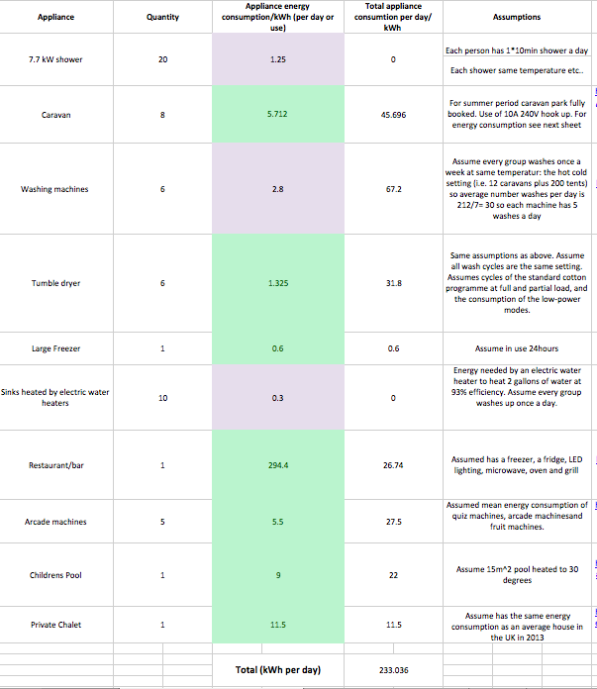

(Camping and Caravanning Club, 2015; Michael Bluejay, 2013; Bosch, 2015; Currys, 2014; National Union of Students, (n.d.); Department of Energy & Climate Change ,2014)

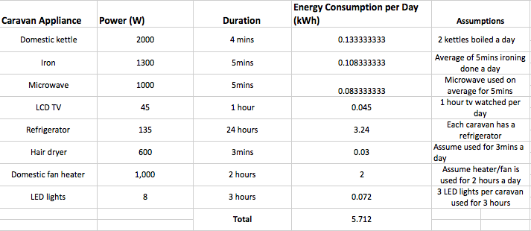
Appendix B

(Camping and Caravanning Club, 2015; UK campsite, 2014)

Appendix C
When working out the capacity of the electrical storage system it is best to use the Sauer’s approach. This is done by calculating the amount of energy the battery storage system can absorb during its cycle life and discharge. An example of this is the company Deutsche Energieversorgung’s conventional lithium-ion battery system that has 3,000 cycles for a capacity of 24 kilowatt hours, this equals to 72,000 kilowatt hours in total over the battery’s life time. A 50% depth of discharge at which this cycle life can be achieved must be deducted. Also another 80% must be deducted to cover the loss of efficiency of the battery through the systems lifetime. After deducting all the losses of efficiencies in its cycle life, the battery now has a capacity of approximately 30,000 kilowatt hours. At £1540.60 for the system, storage costs come to around 14 pence per kilowatt hour. If you add the 8 pence it costs to produce power on-site, the total cost comes to 22 pence. This is substantially higher than the current domestic electricity cost of around 16 pence – meaning that the system is not currently economically favourable when it comes to comparing it with an off grid system. Modern lead-acid batteries offer even less value for money, according to Sauer’s calculations. Storage costs alone come to at least 23 pence for current systems compared with 14 pence for a conventional lithium-ion battery (SOLARENERGYSTORAGE, 2014).
Cost calculations
$$\frac{3000kwh}{3000 cycles}=10kwh per cycle which costs £1540.60 for battery pack with a capacity of 10kwh per cycle$$
$$So for a battery pack with a capcity of 120kwh will cost \frac{120kwh}{10kwh}*£1540.60=£18487.00$$
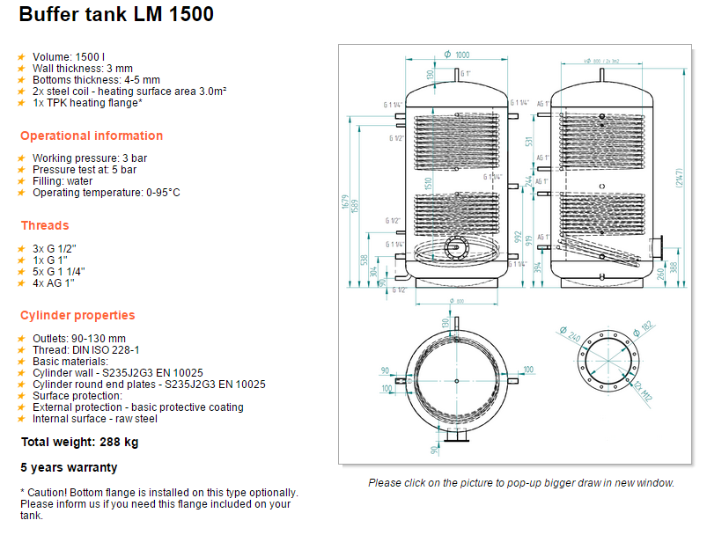(Buffer-tank.co.uk, 2015)
Appendix D
Batteries store electricity for use during times that the system is not producing electricity.
Charge controllers prevent battery voltage from exceeding a certain charge voltage setting during charging by reducing charge current delivered to the battery. A battery will charge if PV modules or a wind generator was connected directly to a battery without a charge controller, but as battery state of charge rises so do battery voltage. Without a charge controller voltage can rise so high once the battery is charged that the battery or attached systems may be damaged
Power Conditioning Equipment are inverters convert DC electricity from the energy sources to standard AC appliances. Other basic elements to power conditioning are frequency of AC cycle, voltage consistency and quality of the AC cycles – whether it is jagged or smooth.
Safety equipment protect stand-alone and grid-connected small renewable energy systems from being damaged or harming people during events like lightening events, power surges, or malfunctioning equipment.
Safety disconnects -- Automatic and manual safety disconnects protect the wiring and components of the small renewable energy system from power surges and other equipment malfunctions. They also ensure that the system can be shut down safely for maintenance and repair.
Grounding equipment -- This equipment provides a well-defined, low-resistance path from your system to the ground to protect the system against current surges from lightning strikes or equipment malfunctions.
Surge protection -- These devices also help protect your system in the event that it, or nearby power lines (in the case of grid-connected systems), are struck by lightning (Energy.gov, 2015).
Appendix E
SB3024iL: The Solar Boost 3024i is a 24V MPPT type Photovoltaic (PV) battery charge controller. It also includes an auxiliary output which can serve as a 20 amp load controller. The DUO-Option Diversion Control upgrade converts the 3024’s 20 amp auxiliary output into a separate 20 amp diversion type charge controller.
The Diversion Control allows a 3024 to provide diversion type charge control for hydroelectric, wind or similar generator type power sources while at the same time and within the same unit providing MPPT type PV charge control. The Diversion Control upgrade also allows the 3024 to divert full available PV and generator power which is not required for battery charging to a useful purpose such as room heater (Blueskyenergyinc.com, 2015).
Appendix F
Table of contributions to the project for each individual team member:
Table 3 showing the roles of each group member in the project
Group Member | Role in project
Liam | Calculations for campsite power requirement, wind turbine and solar panel calculations.
Lewis | Responsible for biomass calculations, energy consumption data as assisting with the economic feasibility.
Siti | Responsible for control and monitoring systems
Abdulla | Responsible for introduction, economics as well as structuring the report and presentations.
Musa | Responsible for storage systems.

In the above table each group member was responsible for researching their field, presenting their findings in any presentations and then placing their findings within the report where it was then edited as a group.

