Dench-Gym

## CE 1IEE Eco-Gym Final Report

Ellena honeyborne 1430716 maciej gorski 1454289 Iustin irimescu 1448817 jonathan chin 1461293 dhruv datta 1444881 dami shoroye 1413230

team project

28th february 2015

# executive summary

The aim of this report is to illustrate the consulting engineers’ calculations and research into off-grid gym machines, a swimming pool and human power to create a new economically feasible off-grid eco-gym ‘Dench Gym’. For the gym plan, the team surveyed existing gyms and looked into current electricity and gas prices. The average membership price for a 1500 membership gym with a 25x10m pool was £30.00 per month, giving a total yearly profit of £540,000.00. The average gas price came out at 4.35p per kWh and the electricity price 15p per kWh.

The team chose the city of Truro, Cornwall as their location due to the good solar irradiation, wind speeds, the population being sufficient to power the gym machines by human power and it meeting specification of a city centre gym – the Client then purchased the land.

The existing single glazed windows are to be replaced with double glazing leading to a heat loss saving and all repairs are to be done in concrete due to its good thermal mass – lowering costs for the eco-gym. To lower heat loss even more 2 * 740w portable dehumidifies will remove sweat from the gym.

The size of the gym was determined by adding up the machinery, giving sufficient space around it and adding up this with the café, reception and changing room size – this gave the team a total of 1000m² of area with 600m² of roof space for solar panels. To meet client specification and an average of 1000 members attending the gym per day, the gym houses 20 of each cardio machine, 35 resistance machines, 2 sets of free weights and a matted area.

The eco-gym will be using 6 typical vertical fiberglass wind turbines with a maximum speed of 14m/s, a total power production 54,000kWh per year and a total cost of £9000.00, as well as a 90 kWp solar system with 360 solar panels producing 77197.5 kWh/per year costing £104,600.00, leading to a total energy payback time of 6 years. The gym will also house a 44 kW biodiesel back-up generator when the wind and solar power are not sufficient to power the gym, costing £10,000.00. Using biodiesel instead of energy from the grid, gave a total saving of £350.98 and 28.5 years pay back. The team also specified a 25m long x 10m wide varying depth pool to meet British Standards. The 325000L pool is to be heated to 25 degrees by 600% efficient heat pumps costing £3725.92 per year and any excess energy sold to the grid.

Using the average of 1000 people per day in the gym and an average of 120000 watts of power generated each day, the human power produced per week totalled 28,200 kWh. The total gym and cafe cost totalled £185,338, the Outdoor Area £218,211, the toilets £729 and the materials £22,730 leading to a total initial cost of £441,672.00 and a total consumption of 87,934 kWh/year for Dench Gym. This is compared to an on-grid gym costing £350,000.00 and consuming 500,000 kWh/year.

Overall Dench gym is £91,672 more expensive than an on-grid gym. However, the total electricity consumption per year in an on-grid gym is significantly higher than the team’s eco-gym with an overall saving of 421066 kWh of electricity each year. Dench gym also has energy generation from solar and human power, leading to a £61,809.90 saving every year on electricity. In order to compensate the (£) 91,672 extra for the eco-gym construction, it would take £441,672 / (cost of electricity saved per year) £61,809.90 + (Feed In tariff) £17572 = 441672/ (61,809.90 + 17572) = 6 years. This shows that an eco-gym is economically feasible without compromising customer satisfaction or client specification.

# table of contents

1. INTRODUCTION……………………………………………………………………………...4

2. locaTION………………………………………………………………………….…………4

3. planning………………………………………………………………………….……….4, 5

4. peak and off peak times………………………………………………………………5

5. renewable energy generation………………………………………………. 6, 7, 8

6. storage………………………………………………………………………….………... 8, 9

7. heat loss………………………………………………………………………….…..9, 10, 11

8. Gym machinery costs…………………………………………………………...11, 12, 13

9. energy payback AND CONCLUSION………………………………………………... 13

10. references…………………………………………………………………….14, 15, 16, 17

11. appendix……………………………………………………………..18, 19, 20, 21, 22, 23, 24

12. MEETING MINUTES……………………………………………....25, 26, 27, 28, 29, 30, 31, 32

# 1.0 introduction

With increasing fossil fuel emissions causing a rise in temperatures (Climate change: Vital Signs of the Planet, 2015) and a decrease in global resources, it is now vital to find viable renewable alternatives to burning coal, oil and natural gas.

The aim of this report is to illustrate the team’s research and findings into a new Eco-gym powered only by renewable energy sources and whether it is economically feasible for future generations. This will meet client specification to design an off-grid, self-sufficient city gym with 1500 memberships and modern facilities including a cafeteria, 25m swimming pool, cardio-vascular and resistance machines. The group focused on researching into existing gyms, location, structurally limiting heat loss, budget/costing and renewable energy sources – this includes large and small energy solutions, energy payback and feasibility compared to on-grid powered gyms.

# 2.0 location

The location of the gym was dependant on the group’s main renewable energy types – Solar and wind power. A compromise between sun and wind was necessary, as the sunniest places in the United Kingdom often do not have high or constant wind speeds (The Weather Channel, 2014) meaning less turbine generated power. The team looked at the windiest parts of the UK (see Appendix A) and compared them to the sunniest parts (See Appendix B) - Cornwall was reached as the prime location with an average of 6m/s of wind (The Weather Channel, 2014) and 1100 kWh/m² of solar irradiation (Planning guidance for the development of large scale ground mounted solar PV systems, 2015). The eco-gym will be located in Truro, the only city in Cornwall (Truro.gov.uk, 2015) to meet client specification of a ‘city centre gym’.

The population stands at 45,000 people (Cornwall Council Community Intelligence Team, 2015) and with the eco-gym holding 1500 memberships and on average 15% of people holding gym memberships (Statista, 2015) the population is more than enough to meet our membership and energy needs.

# 3.0 planning

The team started by making assumptions about the project:

1. The team has been hired as Consulting Chemical, Electrical and Civil Engineers on a project to create a new off-grid eco-gym

2. The Client has purchased a single storey building with 1000m² of floor space, concrete walls, a concrete floor slab and concrete trench fill foundations in Truro on the teams’ advice.

3. The Client has hired sub-contractors to carry out the internal fittings i.e. the mirrors, showers, toilets, tables/chairs in the café, setting up the machinery etc.

4. The Client has hired building contractors for manual labour and specialist sub-contractors for the pool.

5. A company has been hired to provide food and services for the café.

The team started planning the eco-gym by calling and existing gyms. The team asked questions about membership prices, the size of the gym, peak and non-peak times, the amount of cardio machines, resistance machines and free weights (Martley Rivers Gym, Pershore Rivers Gym, University Of Birmingham Gym and David Lloyd Gyms). The team gained the following results:

1. The average membership price for a large city gym came up at £30.00 per month, giving the team a profit of (30 x 1500 memberships x 12 months) £540,000.00 per year in memberships.

2. The average off peak and peak times fell between 7am-5pm and 6pm-10pm and around 70% of members attended during the peak times.

3. For a large David Lloyd Gym in London (a city centre gym) it was necessary to have 20 of each cardio machine, 35 resistance machines, 2 sets of free weights and a matted area. This was not only to meet Client specification but also customer needs.

The team also researched into average gas and electricity costs to compare the power usage and consumption to an on-grid gym. The price of Electricity was 15p per kWh on average (Mark, 2015) and the price of Gas 4.3p per kWh on average (Mark, 2015).

The size of the gym was determined by looking at the averages sizes in m³ for the equipment, adding a 1m³ area around the smaller equipment, a 2m³ area around the larger equipment and 6m wide walkways giving the gym an overall size of 600m² including the café and reception area. The pool is 250m² + 150m² outside area = 400m² including the toilets and showers- Refer to Appendix P.

# 4.0 peak and off-peak figures

From the above section you can see that, through research, the team found the standard off-peak and peak times of a city centre gym were 7am-5pm and 6pm-10pm. The team used surveys from existing gyms to find the average amount of times people went to the gym per week - refer to Appendix C. By looking at the number of people that said they went to the gym * the number of times they went per week and cumulating this gave a total which was divided into 1500 memberships.

Table 1 below, shows the estimation for the number of members attending the gym each day and the 70%/30% split for off-peak and peak times. Refer to Appendix 4 for hourly figures.

|  |  |  |  |
| --- | --- | --- | --- |
| Day | Off-peak and peak times | No. of members off-peak | No. of members on peak |
| Monday | 7am-5pm 🡪 6pm-10pm | 315 | 735 |
| Tuesday  Wednesday  Thursday  Friday  Saturday  Sunday | 7am-5pm 🡪 6pm-10pm  7am-5pm 🡪 6pm-10pm  7am-5pm 🡪 6pm-10pm  7am-5pm 🡪 6pm-10pm  7am-5pm  7am-5pm | 225  315  315  158  675  158 | 525  735  735  367  -  Table 1 |

# 5.0 renewable energy generation

5.1 WIND TURBINES

About 40% of all wind in Europe is blown over the UK, making it ideal for creating energy via wind turbines. A typical system in an exposed site can generate more power than only lights and electrical appliances. In the eco-gym garden 6 typical vertical fiberglass wind turbines with a maximum speed of 14m/s will be used with a price of £15000.00 (Kingspanwind.com, 2015) each – Refer to Appendix J. The table below shows the energy inputs and outputs of this type of wind turbine:

|  |  |
| --- | --- |
| Turbine Operational Information | |
| Average Annual Energy | 9000 kWh |
| Cut-in Wind Speed | 3.5 m/s |
| Max Power Wind Speed | 14 m/s |
| Cut-out Wind Speed | 20 m/s |
| Peak Power Output | 6.1 kW |

As the gym will house six turbines, this means a total energy production of 54,000kWh and a total cost of £9000.00. Maintaining one turbine costs £150 per year (Energysavingtrust.org.uk, 2015), so total maintenance checks for the turbines will cost Dench Gym (£150 (per year) * 6 =) £900.00.

Because of the use of wind turbines, Dench Gym is eligible for feed-in tariffs i.e. the eco-gym will earn money for each kWh of renewable electricity generated in the system. For Dench Gym’s system of 1.5kW to 15kW wind turbines, the feed-in tariff is 16p/kWh (Energysavingtrust.org.uk, 2015).

Payback Time As the total power generation of the wind turbines amounts to 9000 kWh per year, 6 turbines will earn at £1440.00 per year from the income generation tariff (Energysavingtrust.org.uk, 2015) – Refer to Appendix K. In fuel saving:

15p/kWh (Electricity cost) * 9000 kWh (Wind turbine power) = £1350.00 £1440 (Income tariff) + £1350 = £2790 of savings for each turbine per year

This leads to (£16,740.00 per year - £150 (maintenance costs) =) £15,840.00 of total savings on Dench Gym’s wind turbines per year and a 6 year energy payback time.

5.2 SOLAR PANELS

On average one solar panel needs 1.6m² of roof area and with Dench Gym’s roof area totaling 600m² (Refer to Appendix L), the roof of the gym can hold (600/1.6 =) 375 solar panels. Because of this, the team chose a 90 kWp (kilo-watt-peak) solar system with around 360 solar panels. In the UK a typical solar system can be expected to generate 2.35 kWh of electricity for every kilowatt-peak (kWp) of capacity installed (Solarselections.co.uk, 2015), therefore Dench Gym’s system will generate:

90 kWp * 2.35 kWh =211.5 kWh/per day

211.5 * 365 days = 77197.5 kWh/per year

Cost and Payback

The team found that the cost of a 90 kWp solar system is £104,600.00 all inclusive (Solarselections.co.uk, 2015). The same amount of energy from the grid would cost:

77197.5 kWh (Power from solar panels) * 0.15p = £11,579.63 from the grid

Dench Gym is also eligible for feed-in tariffs on solar panels and for a 10kW system or more £11.57p/kWh (Energysavingtrust.org.uk, 2015) is earned, leading to:

77197.5 kWh * 0.1157 = £8931.75 earned from feed in tariffs

This gave the team a total of £20,511.44 and an energy payback time of 5 years for solar power.

In total, the Dench Gym will generate a total of (77,197.5 + 54,000 =) 131197.5 kWh/p year in eco-power.

5.3 GENERATOR POWER Due to wind turbines relying on particular weather and solar panels not being able to produce power during the night; the team decided to use a 44 kW biodiesel generator costing £10,000 all inclusive (Bio Diesel Generators, 2015), for a backup power source - Refer to Appendix M for the full specification. As biodiesel costs 61p for 10+ 20 Litre cans (Cateroils.co.uk, 2015) and the generator runs at 9.5L/h (Bio Diesel Generators, 2015) the calculated costs are (refer to Appendix L):

9.5 (L/h) * 0.61 (p) = £5.795 an hour * 24 hours = £139.08 to run to generator for one day

Getting the same amount of energy from the grid would cost Dench Gym:

44kWh * 0.15 (cost of electricity) = £6.60 for one hour * 24 hours = £158.40 for one day

From the above calculation the team found that running a bio diesel generator is cheaper by £ 19.32 per day than taking power from the grid. Assuming that the generator would be used from late November to early March (about 109 days) for four hours per day:

5.795 * 4 hours = £23.18 per day * 109 days = £2526.62 with bio diesel

£6.60 * 4 hours = £26.40 per day * 109 days = £2877.60 from the grid

Giving a total of (2877.6 – 2526.62) £350.98 savings compared to a generator connected to the grid and an energy payback time of 28.5 years.

6.4 SWIMMING POOL

The team chose a British standard size swimming pool of 25m long x 10m wide and a varying depth (Sport England – Design Guide Notice, 2015) to meet client specification and to achieve the lowest cost. The first 4m length will be 1m deep, the next 17m will be 1.5m deep and the last 3m will be 1.9m deep – this leads to a total volume of 352m³ and 325,000L of water to fill the swimming pool, refer to Appendix N for full calculations.

To meet client specification, the team needed to heat the pool from 10°C to 25°C. Based on a loss of 1°C per day, 116 kW is needed to heat 100,000L a constant 25°C, meaning:

116kW * 3.52 = 408.32 kW per day to heat the swimming pool

408.32 kW * 365 days = 149,036.8 kW per year

The team also had to take into account the efficiency of the heaters to get an accurate energy consumption figure compared to a gas or electric heater. As an electric heater is around 90% efficient and a gas heater is 85% efficient:

149036.8 / 0.90 = 165596.44 kWh

165596.44 * 0.15 (Electricity price) = £24,839.47 per year for an electric heater

149036.8 / 0.85 = 175,337.41 kWh

175,337.41 * 0.043 = £7539.51 per year for a gas heater

The team made a decision to heat the swimming pool by heat pumps as an off-grid solution. Heat pumps use electricity to run and have an efficiency of up to 600%, meaning for every 1 kWh the client will receive 6 kW of energy:

149036.8 / 6 = 24839.47 kWh

24839.47 * 0.15 (electricity price) = £3725.92 per year

Although in the first year a heat pump will cost the client more (refer to Appendix O), because the running cost of the heat pump is two times less than a regular gas heater in year two it is a more economically viable investment overall.

# 6.0 storage methods

The team looked into the cost and efficiency of various energy storage methods to determine which one is the most viable for the eco-gym.

* The first storage method the team looked at was Lithium-Ion batteries. The advantages of lithium ion batteries are that they have high energy density, meaning they can store a large amount of energy – they also have a small amount of leakage. However, the price is a major disadvantage with an 8.8 kWh battery costing £17,222.00 and an 11kWh costing £19,910.00 (Rfisolar.com.au, 2015).
* The team also looked at PEM (proton exchange membrane) Hydrogen Fuel Cells. The advantages of Hydrogen fuel cells are that they also have a high energy density; however, they are expensive and raise safety concerns. The hydrogen would be obtained by water electrolysis with energy from renewable sources. It would then be stored in high pressure tanks, and used to obtain energy when needed, by reacting with oxygen inside the fuel cell (Energy Industry in the Highlands, 2015).

Reactions for Hydrogen Fuel Cell:

Anode: H2->2H+2e

Cathode: ½ O2+2H+2e->H2O

Overall: ½ O2+H2->H2O

The efficiency of the electrolysis process is 96% and that of the fuel cell reaction is 60% (Energy Industry in the Highlands, 2015).

The cost of a hydrogen installation would be £67.00 for the fuel cell and £669.00 for the electrolyser (Horizon Fuel Cell Technologies, 2015).

* A flywheel was the third option the team looked at. Assuming that the eco-gym has a flywheel with a 4m diameter and a mass of 50 kg, spinning at 3000 rpm the energy stored in it would be:

Kinetic Energy = 0.5 * I * ω² = 2.74 kWh

(I is the moment of inertia and ω is the angular velocity)

Although the short period of time during which the energy is stored would prove to be inconvenient for the eco-gym.

* Compressed air could also be a storage method for the new eco-gym. Using a tank with a diameter of 4 metres, a height of 5 metres and compressing the air at 20 MPa, the energy stored would be:

E = ln * (Pa/Pb) = 1850 kWh.

This solution would store enough energy to suit our needs; however the high pressure inside the tank is unachievable.

* Molten salt is a method used to store the excess heat from concentrated solar thermal panels. The salt is liquefied and stored in containers until the demand is high enough and then the sodium and chlorine ions react, which produces electricity. However, our solar thermal panels are incapable of producing the required output so this is not a viable option for the new eco-gym.

Overall the only viable storage methods are lithium-ion batteries and hydrogen fuel cells. However, because of the costs associated with these two, our recommendation is to sell our excess energy to the main grid.

# 7.0 heat loss

7.1 STRUCTURAL ELEMENTS The Client picked this building because of the concrete walls and concrete floor slab – some of these may also need to be replaced. Concrete is a good material for the eco-gym due to its physical and chemical properties. Concrete out performs wood as a building material and the use of concrete does not involve high maintenance and repair costs. Concrete is incredibly versatile, durable, cost effective and sustainable and therefore is the perfect material to structure Dench Gym. The main reasons why concrete should be used in any repairs are observed in detail below.

Economic Viability

Concrete stands as one of the most efficient and cost effective ways of producing energy efficient structures. As Dench Gym is a sustainable structure it would be able to yield life cycle savings of up to 20% of the main building/construction costs (Saskatchewan Ready Mix Concrete Association, 2010) – most of this is due to the concrete’s thermal mass and it’s “Albedo effect”(A. Sweeney, 2002).

Albedo Effect

As concrete has a high thermal mass, the use of concrete in the walls and floor slab slows the passage of heat energy being transferred reducing rapid temperature changes. This would reduce the energy needed for heating/air-conditioning and offers an annual energy saving over the lifetime of the gym. (Cement Sustainability Initative, 2012)

The albedo effect is the percentage of radiation that is reflected off the surface of the concrete. For example, an albedo value of 1 means 100 percent of incident radiation is reflected and none absorbed and an albedo value of 0 means that 0% of incoming radiation is reflected so all is absorbed. Concrete albedo value is 0.55. (Ronnen Levinson, 2001), meaning more light is reflected and less heat is absorbed through the concrete, resulting in cooler temperatures. This also reduces the "urban heat island effect” and therefore allows for less use of air conditioning which would, if used, consume a lot of energy. If this were to be combined with cooling systems the concrete structure can reduce heating and cooling energy requirements by 29% or more. (Ecocem, 2012)

Sustainability

As an environmentally conscious business, Dench gym aims to be sustainable as well as to use materials which have the smallest carbon footprint. Although the production of a cubic metre of concrete generates 210 kilograms of carbon dioxide, these effects are cancelled out by the fact that cement unused after construction can be easily recycled and can be added to cement kilns and provide a source of heat (Saskatchewan Ready Mix Concrete Association, 2010). Secondly, due to the durability of concrete and its’ fire resistance, repeated repairs or replacements will not be needed. This means over a long period of time the carbon dioxide generated in the production of concrete is mitigated by its’ durability. (Ronnen Levinson, 2001)

Cost

Concrete is by far one of the cheapest building materials available in the modern day with price per square foot ranging from **£2.11 to £3.40. Therefore this is very cost effective as a building material** (Concrete Network, 2013)**.**

Insulation

The use of insulation for the gym will be one of the cheapest and most effective ways of keeping the gym at a usable temperature, it will be especially effective during the winter months and the fact that it is a one off cost means that it is defiantly a commercially viable solution. The most effective solution for us is the use of cavity wall insulation - Cavity wall insulation is insulation placed between the outer and inner shell of the wall that we are using.

We have chosen to use polystyrene beads for the insulation within the cavity wall. Cavity wall insulation works due to the air pockets formed within the beads. The air pockets work by reducing natural convection and thus minimising heat loss, which in turn reduces overall costs (Hall et al. 2012). As we are using concrete for floors we will not need to worry about flooring insulation.

Another use of the cavity wall is the fact that it reduces the risk of rain penetration from the outer environment by separating the 2 walls. Building guidelines dictate that a minimum of 50mm air space is required between the walls but the team have decided to use wider air gaps when dealing with areas more prone to rain penetration (Doran, 2009). Polystyrene beads have also been chosen over mineral wool as the cavity wall filling due to the opinion of experts in the field - One of these many experts is YouGen expert Tim Pullen. He described mineral wool as the ‘worst kind’ of insulation to use as it has the potential, if not packed properly, to cause cold spots within the wall, reduce the efficiency and increase the risk of condensation within the cavity (YouGen, N.D.).

Fig 1 shows an image of cavity wall insulation (energy saving trust, N.D.)

Double-glazing

Like with insulation, double-glazing is another method of prevention of heat loss that Dench gym is including within its final gym design. Double-glazing works by reducing heat loss via convection. This is a consequence of the air gaps between the two panes of glass, which essentially reduce the heat transfer through the window limiting heat loss from the building. Furthermore, it will contribute to a more pleasant gym atmosphere by reducing the outside noise and therefore, giving Dench gym customers a better overall experience (Double glazing N.D.).

Using Fourier’s law, which is stated below, the team were able to calculate how much energy is lost. Fourier’s law describes relationship between the conduction rate in a material and the temperature gradient in the direction of energy flow. Where Q is heat transferred, dT/dx is the temperature gradient, k is the thermal conductivity of the material and A is the surface area of the material (Leeke, 2015).



The sum version of Fourier’s law is seen below in which three layers of material are considered (glass-air-glass). When considering double glazing, the denominator of the equation will be larger due to the 3 materials heat has to be transferred through; hence heat lost or transferred through double glazing windows is smaller.

(Leeke 2015)

7.2 DEHUMIDIFIER As consulting engineers the team had to come up with a way to remove excess moisture from sweat within the gym – a portable dehumidifier that was large enough for the 600m² gym was decided as the most viable option.

Firstly, the team assumed that a person releases 0.95 litres of sweat during an hour of moderate exercise (Anderson, D. (N.D.)). Based on an average of 1000 people coming to the gym every day in one hour there will be around 40 people. This means there will on average be:

40 * 0.95=38 litres of sweat per hour

From this the team found 2 subtitle portable dehumidifiers at 740w to be the best option – this removes up to 50 litres of moisture and has an LCD display to monitor the input and output. (The costing of this will be included in the costing section.)

# 8.0 gym machinery costs

8.1 MACHINERY COSTS Table 2 shows the number of machines, their special features and the cost per unit for Dench Gym (Boesel, 2015).

|  |  |  |  |
| --- | --- | --- | --- |
| Equipment | Quantity | Features | Cost per unit |
| Gym bikes | 20 | - Built in ECO – POWER micro power inverter. - Heart rate sensors - Operates magnetically without consuming electricity. - Electronic gadgets connection option | £2000.00 |
| Treadmills | 20 | - Built in ECO – POWER micro power inverter. - Heart rate sensors - Operates magnetically without consuming electricity. - Electronic gadgets connection option | £2600.00 |
| Rowing machines | 8 | - Built in ECO – POWER inverter an heart rate sensors - Operates magnetically without consuming electricity  - Electronic gadgets connection option | £2200.00 |
| Elliptical cross trainers | 20 | - Built in ECO – POWER micro power inverter. - Heart rate sensors - Operates magnetically without consuming electricity. - Electronic gadgets connection option | £2200.00 |
| Resistance training machines | 35 | - Heart rate sensors | £400.00 |
| Steppers | 6 | - Built in ECO – POWER micro power inverter. - Heart rate sensors and electronic gadgets connection - Operates magnetically without consuming electricity. | £2200.00 |

8.2 HUMAN POWER The science behind generating power from gym equipment is not new. For quite a long time, people have been using dynamos on their bicycles to power the lamps during the night - generating power in a gym setting using the same technology.

Each gym machine produces DC power once mechanical energy is applied. The dynamo then uses an integrated micro power inverter to convert it into AC power. This is then used to power other components of the gym (News.bbc.co.uk, 2015). A person can generate 120 watts per hour on average during an exercise. Assuming each person uses the gym equipment an hour per day and an average of 1000 people come into the gym every day, that gave the team 120000 watts of power generated each day. However, gym machines are usually about 85% efficient, which means 102 kW of useful power per day. Table 3 shows the electricity contribution per year of human power in Dench Gym. For a more detailed table, refer to Appendix D.

|  |  |  |
| --- | --- | --- |
| Day | No. Of people  In total | Electricity contribution per year (kWh/year) |
| Monday | 1050 | 5600 |
| Tuesday | 850 | 4000 |
| Wednesday | 1050 | 5600 |
| Thursday | 1050 | 5700 |
| Friday | 525 | 2800 |
| Saturday | 675 | 3600 |
| Sunday | 160 | 900 |

Total = 28200

As of 2015, there are 52 Mondays, Tuesdays, Wednesdays, Fridays, Saturdays and Sundays and 53 Thursdays.  
  
Electricity contribution per year for Mondays (kWh/year) = No. Of people coming on Monday (315 +735) * number of hours people use the machinery per day (1.0hr) * power generated by each person per hour (0.12kW) * efficiency of the gym machines (0.85%) * 52 weeks  
  
This is then repeated to calculate electricity contribution for Tuesday, Wednesday, Fridays, Saturdays and Sundays. However since there are 53 Thursdays in a year, the electricity contribution is slightly different - the total energy contribution is calculated as above, but with 53 weeks instead of 52.  
  
Electricity contribution per year for Thursdays (kWh/year) = No. Of people coming on Thursday (735 +315) * number of hours people use the machine per day (1.0hr) power generated by each person per hour (0.12kW) * efficiency of the gym machines (0.85%) * 53 weeks.

8.3 OVERALL COSTINGS The total cost of each component can be calculated as follows,

Electricity consumption (kWh/year) = power needed by equipment (kW) x operating

time per day (h) x 365 days

Annual operating cost (£) = average electricity cost unit (kWh/p) x electricity consumption (kWh/year)   
Total cost (£) = (cost per unit x quantity) (£) + annual operating cost (£)

Table 4 shows the total cost of the fitness area, swimming pool, outdoor area, materials and electricity consumption. The full breakdown of costs for the gym and café can be found in Appendix E, Swimming pool costs in Appendix F, Outdoor area Appendix G, Toilets Appendix H and Materials in Appendix I.

|  |  |  |  |  |
| --- | --- | --- | --- | --- |
| Equipment | Total Electricity  Consumption (kWh/year) | Total Electricity Generation (kWh/year) | Total Annual operating costs (£) | Total cost (£) |
| Gym and Cafe | 59,912 | - | 9015.5 | 185,338 |
| Swimming Pool | 25,759 | - | 3864 | 14664 |
| Outdoor Area | 73 | 133,200 | 11 | 218,211 |
| Toilets | 2190 |  | 329 | 729 |
| Materials | - | - | - | 22,730 |
| Human Power |  | 28200 |  |  |

Total = 87,934 161,400 441,672

This shows that the total electricity consumption of Dench Gym is 87,934 kWh/year, total generation is 161,400 kWh/year and total costs of £441,672, showing an energy payback scheme is necessary.

# 9.0 energy payback and conclusion

Because of the advanced technology needed for an eco-gym and the number of commercial gym machinery being retrofitted with micro power inverters to meet demand, an eco-gym will always be more costly than an on-grid gym. However, with Dench Gym investing in green energy production through human and solar power, the eco-gym provides a better environment for consumers and energy payback. By cumulating the costs for each section of the gym, an initial cost of the gym has been reached.

Cost of electricity per year (£) = Average UK electricity cost unit (15p/kWh) * Total

Electricity consumption (kwh/year)

Cost of electricity saved per year (£) = Average UK electricity cost unit (15p/kWh) *

Total electricity generated per year (kWh/year)

|  |  |  |  |  |  |  |
| --- | --- | --- | --- | --- | --- | --- |
|  | Initial cost (£) | Total Electricity consumption  (kWh/year) | Total electricity generated (kWh/year) | Cost of electricity per year (£) | Cost of electricity saved per year (£) | Feed in tariffs (£) |
| Dench Gym | 441,672 | 87,934 | 161400 | 13,190.10 | 61,809.90 | 17572 |
| Normal Gym | 350000 | 500000 | 0 | 75000 | 0 | 0 |

9.1 CONCLUSION By taking the difference of the initial total cost of both gyms in the table above, it shows that Dench gym is £91,672 more expensive than an on-grid gym. However, the total electricity consumption per year in an on-grid gym is significantly higher than the team’s eco-gym. This means an overall saving of 421066 kWh of electricity each consecutive year. Dench gym also has energy generation from solar and human power, leading to a £61,809.90 saving every year on electricity. In order to compensate the (£) 91,672 extra for the eco-gym construction, it would take approximately:

(Total Initial cost) £441,672 / (cost of electricity saved per year) £61,809.90 + (Feed

In tariff) £17572 = 441672/ (61,809.90 + 17572) = 6 years payback time

# 10.0 references

2015, Y. (2015). *YouGen UK*. [online] YouGen UK. Available at: http://www.yougen.co.uk/energy-saving/Insulation/ [Accessed 12 Mar. 2015].

App.knovel.com, (2015). *Knovel Title -*. [online] Available at: http://app.knovel.com/web/toc.v/cid:kpMEBMECA7/viewerType:toc/root_slug:modern-earth-buildings/url_slug:kt00C54WU1?b-q=cavity%20wall%20insulation&b-subscription=TRUE&b-group-by=true&b-sort-on=default [Accessed 12 Mar. 2015].

App.knovel.com, (2015). *Knovel Title -*. [online] Available at: http://app.knovel.com/web/toc.v/cid:kpSEME0022/viewerType:toc/root_slug:site-engineers-manual/url_slug:kt00BT22O3?b-q=cavity%20wall&b-subscription=TRUE&b-group-by=true&b-sort-on=default [Accessed 12 Mar. 2015].

Boesel, A. (2015). *The Green Microgym | Electricity Generating Fitness*. [online] The Green Microgym: Eco Fitness Gyms, Electricity-Generating Exercise Equipment in Portland, Oregon. Available at: http://www.thegreenmicrogym.com [Accessed 12 Mar. 2015].

Boesel, A. (2015). *The Green Microgym | Electricity Generating Fitness*. [online] The Green Microgym: Eco Fitness Gyms, Electricity-Generating Exercise Equipment in Portland, Oregon. Available at: http://www.thegreenmicrogym.com [Accessed 12 Mar. 2015].

Concretenetwork.com, (2015). *Concrete Prices - How much does concrete cost? - The Concrete Network*. [online] Available at: http://www.concretenetwork.com/concrete-prices.html [Accessed 12 Mar. 2015].

Concreteworksharder.com, (2015). *Why Is Concrete Better?*. [online] Available at: http://www.concreteworksharder.com/resources/why-is-concrete-better [Accessed 12 Mar. 2015].

Cornwall Council Community Intelligence Team, (2015). *Community Network Profile - Truro*. [online] Available at: https://www.cornwall.gov.uk/media/3626336/TruroRoseland.pdf [Accessed 10 Mar. 2015].

Cyberphysics.co.uk, (2015). *Double glazing - physics GCSE*. [online] Available at: http://www.cyberphysics.co.uk/topics/heat/heat_travel/double_glazing.htm [Accessed 12 Mar. 2015].

Ecocem.ie, (2015). *The Albedo Effect*. [online] Available at: http://www.ecocem.ie/environmental,albedo.htm [Accessed 12 Mar. 2015].

Energy Industry in the Highlands. (2015). 1st ed. [ebook] Inverness, Scotland: Hi-Energy. Available at: http://www.hi-energy.org.uk/Downloads/Hydrogen%20Fuel%20Cell%20Resource/2-Stationary-and-portable-fuel-cells-information-resource.pdf) [Accessed 11 Mar. 2015].

Energysavingtrust.org.uk, (2015). *Cavity wall | Energy Saving Trust*. [online] Available at: http://www.energysavingtrust.org.uk/domestic/cavity-wall [Accessed 12 Mar. 2015].

Energysavingtrust.org.uk, (2015). *Cavity wall | Energy Saving Trust*. [online] Available at: http://www.energysavingtrust.org.uk/domestic/cavity-wall [Accessed 12 Mar. 2015].

Global Climate Change, (2015). *Earth Right Now*. [online] Available at: http://climate.nasa.gov/blog?m_y=02-2015 [Accessed 12 Mar. 2015].

Horizon Fuel Cell Technologies, (2015). *Horizon Fuel Cell Technologies*. [online] Available at: http://www.horizonfuelcell.com/ [Accessed 11 Mar. 2015].

Leeke, G. (2015). *Fluid Flow, Thermodynamics and Heat transfer*. University Of Birmingham: G. Leeke, pp.16-18.

Mark, R. (2015). *How is your energy bill calculated? | MoneySuperMarket.com*. [online] Moneysupermarket.com. Available at: http://www.moneysupermarket.com/c/news/how-is-your-energy-bill-calculated/0026474/ [Accessed 11 Mar. 2015].

Net.workspace.co.uk, (2015). *How to start a gym*. [online] Available at: http://net.workspace.co.uk/social/resources/how-to-start-a-gym [Accessed 12 Mar. 2015].

News.bbc.co.uk, (2015). *BBC NEWS | Technology | A gym powered by sweat and tears*. [online] Available at: http://news.bbc.co.uk/1/hi/technology/7796215.stm [Accessed 12 Mar. 2015].

Planning guidance for the development of large scale ground mounted solar PV systems. (2015). 1st ed. [ebook] Truro, Cornwall: Cornwall Council, p.5. Available at: http://www.bre.co.uk/filelibrary/pdf/other_pdfs/KN5524_Planning_Guidance_reduced.pdf [Accessed 11 Mar. 2015].

Ratcliff, R. (2015). *Properties of Concrete*. [online] Wbcsdcement.org. Available at: http://www.wbcsdcement.org/index.php/key-issues/sustainability-with-concrete/properties-of-concrete [Accessed 12 Mar. 2015].

Rfisolar.com.au, (2015). *Bosch BPT-S 5 Hybrid system with 5kW inverter and 8.8kWh lithium ion batteries - Bosch - Energy Storage - Browse Products - RFI Solar*. [online] Available at: http://rfisolar.com.au/browse-products/energy-storgae/bosch/bosch-bpt-s-5-hybrid-system-with-5kw-inverter-and-8-8kwh-lithium-ion-batteries.html#tab_spec [Accessed 11 Mar. 2015].

SparkPeople, (2015). *Fluid and Water Needs During Exercise*. [online] Available at: http://www.sparkpeople.com/resource/fitness_articles.asp?id=101 [Accessed 12 Mar. 2015].

Spectrum.ieee.org, (2010). *These Exercise Machines Turn Your Sweat Into Electricity - IEEE Spectrum*. [online] Available at: http://spectrum.ieee.org/green-tech/conservation/these-exercise-machines-turn-your-sweat-into-electricity [Accessed 12 Mar. 2015].

Statista, (2015). *Percentage of U.S. population with health club membership 2012 | Survey*. [online] Available at: http://www.statista.com/statistics/246959/share-of-us-population-with-health-club-membership/ [Accessed 10 Mar. 2015].

Truro.gov.uk, (2015). *Truro City Council, Truro, Cornwall*. [online] Available at: http://truro.gov.uk/index.aspx [Accessed 12 Mar. 2015].

Uk.weather.com, (2015). *The Weather Channel - Weather Forecasts, 10 day, weekend, Alerts, Severe, Storm, Maps, News, Videos*. [online] Available at: http://uk.weather.com/ [Accessed 12 Mar. 2015].

Viking-direct.co.uk, (2015). *Igenix 50 litre portable dehumidifier with LCD display*. [online] Available at: http://www.viking-direct.co.uk/catalog/catalogSku.do?id=6740361&cm_mmc=Google-_-PLA_GEN_GOOGLE-SHOPPING_office-furniture-and-seating-_-Fans-_-6740361&_%24ja=cgid:16600085297%7Ctsid:34770%7Ccid:242834537%7Clid:91705106297%7Cnw:g%7Ccrid:55356845657%7Crnd:3470881872357882128%7Cdvc:c%7Cadp:1o3%7Cbku:1&gclid=CKGPm6frm8QCFRQatAodP1gAuw [Accessed 12 Mar. 2015].

Aeoluspower-windenergy.co.uk, (2015). *Aeolus Power installed Endurance E-3120 Production, sited in Cornwall*. [online] Available at: http://www.aeoluspower-windenergy.co.uk/publicData.php [Accessed 14 Mar. 2015].

Bio Diesel Generators. (2015). 1st ed. [ebook] Yorkshire: jspower, p.1. Available at: http://www.jspower.co.uk/images/uploads/BD%2050kVA.pdf [Accessed 15 Mar. 2015].

Cateroils.co.uk, (2015). *FRESH OIL - Cater Oils waste cooking oil collection*. [online] Available at: http://www.cateroils.co.uk/fresh-oil/4586205187 [Accessed 15 Mar. 2015].

Energysavingtrust.org.uk, (2015). *Feed-in Tariff scheme | Energy Saving Trust*. [online] Available at: http://www.energysavingtrust.org.uk/domestic/content/feed-tariff-scheme [Accessed 14 Mar. 2015].

Energysavingtrust.org.uk, (2015). *Solar Energy Check | Energy Saving Trust*. [online] Available at: http://www.energysavingtrust.org.uk/scotland/tools-and-calculators/solar-energy-check [Accessed 14 Mar. 2015].

Energysavingtrust.org.uk, (2015). *Tools and Calculators | Energy Saving Trust*. [online] Available at: http://www.energysavingtrust.org.uk/domestic/content/tools-and-calculators [Accessed 14 Mar. 2015].

Energysavingtrust.org.uk, (2015). *Wind turbines | Energy Saving Trust*. [online] Available at: http://www.energysavingtrust.org.uk/domestic/content/wind-turbines [Accessed 14 Mar. 2015].

Kingspanwind.com, (2015). *Kingspan Wind 6KW turbine | Kingspan Wind Homepage*. [online] Available at: http://kingspanwind.com/products/kw6/ [Accessed 14 Mar. 2015].

Solarselections.co.uk, (2015). *Compare 1.5kW solar system prices & components - Solar Selections*. [online] Available at: http://www.solarselections.co.uk/blog/1-5kwp-solar-systems-in-the-uk-compare-prices [Accessed 14 Mar. 2015].

Sport England - Design Guide Notice. (2015). 1st ed. [ebook] Sport England. Available at: http://www.sportengland.org/media/187399/swimming-pools-2013-appendix-5-further-information.pdf [Accessed 15 Mar. 2015].

Us, A. and Maehlum, M. (2012). *Which Solar Panel Type is Best? Mono-, Polycrystalline or Thin Film?*. [online] Energy Informative. Available at: http://energyinformative.org/best-solar-panel-monocrystalline-polycrystalline-thin-film/ [Accessed 14 Mar. 2015]

# 11.0 appendix

Appendix A

Appendix A shows a map highlighting the windiest parts of the UK.

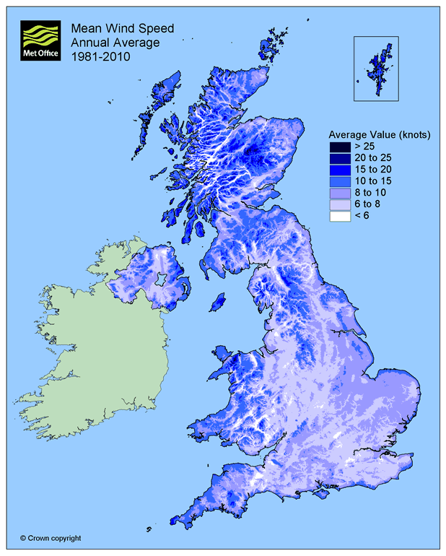

Appendix B

Appendix B shows a map of the sunniest parts of the UK.

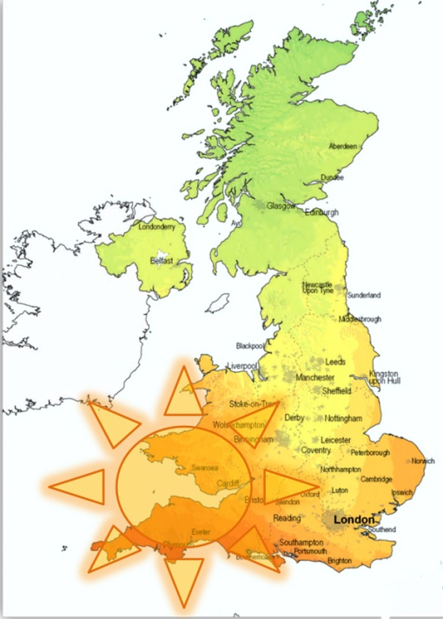

Appendix C

A graph showing the amount of times our target audience went to the gym a week.

X line = No. of times people go to the gym a week

Y line = How many people voted for each number of times

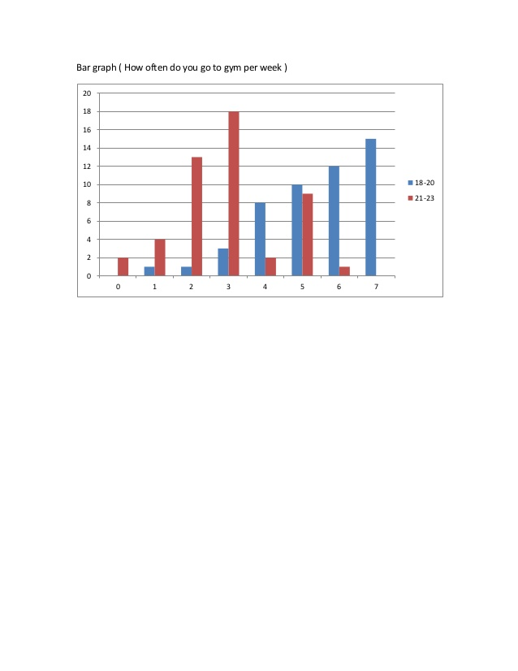

Appendix D

Appendix D shows a more detailed human power table.

|  |  |  |  |
| --- | --- | --- | --- |
| Day | Time | No. Of people | Electricity contribution per year (kwh/year) |
| Monday | 7am – 5pm | 315 | 5600 |
| 6pm – 10pm | 735 |
| Tuesday | 7am – 5pm | 225 | 4000 |
| 6pm – 10 pm | 525 |
| Wednesday | 7am – 5pm | 315 | 5600 |
| 6pm – 10 pm | 735 |
| Thursday | 7am – 5pm | 315 | 5700 |
| 6pm – 10 pm | 735 |
| Friday | 7am – 5pm | 158 | 2800 |
| 6pm – 10 pm | 367 |
| Saturday | 7am – 5pm | 675 | 3600 |
| Sunday | 7am – 5pm | 160 | 900 |

Appendix E

Appendix E shows a full detailed table of costs for the fitness room and cafeteria.

|  |  |  |  |  |  |
| --- | --- | --- | --- | --- | --- |
| Equipment | Quantity | Cost per unit (£) | Electricity  Consumption (kwh/year) | Annual operating cost (£) | Total cost (£) |
| LED lights | 130 | 5 | 3560 | 534 | 1184 |
| Surround sound system | 2 | 70 | 2200 | 330 | 470 |
| Vending machines | 2 | 2500 | 2555 | 383 | 5383 |
| Air conditioning system (centralized) | 2 | 2400 | 38325 | 5750 | 10550 |
| Dehumidifier | 2 | 300 | 4050 | 607.5 | 1208 |
| LED screen TV | 5 | 300 | 2740 | 411 | 1911 |
| Treadmill | 20 | 2200 | 0 | 0 | 44000 |
| Gym bikes | 20 | 1800 | 0 | 0 | 36000 |
| Rowing machines | 8 | 2200 | 0 | 0 | 17600 |
| Elliptical cross trainers | 20 | 2000 | 0 | 0 | 40000 |
| Resistance training machines | 35 | 400 | 0 | 0 | 14000 |
| Steppers | 6 | 2000 | 0 | 0 | 12000 |
| Cafe | 1 | 1250 | 6482 | 1000 | 2240 |

Appendix F

Appendix F shows the full table of costs for the swimming pool.

|  |  |  |  |  |  |
| --- | --- | --- | --- | --- | --- |
| Equipment | Quantity | Cost per unit (£) | Electricity consumption (kwh/year) | Annual operating cost (£) | Total cost (£) |
| Heat pumps | 1 | 10390 | 24840 | 3726 | 14116 |
| Pool cover | 1 | 200 | 0 | 0 | 200 |
| LED light | 30 | 5 | 821 | 123 | 273 |
| LED underwater pool light | 6 | 10 | 98 | 15 | 75 |

Appendix G

Appendix G shows the full cost table for the outdoor area of the eco-gym.

|  |  |  |  |  |  |
| --- | --- | --- | --- | --- | --- |
| Equipment | Quantity | Cost per unit (£) | Electricity generation (kwh/year) | Electricity consumption (kwh/year) | Annual operating cost (£) |
| Wind turbines | 6 | 15000 | 54000 | 0 | 0 |
| Ground LED spotlights | 20 | 10 | 0 | 73 | 11 |
| Solar photovoltaic panels | 360 | 290 | 77200 | 0 | 0 |
| Solar thermal panels | 2 | 4000 | 2000 | 0 | 0 |
| Equipment | Quantity | Cost per unit (£) | Electricity  Consumption (kwh/year) | Annual operating cost  (£) | Total cost (£) |
| LED lights | 80 | 5 | 2190 | 329 | 729 |

Appendix H

Appendix H shows the costs for the materials of the gym.

|  |  |  |  |  |
| --- | --- | --- | --- | --- |
| Equipment | Quantity | Cost per unit (m3) | Annual operating cost (£) | Total cost (£) |
| Double glazing glass | 123 | 30 | 0 | 3690 |
| Polystyrene cavity insulation beads | 1190 | 16 | 0 | 19040 |

Appendix I

Appendix I shows the total costs of the gym.

|  |  |  |  |  |  |
| --- | --- | --- | --- | --- | --- |
|  | Initial cost (£) | Total Electricity consumption  (kWh/year) | Total electricity generated (kWh/year) | Cost of electricity per year (£) | Cost of electricity saved per year (£) |
| Dench Gym | 540620 | 383612 | 161400 | 57542 | 41668 |
| Normal Gym | 350000 | 500000 | 0 | 75000 | 0 |

Appendix J

Appendix J shows the full wind turbine specification.

Wind turbine used by the gym (spec):

|  |  |
| --- | --- |
| Physical Information | |
| Axis | Vertical |
| Height | 5.2 m |
| Width | 1.8 m |
| Swept Area | 5.76 m² |
| Weight | 500 kg |
| Blade Material | Fiberglass |
| Total Price | £ 15000 |

Appendix K

Appendix K shows the cash back calculator with the income generation tariff.

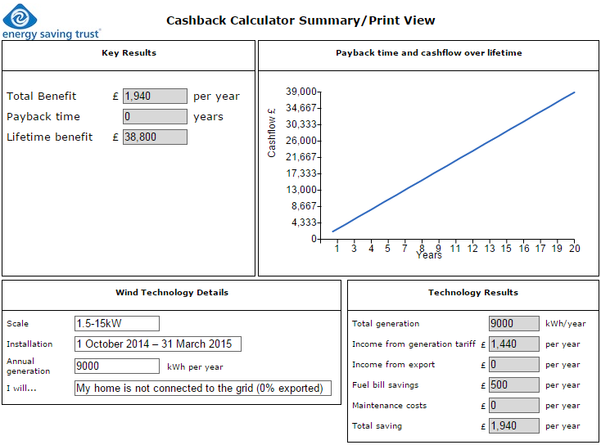

Appendix L

Appendix L shows bio diesel costs.

|  |  |  |  |
| --- | --- | --- | --- |
| Price of Biodiesel ( Cans - 20 L) | | | |
| Cans | 1 – 4 | 5 - 9 | 10 + |
| Price per can | £ 15 | £ 13.6 | £ 12.2 |
| Price per litre | £ 0.75 | £ 0.68 | £ 0.61 |

Appendix M

Appendix M shows the bio diesel generator full specification.

|  |  |
| --- | --- |
| Generator Spec | |
| Energy produced | 44 kW |
| Fuel tank capacity | 220 L |
| Fuel consumption | 9.5 L per h |

Appendix N

Swimming pool has dimensions: 25m long, 10m wide and height (varies).

Area of the side wall in the swimming pool is length x height.

$$A_{SW}=1m×4m+1.5m×17m+1.9m×3m$$

$$A_{SW}=35.2m²$$

$$Volume=A_{SW}×width$$

$$Volume=35.2×10$$

$$Volume=352m³$$

To change volume of the swimming pool into litres, volume needs to be multiplied by 1000.

$$Water\left(L\right)=352×1000$$

$$Water\left(L\right)=352000 L$$

Appendix O

Appendix O shows a comparison to electric and gas heaters.

|  |  |  |  |
| --- | --- | --- | --- |
| Comparison of the heaters and expenses | | | |
|  | Electric Heater | Gas Heater | Heat pump |
| Cost per hour | £ 2.836 | £ 0.861 | £ 0.425 |
| Cost per day | £ 68.05 | £ 20.66 | £ 10.21 |
| Cost per year | £ 24839.47 | £ 7539.51 | £ 3725.92 |
|  |  |  |  |
| Cost of the heater VAT | £ 2585.56 | £ 3824.7 | £ 10390 |
| Cost of the heater Ex VAT | £ 2154.63 | £ 3187.25 | £ 8658.34 |
| Total cost - 1st year (VAT) | £ 27425.03 | £ 11364.21 | £ 14115.92 |
| Total cost - 2nd year | £ 52264.5 | £ 18903.72 | £ 17841.84 |

Appendix P

Appendix P shows the gym layout.

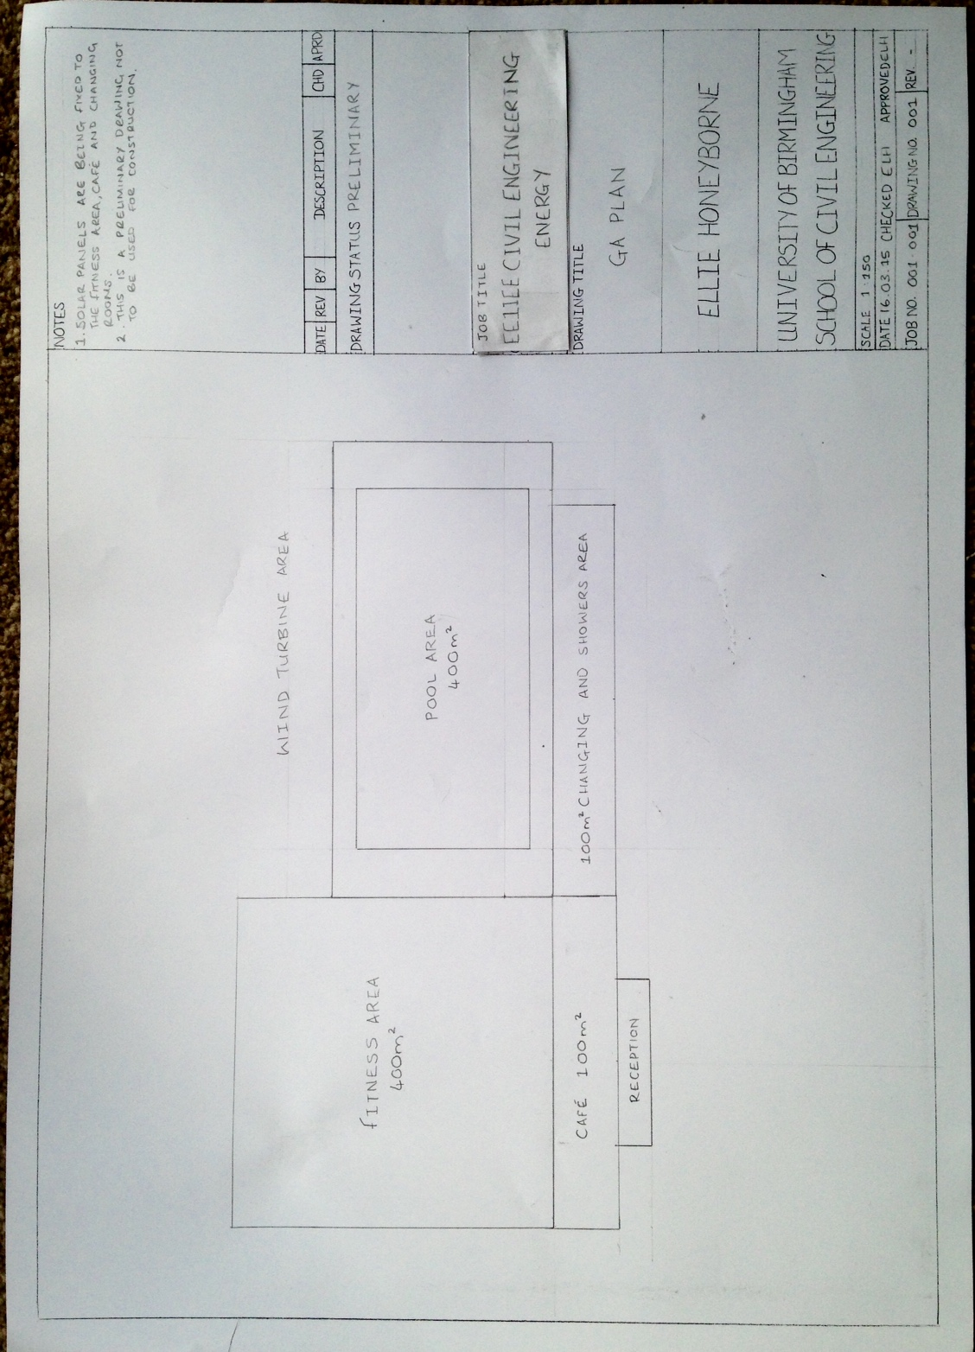

# 12.0 meeting minutes

# UOB

# Minutes of the meetings of energy engineering

Meeting 1

**Meeting held on**: **Meeting commenced at**: 9.00am

**Attendees**: Ellie Honeyborne, Iustin Irimescu, Dhruv Datta, Dami Shoroye, Jonathon Chin, Maicej Gorski

**- Start of minutes -**

**Apologies/Absence**: -

**Recording of meetings**: The proceedings of the first meeting assigned (Ellie Honeyborne) to the recording, distribution and archiving of meeting minutes.

**Actions from previous meeting:**

|  |  |  |  |  |
| --- | --- | --- | --- | --- |
| Action | Assigned to (initials) | Due by | Received | Comments |
| All team members to meet on 4th and discuss interim presentation | ALL | 04.02.15 | 04.02.15 |  |

**Agenda:**

|  |  |
| --- | --- |
| **Agenda Item** | **Discussion/Resolution** |
| Discuss data collection | EH look at data collection and ring up gyms etc. |
| Assign responsibilities for energy production etc. | MG and II to look at renewable energy storage and generation |
| Assign next meeting date | Tuesday 10th February |

**Actions:**

|  |  |  |  |
| --- | --- | --- | --- |
| Action | Assigned to (initials) | Due by | Comments |
| Start Interim Presentation | EH, DD, DS, II, MG, JC | 10.02.15 | Majority of work completed |

**Conclusion:**

* The next meeting is to take place at: 10th February 2015 – Learning Centre
* Timings and locations of future meetings will be discussed at the next meeting.

**Meeting concluded at: 11.00am**

**- End of minutes -**

Secretary: Ellie Honeyborne Chair: Dhruv Datta

Date: 10.02.15

# UOB

# Minutes of the meetings of energy engineering

Meeting 2

**Meeting held on**: **Meeting commenced at**: 1.00pm

**Attendees**: Ellie Honeyborne, Iustin Irimescu, Dhruv Datta, Dami Shoroye, Jonathon Chin, Maicej Gorski

**- Start of minutes -**

**Apologies/Absence**: -

**Recording of meetings**: The proceedings of the first meeting assigned (Ellie Honeyborne) to the recording, distribution and archiving of meeting minutes.

**Actions from previous meeting:**

|  |  |  |  |  |
| --- | --- | --- | --- | --- |
| Action | Assigned to (initials) | Due by | Received | Comments |
| All team members to meet on 10th and discuss interim presentation | ALL | 10.02.15 | 10.02.15 |  |

**Agenda:**

|  |  |
| --- | --- |
| **Agenda Item** | **Discussion/Resolution** |
| Look at and amend interim PowerPoint | Looked at pp |
| Assign slides for each person to read | EH to do gym layout, II & MG to do renewable energy |
| Prepare for interim presentation | Present on Wednesday 11th February |

**Actions:**

|  |  |  |  |
| --- | --- | --- | --- |
| Action | Assigned to (initials) | Due by | Comments |
| Be prepared for Wednesday | EH, DD, DS, II, MG, JC | 11.02.15 |  |

**Conclusion:**

* The next meeting is to take place at: 18th February 2015 – Learning Centre
* Timings and locations of future meetings will be discussed at the next meeting.

**Meeting concluded at: 2.00pm**

**- End of minutes -**

Secretary: Ellie Honeyborne Chair: Dhruv Datta

Date: 18.02.15

# UOB

# Minutes of the meetings of energy engineering

Meeting 3

**Meeting held on**: **Meeting commenced at**: 9.30am

**Attendees**: Ellie Honeyborne, Iustin Irimescu, Dhruv Datta, Dami Shoroye, Jonathon Chin, Maicej Gorski

**- Start of minutes -**

**Apologies/Absence**: -

**Recording of meetings**: The proceedings of the first meeting assigned (Ellie Honeyborne) to the recording, distribution and archiving of meeting minutes.

**Actions from previous meeting:**

|  |  |  |  |  |
| --- | --- | --- | --- | --- |
| Action | Assigned to (initials) | Due by | Received | Comments |
| Present Interim | ALL | 11.02.15 | 11.02.15 |  |

**Agenda:**

|  |  |
| --- | --- |
| **Agenda Item** | **Discussion/Resolution** |
| Discuss Interim score | Make sure to add more numbers in to back up our decisions |
| Assign responsibilities for final presentation | EH to look at gym design and machinery, II and MG to look at renewable energy, DH and DD insulation and heating, JH to look at total costings |
| Assign next meeting date | Tuesday 25th February |

**Actions:**

|  |  |  |  |
| --- | --- | --- | --- |
| Action | Assigned to (initials) | Due by | Comments |
| Start Final Presentation | EH, DD, DS, II, MG, JC | 25.02.15 | Ideas started |

**Conclusion:**

* The next meeting is to take place at: 25th February 2015 – Learning Centre
* Timings and locations of future meetings will be discussed at the next meeting.

**Meeting concluded at: 11.00am**

**- End of minutes -**

Secretary: Ellie Honeyborne Chair: Dhruv Datta

Date: 18.02.15

# UOB

# Minutes of the meetings of energy engineering

Meeting 4

**Meeting held on**: **Meeting commenced at**: 9.00am

**Attendees**: Ellie Honeyborne, Iustin Irimescu, Dhruv Datta, Dami Shoroye, Jonathon Chin, Maicej Gorski

**- Start of minutes -**

**Apologies/Absence**: -

**Recording of meetings**: The proceedings of the first meeting assigned (Ellie Honeyborne) to the recording, distribution and archiving of meeting minutes.

**Actions from previous meeting:**

|  |  |  |  |  |
| --- | --- | --- | --- | --- |
| Action | Assigned to (initials) | Due by | Received | Comments |
| All team members to meet on 25th and discuss final presentation | ALL | 25.02.15 | 25.02.15 |  |

**Agenda:**

|  |  |
| --- | --- |
| **Agenda Item** | **Discussion/Resolution** |
| Discuss data collection | ALL |
| Put information on PowerPoint presentation | ALL |
| Match up figures and check each other’s work | ALL |

**Actions:**

|  |  |  |  |
| --- | --- | --- | --- |
| Action | Assigned to (initials) | Due by | Comments |
| Finish PP presentation and practice individual speaking parts | EH, DD, DS, II, MG, JC | 03.03.15 | Majority of work completed |

**Conclusion:**

* The next meeting is to take place at: 3rd March 2015 – Learning Centre
* Timings and locations of future meetings will be discussed at the next meeting.

**Meeting concluded at: 11.00am**

**- End of minutes -**

Secretary: Ellie Honeyborne Chair: Dhruv Datta

Date: 25.02.15

# UOB

# Minutes of the meetings of energy engineering

Meeting 5

**Meeting held on**: **Meeting commenced at**: 5.00pm

**Attendees**: Ellie Honeyborne, Iustin Irimescu, Dhruv Datta, Dami Shoroye, Jonathon Chin, Maicej Gorski

**- Start of minutes -**

**Apologies/Absence**: -

**Recording of meetings**: The proceedings of the first meeting assigned (Ellie Honeyborne) to the recording, distribution and archiving of meeting minutes.

**Actions from previous meeting:**

|  |  |  |  |  |
| --- | --- | --- | --- | --- |
| Action | Assigned to (initials) | Due by | Received | Comments |
| All team members to practice their speaking parts for Final presentation | ALL | 03.03.15 | 03.03.15 |  |

**Agenda:**

|  |  |
| --- | --- |
| **Agenda Item** | **Discussion/Resolution** |
| Discuss the final PowerPoint presentation | ALL |
| Practice speaking parts and time it | ALL |
| Assign next meeting date | Friday 6th March |

**Actions:**

|  |  |  |  |
| --- | --- | --- | --- |
| Action | Assigned to (initials) | Due by | Comments |
| Keep info from final presentation for report | EH, DD, DS, II, MG, JC | 06.03.15 | Start the final report |

**Conclusion:**

* The next meeting is to take place at: 6th March 2015 – Learning Centre
* Timings and locations of future meetings will be discussed at the next meeting.

**Meeting concluded at: 7.00pm**

**- End of minutes -**

Secretary: Ellie Honeyborne Chair: Dhruv Datta

Date: 03.03.15

# UOB

# Minutes of the meetings of energy engineering

Meeting 6

**Meeting held on**: **Meeting commenced at**: 4.00pm

**Attendees**: Ellie Honeyborne, Iustin Irimescu, Dhruv Datta, Dami Shoroye, Jonathon Chin, Maicej Gorski

**- Start of minutes -**

**Apologies/Absence**: -

**Recording of meetings**: The proceedings of the first meeting assigned (Ellie Honeyborne) to the recording, distribution and archiving of meeting minutes.

**Actions from previous meeting:**

|  |  |  |  |  |
| --- | --- | --- | --- | --- |
| Action | Assigned to (initials) | Due by | Received | Comments |
| All team members to have finished report for checking | ALL | 06.03.15 | 06.03.15 |  |

**Agenda:**

|  |  |
| --- | --- |
| **Agenda Item** | **Discussion/Resolution** |
| Discuss final report | ALL |
| Cross reference calculations | ALL |
| Last team meeting | Thursday 12th February |

**Actions:**

|  |  |  |  |
| --- | --- | --- | --- |
| Action | Assigned to (initials) | Due by | Comments |
| Finish report | EH, DD, DS, II, MG, JC | 12.03.15 |  |

**Conclusion:**

* The next meeting is to take place at: 12th March 2015 – Design Centre
* Timings and locations of future meetings will be discussed at the next meeting.

**Meeting concluded at: 7.00pm**

**- End of minutes -**

Secretary: Ellie Honeyborne Chair: Dhruv Datta

Date: 06.03.15

# UOB

# Minutes of the meetings of energy engineering

Meeting 7

**Meeting held on**: **Meeting commenced at**: 4.00pm

**Attendees**: Ellie Honeyborne, Iustin Irimescu, Dhruv Datta, Dami Shoroye, Jonathon Chin, Maicej Gorski

**- Start of minutes -**

**Apologies/Absence**: -

**Recording of meetings**: The proceedings of the first meeting assigned (Ellie Honeyborne) to the recording, distribution and archiving of meeting minutes.

**Actions from previous meeting:**

|  |  |  |  |  |
| --- | --- | --- | --- | --- |
| Action | Assigned to (initials) | Due by | Received | Comments |
| Finish report | ALL | 12.03.15 | 12.03.15 |  |

**Agenda:**

|  |  |
| --- | --- |
| **Agenda Item** | **Discussion/Resolution** |
| Check final report and all read through | (EH to bring) ALL to read |
| Write meeting minutes up | EH |
| Assign handing in time (Canvas) | Friday 13th February |

**Actions:**

|  |  |  |  |
| --- | --- | --- | --- |
| Action | Assigned to (initials) | Due by | Comments |
| Hand in report | EH, DD, DS, II, MG, JC | 13.03.15 | With meeting minutes, appendices etc. |

**Conclusion:**

* The next meeting is to take place at: -

**Meeting concluded at: 7.00pm**

**- End of minutes -**

Secretary: Ellie Honeyborne Chair: Dhruv Datta

Date: 12.03.15