ELECTRONIC, ELECTRICAL AND COMPUTER ENGINEERING





EE2E1 2014/2015

Introduction to Java Programming

Programming Exercise 1

Editing, compiling and running Java programs

Dr M. Spann

- Aims and Objectives

This is a gentle introductory (and non-assessed!) lab, which is aimed at learning how to use the Java programming environment, and, in particular, how to compile, edit and run Java programs using the TextPad text editor. Also, it will cover the simple use of strings as well as the Arrays class.

- Preparatory Work

Read the appendix to this document where the basic use of TextPad has been described.

3. Lab Work

3.1 Inputting a simple Java program

Type into the TextPad main editing window the following program.

import java.util.*;

public class MyFirstApp

{

public static void main(String args[])

{

String myName=" "; // Enter your name here

System.out.println("My name is " + myName);

}
}

Initialize the string myName to your name. Save your file in a filename called “MyFirstApp.java”. You may wish to create a sub-directory to store all of your Java source code. Compile and run this program. If you get an error when you try to run the program, close the file and re-open it by accessing it through the Y drive path directly.

Try creating a compilation error (for example change the word System to Sstem). Re-compile the program and observe how TextPad flags the error. Note that importing java.util.* is not necessary for this program to work. It is for later.

3.2 Entering your name from the command line

It is easy to enter your name as command line arguments. Thus when you run the program you use the command line :

java MyFirstApp John Smith
In this case, args[0] would be John and args[1] would be Smith. Re-write the above program with your name entered from the command line. You will have to select Tools – Run on TextPad to input the command line parameters. (In the Parameters box, MyFirstApp is the first parameter (the name of the class file to be run) and the next two parameters are John and Smith which are args[0] and args[1].)

3.3 Using the String class

The String class has a number of useful methods for manipulating strings. Thus length() returns the length of a string (number of characters including internal space characters) and charAt(index) returns the character at position index in the string with the first character being index 0.

Use these methods to enable your program to print out your name in reverse.

Also check out other methods of the String class using the java documentation at docs

3.4 Using the Arrays class

There are hundreds of classes in the Java API and many hundreds if not thousands of methods. No one can learn how to use all of them. One of the key skills in Java programming is to be able to quickly and efficiently use the online documentation to find out how to use a particularly class and its methods.

Suppose we want to sort the string containing our name into alphabetical order. Again using the documentation, look at the methods of the Arrays class. See if you can find a suitable sort() method. Use this method to enable your program to print out an alphabetically sorted version of your name. Note that the Arrays class is in the java.util package which explains why this package has to be imported. (The String class on the other hand is in the java.lang package which is automatically imported).

A key point to note is that the sort() method is a static method of Arrays and hence is called through the class name - in other words as in Arrays.sort(). In contrast, the String methods referred to in the previous section are non-static and hence are called through the object name - in other words as in str.length() where str is the object variable name of class String. If you still are not clear about the distinction after you have had the lecture on classes, please ask!! This is an important concept.

Appendix

The TextPad text editor

Introduction

TextPad is a simple multi-file Windows-based text editor. You can consider TextPad to be similar to NotePad but more powerful. It is easy to use and very flexible.

The nice thing about TextPad for our purposes is that it is easy to link it with the Java sdk (Standard Development Kit) installed on your computer (at the time of writing this lab sheet, the currently installed version is j2sdk1.5.0). This contains, for example, the tools for compiling (javac) Java programs and running the command interpreter (java). Thus your application (or applet) source files can be loaded into TextPad and then compiled and run from simple button clicks from the TextPad toolbar.

TextPad contains many fancy features, far too many here to list. However, ones that you will immediately find useful are a spell checker, line numbering and a simple way of switching between the currently displayed file.

Using TextPad

Using TextPad for the first time is easy. Clicking on the TextPad icon on the desktop or invoking it from Start – Programs - TextPad puts up the main TextPad window. Along the top is the main toolbar. There is the main editing window and a window to the left of that displaying the source files which have been loaded. This will initially be empty.

Clicking File – Open loads in a source file and its contents are displayed in the main editing window. Note that if it is a Java program, key words (such as public and class) are colour coded blue. The name of the source file is then displayed in the left hand window. You can load in as many files as you like and each filename appears in the left hand window. It’s easy to switch between currently displayed source files – just click on the file you want to display in the left hand window.

Another useful tip is to enable line numbering in the main editing window. This is easily done by clicking the View button in the tool bar and then clicking Line Numbers. The line numbers then appear down the left hand side of the main editing window. The figure below shows the TextPad window open with a Java program¸ MyFirstApp.java, loaded. Also, line numbering has been enabled.

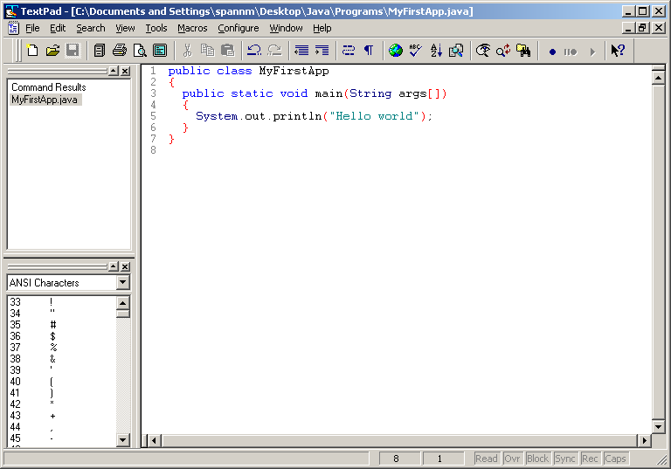

Once you have loaded in a Java source file, you will want to compile and run it. This again is easy in TextPad. Click on the Tools pull down menu and then Compile Java to compile your program. After compiling, if there are errors, these appear in the main editing window if Command Results is selected in the left hand window. The offending line numbers are displayed. Once you have corrected all of the compilation errors, select Run Java Application and the program runs in a command window. If you select the Run option, a pop up window appears and you are asked to input the command and any parameters. The command in this case will be java and the first parameter is MyFirstApp. Any other command line parameters will follow in the same box.

That’s about the basics. Obviously, for large applications there will be multiple files, but selecting Compile Java for the file contain the main method ensures that all files which have been updated will be compiled automatically (rather like the Unix make command) so you don’t have to worry about separately compiling individual files.

