



EE2E1 2010/2011

Introduction to Java Programming

Programming Exercise 4

Graphical User Interfaces

Dr M. Spann

- Aims and Objectives

This is the third of the assessed Java labs and is about implementing a graphical user interface to create an ImageToy game. This is an electronic version of an old children’s game which re-creates a jumbled up picture by moving one piece at a time. Figure 1 shows an original image and it’s jumbled up version with one piece of the original image missing thus creating a gap in which to shuffle individual pieces. By convention the piece at the bottom right of the original image has been removed and then the image shuffled. The image can be re-constructed by moving the mouse pointer into a piece of the shuffled image adjacent to the gap and then clicking the mouse button. This then swaps the image piece and the gap.

- Preparatory Work

This assignment will make use of some of the code for the MouseTracker program that we looked at in a previous lecture. You will also need to be able to deal with images. In a previous lecture we looked at a program to load and display an image. I have written a simple Java class called ImageLoader which enables you to load an image (either a gif or jpeg file) using a file dialogue box, display the image in a graphics frame and store the loaded image as a BufferedImage object as a private instance field of the class. You can download ImageLoader.java by going to http://www.eee.bham.ac.uk/spannm/Java Stuff/Jtest/ImageLoader.zip and you are free to include this code as part of your program. You will find the functionality of the BufferedImage class very useful in this exercise so check out the online documentation for this class.

As a guide to how the program should work, I have written a version as an applet, which you are free to play. Check out http://www.eee.bham.ac.uk/spannm/Java Stuff/ImageToyApplet/ImageToyApplet.html. You can choose 1 from a short list of pre-selected images, which are on my web-page, to play with. (Applets are somewhat restrictive when it comes to accessing file systems. Applications have no such restrictions.)

- Lab Work

Implement the ImageToy as a Java application. Use the code in ImageLoader.java to load any image stored as a gif or jpeg file and display it. Your program should ask the user for the number of pieces in which to shuffle the image. It should then randomly shuffle all of the pieces of the image. The number of pieces in the shuffled image, and hence the difficulty of reconstructing the image, should be left as a user choice. (Think carefully about how to shuffle the image. Your program must be able to ‘un-shuffle’ the shuffled image back to its original form by moving image blocks into the adjacent gap. Just randomly moving image blocks around won’t necessarily give you this!)

Finally it should then allow the user to play the game by clicking on pieces to move them. Clearly, only if the user clicks on a piece adjacent to the gap should the piece be moved.

Think carefully how you want to represent the shuffled image. You should certainly avoid having to store the original image and its shuffled version as separate images as this is very inefficient!

4. Extension lab work

Using image analysis and machine intelligence techniques, implement an algorithm that is able to automatically re-create the original image from the shuffled version.

(Only kidding!!)

5. Assessment

As in previous labs you will be assessed on the basis of a formal report. The formal report should include the headings outlined in the Introduction to the Java Programming Laboratories document plus any additional headings you want to include. However, you will also be expected to give a brief demonstration of your program during the lab and your final mark for the assignment will reflect the demonstrated functionality of your program as well as the quality of the report.

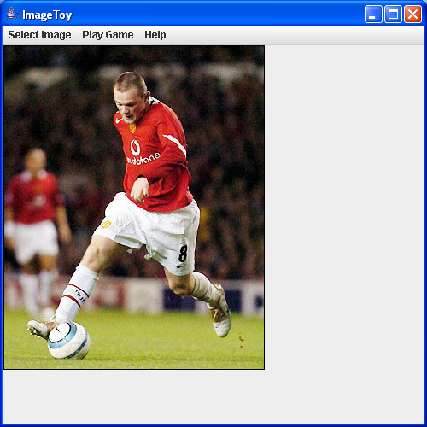
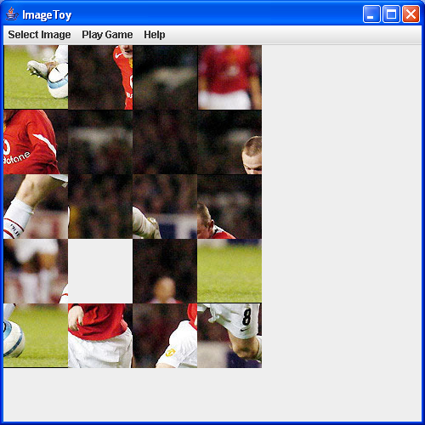
Figure 1

