|  |
| --- |
| University Of Birmingham |
| EE3GP MEng Group Project |
| Group C ‘Dancing Broom’ |
|  |
|  |
| **12/13/2013** |

Aaron Lyons

Kh Sam

Kavin Kalai Selvan

Sam James

Piotr Opacki

Alex Farmer

Liew Kit Shen

|  |
| --- |
|  |

Contents

Executive Summary 2

Introduction 2

Functional Decomposition 3

Group Management Structure 3

Group Organisation 4

Group Contract 4

Time Management 4

Cost Analysis 5

Literature Review 6

Market Research 6

Inverted Pendulum 6

Electrical Design 8

Communication Network 9

Communication methods 9

Communication Laws 10

Vision System 10

Software Choice 10

Control System 11

PID Controller 11

Fuzzy Logic Controller 12

Comparison between PID controller and Fuzzy Logic 12

How we plan to use Fuzzy logic in our system 12

Mechanical Design 12

Omni-Wheels 13

Three / Four wheels 13

The X-Y table 13

Technical Review 14

Electronics Implementation 14

Power Converters 15

Block/Board Diagram 15

Microcontroller Choice 16

Pseudo Code 17

PSEUDOCODE #1 17

PSEUDOCODE #2 18

Mechanical Design 18

Vision System 19

Background subtraction 19

Using threshold for image processing 20

Using feature detection 20

Control System and Fuzzy Logic 22

Modelling noise and disturbances 22

Modelling the Lag of the webcams 22

Finding the transfer function of the plant 23

Moment of Inertia 23

Fuzzy Logic Control System 23

Calculating acceleration of base of platform 24

Creating the Fuzzy Controller in Lab View 24

Combining the Visual System and the Fuzzy Controller 24

Experimental Verification of Analytic Material 24

Centre of Mass 25

Coefficient of Friction 25

Moment of Inertia 25

Minimum Time Response 25

Problems Encountered 26

Software: 26

Calculating the Moment of Inertia 26

Purchasing of Materials 26

Hardware: 27

Simplification of the Specification 27

Future Plan and Conclusion 27

Further Detail into Future of Electronics 28

Further Detail into Future of Control System 29

Further Detail into Future of Control System and System Integration 29

Further Detail into Future of Mechanics 30

Conclusion 31

Appendix I: References 32

Appendix II: Summary of Meetings 34

Appendix III: Signed Group Contract 35

Appendix IV: Work Breakdown Structure 37

Appendix V: Critical Path Diagram 39

Appendix VI: Vision System in Lab View 41

Appendix VII: Vision System in Lab View 41

Appendix VIII: Creating the Fuzzy Controller in Lab View 42

Appendix IX: Connecting Control System and Vision System together 44

Appendix X: Calculations for finding the moment of inertia 45

Appendix XI: Calculations for finding the plant transfer function 47

Appendix XII: Flow Charts 51

Appendix XIII: CV Liew Shen 52

CV: Alexander Farmer 55

CV Sam James 58

CV Piotr Opacki 60

CV Kavin Selvan 63

CV Aaron Lyons 65

CV Sam Hau 67

# 

# Executive Summary

Balancing a broom on a hand or finger has always been a difficult activity. This report provides an analysis into the University of Birmingham’s MEng Group project 2013-2014 for the ‘Dancing Broom’ and the design solutions which have been developed to overcome this problem. The report looks at the group and time management as well as the technical achievements. It also provides an in depth background into the problem and the group’s solution to this problem.

Group C have come up with a modern world solution to this problem. We aim to use a real time active vision system within two planes to detect the brush. The brush will be connected to a moving platform whose movement is designed to counteract the movement of the brush.

The research section draws attention to the need for holonomic motion, to provide the platform with the capability to move in 360 degrees and to allow it to respond to the brush falling in any direction. Further research revealed that the best way to go about this would be through the use of four Omni-wheels. The report delves into the fundamentals of control systems and how they will be used within this project. Finding that an appropriate controller would be required, it was concluded that the Fuzzy controller would be most appropriate with a set of rules relating the angle of deviation and the acceleration of the platform. The main factors which need to be considered when developing the control system is the physics behind the falling broom, such as the moment of inertia, centre of mass and critical angle.

# Introduction

In times of intense boredom, we have all been tempted to have a go at balancing a ruler or pencil or even a brush on the end of a finger. Sometimes we are quite successful, and sometimes it ends in disaster, but it doesn’t stop us trying.

And sometimes, in search of excitement, we’ve had a go at riding a Segway PT or even a unicycle, again with varying degrees of success.

All of these activities can loosely be described as an inverted pendulum problem, where the centre of mass is above the pivot point. If you manage to keep the pivot point directly below the centre of mass then you will have great success, if you don’t then failure is on the cards.

With the ruler on the end of your finger your natural reaction is to move your hand forwards and backwards and side to side to maintain the balance. You are actually, without really knowing it, trying to keep the pivot point directly below the centre of mass.

Our group report will look into different solutions to balancing a household broom on a moving platform. Think of the broom as the ruler and the moving platform as your hand going forwards and backwards and side to side.

The specification states that we are required to design, prototype and demonstrate a system which is able to balance a broom vertically upright on a moving platform with a real time multi-view active vision system. Figure 1 gives a visual description of the specification.

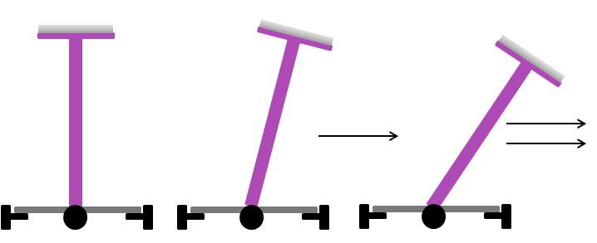The report is divided into four main sections, it will first consider the group and time management structure, and it will then go onto the literature review. It will then go on to describe our solution and finally the future plans for the remainder of the project.

Figure 1: Diagram of the specification

The purpose of this report is to introduce our groups design idea, through the use of 3D modelling, circuit diagrams and block diagrams. It aims to take you step by step through each stage which was undertaken and our current result.

# Functional Decomposition

Before jumping straight into the project, it is best to break the specification down into parts. This gives more of an idea of what the sections required are and the dependencies of each part on other parts. The functional decomposition diagram for our project is shown below in



Figure 2: Functional Decomposition Diagram

# Group Management Structure

The group management structure was developed using the functional decomposition from figure 2. We wanted to assign roles to the main parts to the group depending entirely on each group member’s strengths and weaknesses. As we want to try and get the most out of each team member to ensure that the project is as successful as it could possibly be. Therefore we decided on the following roles:



Figure 3: Group Management Structure

* Project manager is in charge of the time management, organising meeting, designating tasks and ensuring that the group work as effectively as a team as possible.
* Electronics is in charge of the communication network, the motor drive system, software development
* Control System is in charge of the controller and the physics behind the project, they must find ways of running two control systems at the same time to ensure the system is as efficient as possible.
* Vision System is in charge of getting the two cameras to detect the location of the brush and to determine the angle of deviation of the brush and output this angle as the output of the feedback loop.

# Group Organisation

To ensure that the group maintained communication throughout the project, we held regular meetings every week with our supervisor and also created a Facebook group and shared Dropbox account so that work could be quickly shared. Minutes were taken from each of the meetings for proof of what was said as well as the action points which were decided upon for referencing. Appendix II on page 33 shows the summary of the meetings so far.

# Group Contract

Before we began the project, we made a group contract; this included all the rules which should be abided by throughout the project, to ensure that marks aren’t taken off and to more importantly ensures that we work as well as possible as a team and to get the best outcome from the project. All group members signed the contract and therefore agree with all the points raised. The Group Contract is included within Appendix III: Signed Group Contract on page 34.

As well as a group contract, we also had to fill a full hazard and risk assessment form and hand it in before any items were purchased or any development could begin. This is to cover ourselves and the University in case there are any problems during the project. It includes the hazards, the people at risk and the control methods implemented to prevent these hazards.

# Time Management

Once the roles and tasks for the project had been decided upon, we needed to develop a time management plan. This was devised to ensure that the project is completed on time as well as to the best of our ability and to give a structure to the project. We decided to go about the time management in stages as shown below:

1. Work Breakdown Structure (WBS)
2. Gantt Chart
3. Critical Path Analysis

Each one of these provides different information and a different outlook into the time management of the project.

The work breakdown structure is the starting point of all time management plans. It includes all of the tasks required to complete the project, as well as the number of days, the people and the resources required. The breakdown structure of our project is shown in Appendix IV on page 36.

The Gantt chart shown below gives a graphical representation of the WBS; it also allows us to see when we require multiple tasks to be completed at the same time. This has been our main reference point for the time management for the project so far:

However a great way to work with tasks which run parallel to one another is through Critical Path Analysis. The Critical Path Diagram is shown in Appendix V on page 38 as well as the table for the critical path diagram. This shows both the latest and earliest times in which we can complete each of the tasks before it will have an effect on the rest of the tasks.

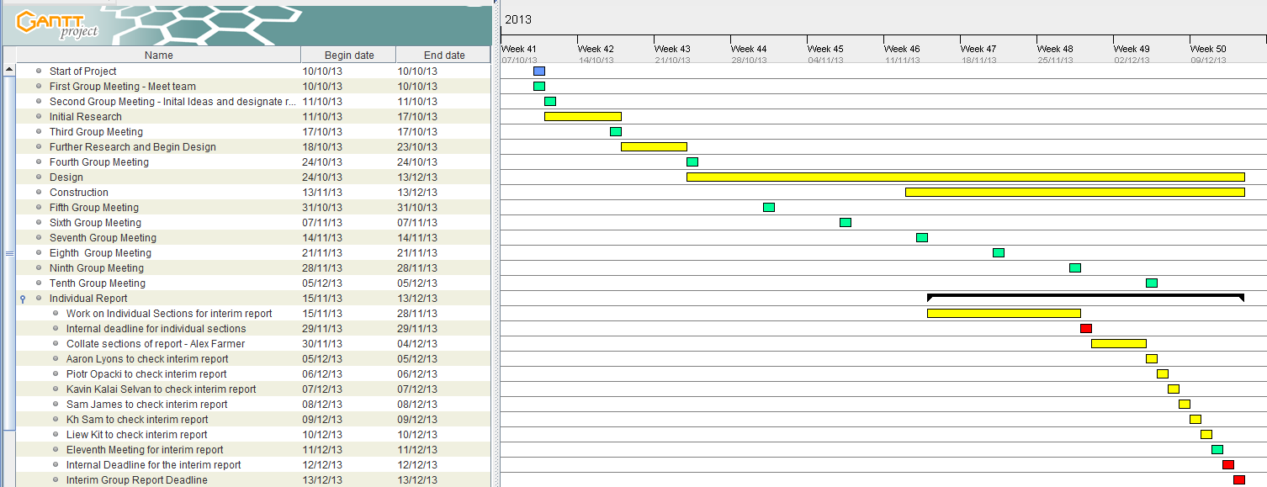

Figure 4: Research and Individual Report, Gantt chart

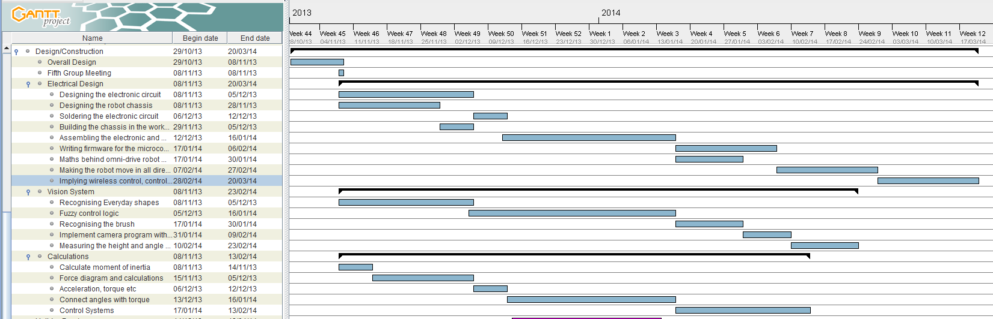

Figure 5: Design/Construction, Gantt chart

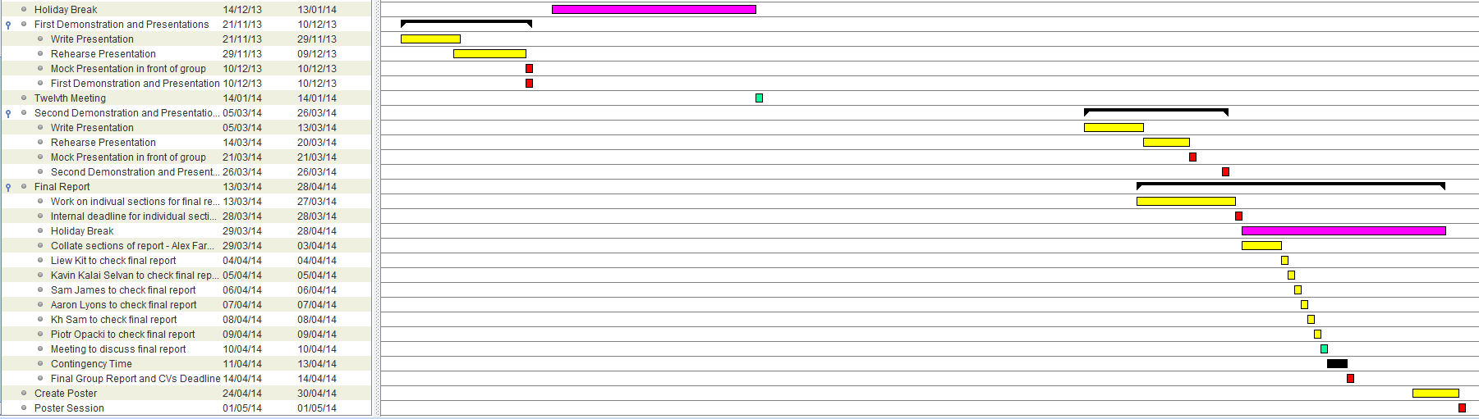

Figure 6: Second Demonstration and Final Report

# Cost Analysis

For this project we have been assigned £1200 to spend. All purchases were run through the entire group first and only the project manager is able to place the order. To make sure that we kept track of all of the items purchased an excel document was created, similar to the example shown below in figure 7. This includes the name of the supplier, the product code and description, the cost and the total amount of money spent so far. We also decided to set aside £200 as contingency budget just in case something goes wrong and we need money to correct this. As can be seen from the figure 7, we have so far spent £282.61, this means we still have £917.39 left; this should easily be enough as we have already purchased the main components.

|  |  |  |  |  |  |
| --- | --- | --- | --- | --- | --- |
| **Supplier** | **Product Code** | **Description** | **Unit Price (Excluding VAT)** | **Quantity** | **Total Price (Excluding VAT)** |
| Farnell | 1576881 | Microcontroller - PIC24HJ128GP502 | £4.75 | 2 | £9.50 |
| Farnell | 403295 | Motor Driver – L298 | £4.70 | 2 | £9.40 |
| Farnell | 1564682 | Voltage Regulator (5V) | £2.82 | 1 | £2.82 |
| Rapid Electronics | 533-3254 | Voltage Regulator (3.3V) | £2.90 | 1 | £2.90 |
| RS components | 715-7217 | RADIAL LEAD INDUCTOR 68UH | £1.69 | 1 | £1.69 |
| RS components | 715-7175 | BOBBIN INDUCTOR 100UH | £2.11 | 1 | £2.11 |
| Active Robots Limited | **16002** | FAULHABER 12V DC CORELESS MOTO | £60.23 | 2 | £120.46 |
| Active Robots Limited | **14145** | 60MM DOUBLE ALUMINIUM OMNI WHEEL | £17.15 | 2 | £34.30 |
| Active Robots Limited | 18020 | 6mm Nexus Robot Hub 18020 | £6.85 | 2 | £13.70 |
| Rapid Electronics | 22-0930 | 8 Way Crimp Housing | £0.16 | 4 | £0.64 |
| Rapid Electronics | 22-0975 | 8 Way Straight Header | £0.28 | 4 | £1.12 |
| Rapid Electronics | 22-0915 | 4 Way Crimp Housing | £0.08 | 4 | £0.32 |
| Rapid Electronics | 22-0960 | 4 Way Straight Header | £0.15 | 4 | £0.60 |
| Farnell | 1642369 | Amber Wireless – AMB2560 | £60.69 | 1 | £60.69 |
| Farnell | 1642368 | Amber Wireless – AMB2520 | £17.32 | 1 | £17.32 |
| Stores | - | Veroboard | £1.28 | 3 | £3.84 |
| Stores | - | Crimp Recepticles | £0.02 | 60 | £1.20 |
| **Total Cost** |  |  |  |  | **£282.61** |

Figure 7: Items bought so far in the project

# Literature Review

The aim of the literature review is to understand the options available to us and to allow us to make informed choices regarding our project decisions. This section has been split into four main categories:

1. Market Research
2. Electronics
3. Control Systems
4. Mechanics

## Market Research

We started our research by looking into what is currently available on the market, to allow us to think outside the box and to see if there are things out there already which could improve our project. Market research allows us to set realistic targets and to get a good understanding into the field we plan to go into. We came across multiple projects which are similar and these are explained below:

### Inverted Pendulum

Initial research showed that for us to be able to balance a broom, we will need to know the physical elements that act on the broom. This led to us to identifying what forces are acting on the broom to cause it to fall, and how we would go about calculating the identified parameters. Ogata (2010, p. 68) shows a common free body diagram of an inverted pendulum (figure 8), that allows us to visualise (in 2d form) the forces that act on the broom.

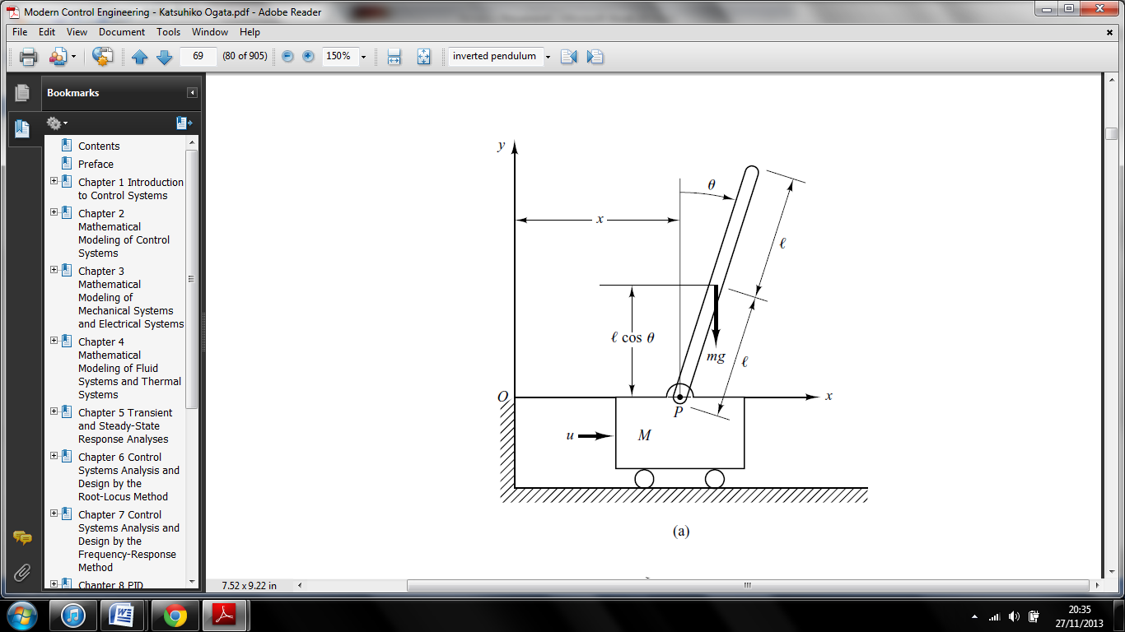

One of our design ideas is to create a moving platform for our broom, which can be likened to the cart in the inverted pendulum control problem. With this in mind, we identified that the key parameters that we will need for the physics of the broom are the mass of the broom and base, the friction of the cart and the moment of inertia of the broom. Sultan’s (2003, pg 13-62) report shows system parameters that are similar to these outlined showing that we are on the right lines.

Figure 8: Inverted Pendulum Force Diagram

Calculating the moment of inertia for our broom will differ from the inverted pendulum projects, due to the broom not just comprising of a simple rod with a moment of inertia of $\frac{1}{3}Ml^{2}$. We identified that our broom is made up of two composite shapes (a hollow cylinder and a cuboid brush end). According to (Venable 2010 pg. 13-16), the parallel axis theorem allows us to combine moments of inertia for separate entities, with respect to the centre of gravity, as long as they are both through the same axis

Upon observation, the centre of gravity for the broom needs to be found, as due to the weight of the brush end, the centre of gravity is not central, and is needed to calculate the moment of inertia. The experiment to find the centre of mass is to hang the object from the ceiling, then using a plumb bob, trace a line vertically down, before repeating on multiple points to find an intersect (Berkeley 2013, pg 1) .

We believe we will also need to identify what the critical angle of our broom is, i.e. how far can the broom go before it completely falls. Gustavo (n.d, Pg. 2) suggests however that for every excitation amplitude and frequency, there is a maximum critical angle of release, which will be larger based on how stable the final system is. This implies that it may not be necessary in our calculations to find the critical angle as we first thought.

The equations of motion will allow us to describe in terms of motion with respect to time, the behaviour of our system. Jeremic’s (2012, pg 1-45) presentation shows a possible method to deriving these equations for an inverted pendulum using Lagrangian equations. From observation, most pendulum projects have used these mechanics as opposed to other methods like Hamilton’s equations.

Deriving these equations for our system will allow us to create a mathematical model for our system. This will include us obtaining a transfer function for our system that will define its stability, as well as having a state space representation of the system. Having these calculations will ensure we can model and analyse our system easily and effectively.

Other than the inverted pendulum, our research on similar designs mostly led us to self-balancing robots. Whilst these could be considered as similar project examples, they only work in one direction (x axis) and provide no extra information regarding control systems and implementing a camera vision system to the inverted pendulum example.

A pencil balancing project from an institute of Neuroinformatics group (2008, pg 2-4) provides us with an example system that can work in both the x and y axis, however, they use dynamic vision sensors instead of cameras for their vision system. Although, they do talk about how they created independent algorithms for each axis, before finding the position with a combination of the two, which may be a suitable method for our system progression.

## Electrical Design

The elements that need to be looked at when considering the electrical design include the choice of motors we could use and the communication methods available. There are two main types of electric motor: direct current (DC) and alternating current (AC). Due to a simpler control, higher efficiency and popularity of DC motors in robotics, we have decided to go with the DC Motor.

From E. H. Werninck (1978, p48), we found the advantages of using DC motors are that they have increased flexibility and control to their AC counterparts. They also are capable of operating over a very wide range continuously.

|  |  |
| --- | --- |
| **DC** | **AC** |
| Popular in robotics | Popular in industrial applications |
| Easy to control using a microprocessor | Requires more advanced circuitry to provide at least two-phase power |
| Comes in easy to install small sizes | Usually comes only in large sizes to drive big loads |
| More models available | Fewer models available |

Figure 9: DC vs. AC Motors

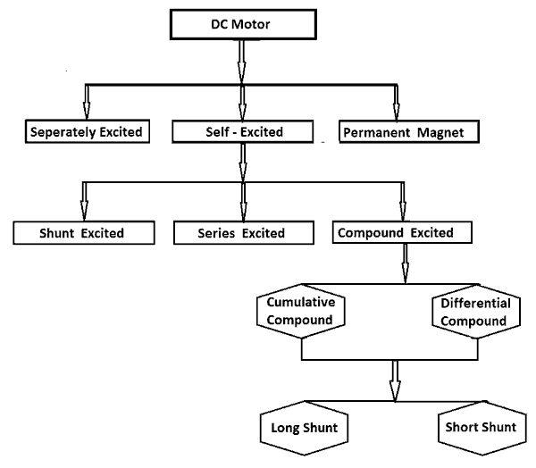There are many types of DC motors on the market as shown in figure 10. From (Jeff Keljik, 2009, p.5) it says that “Shunt, series, compound and permanent magnet motors are all widely used”. He also explains that the difference between them is that a shunt motor has the field circuit and armature connected in parallel, whilst a series motor has them in series, and a compound has both windings. Finally a permanent motor only has an armature connection.

Figure : Types of DC motors ([http://www.electrical4u.com](http://www.electrical4u.com/), Oct 2013)

Because we require a high precision of movement from the platform, we could use brushless stepper motors (permanent magnet). “In stepping motors rotation is produced by sequentially switching suitably connected windings to produce discrete angular steps of essentially uniform magnitude.” (E. H. Werninck, 1978**,** p553). The biggest drawback for these motors however, is their dramatic decrease in torque with speed. Our platform must be able to accelerate quickly in order to keep the broom steady at all times.

A high performance alternative is a servomotor. It uses a control circuit and a position sensor to achieve closed-loop feedback and deliver constant torque. Servomotors were originally designed to rotate their shaft by a certain angle and then stop, however we want our wheels to rotate continuously which would mean having to modify one. A servomotor, in simple terms, is a DC motor with all the electronics built into the package. A breakdown of differences between the two can be found in figure 11.

|  |  |
| --- | --- |
| **DC** | **Servomotor** |
| Torque can drop at low speeds | Built in control circuit provides continuous torque |
| Connects with just 2 wires | Requires 3 wires: 2 for power and 1 for control |
| Cheaper | More expensive |
| Requires a motor driver chip | Comes with the built in electronics |
| Can be difficult to mount | Comes in easy to install package |
| Doesn’t provide position feedback | Can move the shaft very precisely |
| Shaft rotates freely around full 360 degrees | Requires modification in order to rotate one full circle |

Figure 11: DC vs. servomotor comparison

Since a servomotor is basically a DC motor with built in shaft position encoder and motor driver we have chosen to use DC motors. We don’t need position feedback but we need a good value motor for our money. Rather than modifying a servomotor for continuous operation we will simply buy a DC motor and a driver chip which will cost less in total.

## Communication Network

Our initial research into communications found that Howstuffwork (2000, pg 6) provided a basic introduction into radio communication via a simple wireless transmitter and receiver. It suggested using a sine wave oscillator (carrier signal), before modulating this with the signal we intend to communicate to the robot with. We could possibly use an LC circuit for the oscillator and a transistor circuit for the modulation. We could then possibly boost the signal with a transistor power amplifier.

For the receiver on the robot we thought about using a filter to demodulate the received signal. However, upon speaking to the group at our second meeting, we decided that this solution would be too complicated, especially as we would have to take the output signal from the computer USB port and transform this into a broadcast-able signal.

### Communication methods

We looked into the different types of communication methods. Figure 12 shows the results which we found:

|  |  |  |
| --- | --- | --- |
| **Option** | **Advantages** | **Disadvantages** |
| **Radio Frequency** | Can design ourselves or buy pre-made packages  Used for short or medium range communication  A range of data rates |  |
| **Infrared** | Easy to build  Can use built-in modules inside PC | Needs line-of-sight without obstruction  Used for very short (~5m) range communication |
| **Satellite** | Very high data rate | Delay as signal is transmitted  Would have to hire space on a satellite  For long range communication |
| **Bluetooth** | Useful for purposes previously involving infrared  Easy to set up with pre-existing devices | Low bandwidth  Not good for large amounts of data |

Figure 12: Different forms of communication methods

### Communication Laws

We need to ensure we comply with all communication laws throughout our design. We started by looking at the OFCOM (The Office of Communications) website. At first we found an online copy of the Communications Act 2003, Part 2 of which detailed the law and legislation surrounding “NETWORKS, SERVICES AND THE RADIO SPECTRUM”. This was a detailed legislation in which we didn’t understand the legal terms.

Instead we found a “Guide to the use of radio transmitters and the law”, which simplified the legislation. From this we found that we are likely to be exempt from needing a license if our purpose came under “model control equipment” or if we kept our communications to low power. From further investigation we found a comprehensive frequency allocation list (UK), showing frequencies under 8.3KHz and above 27GHz are unallocated, hence free to use.

However, as we came to the conclusion that we were likely to use pre-made transmitter/receiver/transceiver modules we checked the frequencies that are used. The main frequencies used are: 433MHz, 868MHz and 2.4 GHz. As these are not unallocated frequencies according the list we found earlier we were unsure if they would be OK to use. However, we spoke to Edd Stewart, our supervisor, about this and he informed us that this law was only applicable to those intending to design and create new products. Thus, we would be able to buy products that used these frequencies as it can be assumed that the manufacturer has gained the necessary license for them and therefore we would not need to gain one of our own.

## Vision System

The vision system is the sensor for our project, and will be within the feedback loop of our control system. It will firstly detect the object and the location of it, and then calculate its angle of deviation away from the equilibrium position.

### Software Choice

The first thing that needed to be research was which software to implement our vision system on. We identified these as either Lab View, or Matlab. From Lent (2013), we found that with Matlab, we get a tool to build ‘graphical, mathematical and user interfaces’. National Instruments state that Lab View is a ‘comprehensive tool for control systems and measurements. This is furthered by Halvorsen (2013, pg1), telling us that it a tool for data acquisition, instrument control and industrial automation. From these general definitions, we see Lab View as suitable for our control and vision systems.

Choosing between wired and wireless cameras was our next choice to make. After talks with the technicians, we decided keeping it simple and stay with wired to begin, then moving to wireless afterwards if we have time. The placement of the cameras is important to give accurate results. Putting them on the platform could be risky due to the robots vibration, whilst having them separate to the robot could become problematic if the robot leaves the cameras line of site.

## Control System

The control design will be one of the most vital aspects of the project, as it will ultimately define how the broom will be stabilised continuously. A block diagram of the system is created so that the operation of the system can be visualised. We are looking to create a type of automatic controller, which will be able to compare the desired system input to the deviated output, and be able to correct the error continuously. This type of controller is explained in Ogata’s book Modern Control Systems (pg 21-22).

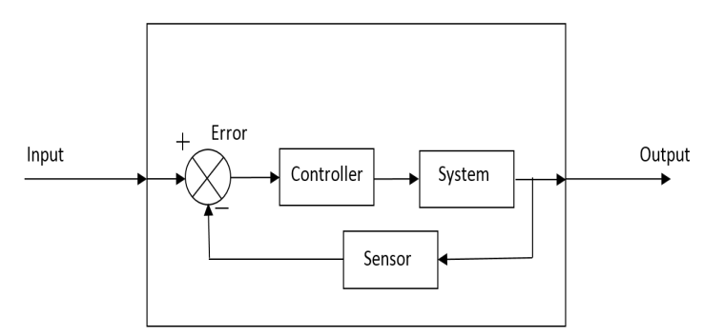With reference to Hill’s Standard handbook of electronic engineering (19, pg 1359-1360), we see a control similar to our one above to describe our idea for the system: Our sensor system will be implemented using the vision system. For our controller we have the option to use either traditional (PID) control methods, or more modern (fuzzy logic) methods. Whilst traditional methods are familiar to us, we have yet to use more modern methods.

Figure 13: Basic Control System

### PID Controller

The first type of controller we researched into is the PID controller (Proportional-Integral-Derivative controller). Astrom and Hagglund (1995, p.1) states that “The PID controller has several important functions: it provides feedback; it has the ability to eliminate steady state offsets through integral action; it can anticipate the future through derivative action.”

The PID controller consists of three major parts, proportional, integral and derivative, which we can change to get the optimal response from our controller. Figure 14 shows a basic PID controller block diagram.

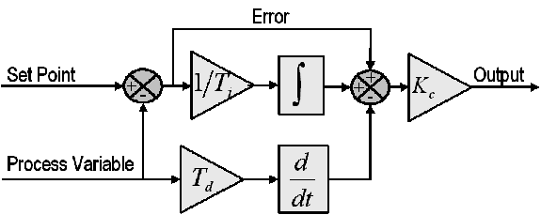To find out the values for the PID controller gains, we need to use a method called the ‘Ziegler Nichols Method’. An inverted pendulum using PID control was found on [ctms.engin.umich.edu](http://ctms.engin.umich.edu/) that shows a system model of an inverted pendulum with the use of PID control through MATLAB. The process used in this example proves useful insight on how we would go about implementing the control of our system. The accompanying page on system modelling provides us with further information on what was discussed previously regarding the mathematical model of the system.

Figure 14: Basic Idea behind the PID controller http://www.ni.com/white-paper/3782/en/

### Fuzzy Logic Controller

Fuzzy control system is a control system based on fuzzy logic, a logical system that is much closer in spirit to human thinking and natural language than the traditional logical systems. Therefore, fuzzy logic provides conversion of knowledge from expert to a linguistic control strategy used as automatic control strategy. Instead of assuming a statement must be true or false as traditional techniques, fuzzy logic permits varying degrees of truth (Bucknell, n.d, pg 1-6).

Vernon’s (n.d, pg.1-9) paper on fuzzy logic systems provides a useful insight into why and where fuzzy logic is used. Noticeably, (pg. 8) is a section looking at fuzzy control in a system similar to the one above. Implemented in our system is shown below:

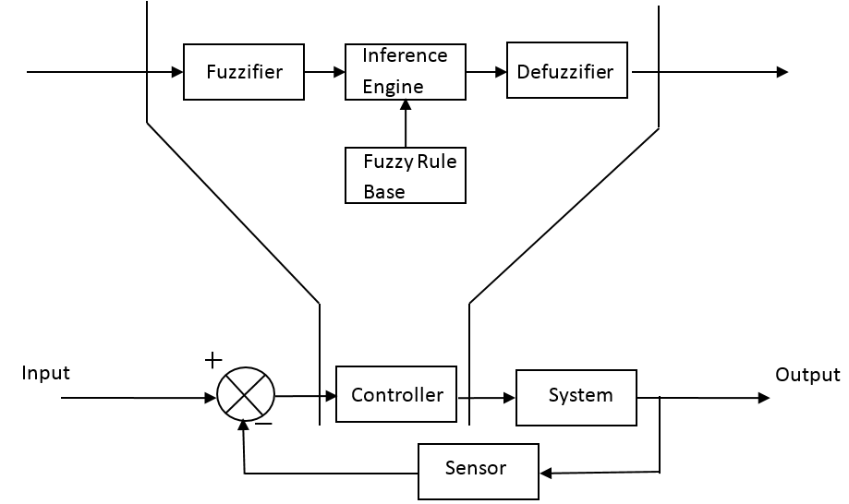

From doing the research into the two types we decided to go for fuzzy logic. There is only TRUE (1) or FALSE (0) in traditional control techniques, but instead of TRUE and FALSE, fuzzy does provide partially TRUE, partially FALSE and even grades of TRUE or FALSE.

Figure : Control System with Fuzzy Logic Controller

### Comparison between PID controller and Fuzzy Logic

Fuzzy control technique can provide the same result as PID; however, fuzzy control technique can be done in less complexity (Trammell, n.d.). Fuzzy control technique does provide a better stability, smaller overshoot, and faster response (Gaurav, 2012, pg 1-5).

It can provide more precise output and less complexity compare to the traditional control techniques. There is not a fixed or precise input for the control system, therefore, fuzzy control techniques is more suitable for the project compare to the traditional techniques since it can work with less precise input (Gaurav, 2012, pg 1-5). We also found that PID can work with fuzzy control system to get a more precise output.

### How we plan to use Fuzzy logic in our system

Fuzzy control system acquires data/value (angle of the broom) from the vision system. Data is processed based on the pre-assigned rules which had set in the fuzzy control system. The output of the control system is sent to a microcontroller to control the direction and speed of the robot based on pulse width modulation (PWM). Therefore, PWM varies based on the angular acceleration of the broom which is calculated based on the angle of the broom.

## Mechanical Design

This section explains everything in regards to the physical platform, how we are going to get everything to move as required. How we will provide 360 degree movement (holonomic motion) and what method will provide us with the quickest response time appropriate for this specification.

### Omni-Wheels

The first obvious problem with the project is the drive system. The mobile platform is required to have a freedom of movement in the x axis, y axis, and rotate about the origin i.e. holonomic movement. In order to achieve this we will use Omni wheels. The reason behind the use of Omni wheels is the fact that the Omni Wheels have rollers which are placed perpendicular to the main wheel which allows the wheel not only to move forward but also sideways when force is applied.

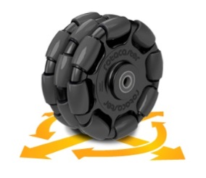Oliveira et al (n.d, p12) states that “Robots with Omni-directional locomotion are increasingly popular due to their enhanced mobility when compared with traditional robots”. Figure 16 shows an image on the type of Omni-wheel we wish to use.

Figure 16: Omni wheel (Wikipedia.org, Oct 2013)

### Three / Four wheels

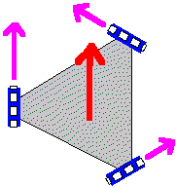A 4-wheel platform is much more efficient than a three-wheel platform. This is primarily because with three wheels only one wheel can be facing the direction of movement at one time whereas a robot with four wheels has two pairs of them increasing the torque and efficiency. We can see this difference very clearly on the illustration below:

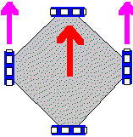Because of the advantages in efficiency and torque of a 4-wheel drive, we will equip our robot with such a solution. Also the maths behind a robot with 4 wheels is much simpler than the one behind a robot with three wheels. This is illustrated in figure 17.

Figure 17: 3 wheels vs 4 wheels (http://www.societyofrobots.com, Oct 2013)

This implies the microprocessor controlling the motors won’t have to make too many advanced trigonometric calculations increasing the overall speed of our system. Another advantage is that we can make one pair of wheels respond to the feedback from camera X and the other pair responds to the feedback from camera Y, hence simplifying the project.

### The X-Y table

It was suggested to us by Dave Checkleythat we could use an X-Y table to hold the platform which we build and provide the movement necessary to keep our broom balanced. To this end we looked into the options of both building our own X-Y table or simply buying one that had already been built by another party as well as the benefits and deficits to using an X-Y table.

The XY Table consists of two rails which are in the X and Y axes and are both independent of each other. Each rail is connected to its own servomotor, which allows for instantaneous correction of the angle deviation of the inverted pendulum. Because there is an x-axis rail and y-axis rail, the inverted pendulum can be corrected if it falls diagonally by simply moving the y-axis rail and the x-axis rail in conjugation with each other. Figure 18 shows an illustration of an x-y table.

InteliDrives states that “There are various factors which are quite essential to an XY table and they include resolution required, repeatability, accuracy, the applications appropriate motor and whether there is need for an encoder or not”.

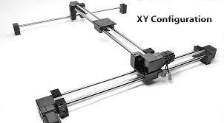Wikipedia suggested that X-Y tables are mostly used for precise positioning, rather than for fast movement. As our project relies on our platform being able to move quickly, the idea of using an X-Y table was starting to not look feasible. We then found a few examples of “DIY” X-Y tables on the Instructables website.

Figure 18: The X-Y table

Each of these gave detailed instructions on how to construct a table using readily available materials and tools. However, the instructions were often very technical on the mechanical side, and a number of the processes needed seemed to be complex. Also, most had demonstration videos available on Youtube. From this it became more evident that the tables where designed for accuracy (e.g. drilling or drawing) rather than fast movement. Furthermore, the movements shown by a number of them was also very jerky, which would likely result in de-stabilising our broom, and therefore going against the purpose of our project.

With respect to buying a pre-made table we found that buying any from the UK was difficult, with most results being from the US. Along with this, the products came in a price range from $200-$2000+. Most were also unsuited to our purpose, instead being designed to hold carriages that hung down, rather than platforms on top, or being too small to allow much movement. Figure 19 below shows the comparison between the Omni-wheels and the X-Y tables:

|  |  |  |
| --- | --- | --- |
|  | **Omni-Wheel Robot** | **XY Table** |
| Pro’s | The platform is able to move as far as possible in any direction to correct the deviation of the broom | Response time of the table is fast enough to correct the inverted pendulum  Fewer components required to operate thus fewer bugs that will be present. |
| Con’s | Response time of the robot may not be fast enough  The Omni-Wheel robot will be heavier than the XY Table  When the Omni-Wheel Robot is moving to correct the inverted pendulum, there is no limit to how far it will go thus there is a chance of hitting somebody. | The length of the rails are fixed, thus if the inverted pendulum goes beyond the length of the rails it will no longer be corrected. |

Figure 19: Comparison between X-Y table and Omni-wheels

# Technical Review

In this section, we are going to use the research which we just did in the literature review section to try and come up with some basic ideas for our project.

## Electronics Implementation

The motor driver circuit consists of a dual H-bridge motor driver, the L298, the motors, diodes to protect against back e.m.f and capacitors across the supply rails. When provided with a pulse width modulated signal at one of the input the L298 provides a smooth voltage at its output, using the mark-space ratio of the input to determine the output as a proportion of the high voltage supply, Vs, e.g. a signal with a mark-space ratio of 0.5 would result in the output being 0.5Vs.

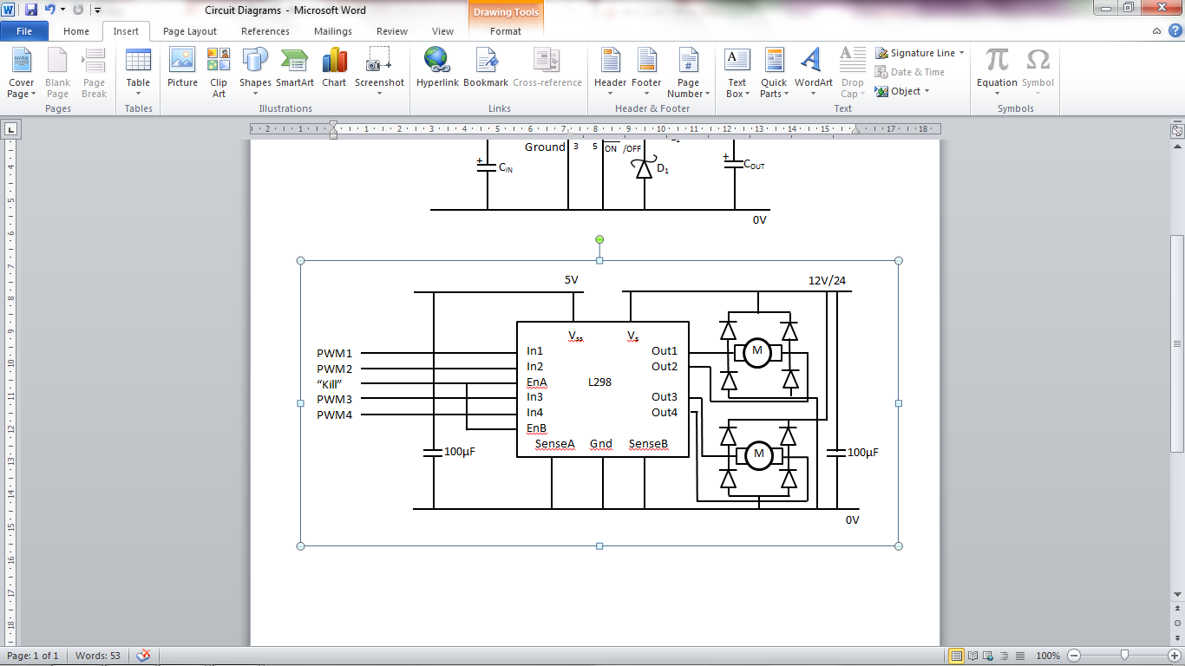 If the other input were then to be held low then this operation would cause the motors to be driven in one direction only, when two PWM signals that are the inverse of each other are applied at the same time to the same set of inputs, e.g. In1 and In2, the motors can be driven in both directions. As we require movement in both directions we decided to use this configuration. The diodes are positioned between the connections to the motors and the power rails in order to re-route any back e.m.f caused when the motors are stopped. The “kill” input is connected to the enable pins of the motor driver, when high the circuit will work as described above, but pulled low this will hold the connected outputs low, no matter what the signals on the inputs are. The two capacitors are used to protect against erroneous voltages at turn off and turn on.

Figure : Motor Controller

## Power Converters

The LM2576t can take in an unregulated DC voltage anywhere between 7V and 40V and step it down to a smooth, regulated voltage whilst also providing a maximum current of 3A. The ON/OFF output is held low in order to keep the voltage converter on. The diode has to be a Schottky diode as a fast switching speed is necessary for the circuit to function properly. The inductor and output capacitor are used to smooth the output voltage, removing any ripples left over from the output of the regulator. The smoothed voltage has to be connected to the feedback pin of the LM2576t in order to keep the output regulated at the necessary voltage. We are using a 5V and a 3.3V variant, with the only difference between the two circuits being the value of the inductor, which was selected using the data sheet and comparing the expected input voltage against the maximum expected output current. 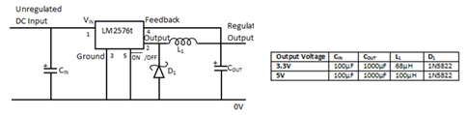

Figure 21: Power Converter

## Block/Board Diagram

The power supply will provide a 12V and a 0V power rail, when passed through the two voltage regulators a 3.3V and 5V power rail are also created which are fed to the central microprocessor board. This central board then re-routes these four power lines to each of the others boards as necessary.

Meanwhile, the wireless RF module is connected to the UARTs on the microprocessors in order to provide communication with the PC issuing the instructions. The two microprocessors are then connected to the motor controller board in order to provide the pulse width modulation signals as well as the enable signals. The motor controllers then feed their regulated outputs to the motors in order to drive them as instructed by the microprocessor. Finally, the shaft encoders on the motors then feed their readings back to the microprocessors to help with driving the motors.

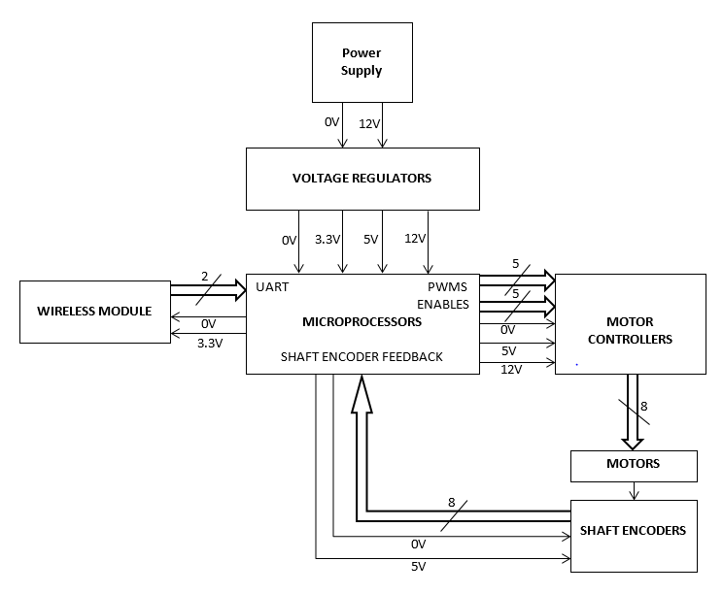  
Figure 22: Block Diagram of Electronics

Microcontroller Choice  
Nowadays there are many options on the market when it comes to choosing an MCU for an embedded project. The most common ones are PICs and AVR Microcontrollers. Prototyping boards such as Arduino are also very popular. Alternatively, we could use a Raspberry Pi, which is a stand-alone computer and connect cameras to it in order to build a fully embedded system. Each of these have pros and cons which are described in a table below:

|  |  |  |
| --- | --- | --- |
| **Options** | **Advantages** | **Disadvantages** |
| **PIC** | We used it in the past | Not many IOs in DIP packages |
| Cheap | Maximum operating frequency = 80 MHz |
| Comes in an easy to prototype DIP package | Most advanced compilers are costly |
| **AVR** | Comes in an easy to prototype DIP package | Maximum operating frequency = 32 MHz |
| A free high quality compiler with full optimizations | We haven’t got much experience with AVRs |
| **Arduino** | Easy to use board | Only 20 IOs available in Arduino UNO |
| No need to worry about choosing the right crystal | The user is stuck with only one microcontroller |
| No need for a programmer | More expensive than a single microcontroller chip |
| Lots of example projects online |  |
| **Raspberry Pi** | Runs at 700 MHz | Only 26 IOs available |
| Could potentially use cameras for digital vision without the need for a laptop/PC | Although cameras are supported, real time processing could be a big struggle |
| Very powerful platform | Not good at driving motors accurately in real time |
|  | The most expensive option |
|  | We don’t have experience at using this platform |

Figure 23: Microcontroller choices

From the options above we chose to work with a PIC microcontroller. We have plenty of hands-on experience with these devices and think they are reliable. Since the robot we are building is supposed to receive movement commands from a laptop/PC and drive the motors accordingly we don’t need to use a development platform like Arduino. Firstly; it’s too large, secondly; it’s more expensive than a single PIC chip and thirdly it doesn’t offer as much flexibility as building our own circuit from scratch with all components chosen specifically for our project. A Raspberry Pi computer would be a very ambitious option. Building a completely stand-alone system which can work without a laptop or PC would be a great achievement however we don’t believe that the Raspberry Pi is powerful enough to perform real-time digital vision and control the motors accurately enough.

We need our PIC to be very fast in order to reduce the lag between the commands received wirelessly and driving the motors as required to the position where the broom is stable again. We also need the following amount of each peripheral:

* 4x PWM (to drive 4 motors)
* 1x UART (for wireless communications)

Here are 3 PICs we have considered:

|  |  |  |  |
| --- | --- | --- | --- |
| **Part** | **PIC24HJ128GP502** | **PIC18F27J53** | **PIC24FJ64GA102** |
| **I/O pins** | 21 | 22 | 21 |
| **Max CPU Speed** | 80 MHz | 48 MHz | 32 MHz |
| **Digital Comm. Peripherals** | 2-UART | 2-UART | 2-UART |
| **Capture/Compare PWM Peripherals** | 4-Output Comp. & Std. PWM, 16-bitPWM, 4-Input Capture | 7-CCP, 3-ECCP, 10-bitPWM | 5-Output Comp. & Std. PWM, 16-bitPWM, 5-Input Capture |
| **Digital Timers** | 5x16-bit, 2x32-bit | 4x8-bit, 4x16-bit | 15x16-bit, 7x32-bit |
| **Operating Voltage** | 3V - 3.6V | 2V - 3.6V | 2V - 3.6V |

Figure 24:

Based on the above comparison table we are going to use PIC24HJ128GP502 because it is the fastest from all the devices. It also features the same amount of PWM Peripherals that we need and twice the amount of UARTs. Each motor requires 2 PWM signals in order to run in both directions hence we may need to use 2 microcontrollers.

## Pseudo Code

There are many ways of controlling the robot using a computer. Here are two, slightly different, pseudo codes describing the way robot would respond to the commands sent to it:

### PSEUDOCODE #1

Continues commanding the robot where to go

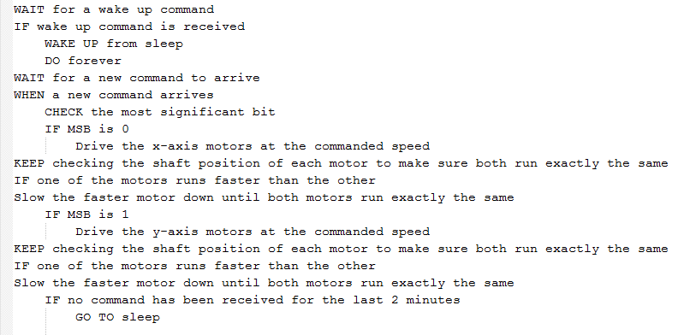  
Figure 25: Pseudo Code #1

### PSEUDOCODE #2

Commanding the robot where to go and how far and leaving it alone to perform the movement by itself

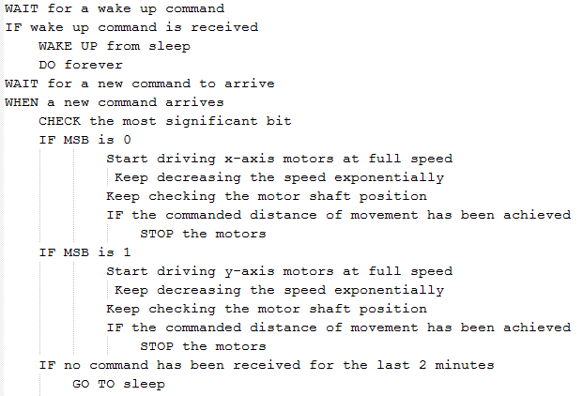

Figure 26: Pseudo Code #2

Along with the pseudo code above, are accompanying flow diagrams, which can be found in appendix XII on page 50.

## Mechanical Design

The platform chosen to balance the broom as an inverted pendulum was an Omni wheel base design; this design was chosen after much research and deliration done by the group as a whole. The concept of the Omni wheel design is based around the fact that the Omni wheel operates just like any other wheel except it also gives the flexibility of side movements as well through the use of side rollers which are placed perpendicularly to the wheel axis; this allow the wheels to roll on the rollers when a sideways force is applied to the base.

To give us a rough idea of what we wanted our platform to look before constructing it, we decided to design it first on 3D modelling software called SolidWorks. This allowed us to design the sub-components and then put them all together into one

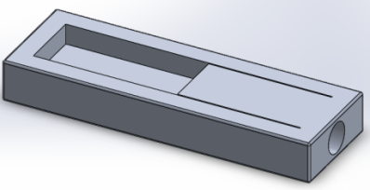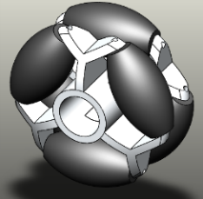

Figure 27: Sub-components for the mechanical design of the platform

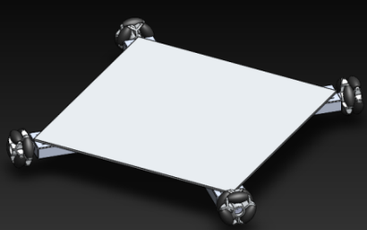

Figure 28: Final Design of the Omni Wheel Base

The reason the Omni Wheels are place at such an angle on the base is that the Omni Wheels are required to be placed perpendicularly to the load it is going to carry e.g. the broom and as the broom is placed in the direct centre of the base, the Omni Wheels are placed at a 45 degree angle to the centre of the base.

## Vision System

In this section, we are going to look into the different methods we could use to detect the location of the broom and to calculate the angle of deviation. The basic process of the vision system is shown below in :



Figure 29: Basic Flowchart for the Vision System

However, there are several approaches for image processing that we found from our research, the ones which interested are the following:

1. Background subtraction
2. Threshold image processing
3. Pattern matching

## Background subtraction

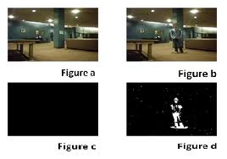Our initial idea was to use background subtraction. This works by starting off by telling the computer vision to isolate the foreground object from the rest of the image. The computer vision is able to compare the current images against the background model, and then subtract away the known background. The objects left after the subtraction are the foreground object. Figure 30 shows the stages of how background subtraction works.

Figure : How Background Subtraction Works

The image shows the sampled result of the background subtraction method. According to our design and objective, the background subtraction method does not fit our requirements, because the background and the robot have to be stationary, but the robot is constantly moving to balance the broom. Thus the computer vision might end up detecting both the robot and the broom instead of just detecting the broom.

## Using threshold for image processing

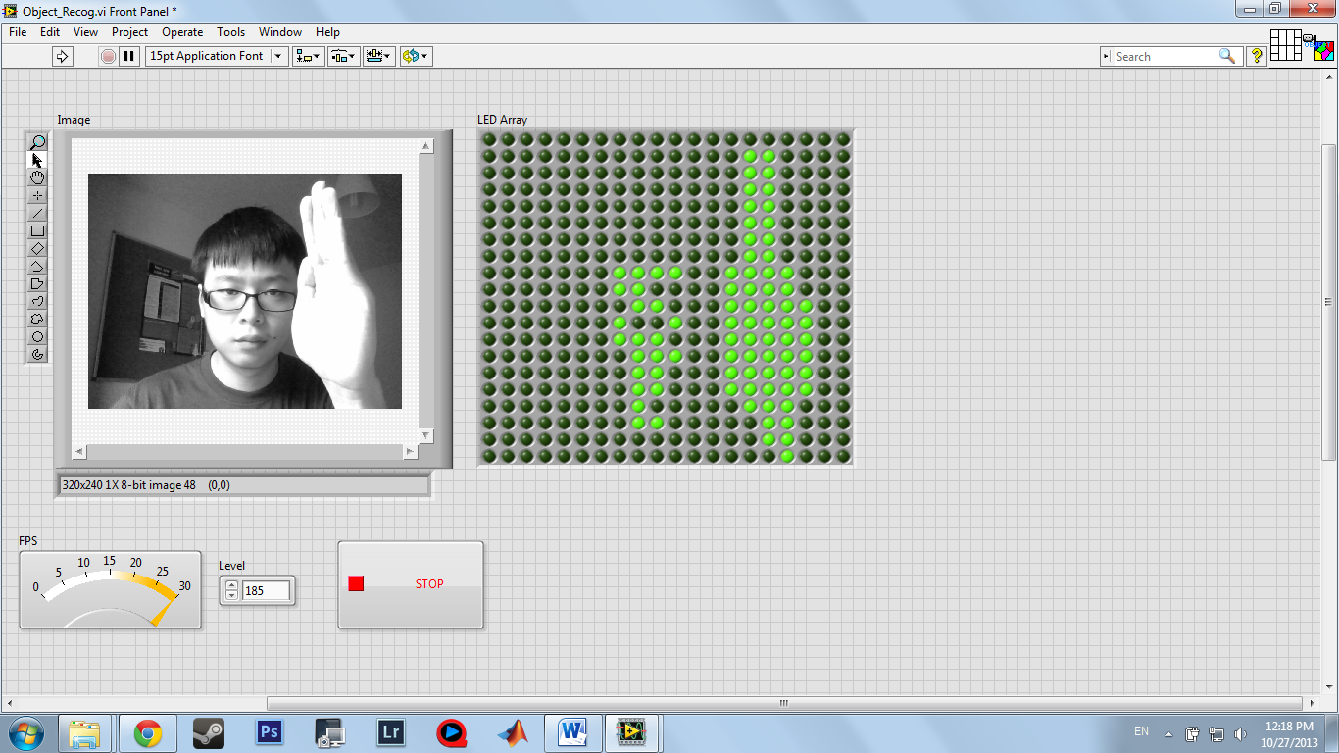The second design idea is to simply acquire real time images from the webcam and to transfer them into grey scale. This result will be transferred into threshold reading, which also means transferring images into black or white. It interprets every pixel of the images and decides whether the value should be in white “1” or black “0”.

To make this easier to visualise, the result is also transferred into an LED array. From the result below, we can see if the exposure of the images is high, the led array will light up, and other below of the exposure value will be black.

Figure 31: Using threshold for image processing

By exposing the brightness of the foreground object, we may able to detect the angle of the object. However, these exposure values might affect other areas of the images and could potentially cause confusion to the computer vision system. As you can see the above result, it is difficult to isolate the foreground object with the background because the exposure value of the background is very similar to the foreground object. The block diagram for this threshold processing in Lab View is shown below in figure 32:

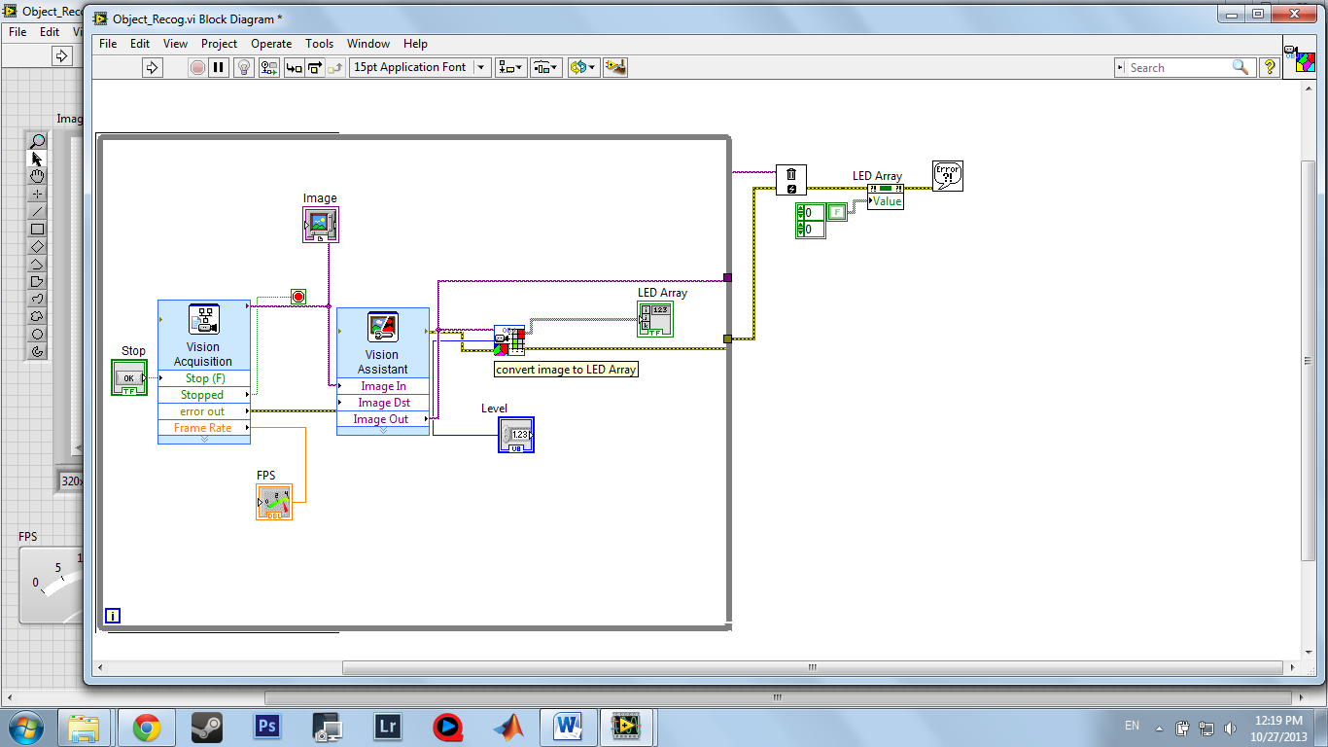

Figure 32: Lab View block Diagram of the vision system

## Using feature detection

Our final idea, we designed the pattern recognition using geometric pattern matching. The computer vision recognizes the pattern of the object by defining the edge of the object. For example, if I’m telling the system to recognize the following pattern, this is what we see:

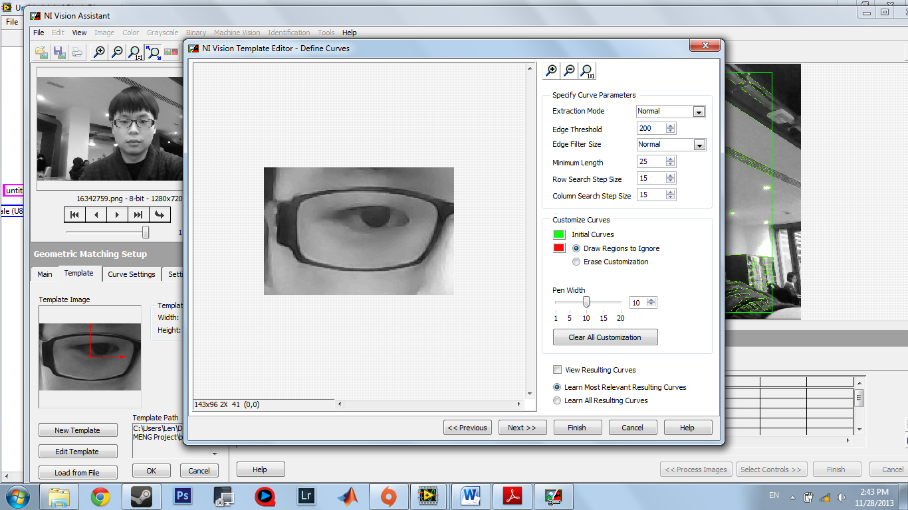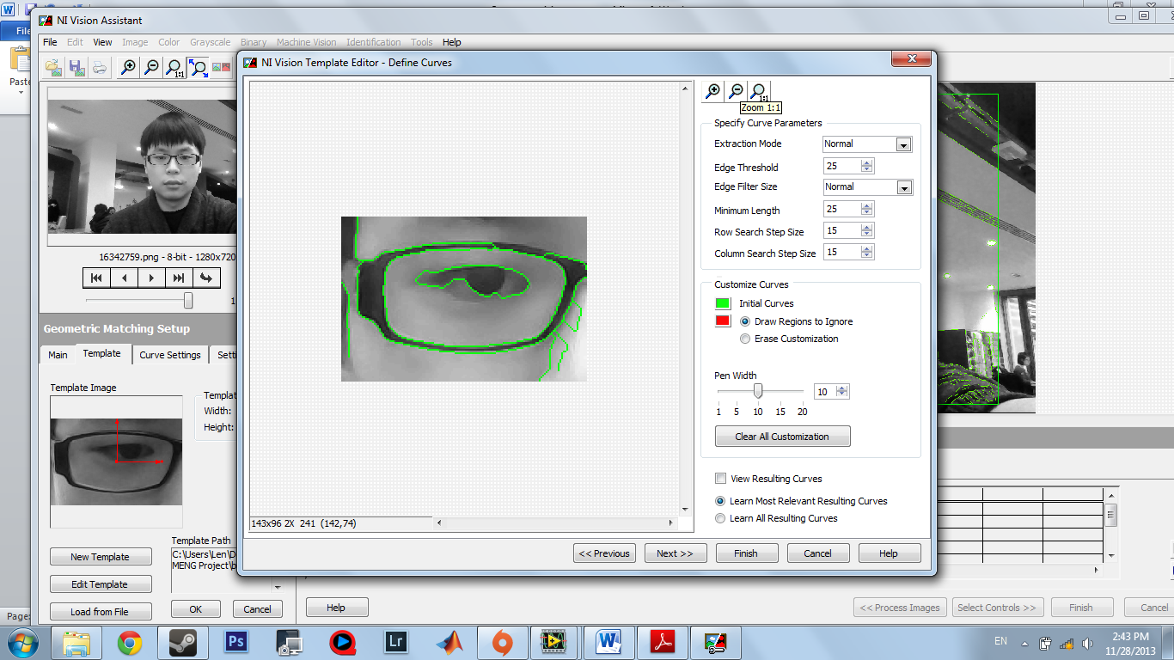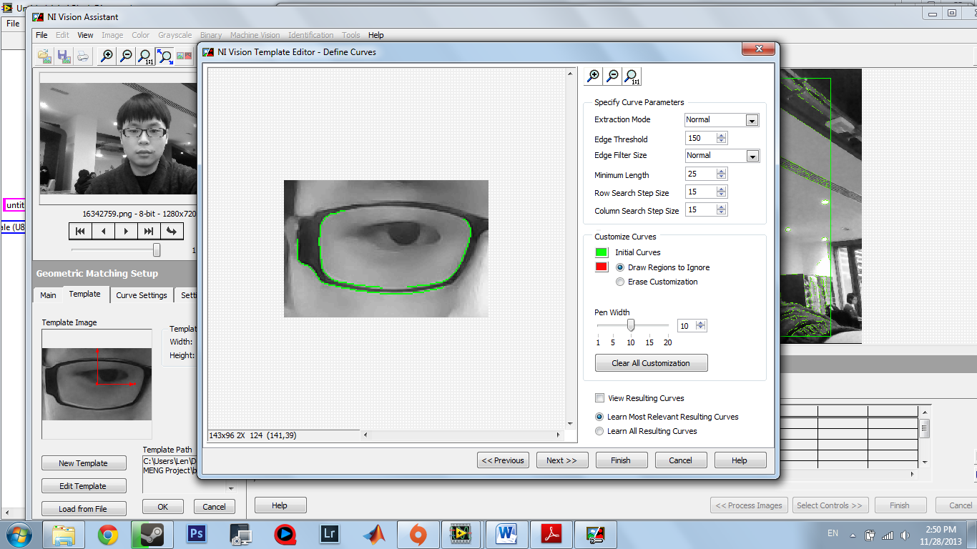  
Figure 33: Using Feature Detection

The green line represents the edges of the object. However these edges do not look the same if a different lighting environment is applied, the edges may seem more or less as can be seen from the comparison between the two images within figure 33.

If fewer edges appear, it becomes harder for the system to track. To overcome this problem, we have to calibrate the vision system by telling the system what threshold values we require. So the edges may appear clearer, to illustrate the idea, here is an example:

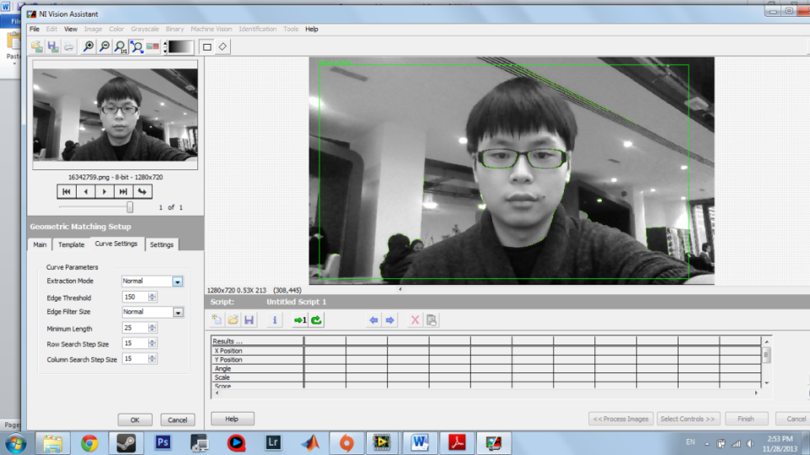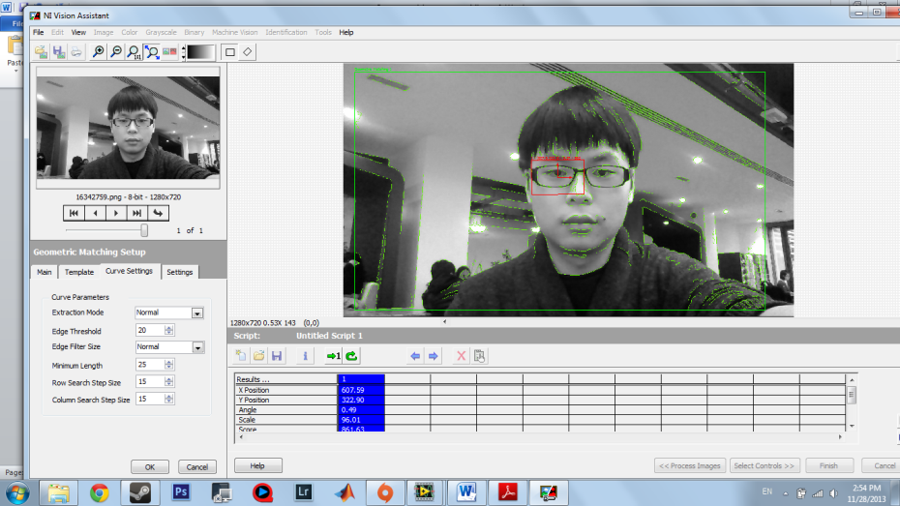  
Figure 34: Edge Threshold = 150 and 20

The operation goes like this. We first create a template (object) to be detected so the software is able to know which objects is needed to detect and which is not. For example, we created the template to be the glasses of the user. Now the software will keep searching this pattern (spectacles) until it is found. This can be seen below in figure 35.

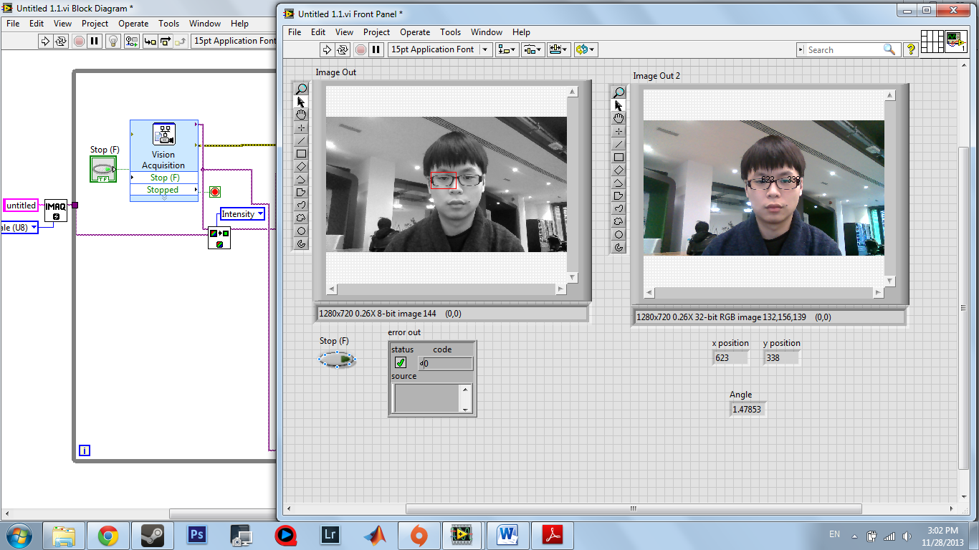

Figure 35: Feature Detection

To calculate the angle of the matched object, we have reversed engineer our other work and integrate with our program. What we require is to add additional output data from the vision assistant toolkit which had interpreted the angle of the matched object.

|  |  |  |
| --- | --- | --- |
| **Design** | **Advantages** | **Disadvantages** |
| **Background subtraction** | *-easy to design the program*  *-fast respond* | *-cant select the region of interest to detect the object* |
| **threshold for image processing** | *-Simple design and understandable*  *-Level of threshold can be varies*  *-Fast response from the LED array* | *-Backgrounds of the images have to be constant.*  *-Unreliable as in might not accurate to detect the angular because we can’t reach the minimum pixel size (further processing).* |
| **feature detection** | *-can detect various objects*  *-edge of the threshold can be controlled for better detection* | -*unstable output due to poor screen resolution from camera*  -required higher FPS (frame rate per second ) camera |

We concluded using the pattern regonisation fits our requirements best, however this program code can only work for using one webcam. To work with two camera, further reasearch and experiment trial and error are needed. Both systems for pattern recognition and feature detection can be found in appendix VI and VII both on page 40.

## Control System and Fuzzy Logic

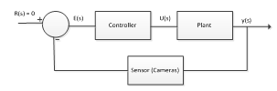 We concluded that we are going to set an equilibrium point; this is going to be an angle of zero. Therefore we are going to set the input reference (angle) of the control system to be equal to zero.

Figure 36: Basic Model of our control system

Now that we have decided upon the controller, we now need to design the structure of our control system. We know that our system will be using fuzzy logic as the controller and that it is going to be a closed loop with the feedback path. This is shown in figure36 above.

## Modelling noise and disturbances

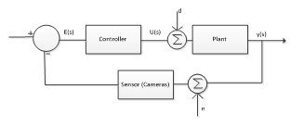

There will be two disturbances which could affect our system and these are the disturbances from the load as well as the noise from the cameras. These have to therefore be accounted for within the control system as shown in figure 37.

Figure 37: Control System modelling disturbances

## Modelling the Lag of the webcams

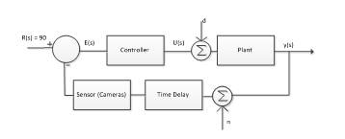We are trying to create a system which works in real time; this is where the problem with the speed of response of the webcams comes in. As the webcams can’t process the data quick enough, we are going to have to model in time delays into the control system. This is so that the system synchronises correctly with the camera.

Figure : Control System with time delay

Where the time delay block will have the equation $time delay= e^{-st}$, where t is the amount of time in which you want to delay the control system by. We will have to try and model these values.

## Finding the transfer function of the plant

If we are going to use the PID controller, we are going to have to develop a transfer function for our system. To do this we are going to start with a force diagram as shown below in figure 39. This is for the basic inverted pendulum, so it is pivoted and can only fall in one dimension:

We can analyse this force diagram to find the systems transfer function, this is shown in Appendix XI on pagec46. The transfer function which we got from this calculation is shown below:

$$G\left(s\right)=\frac{mIs}{qs^{3}+bs^{2}\left(I+mI^{2}\right)-mgI\left(M+m\right)s-bmgl} (Equation 1.0)$$

Where: *M = Mass of the platform, m = mass of the broom, I = Moment of Inertia of the broom, b = friction coefficient of the platform, g = gravitational field strength, l = length of the broom*

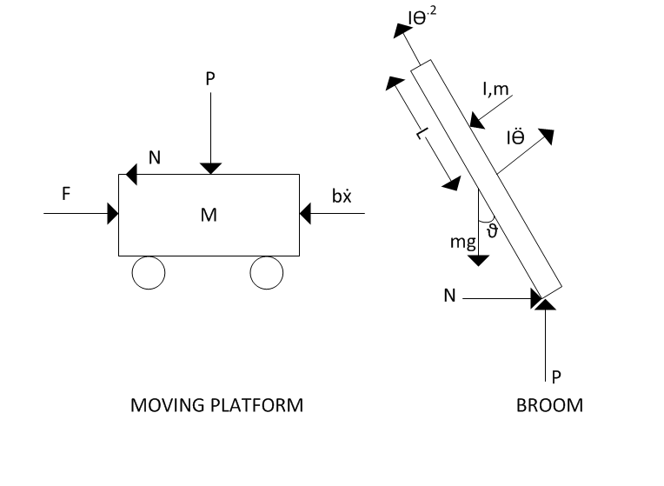  
Figure 39: Force diagram of the basic inverted pendulum

## Moment of Inertia

From equation (1.0) we can see that the transfer function requires the value for the moment of inertia ‘I’ of the broom. The Moment of inertia is a name given to rotational inertia. It is an essential component to find other variables that are needed for our rotational mechanic calculations. It can be used to torque using angular acceleration (T=Id).

We have gone about this both the practically and mathematically. The mathematical approach is shown in Appendix X on page44. The result we got from these calculations is shown below:

$$I_{pa}=\frac{M(a^{2}+b^{2})}{4}+ \frac{1}{12}M\left(d^{2}+w^{2}\right)+M{\left(d+d_{2}\right)}^{2} (Equation 2.0)$$

## Fuzzy Logic Control System

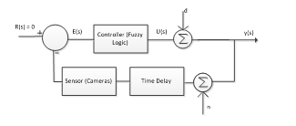

As we decided we are going to use Fuzzy Logic, we don’t need to use a transfer function, as the fuzzy logic system will input an angle and output acceleration for the moving platform, as shown in figure 40.

Figure : Control System integrating fuzzy logic

## Calculating acceleration of base of platform

For the fuzzy logic, we are going to be outputting different accelerations for the base of the platform depending on the angle which the brush has fallen to. Figure 41 shows what the fuzzy will be inputting and outputting:



Figure 41: Input and Output of the fuzzy logic

For the rules within the fuzzy controller, we need to perform some maths to find out what accelerations are required depending on the angle of deviation of the broom. We are going to set the rules for every ten degrees in which the broom falls, so there will be a new corresponding angle for each ten degrees. These calculations are shown below up until the angle upon which the system will stop as it will not be able to recover the broom:

$$10 degrees →a_{base}=\frac{I-mgLsinθ }{Lmcosθ}= \frac{0.01159-(0.24×9.81×1.2×sin10) }{1.2×0.24×cos10}=$$

$$20 degrees →a_{base}=\frac{I-mgLsinθ }{Lmcosθ}= \frac{0.01159-(0.24×9.81×1.2×sin20) }{1.2×0.24×cos20}=$$

For the calculations we used the value of moment of inertia we got from our experiments which came out to be $0.01159kg/m^{2}$. We also assumed the length of broom was 1.2m, mass 0.24kg. We did this for all the different appropriate angles and then imported these as rules into the fuzzy controller in Lab View as shown in a latter section.

## Creating the Fuzzy Controller in Lab View

We are now going to look into creating this fuzzy logic controller with these pre-defined set of rules just derived using Lab View. A fuzzy system designer is a tool used to design a fuzzy system by giving the name of the input and output variables; value and shape of the membership functions; rules given for every membership function to work between the input and output and method of defuzzication. The appendix VIII on page 41 shows the steps undertaken to achieve this.

## Combining the Visual System and the Fuzzy Controller

Now that we have both a working vision and control system, it is time to combine the two, to get the system working with the feedback loop connected. This is shown in appendix IX on page 43.

# Experimental Verification of Analytic Material

We want to be able to find the values needed for our equations practically as well as mathematically, as these can be more accurate and reliable for a real world response. This section will be split into finding the following values:

1. The Moment of Inertia
2. The Centre of mass
3. Minimum time response
4. Coefficient of friction

## Centre of Mass

Calculating the centre of gravity of the brush requires suspending the broom from a point, before also suspending a weight from that same point. Where the weight suspension intercepts the broom, we draw a line. We then change the point that the broom and weight is suspended from and repeat the process. This will leave us with several lines on the broom that should intercept. This is the centre of gravity of the broom. This can be checked (for rough accuracy) by hanging the broom from the marked point to see if it balances. The length of the broom was found to be 125.5cm.

**Centre of gravity = 92.6cm**

## Coefficient of Friction

Finding the friction of a surface is a relatively simple experiment. We first get a flat piece of our surface, as well as the object (a broom) that we want to see the friction of. We slowly raise the one end of the ramp whilst the object is on it. At the point the object slides down, you measure the height and the length of the slope. We can then find the coefficient of friction between the surfaces using Fr = height / length. The height was roughly 5cm, whilst the length was roughly 35cm.

**Coefficient of friction 0.143 (no unit)**

## Moment of Inertia

Calculating the moment of inertia of the broom is quite a difficult experiment to do without specialist equipment. There is a simple experiment that can be done to calculate the moment of inertia, however, the axis that it is done on is not necessarily the axis that we want it to be.

We first hang the broom by two pieces of string of length l (the longer the string, the longer the period of the broom, with a distance b between each of the pieces of string and the centre of gravity). We will first move the broom back and forth and take down the time per cycle, as well as slowly rotating it side to side. With this result we will use the calculation below to calculate the moment of inertia for the broom:

$$I= \frac{mgT^{2}b^{2}}{4π^{2}l}$$

Where: Mg = mass of the broom (0.7Kg), T = time period, L = length of string (2.355m), B = distance between string and centre of gravity (0.2m)

**Lap results (s):**

6.117, 5.683, 6.168, 6.266, 5.911, 6.543, 5.958, 6.243, 6.294, 6.294, 5.792, 6.694, 6.683

Average = 6.204 seconds. This gives us a moment of inertia of:

$$I= \frac{0.7*{6.204}^{2}*{0.2}^{2}}{4π^{2}*2.355}= 0.01159kg/m^{2}$$

## Minimum Time Response

The time response for our broom can be estimated by first finding how long it takes for the broom to fall from 0° to 90° (I.e.) to reach the floor.

Lap Results (s):

*1.828, 2.084, 1.807, 1.608, 1.633, 1.623, 1.792, 1.404, 1.699, 1.680*

*Added together and divided by 10 =* ***1.7155 seconds***

This time response measured means that our system will have to run at a speed faster than this. The minimum time response will have to take into account the critical angle of the system, as the broom will become impossible to correct once it reaches the critical angle, hence, to find the minimum response, we would need to do the use the following formulae:

$$\frac{Ca }{90° }*1.7155s$$

This means that using the time response found previously, we can figure out the minimum time response by finding the difference between the critical angle and the total angle, before multiplying it by the time response.

# Problems Encountered

During the duration project there will be problems that will arise, and there will be methods used by the group to overcome said problems, below is a list of the problems our group has encountered in the duration of our project and the methods used to overcome said problems.

## Software:

Some of the issues concerning the software part of the project stems from the use of software such as Lab View. This software’s requires the use of extensive libraries to operate, if there is even one library missing from the codes all the hard spent hours writing the codes for the program will be wasted. This problem was encountered by our two lead programmers in the group, Liew Shen and Kh Sam. After encountering this problems with their respective software, the solution that they used way a 2 step solution which was

* Download the latest version of Lab View (Evaluation)
* If the latest version still had missing libraries, update the library list by specifically downloading the library from dedicated websites. (Evaluation toolkits)

## Calculating the Moment of Inertia

During the calculation of the moment of inertia, the group hit a roadblock in which it was difficult to get the final equation for the moment of inertia of the broom as the group had a limited knowledge of physics. The final equation of the moment of inertia of the broom is a crucial to the group progress as it will be used in finding the acceleration of the base which then allows for the motor torque to be calculated thus allowing the group to choose a motor with the calculated torque, as such many methods were used to counter this problem from researching online webpages and visiting the library to borrow books. Finally the problem was countered when the group spoke to a post graduate student who had a degree in Mechanical Engineering, we asked him to explain to us the basic principles of the moment of inertia which we then used to solve our problem.

## Purchasing of Materials

During the purchasing of materials, the company Rapid in which the items were purchased from delivered the wrong materials: for example an order for 4” 4 way straight headers but instead the company sent 4” 6 crimp housing and also during the purchasing of the Omni Wheels, the wheel hubs weren’t purchased along with the wheels thus leaving no way to connect the wheel to the motor. Both problems were solved through for the miss-order by placing a new order and ordering wheel hubs to go along with the Omni Wheels.

## Hardware:

The problems encountered with the hardware section are as follows:

* The designing of the Omni Wheel Base was done using the software solid works, the head designer had no previous experience with solid works before and this posed as a problem to the group, as there needed to be a 3D representation of the base for the bench inspection, this problem was overcome by the liberal use of tutorials provided by solid works, the learning aids in the website YouTube and help from the other group members. And now the group has a 3D representation of the Omni Wheel Base.
* The next problem encountered by the group was through the use of the workshop in the Metallurgy and Materials Lab, the workshop was approached by the group to acquire materials for the construction of the base for example: a square aluminium base, and motor housings done by the workshop. The aluminium base was easily provided by the workshop. The group hit a snag when the design for the motor housing was presented to the workshop, the person in charge said that the current design was not suitable. This problem was overcome when the person in charge suggested a design which was more suitable for the base and once the green light was given immediacy began construction of the motor bracket.
* Another problem was encountered by the group when the member in charge of the soldering of the circuit mistakenly removed an already soldered wire from the circuit board which invariably leads to some of the copper strip being detached along with the wire. Once the mistake had been realised, it was immediately rectified by redesigning the circuit board again.

# Simplification of the Specification

To make the project more achievable, it was decided that we would try and construct a 1 dimensional system before moving onto the 2 dimensional systems. Similar to the inverted pendulum project explained in the Literature Review. To do this we aim to get one camera working in the x-plane and to connect this to the control system to output acceleration. With respect to the platform, a broom holder will be constructed; this will pivot the broom and restricts its motion to just one plane.

# Future Plan and Conclusion

So far we have managed to design, build and test the individual sub sections. We now need to go about integrating these together to get the system to firstly work in one plane and to then move onto working in the 2 planes.

|  |  |  |
| --- | --- | --- |
| **Completion Date** | **Task Description** | **People Required** |
| **17/01/2014** | Improve Current Motor Driver Circuit | Piotr Opacki, Sam James |
| **22/01/2014** | New platform designed and built | Kavin |
| **23/01/2014** | Communication Network | Piotr Opacki, Sam James |
| **24/01/2014** | Simplified Vision System | Liew Shen |
| **30/01/2014** | Integration of Vision and Control | Liew Shen, Kh Sam, Alex Farmer, Aaron Lyons |
| **31/01/2014** | Fuzzy Logic Rules | Alex Farmer |
| **03/02/2014** | Testing Integrated System | Whole Group |
| **06/02/2014** | Build 2nd Motor Driver Circuit | Sam James |
| **12/02/2014** | Build 2nd PIC Circuit | Sam James |
| **19/02/2014** | Establish Communication between the 2 PICs | Piotr Opacki |
| **06/03/2014** | Control System working in 2 planes | Alex Farmer, Aaron Lyons, Kh Sam |
| **14/03/2014** | Make Broom Perform Controlled Oscillations | Alex Farmer, Aaron Lyons, Kh Sam |
| **18/03/2014** | Implement Weight Sensor | Kavin |
| **20/03/2014** | Testing | Whole Team |
| **26/03/2014** | 2nd Demonstration and Presentation | Whole Team |

Figure 42: Future Plans for each sub-section

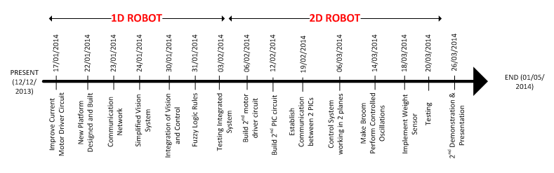

If we are able to stick to this structure, then we will be able to build a system which is able to balance a broom on a moving platform, and to also make it dance by performing controlled oscillations by the time of the second bench inspection.

## Further Detail into Future of Electronics

Firstly, we plan to upgrade the motor driver by replacing the current fly-back diodes surrounding the motor with faster switching ones. In order to boost performance and by attaching a heat sink to help prevent the L298 from being damaged. We aim to have this completed by the end of week one of the second semester **(17/01/2014).**

Following that we plan to establish the wireless connection between the PC and the robot by creating the circuit for the RF module and connecting it to the PIC board. For this we need edit the program on the PIC so that it can react to the instructions provided to it from this connection. This should be completed by **(23/01/2014)**. By the **03/02/2014** we should have a system which should work in one plane.

Therefore the next stage will be to get the system to work in two planes. We therefore need to build the second motor driver circuit so that we can have four motors working at once. This should be completed by **(06/02/2014).**

Next we intend to build a second circuit for another PIC, so that it can be used to drive this second pair of motors. With this we will need to program a second PIC, and modify the programs so that they can differentiate between instructions that are intended for them and the ones that are intended for the other PIC, which should be finished by **12/02/2014**. We then need to get the two PICs to communicate with one another; this will be completed by **19/02/2014.**

Finally if we have time we hope to establish a battery power system so that the robot can become completely wireless and for it to not rely on a separate power supply. This will happen after testing and when we have a fully functional system. For this we will need to research into how to regulate a battery power supply in order to keep the battery from discharging too quickly.

## Further Detail into Future of Control System

For the control system we need to firstly come up with the fuzzy rules for each angle of deviation of the broom. This will be completed firstly for the one dimensional design and will be done again later on for the two-dimensional design. We will adjust the parameters till we get the system to operate at its full potential. We have to wait for the communication link between the PC and the PIC before testing, which is only completed on the **23/01/2014,** so this leaves us with eight days to get the control system working in one plane. For the one dimension system, we will complete this by **31/01/2014.**

The next stage will to make the control system as efficient as possible, getting the two vision systems to work parallel to one another. The cameras and the motors also have a time delay which needs to be modelled in the control system.

## Further Detail into Future of Control System and System Integration

Although the feature recognition designed so far fits our requirements, there is still plenty of room for improvement. Currently the program only works with one camera; we need to expand upon this design in order to work with two different cameras. The possible errors we may encounter will be the processing speed for the program to run with two cameras. We are also concerned that this design may work poorly under poor lighting, although we have the option of adjusting the exposure of the webcam. We found out that if we increase the exposure of the real time dark images, the frame rate of the images will drop, causing an undesired output.

From figure 43, we can see darker images has better frame rate whereas brighter images has lower frame rate. On the other hand, we may introduce a new image processing design, which is colour recognition. Colour recognition allow the computer vision to distinguish object based on the wavelength of the light they reflect, which also mean distinguish object based on it colour. We may consider this design as a backup plan, because we unsure:

1. The shape of the object
2. The operating lighting environment

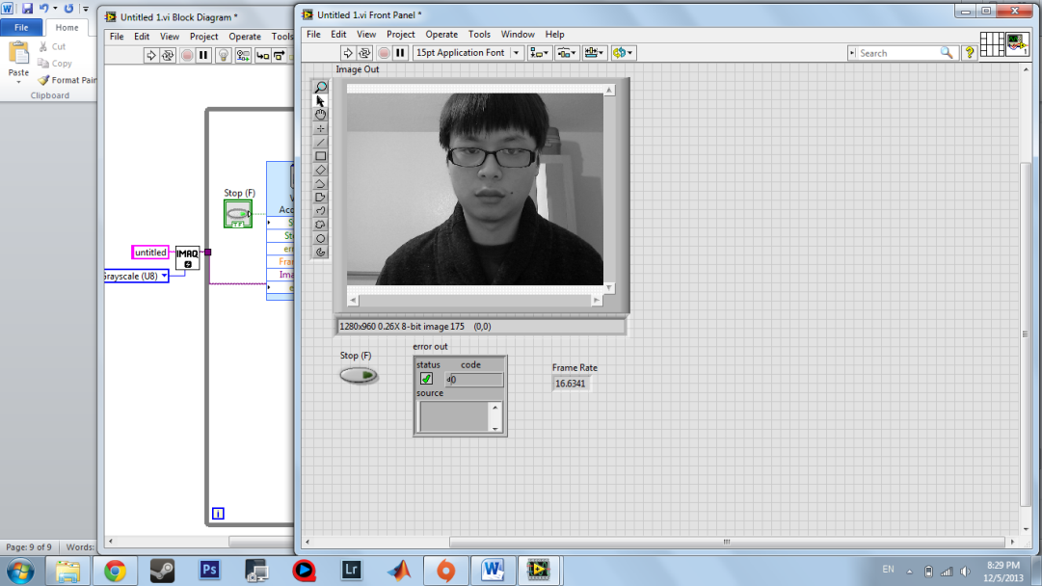 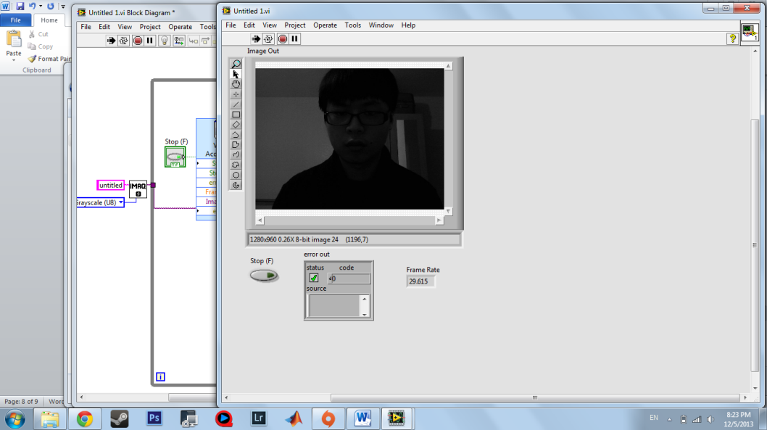

Figure 43: Vision System using two cameras

These problem will be unsolved if we use colour recognition. Besides that, we need to improve our GUI (graphic user interface); we found out that setting up the computer vision system using feature recognition takes longer time than we thought. (Approx. 15 min) this setting includes creating a new template, recalibrating the camera and adjusting the exposure value of the real time images. This should be completed by the end of week 2 **(24/01/2014)** so that we will have time to test the whole control system, make it as efficient as possible and to also plan how we are going to change it to perform controlled oscillations for the remaining eight weeks of the project.

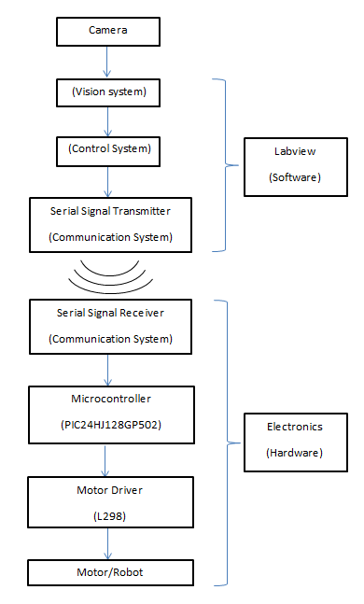The instantaneous angle measured by the vision system is fed back to the control system, which, from the fuzzy logic controller has several instantaneous angular errors set as reference points. These are used for the instantaneous acceleration and speed calculations.

Further research needs to be done on the pattern of membership functions and methods of defuzzification for a better control system. The fuzzy logic controller makes calculations on the rules and patterns of the membership functions to give other details of references and the result of the angular error. The formula used in the calculations depends on the defuzzification method used.

The acceleration needed that is varied by the angular error is sent to the UART transceiver module using the USB UART transceiver. The serial signals between the module and UART are transmitted wirelessly. Settings such as baud rate, data bits etc. are needed to synchronise the transmitter and receiver.

## Further Detail into Future of Mechanics

The mechanical platform constructed so far is just a prototype. By the **22/01/2014** the new platform should be constructed, this platform should consist of two layers. The bottom layer should contain the electronics and the top layer is where the broom will be placed. The purpose of this 2 tier system is to separate the broom and the fragile electronics away from each other.

Additionally the current design of the platform for the bench inspection on the 10th of December, only had two Omni Wheels attached to the base with the other’s being ball transfer units. The Future plans for the base is to replace the ball transfer unit with 2 additional Omni Wheels attached to DC Motors, which will be secured to the base with the motor brackets.

The current motor housing design is adequate for our project requirements, but due to advice from the people running the workshop (Warren), we have decided to go along with Warren’s suggestions for the motor housing. This new motor housing should also be built by the **22/01/2014.**

|  |  |  |
| --- | --- | --- |
|  | **Motor Housing** | **Motor Bracket** |
| **Advantages** | Protects the Motor from the environment, the motor is safely secured as the motor housing encompasses the entire motor. | Easy access to the motor and easier placement of the bracket and has a lighter weight as compared to the motor housing. |
| **Disadvantages** | Requires removal of entire housing to access the motor, additional weight due to the larger amount of aluminium used in the housing | Doesn’t protect the motor from the environment unlike the motor housing. The motor is only secured to the bracket through 3 screws. |

Figure 44: Advantages and Disadvantages of the Motor Housing& Bracket

The topmost tier will house a weight sensor. The purpose of this weight sensor is to detect the weight of the broom; for the initialisation program, so that any object can be balanced upon the platform, independent of its weight. This weight sensor will be attached at a later stage (**18/03/2014).**  shows the different weight sensors we could use; further research will be undertaken nearer to the time.

|  |  |
| --- | --- |
| FC21 & FC22 Compression Load Cells | **Features**  1) Low Cost ;Small size Low noise  2) Robust: high over range capability ;Interchangeable  3) High reliability； Low deflection  4) Essentially unlimited cycle Life expectancy  5) Low off center errors  6) Fast response time  7) Compression Ranges: 2, 5, 10, 25, 50 and 100 Lbf  8) Reverse polarity protected; Compact Easy to Fixture Design |
| FS20 Series Load Cells | **Specifications:**  1) accuracy：+/-1%FS  2) range：1.5 3 lbf (750, 1500 Grams Force) Compression  3) supply voltage：3.3-5V  4) output：1-4V（5V supply voltage）  5) temperature range：0-70℃ |

Figure 45: Different Weight Sensors

# Conclusion

To sum up, the main challenges that we are going to have are integrating all of our different subsystems together, as well as fine tuning our control system (fuzzy logic). Feedback from our initial presentation showed us that we may find the fuzzy logic tuning quite difficult, and hence will be something that will be looked at in depth. The integration of systems is also going to be a challenge, due to the amount of different subsystems that we have.

Bearing this in mind, we should be aiming to get a fully integrated system for one plane up and running quite early into next term, so that we will have enough time to move from one to two planes, as well as allow for the problems with fine tuning and system integration be addressed with enough time left to be able to.

Up to this point, we have successfully managed to stay on target with our time management that was made at the start of the project, however, at the point of making the time management we may over and underestimate the time it takes to complete specific tasks, so we will also need to review these plans to ensure that we have correctly estimated the times.

Finally, at this point we have managed to purchase most of our key components, which means that regarding our budget we should not go anywhere near our total budget. We also believe that the issues that could arise in the future like the systems integration can be complete as long as we give ourselves enough time to complete it.

# Appendix I: References

K. Ogata (2010) Modern Control Systems fifth edition, Prentice Hall, pp 21-22, 68

K. Sultan (2003) Inverted Pendulum Analysis, Design and Implementation, IIEE Visionaries, pp 12-26 (accessed: 16 Oct 2013)

M. Hill (2004) Standard Handbook of Electronic Engineering Fifth Edition, Digital Engineering Library, pp 1357-1384

R.C Dorf, R.H Bishop (2008) Modern Control Systems, Pearson International Edition, pp 1-8

A Gaurav (2013) Comparison between Conventional PID and Fuzzy Logic Controller for Liquid Flow Control: Performance Evaluation of Fuzzy Logic and PID Controller by Using MATLAB/Simulink, IJITEE, pp 1-5

M Araki, n.d. Control system, robotics, and automation, Kyoto University, pp 3 http://www.eolss.net/ebooks/Sample%20Chapters/C18/E6-43-03-03.pdf [Accessed: 12 Nov 2013].

F Bucknell, n.d. An Introduction to Fuzzy Control Systems, [online] http://www.facstaff.bucknell.edu/mastascu/econtrolhtml/Fuzzy/Fuzzy1.html#Introduction [Accessed: 12 Nov 2013].

My Weblog, 2008, PID Controller Simplified, [Online] Available at: http://radhesh.wordpress.com/2008/05/11/pid-controller-simplified/ [Accessed: 12 Nov 2013].

L Trammell, n.d. From PID to Fuzzy Control, [online] Available at: http://www.mstarlabs.com/control/fuzzypid.html [Accessed: 12 Nov 2013].

J Astrom, K. and T Haggulund, PID Controllers: Theory, Designing and Tuning [E-book]. http://aiecp.files.wordpress.com/2012/07/1-0-1-k-j-astrom-pid-controllers-theory-design-and-tuning-2ed.pdf [Accessed: 18 Oct 2013].

J Keljik, 2009, Electricity 4: AC/DC Motors, Controls and Maintenance, [E-book] Cengage Learning.Inc.http://books.google.co.uk/books?id=y69O8PnwLbYC&printsec=frontcover&source=gbs_ge_summary_r&cad=0#v=onepage&q&f=false [Accessed: 20 Oct 2013].

F Faulhaber, 2013, 12V DC Coreless Motor 16002, [Online] Available at: http://www.active-robots.com/faulhaber-12v-dc-coreless-motor-16002.html [Accessed: 20 Oct 2013].

P Oliveira, J Sousa, A Moreira, and J Costa, n.p. Modelling and Assessing of Omni-Directional Robots with Three and Four Wheels. [E-book] INESC-Porto. http://www.intechopen.com/books/contemporary-robotics-challenges-and-solutions/modeling-and-assessing-of-omni-directional-robots-with-three-and-four-wheels [Accessed: 20 October 2013].

Societyofrobots.com, 2013, How to Build Robot Tutorials - Society of Robots, [Online] Available at: http://www.societyofrobots.com/mechanics_dynamics.shtml#torqueforce [Accessed: 17 Oct 2013].

Superdroidrobots.com, 2013, Omni Wheel Robot Platforms | Vectoring Robot Kits, [Online] Available at: http://www.superdroidrobots.com/shop/category.aspx/omni-wheel-robot-kits/61/ [Accessed: 19 Oct 2013].

Societyofrobots.com, 2013, How to Build Robot Tutorials – Fuzzy Logic, [online] Available at: http://www.societyofrobots.com/robot_omni_wheel.shtml#3vs4 [Accessed: 23 Oct 2013].

R Rojas, 2013, a short history of Omni-directional wheels, [e-book] [Accessed: 26 Oct 2013].

I Doroftei, V Grosu, and V Spinu, V. 2013, Omni-directional Mobile Robot – Design and Implementation, [e-book] Romania: “Gh. Asachi” Technical University of Iasi, Available through: http://cdn.intechopen.com/pdfs/465/InTech-Omnidirectional_mobile_robot_design_and_implementation.pdf [Accessed: 26 Oct 2013].

* Top of Form
* Bottom of Form

Brain, Marshall. (07 December 2000), How Radio Works, Available: <http://electronics.howstuffworks.com/radio.htm>. Last accessed 17 November 2013.

Ofcom, (2003), Communications Act 2003, Available: <http://www.legislation.gov.uk/ukpga/2003/21/introduction>. Last accessed 17 November 2013.

Stakeholders.ofcom.org.uk. n.p. Ofcom | Guide to the use of radio transmitters and the law. [Online] Available at: http://stakeholders.ofcom.org.uk/enforcement/spectrum-enforcement/law [Accessed: 17 Nov 2013].

Ofcom, (2013), United Kingdom Frequency Allocation Table, Available: <http://stakeholders.ofcom.org.uk/binaries/spectrum/spectrum-information/UKFAT_2013.pdf>. Last accessed 17 November 2013.

RS Components Ltd, (Unknown), Low Power RF, Available:

<http://uk.rs-online.com/web/generalDisplay.html?id=electronics-hub/connectivity&file=sub3&cm_sp=electronics-uk-_-electronics-hub-_-Low_Power_RF>. Last accessed 17 November 2013.

Wikipedia, 2013, X-Y table, [Online] Available at: http://en.wikipedia.org/wiki/X-Y_table [Accessed: 17 Nov 2013].

S Carl, (2008?), Low Cost Hobby Servo XY Table, Available: <http://www.instructables.com/id/Low-Cost-Hobby-Servo-XY-Table/>. Last accessed 17 November 2013.

TeleToyland, (2008), Hobby Servo XY Table at TeleToyland, Available: <http://www.youtube.com/watch?v=hLkY4V-H80w>. Last accessed 17 November 2013.

TeleToyland, (2011), Arduino Controlled XY T-Slot Table, Available:

<http://www.youtube.com/watch?v=8k-LXopLEls>. Last accessed 17 November 2013.

C.S Lent, n.p. Learning to Program with MATLAB, [E-book] University of Notre Dame, http://it-ebooks.info/read/2465/ [Accessed: 29 Oct 2013].

HALVORSEN, H. 2013.Introduction to Vision Systems in Lab VIEW. [E-book] Telemark University College Department of Electrical Engineering, Information Technology and Cybernetics. http://home.hit.no/~hansha/documents/labview/training/Inttroduction%20to%20Vision%20Systems%20in%20LabVIEW/Introduction%20to%20Vision%20Systems%20in%20LabVIEW.pdf [Accessed: 25 Oct 2013].

Intellidrives.com, 2012, XY Table (2), [Online] Available at: http://www.intellidrives.com/Art-XY-Table-2 [Accessed: 26 Oct 2013].

H.M.L Plants, W.S. Venable (2010) Moments of Inertia of Composite Areas, West Virginia University, pp 13-15 (accessed: 19 Oct 2013)

Berkeleyphysicsdemos.net, 2013, Irregular shapes to determine centre of mass using plumb bob, | Lecture Demonstrations, [Online] Available at: http://berkeleyphysicsdemos.net/node/121 [Accessed: 20 Oct 2013].

G Lee, n.d., The Simulation and Analysis of a Single and Double Inverted Pendulum with a Vertically-Driven Pivot, [e-book] pp. 1-9. http://nldlab.gatech.edu/w/images/f/fb/LeeGustavo_Inverted_Pendulum_Final_Report_.pdf [Accessed: 21 Oct 2013].

F Jeremic, 2012, Derivation of Equations of Motion for Inverted Pendulum Problem.=, [E-book] McMaster University, pp. 1-45.

http://www.cas.mcmaster.ca/~qiao/courses/cs4xo3/presentations/InvPend.pdf [Accessed: 22 Oct 2013].

J Vernon, n.d. Fuzzy Logic Systems, [E-book] Control Systems Principles, pp. 2-12. http://www.control-systems-principles.co.uk/whitepapers/fuzzy-logic-systems.pdf [Accessed: 28 Oct 2013].

Ctms.engin.umich.edu, 2012, Control Tutorials for MATLAB and Simulink - Inverted Pendulum: PID Controller Design, [Online] Available at: http://ctms.engin.umich.edu/CTMS/index.php?example=InvertedPendulum&section=ControlPID [Accessed: 19 Oct 2013].

Ctms.engin.umich.edu, 2012, Control Tutorials for MATLAB and Simulink - Inverted Pendulum: System Modelling, [Online] Available at: http://ctms.engin.umich.edu/CTMS/index.php?example=InvertedPendulum&section=SystemModeling [Accessed: 19 Oct 2013].

M Colombo, 2012, An Inexpensive Self-Balancing Robot, [online] Available at: http://makezine.com/2012/03/28/an-inexpensive-self-balancing-robot/ [Accessed: 17 Oct 2013].

# Appendix II: Summary of Meetings

|  |  |  |
| --- | --- | --- |
| **Meeting Number** | **Description** | **Date** |
| **Meeting One** | This was our initial meeting, where we got to meet our team for the first time, so a group introduction took place as well as swapping contact details. A project manager was also decided upon in this meeting. | 10/10/2013 |
| **Meeting Two** | Roles were decided upon in the group. Decided upon the research which needed to happen. | 11/10/2013 |
| **Meeting Three** | Overview of the group’s further research into their particular parts. Decided on the Fuzzy controller for the control system. An initialisation program would be developed to allow the system to be able to work with any broom independent on the weight, height etc. Using the cameras as well as a weight scale. | 17/10/2013 |
| **Meeting Four** | Fuzzy controller had been developed in Matlab, moved onto trying to develop it within Lab View, so it was compatible with the vision system. List of electronic components was developed to be bought before the next meeting. | 24/10/2013 |
| **Meeting Five** | This meeting was to try and conclude what we need to purchase, as well as to try and complete the hazard and risk assessment form so that it could be handed in on the same day. We concluded on a list of eight items to buy including the communication network and the motors. And also managed to get Edd to sign the risk assessment form. | 31/10/2013 |
| **Meeting Six** | What to develop for bench inspection, decided to just go with the normal inverted pendulum problem (2 dimensions) and to go beyond this in the next semester. | 07/11/2013 |
| **Meeting Seven** | The group needs to do start working on the interim report. For the next meeting it was decided that the whole group should make enhancements to the literature review they handed in so it could be put together by Alex ready for the deadline. | 14/11/2013 |
| **Meeting Eight** | Decided upon who would do the presentation was concluded that Alex and Piotr would present but the whole group have to be there for the questions afterwards. Group also needs to now start working on the technical section for the part they are doing and to email it to Alex before the start of the next meeting. | 21/11/2013 |
| **Meeting Nine** | Decided upon what needs to be put into the presentation, and how the two presenters (Alex and Piotr) would split the presentation up. We also organised several laboratory sessions for the next week. Demonstrated a working motor control circuit, and also got the PWM working for the motors. | 28/11/2013 |
| **Meeting Ten** | Mock Presentation and demonstration. | 05/12/2013 |

Figure 46: Groups Meeting Structure

# Appendix III: Signed Group Contract

GROUP CONTRACT

This is a contract made between each group member within Group C of the EE3GP group project (2013 – 2014):

**Section I: Group Contact Information:**

Alexander Farmer: Telephone: 07557961809 Email: [AJF188@bham.ac.uk](mailto:AJF188@bham.ac.uk)  
Aaron Lyons: Telephone: 07805365007 Email: [AXL180@bham.ac.uk](mailto:AXL180@bham.ac.uk)  
Piotr Opacki: Telephone: 07788578230 Email: [PXO106@bham.ac.uk](mailto:PXO106@bham.ac.uk)  
Sam James: Telephone: 07592824498 Email: SXJ193@bham.ac.uk   
Kavin Selvan: Telephone: 07895992430 Email: [KXK343@bham.ac.uk](mailto:KXK343@bham.ac.uk)  
Kh Sam: Telephone: 07466084442 Email: [KHS335@bham.ac.uk](mailto:KHS335@bham.ac.uk)  
Liew Shen: Telephone: 07466330172 Email: KSL283@bham.ac.uk

**Section II: Group Members Roles and Responsibilities**

**Project Manager and Control Systems**: Alex Farmer  
**Electronics:** Piotr Opacki, Sam James  
**Control Systems**: Aaron Lyons, Kh Sam  
**Vision System:** Liew Shen  
 **Mechanics:** Kavin Selvan

**Section III: Group Objectives**

The objectives for this project are as shown below:

Mike Spann (2013, Appendix A) “To design, prototype and demonstrate a system which is able to balance vertically upright an inverted sweeping brush on a movable platform using a real time multi-view active vision system. An extension to this will be able to be to get the broom to do small controlled oscillations (dance in other words!) whilst still remaining balanced.”

**Section IV: Schedule**

Interim Report: 13/12/2013  
First Demonstration and Presentation: 10/12/2013  
Second Demonstration and Presentation: 26/03/2014  
Poster Session: 01/05/2014  
Final Group Report: 14/04/2014

**Section V: Other Commitments**

|  |  |  |  |
| --- | --- | --- | --- |
| **Member:** | **Role:** | **Commitment:** | **Duration (hrs/week)** |
| Piotr Opacki | Electronics | Football | 3 |
| Job Hunting | 2 |
| Gym | 4 |
| Alex Farmer | Project Manager and Control Systems | EECE Committee | 2 |
| Football | 6 |
| Gym | 7 |
| Searching Summer Placement | 2 |
| Other Modules | 8 |
| Aaron Lyons | Control Systems | Football | 6 |
| Other Modules | 8 |
| Guitar Practise | 14 |
| Sam James | Electronics | Football | 3 |
| Other Modules | 8 |
| Kavin Kalai | Mechanics | Other Modules | 8 |
| Workout | 2 |
| Gaming | 5 |
| Kh Sam | Control Systems | Football | 2 |
| Other Modules | 8 |
| Liew Shen | Vision System: | Football | 1 |
| Other Modules | 8 |
| Gaming | 5 |

**Section VI: Punctuality**

It is expected from each team member that they should attend every group meeting which they are expected to, unless if a valid reason is given the day before the meeting. The whole group is expected to be at both of the presentations and demonstrations

**Section VII: Expectations and responsibilities**

1. **DELIVERY OF WORK**: It is expected from all group members that there work should be delivered to the group collator by the internal deadlines which will be set by the project manager. Every group member will be well informed of this deadline
2. **TEAMWORK**: As part of this team, each member must at all times communicate in the same language as one another, in this case this is English; this allows all the team to understand what is happening. At all times you must make sure that every team member is treated equally.
3. **‘FREE RIDE’**: All team members must contribute and do work and to not depend on the rest of the team to do it for them.
4. **DEDICATION**: All team members must be 100% dedicated to the project and must attend all the group meetings which they are invited to, as well as attend any lab/workshop meetings which they are required to attend
5. **PLAGERISM**: No work provided by any team member will have been taken from any source without a correct reference present.
6. **WHAT YOU WILL GET BACK**: If you obey all of the above, then the group will provide you with a fun, exciting experience, allowing you to put to practise the theory which was been taught up to now.
7. **EXTERNAL ORDERS:** All orders must firstly go through the group and only the project manager is allowed to place this order. The project manager must keep track of the amount of money spent as well as when the orders have been received.

**Section IX: Declaration**

I have read the contractual terms and agree to the terms and conditions stated.



Alexander Farmer Date: 13/12/13

Aaron Lyons . Date: 13/12/13

Piotr Opacki Date: 13/12/13

Sam James Date: 13/12/13

Kavin Selvan Date: 13/12/13

Kh Sam Date: 13/12/13

Liew Shen Date: 13/12/13

# Appendix IV: Work Breakdown Structure

|  |  |  |  |  |
| --- | --- | --- | --- | --- |
| **WBS No** | **Task/Heading** | **Duration** | **People Required** | **End Date** |
| 1.0 | Decide on positions | 1 day | Group | 10/10/2013 |
| 2.0 | First Group Meeting – Meet Team | 1 day | Group | 10/10/2013 |
| 3.0 | Second Group Meeting – Initial Ideas | 1 day | Group | 11/10/2013 |
| 4.0 | Initial Research | 7 days | Group | 17/10/2013 |
| 4.0 | Third Group Meeting | 1 day | Group | 17/10/2013 |
| 5.0 | Further Research and begin design work | 5 days | Group | 24/10/2013 |
| 6.0 | Fourth Group Meeting | 1 day | Group | 24/10/2013 |
| 7.0 | Final Research and documenting research | 3 days | Group | 28/10/2013 |
| 8.0 | Fifth Group Meeting and Hand Risk Assessment in | 1 day | Group | 28/10/2013 |
| 9.0 | Design/Construction | 138 days | Group | 15/03/2014 |
| **7.1** | **Overall Design** | **11 days** | **Group** | **7/11/2013** |
| 7.2 | Fifth Group Meeting – what we need to buy!! | 1 day | Group | 7/11/2013 |
| **7.3** | **Electrical Design** | **100 days** | **Piotr, Sam and Kavin** | **06/03/2014** |
| 7.3.1 | Designing the electronic circuit | 28 days | Piotr and Sam | 5/12/2013 |
| 7.3.2 | Designing the robot chassis | 21 days | Kavin | 28/11/2013 |
| 7.3.3 | Soldering Electronic Circuit | 7 days | Piotr and Sam | 5/12/2013 |
| 7.3.4 | Building the chassis in the workshop | 7 days | Kavin | 5/12/2013 |
| 7.3.5 | Assembling Electronic and mechanical parts of the robot, testing | 14 days | Piotr, Kavin and Sam | 16/01/2014 |
| 7.3.6 | Writing Firmware for the micro-controller | 21 days | Piotr and Sam | 06/02/2014 |
| 7.3.7 | Maths behind Omni-drive robot motion | 14 days | Piotr and Sam | 30/01/2014 |
| 7.3.8 | Making the robot move in all directions with max efficiency | 21 days | Piotr and Sam | 27/02/2014 |
| 7.3.9 | Implying wireless control, controlling the robot using a PC | 21 days | Piotr and Sam | 06/03/2014 |
| 7.4 | **Vision System** | **60 days** | **Kh Sam, Liew Kit, Alex Farmer** | **23/02/2014** |
| 7.4.1 | Recognising everyday shapes | 28 days | Liew Kit, Alex Farmer, Kh Sam | 5/12/2013 |
| 7.4.2 | Fuzzy Control Logic | 14 days | Kh Sam | 16/01/2014 |
| 7.4.3 | Recognising the brush | 14 days | Liew Kit, Alex Farmer, Kh Sam | 30/01/2014 |
| 7.4.4 | Implement camera program with the fuzzy control logic | 10 days | Liew Kit, Alex Farmer, Kh Sam | 09/02/2014 |
| 7.4.5 | Measuring the height and angle deviation from equilibrium position | 14 days | Liew Kit, Alex Farmer, Kh Sam | 23/02/2014 |
| **7.6** | **Calculations** | **60 days** | **Alex and Aaron** | **06/02/2014** |
| 7.6.1 | Calculate moment of inertia | 7 days | Alex and Aaron | 14/11/2013 |
| 7.6.2 | Force Diagram and calculations | 21 days | Alex and Aaron | 05/12/2013 |
| 7.6.3 | Acceleration, Torque etc | 7 days | Alex and Aaron | 12/12/2013 |
| 7.6.4 | Connect angles with torque | 21 days | Alex and Aaron | 16/01/2014 |
| 7.6.5 | Control Systems | 28 days | Alex and Aaron | 06/02/2014 |
| 8.0 | Fifth Group Meeting | 1 day | Group | 31/10/2013 |
| 9.0 | Sixth Group Meeting | 1 day | Group | 07/11/2013 |
| 10.0 | Seventh Group Meeting | 1 day | Group | 14/11/2013 |
| 11.0 | Eighth Group Meeting | 1 day | Group | 21/11/2013 |
| 12.0 | Ninth Group Meeting | 1 day | Group | 28/11/2013 |
| 13.0 | Tenth Group Meeting | 1 day | Group | 05/12/2013 |
| 14.0 | Interim Report | 29 days | Group | 13/12/2013 |
| 14.1 | Work on individual sections for interim report | 13 days | Group | 28/11/2013 |
| 14.2 | Internal Deadline for individual sections | 1 day | Group | 29/11/2013 |
| 14.3 | Collate Sections of report | 5 days | Alex Farmer | 04/12/2013 |
| 14.4 | Check Interim Report (1) | 1 day | Aaron Lyons | 05/12/2013 |
| 14.5 | Check Interim Report (2) | 1 day | Piotr Opacki | 06/12/2013 |
| 14.6 | Check Interim Report (3) | 1 day | Kavin Kalai Selvan | 07/12/2013 |
| 14.7 | Check Interim Report (5) | 1 day | Sam James | 08/12/2013 |
| 14.8 | Check Interim Report (6) | 1 day | Kh Sam | 09/12/2013 |
| 14.9 | Check Interim Report (7) | 1 day | Liew Kit | 110/12/2013 |
| 14.91 | Eleventh Meeting for interim report | 1 day | Group | 11/12/2013 |
| 14.92 | Internal Deadline for the interim report | 1 day | Group | 12/12/2013 |
| **14.93** | **Interim Group Report Deadline** | **1 day** | **Group** | **13/12/2013** |
| 15.0 | Holiday Break | 21 days | Group | 13/01/2014 |
| 16.0 | First Demonstration and Presentations | 21 days | Group | 10/12/2013 |
| 16.1 | Write Presentation | 8 days | Tbd | 29/11/2013 |
| 16.2 | Rehearse Presentation | 11 days | Tbd | 09/12/2013 |
| 16.3 | Mock Presentation in front of group | 1 day | Group | 09/12/2013 |
| **16.4** | **First Demonstration and Presentation** | **1 day** | **Group** | **10/12/2013** |
| 17.0 | Testing | 14 days | Group | 15/03/2014 |
| 18.0 | Twelfth Meeting | 1 day | Group |  |
| 19.0 | Contingency Time | 11 days | Group | 25/03/2014 |
| 20.0 | Second Demonstration and Presentations | 21 days | Group | 26/03/2014 |
| 20.1 | Write Presentation | 8 days | Tbd | 13/03/2014 |
| 20.2 | Rehearse Presentation | 12 days | Tbd | 20/03/2014 |
| 20.3 | Mock Presentation in front of group | 1 day | Group | 21/03/2014 |
| **20.4** | **Second Demonstration and presentation deadline** | **1 day** | **Group** | **26/03/2014** |
| 21.0 | Final Report | 43 days | Group | 14/04/2014 |
| 21.1 | Work on individual sections for final report | 14 days | Group | 27/03/2014 |
| 21.2 | Internal Deadline for individual sections of report | 1 days | Group | 28/03/2014 |
| 21.3 | Holiday Break | 28 days | Group | 28/04/2014 |
| 21.4 | Collate sections of final report | 5 days | Alex Farmer | 03/04/2014 |
| 21.5 | Check Final Report (1) | 1 day | Liew Kit | 04/04/2014 |
| 21.6 | Check Final Report (2) | 1 day | Kavin Kalai Selvan | 05/04/2014 |
| 21.7 | Check Final Report (3) | 1 day | Sam James | 06/04/2014 |
| 21.8 | Check Final Report (5) | 1 day | Aaron Lyons | 07/04/2014 |
| 21.9 | Check Final Report (6) | 1 day | Kh Sam | 08/04/2014 |
| 21.91 | Check Final Report (7) | 1 day | Piotr Opacki | 09/04/2014 |
| 21.92 | Meeting to discuss final report | 1 day | Group | 10/04/2014 |
| 21.93 | Contingency time | 2 days | Group | 13/04/2014 |
| **21.94** | **Final Group Report and CVs deadline** | **1 day** | **Group** | **14/04/2014** |
| 22.0 | Create Poster | 6 days | Tbd | 30/04/2014 |
| **22.1** | **Poster Session** | **1 day** | **Group** | **01/05/2014** |
| 23 | End of project |  |  |  |

Figure 47: Work Breakdown Structure

# Appendix V: Critical Path Diagram

  
Figure 48: Critical Path Diagram

|  |  |  |  |  |  |  |  |
| --- | --- | --- | --- | --- | --- | --- | --- |
| **Event** | **Predecessor** | **Predecessors (TE + TD)** | **TE (days)** | **Event** | **Successor** | **Successors (TL - TD)** | **TE (days)** |
| **1.0** | **-** | **-** | **0** | **23** | **-** | **-** | **191** |
| **2.0** | **1.0** | **1** | **1** | **22.1** | **23** | **191 – 1** | **190** |
| **3.0** | **2.0** | **1 + 1** | **2** | **22.0** | **22.1** | **190 - 6** | **184** |
| **4.0** | **3.0** | **1 + 1** | **2** | **21.9.3** | **22.0** | **184 – 3** | **181** |
| **5.0** | **4.0** | **2 + 7** | **9** | **21.9.2** | **21.9.3** | **181 – 1** | **180** |
| **6.0** | **5.0** | **9 + 5** | **14** | **21.9.1** | **21.9.2** | **180 – 1** | **179** |
| **7.0** | **6.0** | **14 + 1** | **15** | **21.9** | **21.9.1** | **179 – 1** | **178** |
| **8.0** | **7.0** | **15 + 3** | **18** | **21.8** | **21.9** | **178 – 1** | **177** |
| **9.1** | **8.0** | **18 + 1** | **19** | **21.7** | **21.8** | **177 – 1** | **176** |
| **9.2** | **9.1** | **19 + 11** | **30** | **21.6** | **21.7** | **176 – 1** | **175** |
| **9.5.1** | **9.2** | **30 +7** | **37** | **21.5** | **21.6** | **175 – 1** | **174** |
| **10.0** | **9.2**  **9.5.1** | **37 + 6**  **37 + 7** | **43 44** | **21.4** | **21.5** | **174 – 5** | **169** |
| **9.5.2** | **9.5.1** | **44 + 7** | **51** | **21.2** | **21.4** | **169 – 1** | **168** |
| **9.5.3** | **9.5.2** | **51 + 21** | **73** | **21.1** | **21.2** | **168 – 14** | **154** |
| **9.5.4** | **9.5.3** | **73 + 7** | **80** | **20.4** | **21.1** | **154 – 1** | **153** |
| **9.5.5** | **9.5.4** | **80 + 21** | **101** | **20.3** | **20.4** | **153 – 3** | **150** |
| **9.4.1** | **9.2** | **43 + 1** | **44** | **20.2** | **20.3** | **150 – 12** | **138** |
| **9.4.2** | **9.4.1** | **44 + 28** | **72** | **20.1** | **20.2** | **138 – 8** | **130** |
| **9.4.3** | **9.4.2** | **72 + 14** | **86** | **9.3.9** | **20.1 17.0** | **130 – 20 139 – 21** | **110 109** |
| **9.4.4** | **9.4.3** | **86 + 14** | **100** | **17.0** | **18.0 21.1** | **110 – 1 110 - 11** | **109 99** |
| **9.4.5** | **9.4.4** | **100 + 10** | **110** | **18.0** | **19.0** |  |  |
| **9.3.1** | **9.2** | **43 + 1** | **44** | **9.3.8** | **9.3.9** | **110 – 21** | **89** |
| **9.3.2** | **9.2** | **43 + 1** | **44** | **9.3.7** | **9.3.8** | **89 – 14** | **75** |
| **9.3.3** | **9.3.1** | **44 + 28** | **72** | **9.3.6** | **9.3.8** | **75 – 21** | **54** |
| **9.3.4** | **9.3.2** | **44 + 21** | **65** | **9.3.5** | **9.3.6 9.3.7** | **54 – 14 75 – 13** | **40 62** |
| **9.3.5** | **9.3.3**  **9.3.4** | **72 + 7 65 + 7** | **79 72** | **9.3.4** | **9.3.5** | **62 – 7** | **55** |
| **9.3.6** | **9.3.5** | **72 + 14** | **86** | **9.4.5** | **17.0 16.1** | **109 – 14 109 – 14** | **95 95** |
| **9.3.7** | **9.3.5** | **72 + 14** | **86** | **9.4.4** | **9.4.5** | **95 – 10** | **85** |
| **9.3.8** | **9.3.7 9.3.6** | **86 + 14 86 + 21** | **100 107** | **9.4.3** | **9.4.4** | **85 – 14** | **71** |
| **9.3.9** | **9.3.8** | **100 + 21** | **121** | **9.4.2** | **9.4.3** | **71 – 14** | **57** |
| **14.1** | **10.0 9.4.1 9.3.1** | **43 + 1 44 + 7 44 + 7** | **44 51 51** | **9.4.1** | **9.4.2 14.1 17.0** | **57 – 28 17 – 1 109 – 14** | **29 16 95** |
| **14.2** | **14.1** | **44 + 13** | **57** | **9.5.5** | **17.0** | **109 – 28** | **81** |
| **14.3** | **14.2** | **57 + 1** | **58** | **9.5.4** | **9.5.5** | **81 – 21** | **60** |
| **14.4** | **14.3** | **58 + 5** | **63** | **9.5.3** | **9.5.4** | **60 – 7** | **53** |
| **14.5** | **14.4** | **63 + 1** | **64** | **9.5.2** | **9.5.3** | **53 – 21** | **32** |
| **14.6** | **14.5** | **64 + 1** | **65** | **9.5.1** | **9.5.2 10.0** | **32 – 7 32 – 1** | **25 31** |
| **14.7** | **14.6** | **65 + 1** | **66** | **10.0** | **14.1** | **31 – 1** | **30** |
| **14.8** | **14.7** | **66 + 1** | **67** | **14.1** | **14.2** | **30-13** | **17** |
| **14.9** | **14.8** | **67 + 1** | **68** | **14.2** | **14.3** | **17 -1** | **16** |
| **14.9.1** | **14.9 16.4** | **68 + 1 78 + 1** | **69 79** | **14.3** | **14.4** | **16 – 5** | **11** |
| **14.9.2** | **14.9.1** | **69 + 1** | **70** | **14.4** | **14.5** | **11 – 1** | **10** |
| **14.9.3** | **14.9.2** | **70 + 1** | **71** | **14.5** | **14.6** | **10 – 1** | **9** |
| **16.1** | **9.4.1 9.3.1** | **44 + 14 44 + 14** | **58 58** | **14.6** | **14.7** | **9 – 1** | **8** |
| **16.2** | **16.1** | **58 + 8** | **66** | **14.6** | **14.8** | **8 -1** | **7** |
| **16.3** | **16.2** | **66 + 11** | **77** | **14.8** | **14.9** | **7 – 1** | **6** |
| **16.4** | **16.3** | **77 + 1** | **78** | **14.9** | **14.9.1** | **6 – 1** | **5** |
| **17.0** | **9.3.9**  **9.5.5**  **9.4.5** | **121 + 21 101 + 28 110 + 14** | **142 129 124** | **14.9.1** | **14.9.2** | **5 – 1** | **4** |
| **18.0** | **17.0** | **124 + 1** | **125** | **14.9.2** | **14.9.1** | **4 – 1** | **3** |
| **19.0** | **18.0** | **125 + 1** | **126** | **14.9.3** | **14.9.2** | **3 – 1** | **2** |
| **20.1** | **9.3.9** | **121 + 20** | **141** | **16.1** | **16.2** |  |  |
| **20.2** | **20.1** | **141 + 8** | **149** | **16.2** | **16.3** |  |  |
| **20.3** | **20.2** | **149 + 12** | **161** | **16.3** | **16.4** |  |  |
| **20.4** | **20.3** | **161 + 3** | **164** | **16.4** | **14.9.1** |  |  |
| **21.1** | **17.0**  **20.4** | **142 + 11 164 + 1** | **153 165** | **9.3.3** | **9.3.5** | **62 – 28** | **34** |
| **21.2** | **21.1** | **153 + 14** | **167** | **9.3.1** | **9.3.3 14.1 17.0** | **34 – 28 17 – 7 109 – 14** | **6 10 95** |
| **21.3** | **21.2** | **167 + 1** | **168** | **9.3.2** | **9.3.4** | **55 – 21** | **34** |
| **21.4** | **21.3** | **168 + 1** | **169** | **9.2** | **10.0 9.5.1 9.4.1 9.3.1 9.3.2** | **30 – 6 25 – 7 95 – 1 95 – 1 34 – 1** | **24 18 94 94 33** |
| **21.5** | **21.4** | **169 + 5** | **174** | **9.1** | **9.2** | **94 – 11** | **83** |
| **21.6** | **21.5** | **174 + 1** | **175** | **8.0** | **9.1** | **83 – 1** | **82** |
| **21.7** | **21.6** | **175 + 1** | **176** | **7.0** | **8.0** | **82 – 3** | **79** |
| **21.8** | **21.7** | **176 + 1** | **177** | **6.0** | **7.0** | **79 – 1** | **78** |
| **21.9** | **21.8** | **177 + 1** | **178** | **5.0** | **6.0** | **78 – 1** | **77** |
| **21.9.1** | **21.9** | **178 + 1** | **179** | **4.0** | **5.0** | **77 – 5** | **72** |
| **21.9.2** | **21.9.1** | **179 + 1** | **180** | **3.0** | **4.0** | **72 – 7** | **65** |
| **21.9.3** | **21.9.2** | **180 + 1** | **181** | **2.0** | **3.0** | **65 – 1** | **64** |
| **22.0** | **21.9.3** | **181 + 3** | **184** | **1.0** | **2.0** | **64 – 1** | **63** |
| **22.1** | **22.0** | **184 + 6** | **190** |  |  |  |  |
| **23.0** | **22.1** | **190 + 1** | **191** |  |  |  |  |

Figure 49: Calculating the critical path

# Appendix VI: Vision System in Lab View

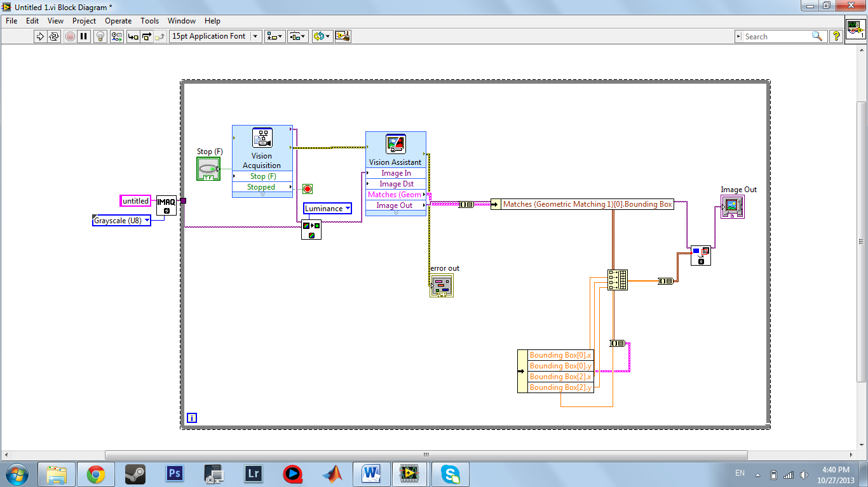

Figure 50: Lab View code for pattern recognition

# Appendix VII: Vision System in Lab View

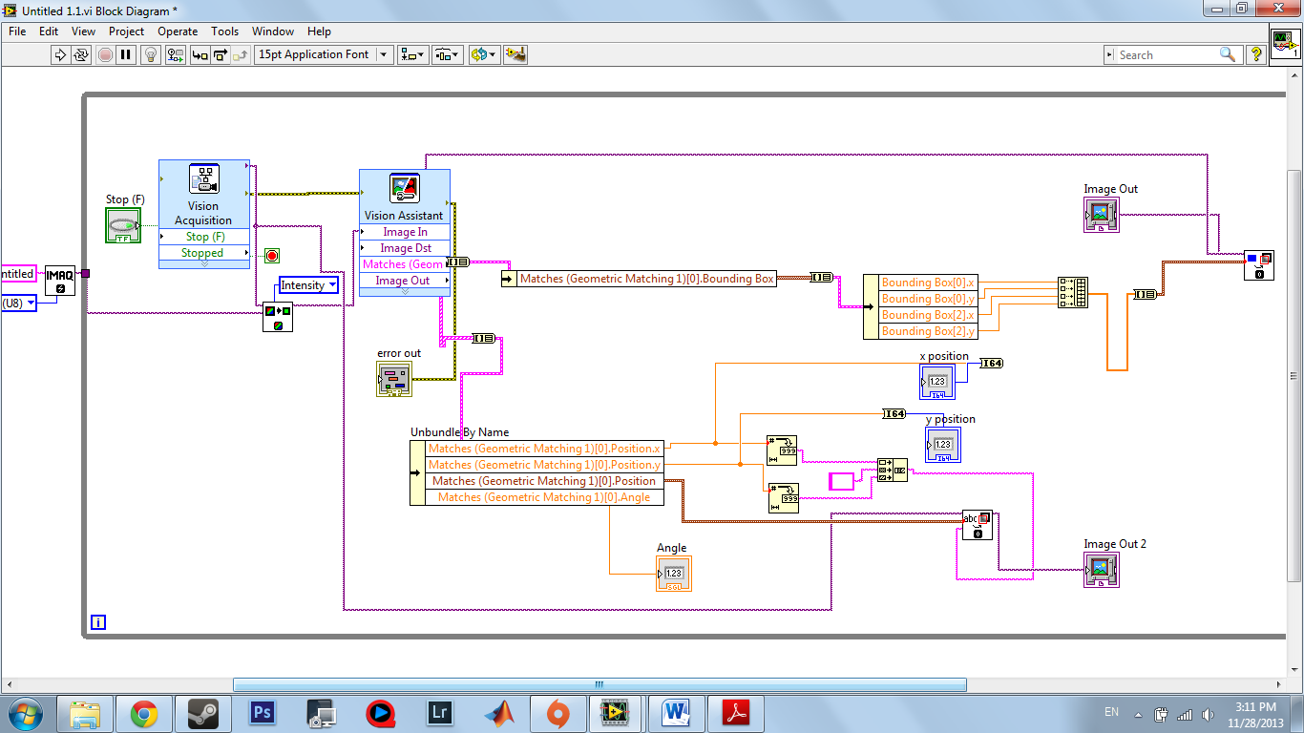  
Figure 51: Using Feature Detection to detect objects in Lab View

# Appendix VIII: Creating the Fuzzy Controller in Lab View

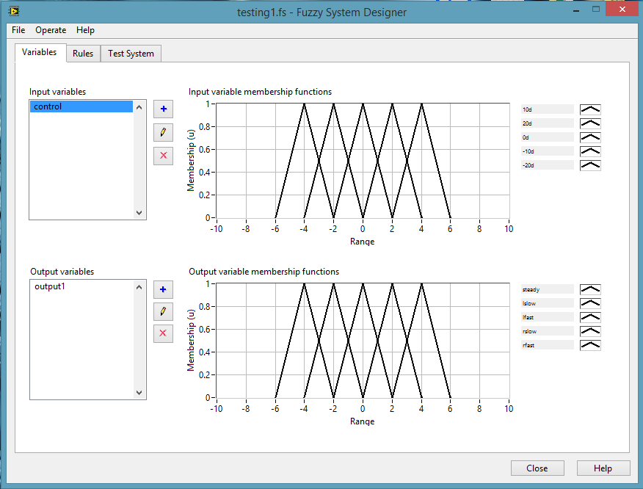

Figure 52: Fuzzy System Designer

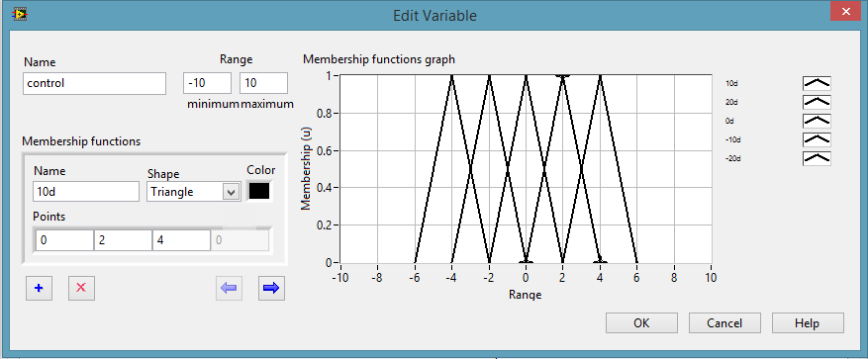

Figure 53: Fuzzy System Designer (Edit Input Variable)

Figure 53 shows the method to design the input variable. The input variable is named as control which the range is set between -10 to 10. Each membership function is given a name with shape and colour. Every end point of the shape is given a specific value. The name of each membership function for the above figure is basically the error of degree for the broom. The value of input variable is basically the degree of error for the broom compare to a vertical broom which is zero degree.

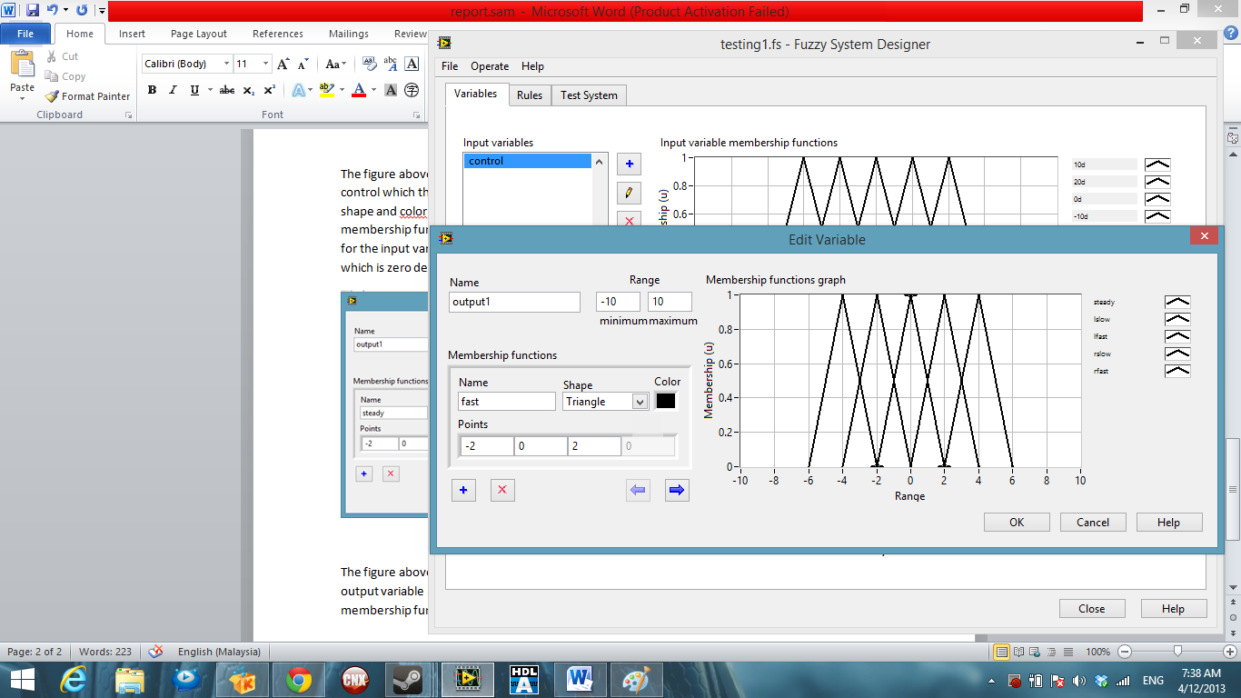

Figure 54: Fuzzy System Designer (Edit Output Variable)

The figure 54 above is showing the method to design the output variable. The method to design the output variable is basically same as the method for input variable. However, the name of each membership function for the above figure is basically the direction and speed of movement for the robot. The value of output variable is basically the direction and speed (value for PWM) used to feedback to the robot (microcontroller).

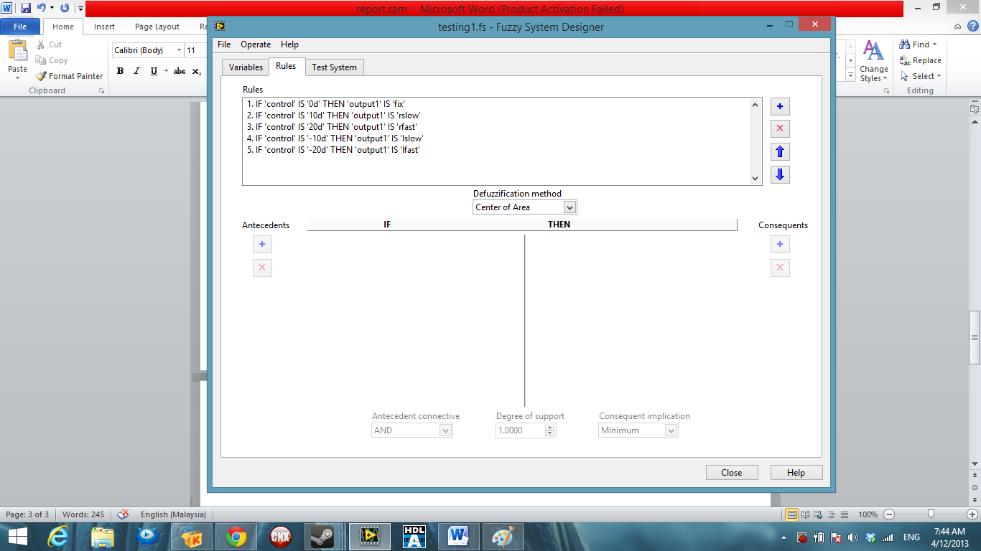

Figure 55: Fuzzy System Designer (Rules for between input and output variables)

Every specific rule is set between the input membership function to match with output membership function. For rules 1 is mean that if value (error of degree) for control (input variable) is zero degree, the output1 (output variable) will stay in “fix” membership function which the speed and direction feedback to the motor will be calculate based around this membership function. Defuzzication method is basically picked for the fuzzy system to make an actual calculation for the input to give specific output based on different kind of method and formula.

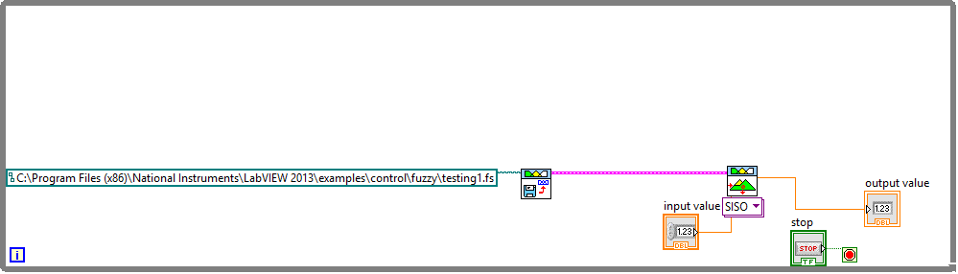

Figure 56: Block Diagram for Fuzzy System

The above figure is the block diagram for fuzzy system to work with the setting which has done on Fuzzy System Designer. FL Load Fuzzy System VI is used to load the setting which has done on Fuzzy System Designer. FL Fuzzy Controller VI is used to provide input and extract output based on the setting has done on Fuzzy System Designer. The input value should be connected to the output of the vision system to get the error of the angle of broom and output value should be connected to the serial system and send to the robot as the direction and speed of the robot.

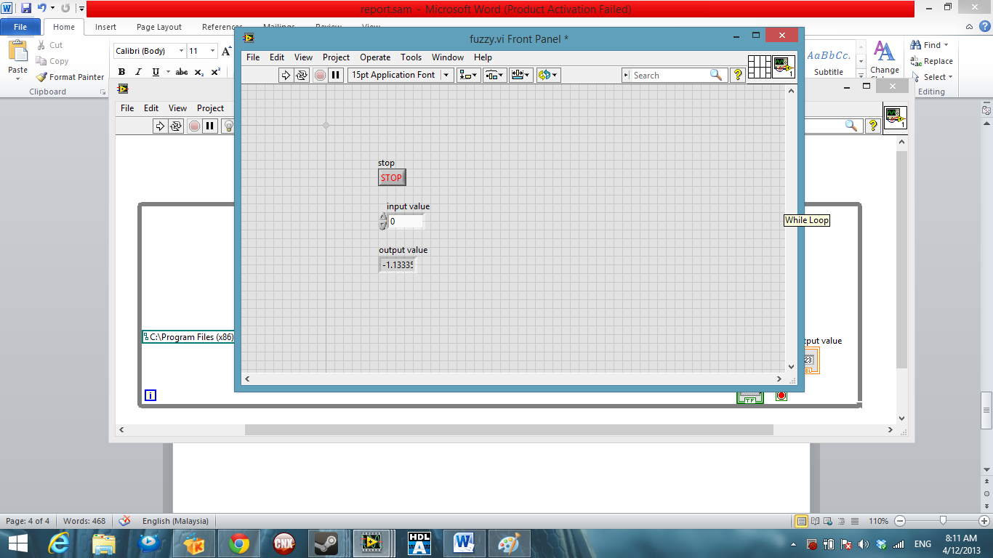

Figure 57: Front panel for Fuzzy System

Figure 58 shows the Fuzzy system with the two membership function graphs connected to them:

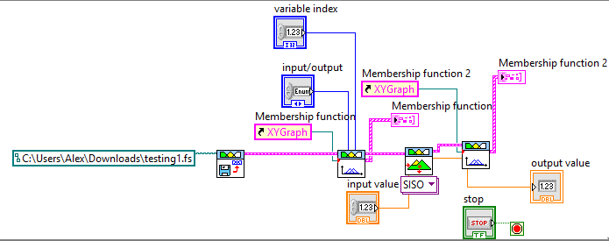

Figure 58: Final Lab View circuit diagram

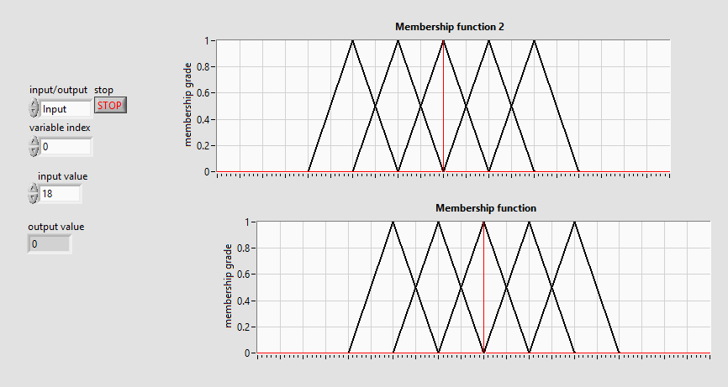

Figure 59: Output from Fuzzy Logic Controller

# Appendix IX: Connecting Control System and Vision System together

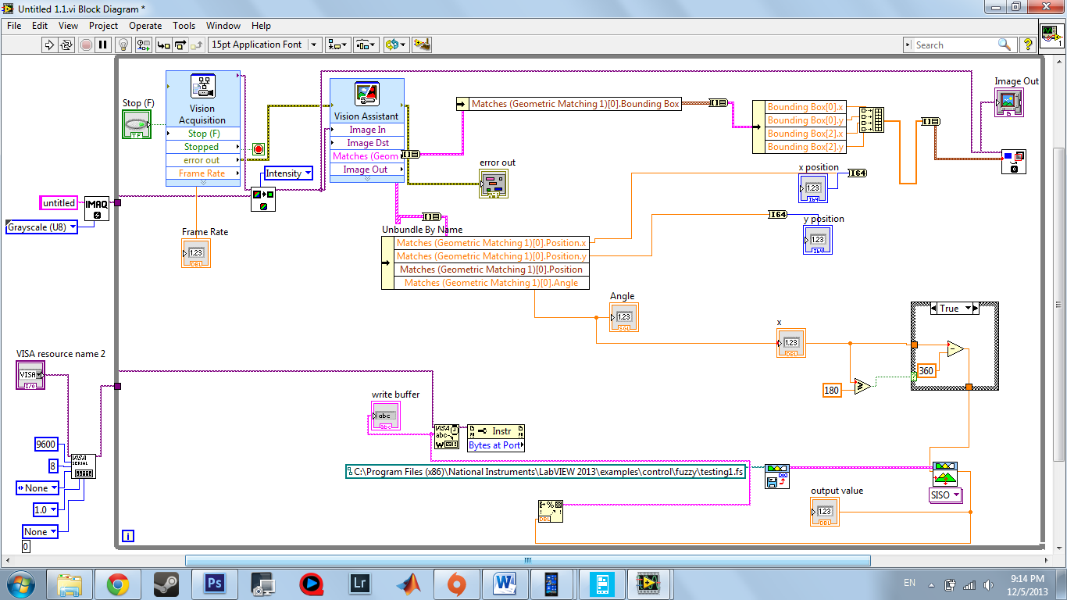

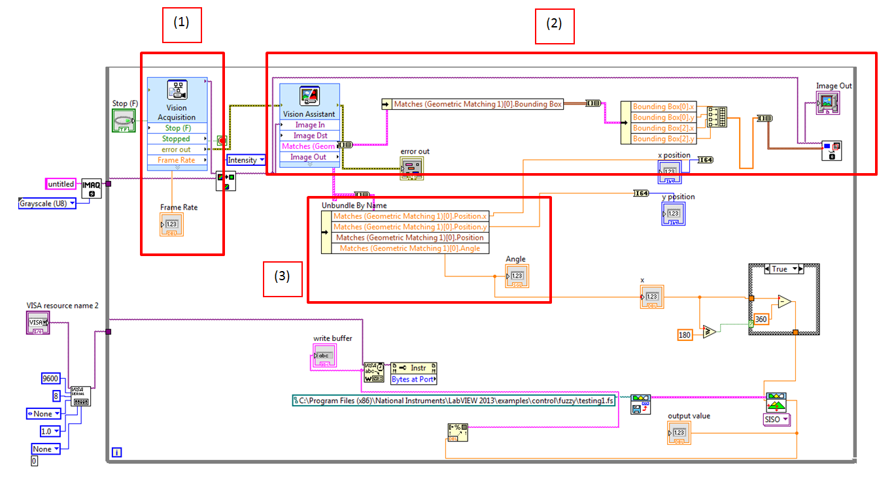

The numbers in the above figure correspond to the following description:  


# Appendix X: Calculations for finding the moment of inertia

The moment of inertia for simple symmetrical shapes are easy to find, however for the broom that we are using it can be a little more complex. We start by first calculating the moment of inertia for the broom cylinder, before finding how this value is changed with the broom end.

The general form of moment of inertia can be defined as:

$$I= \int{r^{2}dm}$$

Using this form we can calculate the moment of inertia for the broom cylinder. Firstly we can replace ‘dm’ with:

$$dm=ρV$$

Where ρ is the density of the cylinder and V is the volume of the cylinder. This now changes the general form of the equation into:

$$I=\int{r^{2}ρV}$$

The area of our cylinder, along with the differentiated area is given as:

$$A= πr^{2}$$

$$dA=2πr dr$$

Substituting this equation in for the volume will now give us inertia to be defined as:

$$I= \int{r^{2}ρ(}2πr dr)L$$

The integral limits will be between the centres of the cylinder (0) and the outer edge of the cylinder (R). We can also now move parameters that don’t have to be integrated out of the integral:

$$I=2πLρ\int_{0}^{R}{r^{3}dr}$$

Integrated this becomes:

$$I=2πLρ [\frac{r^{4}}{4}]_{0}^{R}$$

$$I=2πLρ\frac{R^{4}}{4}= πLρ\frac{R^{4}}{2}$$

The equation for mass can now be used to further simplify our equation down further:

$$M=ρV= ρπR^{2}L$$

So if we define our equation as:

$$I= \frac{ρπR^{2}L*R^{2}}{2}$$

We can substitute mass in for the parameters above, to get a final moment of inertia equation for a cylinder to be:

$$I=\frac{MR^{2}}{2}$$

This gives us the moment of inertia through the centre of the cylinder; however, we want to calculate it from the bottom of the broom. This can be done using the parallel axis theorem.

The parallel axis theorem states that once the moment of inertia of an object about its centre of mass has been determined, the moment about any axis can be determined by the parallel axis theorem.

The parallel axis theorem can be given as:

$$I_{parallel axis}= I_{cm}+Md^{2}$$

$I_{cm}$ Is the originally derived equation for moment of inertia, and d is the distance from the centre of gravity. For our cylinder, this means that the moment of inertia for a cylinder can be found to be:

$$I_{pa}=\frac{MR^{2}}{2}+Md^{2}$$

Most broomsticks tend to be hollow on the inside. This would mean that it is a hollow cylinder we need to find the moment of inertia for. This would not change a great deal calculation wise, except the integration takes place from the inner radius (a) to the outer radius (b), which would simply change our final equation to be:

$$I_{pa}=\frac{M(a^{2}+b^{2})}{2}+Md^{2}$$

Now after calculating the moment of inertia for the cylinder, we need to calculate it for the entirety of the broom, which includes the brush end. For this we need to look at the superposition of moments of inertia, as well as calculate the moment of inertia for the brush end.

To calculate the moment of inertia for the broom end, we take it to be a cuboids shape. The moment of inertia for a cuboid is:

$$I=\frac{1}{12}M({depth}^{2}+{width}^{2})$$

This leads a total moment of inertia to be:

$$I_{pa}=\frac{M(a^{2}+b^{2})}{4}+ \frac{1}{12}M(d^{2}+w^{2})+M{(d+d_{2})}^{2}$$

$d_{2}$ Is the distance from the brush end to the centre of gravity.

The moment of inertia for several objects can simply be added together with the added parallel axis contribution that each of the objects has on the axis (superposition of moments).

# Appendix XI: Calculations for finding the plant transfer function

Forces acting on the base of the platform:

$$M\ddot{x}+b\dot{x}+N=F$$

Forces horizontal to the motion of the pendulum where I = moment of inertia:

$$N=m\dot{x}+mI\ddot{θ}cosθ-mI{\dot{θ}}^{2}sinϑ$$

**This then gives us our first equation of motion:**

$$M\ddot{x}+b\dot{x}+m\dot{x}+mI\ddot{θ}cosθ-mI{\dot{θ}}^{2}sinϑ=F$$

Finding our second equation of motion:

$$Psinϑ+Ncosϑ-mgsinϑ=mI\ddot{ϑ}+m\ddot{x}cosϑ$$

$$-PIsinθ-NIcosθ=I\ddot{θ}$$

So we need to multiply throughout by I:

$$PIsinϑ+NIcosϑ-mgIsinϑ=mI^{2}\ddot{ϑ}+mI\ddot{x}cosϑ$$

$$-I\ddot{θ}-mgIsinϑ=mI^{2}\ddot{ϑ}+mI\ddot{x}cosϑ$$

$$-mgIsinϑ=mI^{2}\ddot{ϑ}+I\ddot{θ}+mI\ddot{x}cosϑ$$

$$-mgIsinϑ=\ddot{ϑ(mI^{2}}+I)+mI\ddot{x}cosϑ$$

**This gives us our second dynamic equation:**

$$-mI\ddot{x}cosϑ=\ddot{ϑ(mI^{2}}+I)+mgIsinϑ$$

**Linearizing the equations:**

$$M\ddot{x}+b\dot{x}+m\dot{x}+mI\ddot{θ}cosθ-mI{\dot{θ}}^{2}sinϑ=F$$

$$-mI\ddot{x}cosϑ=\ddot{ϑ(mI^{2}}+I)+mgIsinϑ$$

The set of equations should be linearized about theta = Pi

Assume that theta is equal to Pi + $∅$ where $∅$ = a small angle from vertical upward direction:

$$cosθ= -1$$

$$sinθ= -∅$$

$$\dot{ϑ^{2}}=0$$

$$mI\ddot{x}=\ddot{ϑ(mI^{2}}+I)+mgIsinϑ$$

$$M\ddot{x}+b\dot{x}+m\dot{x}-mI\ddot{θ}-mI{\dot{θ}}^{2}sinϑ=F$$

These have now given us our linearized equations:

$$mI\ddot{x}=\ddot{∅(mI^{2}}+I)-mgI∅$$

$$\ddot{x(M+m)}+b\dot{x}-mI\ddot{∅}=F$$

F = our input force which we shall now call u

$$mI\ddot{x}=\ddot{∅(mI^{2}}+I)-mgI∅$$

$$\ddot{x(M+m)}+b\dot{x}-mI\ddot{∅}=u$$

$$\left(M+m\right)X(s)s^{2}+bX\left(s\right)s-mI∅(s)s^{2}=U(s)$$

$$mIX(s)s^{2}=(I+mI^{2})∅(s)s^{2}-mgI∅(s)$$

Initial Conditions are assumed to be zero:

$$X\left(s\right)=\frac{(I+mI^{2})∅(s)s^{2}}{mIs^{2}}-\frac{mgI∅(s)}{mIs^{2}}$$

$$X\left(s\right)=\frac{(I+mI^{2})∅(s)}{mI}-\frac{g∅(s)}{s^{2}}$$

$$X\left(s\right)= \left[\frac{(I+mI^{2})}{mI}-\frac{g}{s^{2}}\right]∅(s)$$

$$\left(M+m\right)\left[\frac{(I+mI^{2})}{mI}+\frac{g}{s}\right]∅\left(s\right)s^{2}+b\left[\frac{\left(I+mI^{2}\right)}{mI}+\frac{g}{s}\right]∅\left(s\right)s-mI∅(s)s^{2}=U\left(s\right)$$

$$∅\left(s\right)\left[\left(M+m\right)\left[\frac{(I+mI^{2})}{mI}+\frac{g}{s}\right]s^{2}+b\left[\frac{\left(I+mI^{2}\right)}{mI}+\frac{g}{s}\right]s-mI∅(s)s^{2}\right]=U\left(s\right)$$

$$\frac{∅\left(s\right)}{U\left(s\right)}=\frac{1}{\left(M+m\right)\left[\frac{(I+mI^{2})}{mI}+\frac{g}{s}\right]s^{2}+b\left[\frac{\left(I+mI^{2}\right)}{mI}+\frac{g}{s}\right]s-mIs^{2}}$$

$$\frac{∅\left(s\right)}{U\left(s\right)}=\frac{1}{\left(M+m\right)\left[\frac{(I+mI^{2})}{mI}+\frac{g}{s}\right]s^{2}+\left[\frac{b\left(I+mI^{2}\right)}{mI}+\frac{bg}{s}\right]s-mIs^{2}}$$

$$\frac{∅\left(s\right)}{U\left(s\right)}=\frac{1}{\left(M+m\right)\left[\frac{(I+mI^{2})}{mI}+\frac{g}{s}\right]s^{2}+\frac{b\left(I+mI^{2}\right)s}{mI}-mIs^{2}+bg}$$

$$\frac{∅\left(s\right)}{U\left(s\right)}=\frac{1}{\left(M+m\right)\left[\frac{(I+mI^{2})}{mI}+\frac{g}{s}\right]s^{2}+bs\frac{\left(I+mI^{2}\right)}{mI}-mIs^{2}+bg}$$

$$\frac{∅\left(s\right)}{U\left(s\right)}=\frac{1}{\left[\left(M+m\right)s^{2}+bs\right]\left[\frac{(I+mI^{2})}{mI}\right]+\frac{g\left(M+m\right)s^{2}}{s}-mIs^{2}+bg}$$

$$G(s)=\frac{1}{\frac{Qs^{2}}{mI}+bs\left[\frac{Q+{(mI)}^{2}}{(M+m)mI}\right]+g\left(M+m\right)s+bg}$$

Multiply throughout by ‘mI’…

$$G(s)=\frac{mI}{Qs^{2}+mIbs\left[\frac{Q+{(mI)}^{2}}{\frac{Q+{(mI)}^{2}}{(I+mI^{2})}mI}\right]+mgI\left(M+m\right)s+bgmI}$$

$$G(s)=\frac{mI}{Qs^{2}+bs\left[(I+mI^{2})\right]+mgI\left(M+m\right)s+bgmI}$$

Multiply throughout by s:

$$G\left(s\right)=\frac{mIs}{qs^{3}+bs^{2}\left(I+mI^{2}\right)-mgI\left(M+m\right)s-bmgl}$$

*I = moment of inertia, M = mass of platform, B = friction component, M = mass of brush, g = gravitational force*

**Making the System work in multiple directions**

The main problem so far is that we have only been thinking about the broom falling in one direction, what if it was to fall in another direction? We will need the system to figure out which direction it has fallen in and make the motors move in the opposite direction.

We will go about this in the following manner:



Figure 60: Calculating in both directions

We will calculate the horizontal components both in the x-direction and the y-direction. We can then draw a new diagram as shown in figure 61:



Figure 61: Finding the angle to which it fell

From trigonometry we can find that:

$$\tan\left(\frac{Fcos15}{Fcos25}\right)=θ= tan\left(\frac{cos15}{cos25}\right)=tan⁡(\left(\frac{cosθx}{cosθy}\right)$$

Once, we have calculated the angle to which it fell, we now need to work out which direction it fell, forward/backwards, left/right, we will have to call one of them the positive direction and the other the negative direction.

Left/backwards = negative, if angle is negative on first camera/second camera.

Right/forwards = positive, if angle is positive on first camera/second camera.

# Appendix XII: Flow Charts





# Appendix XIII: CV Liew Shen

Room 1 Flat 24 Ashcroft, Pritchett’s road

Kit Shen, Liew Birmingham, B15 2QU

07466330172 || [KSL283@bham.ac.uk](mailto:KSL283@bham.ac.uk)

_________________________________________________________________________________________________________________

**PERSONAL STATEMENT**

An undergraduate, Meng Electrical and Electronic Engineering (E&E) in University of Birmingham. I have work experience in company’s both research & engineering department and outdoor-field.

I am interested in electronic and electrical based filed and looking for a job where I can utilize my knowledge on electrical and electronic to apply on.

_________________________________________________________________________________________________________________

**EDUCATION**

Year 2012-2015 **University of Birmingham, Birmingham, UK**

**MEng in Electrical and Electronic Engineering**

***(****Grade: 2:1 in 2013)*

All courses are accredited by the institution of Engineering and Technology (IET) that allowed me to develop:

- A solid grounding in the underlying physical and mathematical principles in both modules courses and laboratory works.

- Communication skill throughout the group projects

Year 2011-2012 **Taylor’s University - Malaysia**

**BEng (Hon) in Electrical and electronic Engineering**

*(Grade: 2:1)*

Year 2010-2011 **Taylor’s University College - Malaysia**

**Pre-university, South Australia Matriculation (SAM)**

*(Physic grade B, Mathematic grade B, Further Mathematic grade B )*

Year 2005-2009 **Methodist Boy’s School - Malaysia**

*(SPM Level: physic grade B+, Mathematic grade A+, Additional Mathematic grade B+)*

__________________________________________________________________________________

**WORK EXPERIENCES**

2013 (July-Sept) **Media Technology Department WSL Engineering SDN.BHD (Malaysia)**

*Summer internship* - helps the company creating new product catalogue template

- designing and inspect products specification on the catalogues design.

- sending catalogues to professional bodies or clients to introduce new products

- establish communication with professional bodies from energy utilities company (Ternaga national Malaysia)

2012 ( Jan-Sept)  **Research & Engineering Department** **WSL Engineering SDN.BHD (Malaysia)**

*Full time -*I took part in monitoring products lifespan using accelerated aging, reduce operation error.

* Research different types of silica gel using to isolate the circuit from water vapour, developing water resistance products.
* Handled well with the laboratory equipment, soldering and wiring technique. Creating neat and understandable circuit.
* Repairing faulty lighting products, replacing new chips and components

2010 – 2012 **Customer Service WSL Engineering SDN.BHD (Malaysia)**

*term time* -receive feedback from customer and report it to the company

*Part time* - Replying emails and calls, establish good communication with clients

__________________________________________________________________________________

**ACHIEVEMENT, AWARDS AND POSITIONS OF RESPONSIBILITY**

Year 2011-2012I was appointed to be official **Photographer** for Taylor’s university symphony orchestra. I learned how to communicate and cooperate within the members and always organize my works

Year 2010-nowI’m a self-employfreelance **Photographer**. Hired by small company and event’s organizer to photograph products and events. I’ve learned how to established effective working relationships with people or what they expecting from my work, also always punctual in appointments and exchange opinion on problems encounter

Year 2009I was selected to be the **President** of the science and math club. I have organized the 2009 national science and math quiz event. I’ve develop leadership and the importance of the responsibility.I lead my group member to operate effectively, giving instruction and manage work in time.

_________________________________________________________________________________________________________________

**PERSONAL SKILL**

|  |  |  |  |
| --- | --- | --- | --- |
| Program | Description | Program | Description |
| Adobe Photoshop | Normal media editing program. Usually work with image processing or creating catalog template. | **Adobe Lightroom** | Work with RAW or jpeg image processing. Similar to Photoshop but the workflow is concentrated in picture editing |
| C programing | A integrated toolset to build embedded application on PIC microcontroller | **Matlab** | A numerical Programing language allowing us to calculate complex mathematic |
| Labview | Developing a system using visual programing language. | **Dialux** | An illumination Simulation software by simulating the lighting condition of an environment, |
| VHDL | a hardware description language used to develop electronic design and simulation | **Multisim** | For simulation or designing electronic circuits using software. Capability to reduce design error |

_________________________________________________________________________________________________________________

**Project Experiences**

Year 2013 **Computer vision tracking object**

-Using computer vision (webcam) to track specific object by real time images processing technique

Year 2012 Jan **Air jelly** (Groups of 8)

-A new air transportation which look alike jellyfish

-Awarded Most mechanically advanced project in Taylor’s engineering fair 2012

Year 2011 Jun **Mind control wheel chair** (Groups of 4)

-New interactive system using human mind to operate a wheelchair for disable people

-Awarded best CAD Cam design in Taylor’s engineering fair 2011

-Bronze medallist in 2012 Malaysia Technology Expo (MTE)

Year 2011 Jan **War Robot** (Groups of 4)

-Developed a robot which capability to compete against others robot in robot competition

Year 2010 **Wii Remote Whiteboard interactive system (alone)**

-Develop new multi-point Interactive Whiteboards Using the Wiimote

_________________________________________________________________________________________________________________

**REFERENCE**

References are available on request.

# CV: Alexander Farmer

**Alexander James Farmer**

**Contact Details**

Home Address:       22 Mottram Close                 Email: [AJF188@bham.ac.uk](mailto:AJF188@bham.ac.uk)

                            Grappenhall

                               Warrington                            Phone: 07557961809

                              WA4 2XU    

**Education**

**2011 – Present University of Birmingham  
 MEng Electrical & Electronic Engineering (IET accredited)**

**Blogh Scholarship** (awarded for excellence)

**Second Year Modules (average score 81% - first)**

Digital Systems and Embedded Computing

Electronic Circuits and Devices

Electrical Energy Systems

Fundamentals of Signals and Systems

Project Management and Professional Practise

Speech and Audio Technology

Electromagnetics

Signal Systems and Control

Communication Systems

Multimedia – Music Technology

**2004 – 2011 Lymm High School**   
**A Levels**  
Physics - A  
Mathematics - A  
Systems & Control - A  
Applied ICT – A

**GCSEs**

9 grade A – B (Including Mathematics and English)

**Additional Skills**

**Teamwork** **–** This year I am project managing a team of Electrical and Electronic Engineering students whose challenge is to design and build a robot which should be able to balance a freestanding brush on a moveable platform. As project manager I oversee the budget and resources and I also distribute tasks in a way that ensures each person works to their strengths. I have personally been responsible for the vision and the control system of the robot.

I have also worked as part of a team outside of my course. As a keen sportsman I have learntthe importance of teamwork. Any team I am part of know that they can rely upon me to be committed, flexible and definitely enthusiastic. My warm and friendly nature makes it very easy for me to form successful and lasting relationships with people from all walks of life. I am Sports Rep for the Electrical Engineering Society as well as captain/manager of the football team. This involves negotiating funding from the department, communicating with the league officials and organising the team’s training sessions.

**Computing –** I am extremely proficient in the use ofthe internet, Microsoft Office and Matlab. During my first two years at University I have acquired in-depth knowledge of MPLAB, Micro-Cap, C programming, SFS, VHDL and Macromedia Dreamweaver. I am very confident when applying this software in projects, practical labs and in written reports.

**Communication –** My course involves group work on a daily basis and this has helped me to develop excellent communication skills. As an experienced black belt in Shotokan Karate I am regularly involved in promoting the club within the local community and also with the teaching of the younger members. I convey my drive and enthusiasm to others and encourage them to strive for success themselves.

**Problem Solving –** Studying for my A levels and a degree in a technical subject has made me very logical and methodical when tackling complicated tasks. I thrive on situations which challenge me intellectually and provide me with the opportunity to be creative and innovative when finding successful solutions.

**Work/Work Experience**

**July 2013 – September 2013 Summer Internship at Aquatec Engineering Limited**

As a Junior Engineer I worked on a Matlab based software called AQUAscat toolkit, and this was used in conjunction with the AQUAscat instruments which the company manufacture. My responsibility was to fix a list of bugs in 1000s of lines of code and at the same time make specific enhancements. I was very successful on this task because I approached it in a logical and determined manner. This experience has made me far more self-sufficient and has given me a valuable insight into life within an Electrical Engineering Company.

**June 2010 – August 2010 Sales Assistant at ASDA Superstore Warrington**

Each day I was placed in different departments and given a variety of responsibilities. I thoroughly enjoyed the opportunity of meeting new colleagues and the challenge of carrying out unfamiliar tasks.   
  
_________________________________________________________________________________

**Voluntary Work**

Conservation Society: Clearing wetlands and building natural hedges in Birmingham.

**Interests & Activities**

I am a very enthusiastic middle and long distance runner and enter 5km, 10km and marathon events as personal challenges and also to raise money for charity. I set myself targets to improve upon my personal best times and this motivates me to train on a regular basis. I love fell walking in Cumbria and I am part-way through completing the 214 Wainwright summits. I always rise to a challenge and do everything in my power to make sure that success is the only possible outcome.

_________________________________________________________________________________

**References**

Professor Martin Russell Nicolas Lefebvre  
School of Electronic, Senior Project Engineer  
Electrical & Computer Engineering Aquatec Group Limited  
University of Birmingham High Street   
Pritchatts Road Hartley Wintney   
Birmingham Hampshire  
B15 2TT RG27 8NY

Email: [m.j.russell@bham.ac.uk](mailto:m.j.russell@bham.ac.uk) Email: [nlefebvre@aquatecgroup.com](https://owa01.bham.ac.uk/owa/redir.aspx?C=pzX2n7qOWUWW6KM1_rTskhoHLoGfo9AI17hFacu3UGTu8tnzgRWV8AcshOMM2kbJM_oYUDEI1lY.&URL=mailto%3anlefebvre%40aquatecgroup.com)

# CV Sam James

*Samuel Jozef James – Flat 7, 664 Pershore Road, Birmingham, B29 7NX – 07592824498 (mobile) – s_james93@hotmail.com (e-mail) –* <http://www.linkedin.com/pub/samuel-james/5b/768/b15>

I am a third year undergraduate student looking for a year placement in the Electronic or Communications Engineering industry in order to expand on my practical knowledge and experience, and to gain an insight into how the industry works. I am currently studying towards a Master’s degree in Electronic and Communication Engineering and plan to incorporate an internship between my third and fourth years.

**Education**

2011-present University of Birmingham

MEng Electronic and Communication Engineering (3rd Year)

First year: 65%

Second year: 61%

My second year project involved working in a group to design, build and test a line following robot to compete against other teams from the year. I was my group’s leader, which put me in charge of time- and budget keeping for the project as a whole, as well as making sure each section was completed at a reasonable pace and to a high standard.

2009-2011 Hills Road Sixth Form College, Cambridge

A levels: Electronics (A*), Physics (A*), Maths (A), Further Maths (B)

AS level: Psychology (A)

Previously A very basic grasp of the German language, along with 10 full GCSE grades (A* to C) and two short courses

**Skills and Achievements**

Technical

* C Programming (Microsoft Visual Studio and MPLab)
  + One 20 credit module in First Year at University (C Programming and Algorithmic Problem Solving) and part of a Lab series in Second Year at University (Digital Systems and Embedded Computing)
* Assembler Programming (MPLab)
  + First year at University, half of 20 credit module (Digital Logic and Microprocessor Systems)
* CUPL (Protex DXP)
  + Part of a lab series in Second Year at University (Digital Systems and Embedded Computing)
* MATLAB
  + University second year coursework (Fundamentals of Signals and Systems)
* System and Sub-System Design, Testing and Debugging
  + Electronics A-Level (end of year project mark = 97%), first and second year at University (Digital Logic and Microprocessor Systems, Second Year Group Project)
* VHDL (Active HDL)
  + A 10 credit module in Third Year at University (Computer Hardware and Digital Design)
* Microsoft Office (Word, Powerpoint, Excel, Outlook)
  + Everyday use and school education
* Internet browsing (Mozilla/Mozilla Firefox, Internet Explorer, Google Chrome)
  + Research, leisure and communication

Personal

* Working within a team/small group
  + Cadets (leadership and group-building exercises), work (newest member of the reception desk team), school, Second Year Group Project at University
* Communication (face-to-face and over the phone)
  + Work (reception desk), everyday life – to a high level and with confidence and consideration to others
* Leadership and Organisation
  + Cadets (Ensemble challenge, diorama project, social media online group page), Second Year Group Project at University

**Employment**

2011-2012 Staff Bank, Addenbrooke’s Hospital, Cambridge

Central Pharmacy (July-August 2011)

Clinic 10, Audiology (December 2011)

Day Surgery Unit, Pre-Assessment Team (June-September 2012)

**Interests/Activities**

Before University I was a member of my local Air Training Corps squadron. This provided me with many opportunities to develop my personal skills, such as leading a project to create two dioramas for a competition in which we won both categories we entered, and broaden my range of extra-curricular interests such as aircraft recognition. In my Third Year at University I also joined my department’s football team. In my spare time I enjoy a range of activities including reading, hiking/climbing, cycling, improving my general knowledge, video gaming, and keeping in touch with friends and family.

**References**

Philip Atkins

Personal tutor/lecturer at the University of Birmingham

School of Electronic, Electrical and Computer Engineering

University of Birmingham

Edgbaston

Birmingham

B15 2TT

p.r.atkins@bham.ac.uk

0121 414 4329

Professor Clive Roberts

Professor at the University of Birmingham

Same address as above

c.roberts.20@bham.ac.uk

0121 414 4306

# CV Piotr Opacki

**PIOTR OPACKI**

34 Dawlish Road mobile: 07788578230

Selly Oak e-mail: piotr.opacki@yahoo.com

Birmingham

B29 7AE

I am a third year self-motivated Electronic and Electrical Engineering student who is very enthusiastic about technology. I have developed really good interpersonal and teamwork skills thanks to successful completion of various university group projects and one summer industrial placement.

**EDUCATION**

**2011 - Present** **University of Birmingham**

MEng Electronic and Electrical Engineering

1st year Formula Student project, 1st class performance throughout the year

2nd year Project leader in building an autonomous line following robot in a team of four students

3rd year Currently I am working in a team of seven students developing inverted pendulum control system

**2009 - 2011 Shrewsbury Sixth Form College**

Engineering Education Scheme in partnership with E-On UK

A Levels: Maths (A) Physics (A) Polish (A*)

GCSEs: English (C)

**2008 - 2009 Shrewsbury College of Arts & Tech**

English for Speakers of Other Languages course. Passed with Cambridge ESOL Level 1 qualification.

**RELEVANT EXPERIENCE**

July 2013 - September 2013 **Summer placement at Aquatec Group**

My task was to design an underwater display unit. I had to write firmware in C for an MCU, which generates graphics for the display based on the received data from a data logger, so the user can track temperature, pressure and battery voltage in real time. I managed my time efficiently so at the end of my placement the whole system was fully built including hardware and software parts. During the project I learnt about SPI, UART, NMEA messages, EEPROM memories and graphic displays.

**SKILLS**

Teamwork

* Took part in many university group projects. Particularly proud of being part of Formula Student and successfully leading second year electronic engineering group project (autonomous line following robot)
* Quickly integrated into the Aquatec Group team during summer placement programme

Problem solving

* Cleverly redesigned the chassis of a robot (2nd year group project) in order to increase the manoeuvrability and still be able to accommodate all the electronic parts
* When a previously booked venue for one of Polish Student Society events became unavailable on a short notice I managed to quickly find an alternative room

Interpersonal

* Established a good relationship with my summer placement supervisor which led to a fast progress of the project I was working on

Initiative

* Created a new design for advertising posters for Polish Student Society which has increased the number of new members dramatically
* Made the weekly camp newspaper at Camp Awosting look much better by delivering professional photographs to the journalism counselor and helping him with image processing

High focus on quality

* Made a 3D model of a robot in SolidWorks, which matches perfectly the real-life vehicle
* Delivered wedding photographs to my customers on a DVD with carefully designed case cover which reflects true character of the married couple

**TECHNICAL SKILLS**

|  |  |
| --- | --- |
| * C, VHDL and assembly programming languages * PIC microcontrollers, EEPROMs * Graphic displays * Analogue and Digital circuit design * UART, SPI * NMEA | * MATLAB * Micro-Cap CAD package * 3D Design * MPLAB IDE by Microchip, Lab windows CVI * SFS - Speech Filling System Package * Microsoft Word, Excel, Power Point * Fluent Polish |

**OTHER EXPERIENCE**

2008 - 2012 **A range of summer and part-time jobs**

I have worked at a summer camp Awosting in the USA, Uniq factory, The Relate Charity Shop, Roden Hall Nursing Home, McDonald’s and Domino’s Pizza. I also do photography semi-professionally. I have always tried to keep myself busy and doing something extra apart from studying. Working at the above places helped me to enhance customer service and teamwork skills. My trip to the USA was particularly interesting because I experienced living and working overseas.

**INTERESTS & ACTIVITIES**

I am a Treasurer at Polish Society, which involves asking various companies for sponsorship and managing the group’s budget. Networking is the key. I am also responsible for successful advertising and organising all the events. To keep myself active I go to the gym, play football and ski. Within my friends’ community I am known to be able to fix electronic gadgets, so I am frequently asked for help when something breaks down. Photography is my big hobby as well and I do it semi-professionally.

# CV Kavin Selvan

Kavin Kalai Selvan

Personal Statement:

Completion of undergraduate for Masters (MEng) in Electronic and Electrical Engineering at the University of Birmingham. My goal is to gain valuable experience from the University of Birmingham in my chose field which I can then apply to my future as an engineer.

Education

* Year 2013-2015: **University of Birmingham, Birmingham, UK MEng in Electrical and**

**Electronic Engineering**

* Year 2011-2013: **Taylor’s University Lakeside Campus, Malaysia, BEng in Electrical**

**And Electronic Engineering.**

Brief overview of projects undertaken, each semester there is a group project which involved all the schools of engineering such as EEE, Mechanical and Chemical where all 3 schools are bunched into groups and work together, each semester lasted 14 weeks. Semester 1- Solar Car (Electrical Components), Semester 2- Ergonomics (Plastic Bag Handle), Semester 3- Helping the Community-(Fun Theory Trash Bin Concept) and Semester 4- (Portable Workout Equipment)

* Year 2009-2011 **Taylor’s University College ( A-Levels)**
* Year 2005-2009 **Sri Kuala Lumpur Secondary School (SPM)**

Working Experience

* 2012 (Jan-March) **Denlite Letrik Sdn.Bhd-**Electrical and Mechanical Contractors

Trainee Quantitative Surveyor (Checking the Blueprints of the Worksites and the making sure they were in order, helping put together a tender proposal)

Personal Skill and Technical Achievements

* Assembly Language(MP Lab)

-Prerequisite Course in Taylor’s University Semester 3(Embedded Systems)

* MatLab

-Prerequisite Course in Taylor’s University Semester 3(Computer Applications for Engineers)

* VHDL (Active HDL)
* Course Offered in University of Birmingham(Computer Hardware and Design)
* MultiSim
* Used in Taylors University in semester 2-4 to simulate and plan electronic circuits and eventually make a PCB Board.
* SolidWorks
* Used in University of Birmingham MENg Group project to design a 3D Model of the Omni Wheel Robot for the Inverted Pendulum Project.
* Able to work with people from different fields in the same group for projects, have the ability to function as a group member and effectively follow and accomplish all the tasks provided by the group leader.

Reference

* Mr Kalai Selvan a/l Ratnam

Manager/Owner

Denlite Letrik Sdn.Bhd

Tel: +603 0193333926

Additional Reference available

# CV Aaron Lyons

**Aaron Lyons**

41 George Road, Home: 01902408769

Coseley, Mobile: 07805365007

West Midlands, E:acl7793@btinternet.com

WV14 8RB

**Education**

**2011 – Present - University of Birmingham**

MEng Electrical and Electronic Engineering

**Year 2 –** Average mark 65%

**Year 1 –** Average mark 67%

**2009 –2011 - Dudley College**

Duke of Edinborough Bronze Award

National Diploma in Electrical and Electronic Engineering – Triple Distinction

**2004 – 2009 - The Coseley School**

14 GCSE’s grade A-C including Maths, English, Science, German and Engineering

**Work Experience**

**July-Sept 2013 - Electrical Assembler at Brandenburg**

- working on an assembly line requiring efficient teamwork to ensure the product made it down the line consistently and up to quality standard

- Regularly exceeded expected production rate

- gained experience assembling electrical products

**July-Oct 2012 - Temporary Worker at Intralox, Ambirad, and Culina**

**-** Experienced operating various plastic cutting machinery

**-** Assisting in building industrial air conditioning units

- worked on assembly line requiring close work with other team members

**Jun-July 2012 - Sales Distributer – Strategic Five Marketing**

- Worked in a small team dealing with customers on various products

- Dealt with customers face to face on a daily basis

- Learnt to build relationships with customers to ensure customer satisfaction

**Skills**

**Technical**

- Worked on multiple programming applications including:

C, assembler, VHDL, MATLAB

- Excellent Microsoft Office skills from everyday use and multiple reports written

- Basic skills on Micro-cap, Proteus, CAD, and Blender

**Problem Solving**

- Throughout my engineering education, there have been numerous occasions where logical problems have been tasked to be done.

**Teamwork**

- Multiple university group projects, including third year project in which I am responsible for the physics and control systems of the ‘balancing broom’ project

**Communication**

- Project work that requires close communication skills with other team members

- Multiple job roles that needed excellent communication with customers and other colleagues

­

**Interests and Activities**

Throughout college I undertook numerous projects in my spare time along with a few other students that involved things ranging from engineering projects to outdoor walking activities, which lead to applying and completing the Duke of Edinborough award. I keep active by playing in the engineering football team, whilst previously playing in the universities Gaelic football team. In my spare time I spend most of it creating music and improving my skill on my guitar, which helps me to get creative and innovative. Socialising with friends and family keeps ensures I communicate with people regularly.

**References**

Stuart Hillmansen

Personal tutor - University of Birmingham

School of Electronic, Electrical and Computer Engineering

University of Birmingham

Birmingham

B15 2TT

S.Hillmansen@bham.ac.uk, 0121 414 4289

Liam Peck

Branch Manager – Pertemps

96 King Street

Dudley

DY2 8PR

Liam.peck@pertemps.co.uk, 01384 211181

# CV Sam Hau

**Sam Khang Hau**

48 Dale Road, Birmingham B29 6AG, United Kingdom

Tel +44 (0) 74 6608 4442 email: [khanghau_91@hotmail.com](mailto:khanghau_91@hotmail.com)

**Personal Statement**

* Undergraduate student in Electrical and Electronic Engineering in University of Birmingham
* Have a lot of experience in Engineering Project during Degree and Diploma
* Have working experience in Engineering industry

**Education**

Year 2013-Present **University of Birmingham, Birmingham, UK**

**MENG in Electrical and Electronic Engineering**

Year 2011-2013 **Taylor’s University, Petaling Jaya, Malaysia**

**BENG (Hon) in Electrical and electronic Engineering**

*(Grade: 3.85 of 4)*

Year 2009-2011 **KDU University College, Petaling Jaya, Malaysia**

**Diploma in Electrical and Electronic Engineering**

*(Grade: 3.93 of 4)*

Year 2005-2009 **Tanah Putih Secondary School, Pahang, Malaysia**

*(SPM Level : A for all science and math subjects )*

**Work Experience**

Year 2010 (July-Dec) **Trainee – O.Y.L Research and Development**

* Worked in Testing and Calibration department
* Test components and make comparison with datasheet before large amount of purchasing
* Successfully design a new testing method for few components
* Calibrate devices in every department to make sure those devices work properly based on international rules and regulations.

**Project Experieces**

**BENG (Hon) in Electrical and electronic Engineering**

Mind-Controlled Robot (Group Project)

* Successfully built a robot controlled by using human brain in EEG method

Mind-Controlled Wheelchair (Group Project, Leader)

* Successfully built a wheelchair controlled by using human brain in EEF method
* Won Third Runner-up in transport category in Malaysia Technology Expo

Air-Jelly (Group Project, Leader)

* Successfully built a prototype of a jelly-fish float on the air by just moving it tentacles.
* Won the Best Mechanical Design in Taylor’s Engineering Fair 2012

Racing Cars (Racing team, Senior)

* Built A1 racing cars and won Second and Third Runner-up in 2 different local racing matches.
* Responsible to all Electrical and Electronics part of the racing cars

**Soft Skills**

**Communication:**

* Every project, I need always to communicate with supervisor, sponsors and group mates for the progress, challenges and support.
* Gave presentations to the sponsor about the projects to get funding or sponsor of components
* Communicate with group mates in other discipline of Engineering to get better understanding of their work
* Communicate with every department to get their permission or problem on calibration of devices in their department during internship in O.Y.L Research and Development

**Team Working:**

* Provide opinion or suggestion based on the knowledge from ours own discipline to the project group.
* Provide the best performance and support during racing competition on those mates which facing failure on their part.
* Played football and basketball since I was 5 years old. I tried to be helpful and supportive at all time towards my team-mates. Worked together for cup victories.

|  |  |  |  |
| --- | --- | --- | --- |
| Program | Description | Program | Description |
| C programing | A integrated toolset to build embedded application on PIC microcontroller | **Matlab** | A numerical Programing language allowing us to calculate complex mathematic |
| Labview | Developing a system using visual programing language. | **Proteus** | A software which used to design schematic and PCB diagram; real time simulation on circuit. |
| VHDL | A hardware description language used to develop electronic design and simulation | **Multisim** | For simulation or designing electronic circuits using software. Capability to reduce design error |

**Engineering Software Skills**

***My references are available on request.***